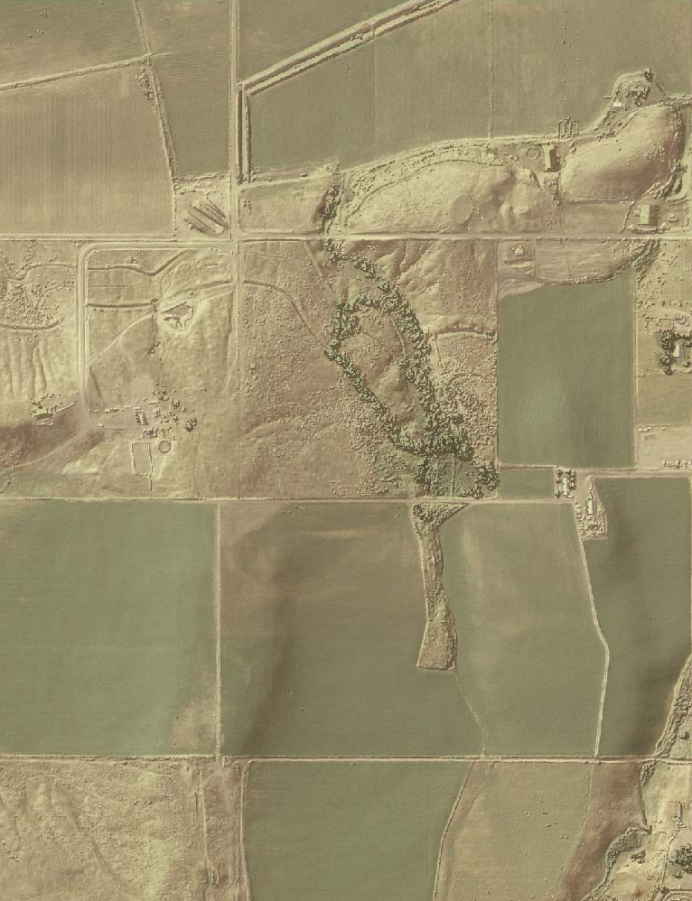

LiDAR Remote Sensing Data Collection
DEPARTMENT OF GEOLOGY AND MINERAL INDUSTRIES
Ontario, oregon

APRIL 24, 2009

Submitted to:

Department of Geology and Mineral Industries
800 NE Oregon Street, Suite 965
Portland, OR 97232


Submitted by:
Watershed Sciences
529 SW 3rd Avenue, Suite 300
Portland, OR 97204


LiDAR Remote Sensing Data Collection:
DOGAMI, Ontario study area

TABLE OF CONTENTS

1. Overview 4
1.1 Study Area (Ontario) 4
2. Accuracy 8
2.1 Relative Accuracy Calibration Results 8
2.2 Absolute Accuracy 10
3. Data Density/Resolution 12
4. Selected Imagery 16

1. Overview

1.1 Study Area (Ontario)
Watershed Sciences, Inc. has collected Light Detection and Ranging (LiDAR) data of the Ontario study area for the Oregon Department of Geology and Mineral Industries (DOGAMI). LiDAR acquisition for the Ontario study area occurred from December 3 to December 10, 2008. The requested LiDAR area of interest (AOI) totals 250 square miles, or 160,166 acres and the total area flown (TAF) covers 261 square miles (167,324 acres). The TAF acreage is greater than the original AOI acreage due to buffering and flight planning optimization (Figure 1.1 below). DOGAMI data are delivered in OGIC(HARN): Projection: Oregon Statewide Lambert Conformal Conic; horizontal and vertical datums: NAD83 (HARN)/NAVD88(Geoid03); Units: International Feet.

Figure 1.1. DOGAMI Ontario study area.
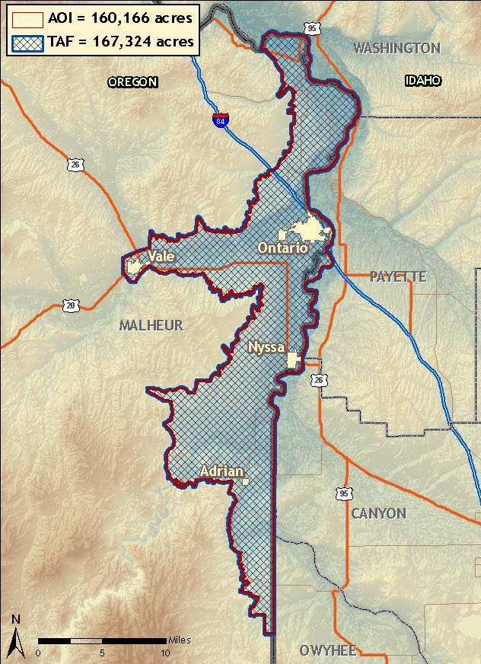

Figure 1.2. Ontario study area with the delivered USGS quads overlaid.
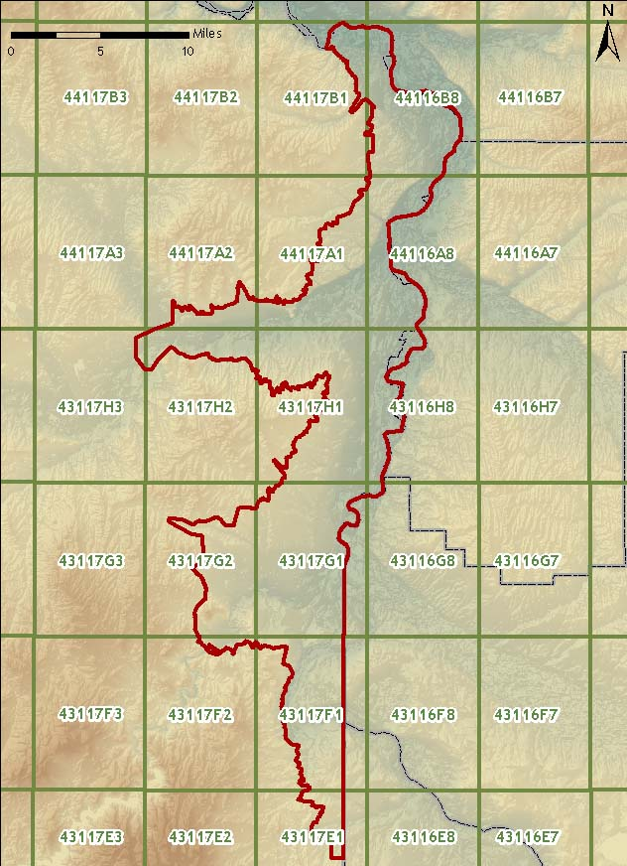
Figure 1.3. Actual flightlines for data delivered in the Ontario study area.
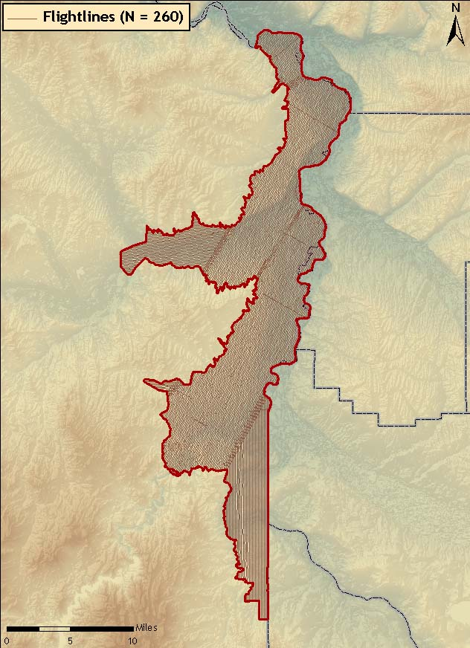
259

Figure 1.4. Base station and real time kinematic locations for the Ontario study area.
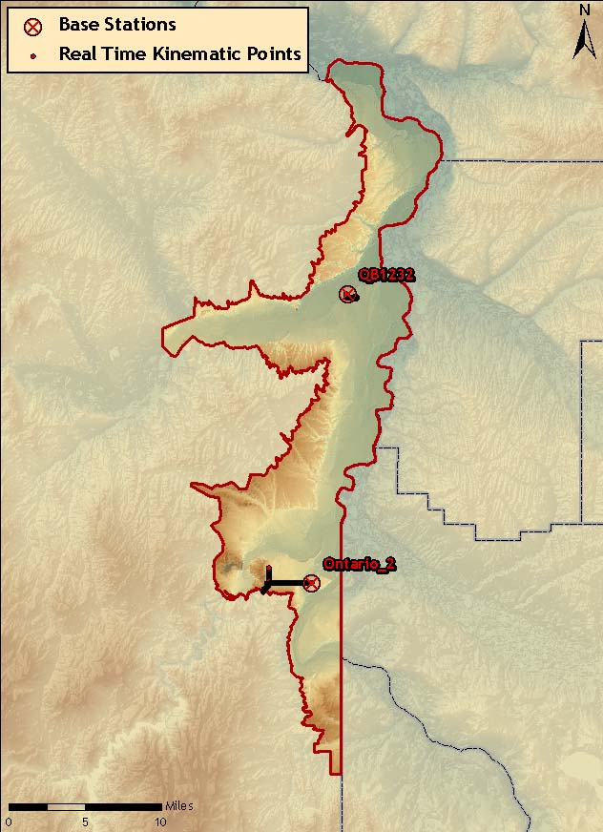

Table 1.1. Base Station Surveyed Coordinates, (NAD83/NAVD88, OPUS corrected) used for kinematic post-processing of the aircraft GPS data for the Ontario study area.

 | Datum NAD83(HARN) |  | GRS80
Base  Station ID | Latitude  (North) | Longitude  (West) | Ellipsoid  Height (m)
QB1232 | 44 01 35.30281 | 117 01 02.04837 | 650.208
Ontario_2 | 43 45 05.49646 | 117 03 51.00866 | 669.230

2. Accuracy

2.1 Relative Accuracy Calibration Results

Relative accuracy statistics are based on the comparison of 259 flightlines and over 3 billion points for data acquired to date.

- Project Average = 0.09ft (0.03m)
- Median Relative Accuracy = 0.09ft (0.03m)
- 1σ Relative Accuracy = 0.10ft (0.03m)
- 2σ Relative Accuracy = 0.12ft (0.04m)

Figure 2.1. Statistical relative accuracies, non slope-adjusted.
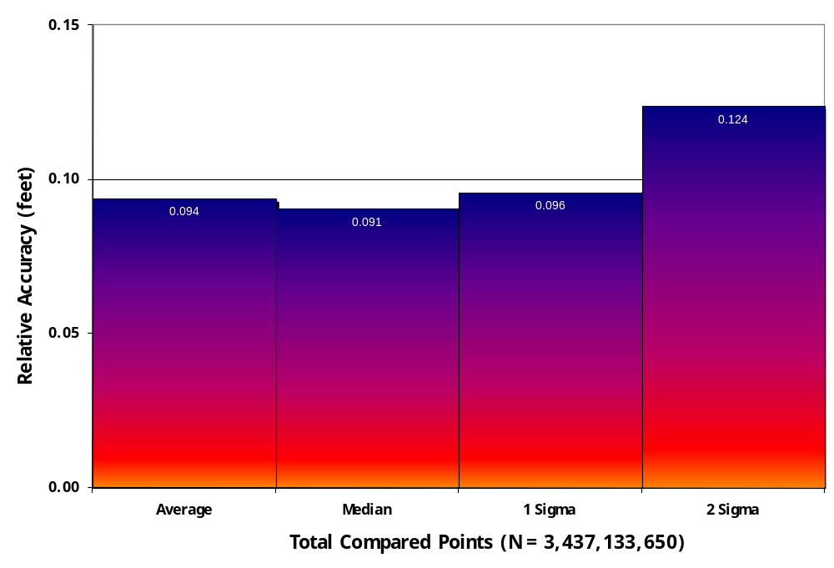

Figure 2.2. Percentage distribution of relative accuracies, non slope-adjusted.
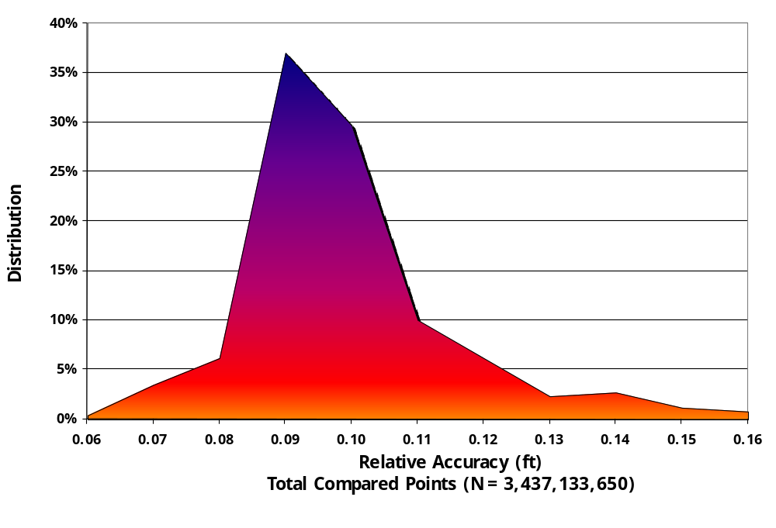

2.2 Absolute Accuracy

Absolute accuracy compares known Real Time Kinematic (RTK) ground survey points to the closest laser point. For the Ontario study area, 2,175 RTK points were collected. Accuracy statistics are reported in Table 2.1 and shown in Figures 2.3-2.4.

Table 2.1. Absolute Accuracy – Deviation between laser points and RTK survey points.

Sample Size (n): 2,175
Root Mean Square Error (RMSE): 0.10 feet
Standard Deviations | Deviations
1 sigma (σ): 0.10 feet | Minimum ∆z: -0.41 feet
2 sigma (σ): 0.21 feet | Maximum ∆z: 0.25 feet
 | Average ∆z: -0.03 feet

Figure 2.3. Ontario Study area histogram statistics
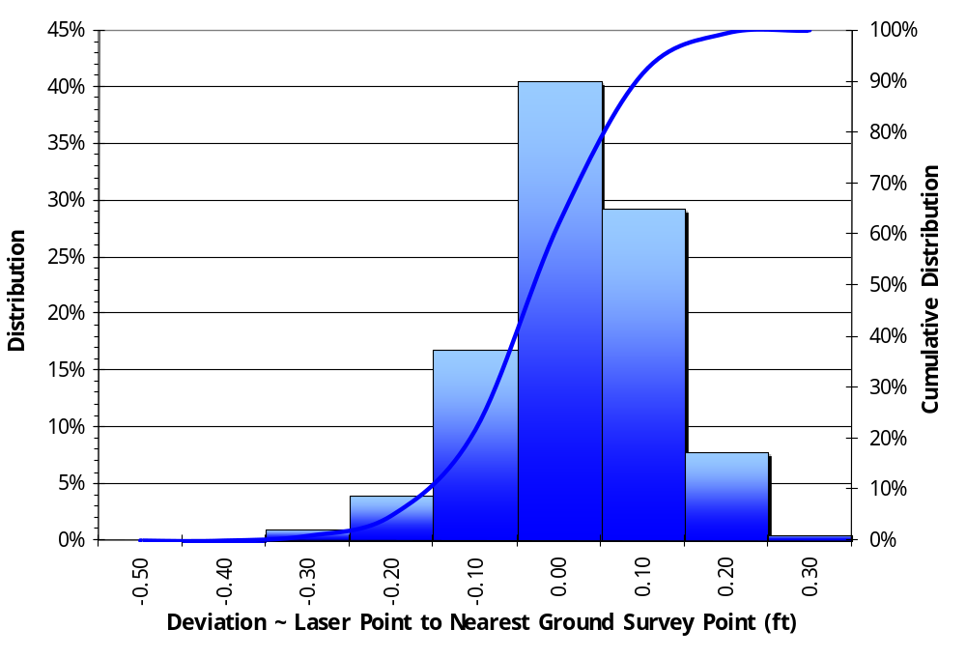

Figure 2.4. Ontario study area point absolute deviation statistics.

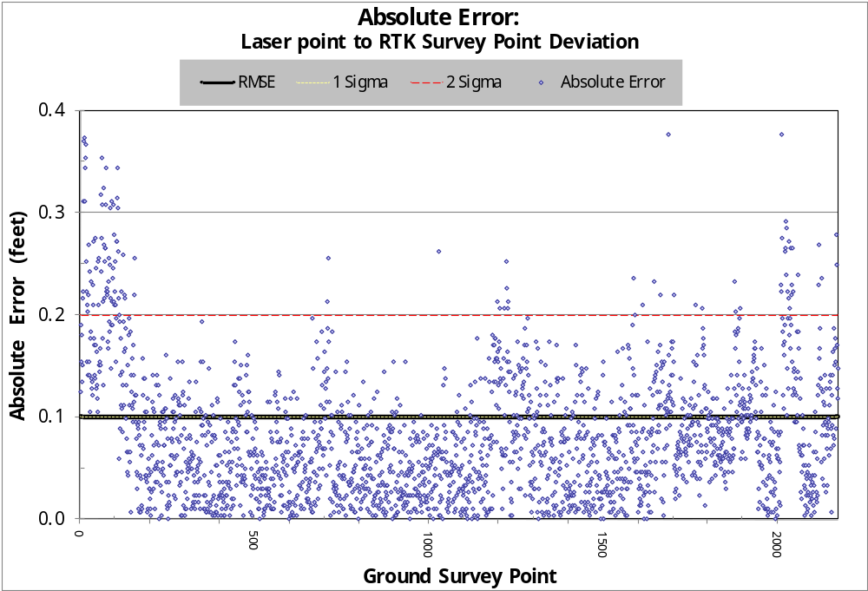

3. Data Density/Resolution

Some types of surfaces (i.e., dense vegetation or water) may return fewer pulses than the laser originally emitted. Therefore, the delivered density can be less than the native density and vary according to distributions of terrain, land cover and water bodies. Density histograms and maps (Figures 3.1 – 3.4) have been calculated based on first return laser point density and ground-classified laser point density.

Table 3.1. Average density statistics for Ontario data.

Average Pulse Density  (per square ft) | Average Pulse Density  (per square m) | Average Ground Density  (per square ft) | Average Ground Density  (per square m)
0.64 | 6.84 | 0.24 | 2.56

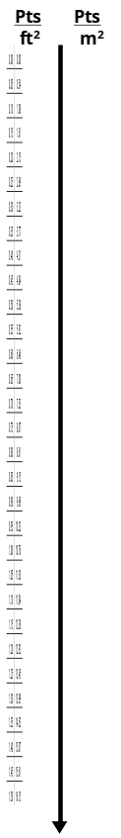
Figure 3.1. Histogram of first return laser point density for Ontario data.
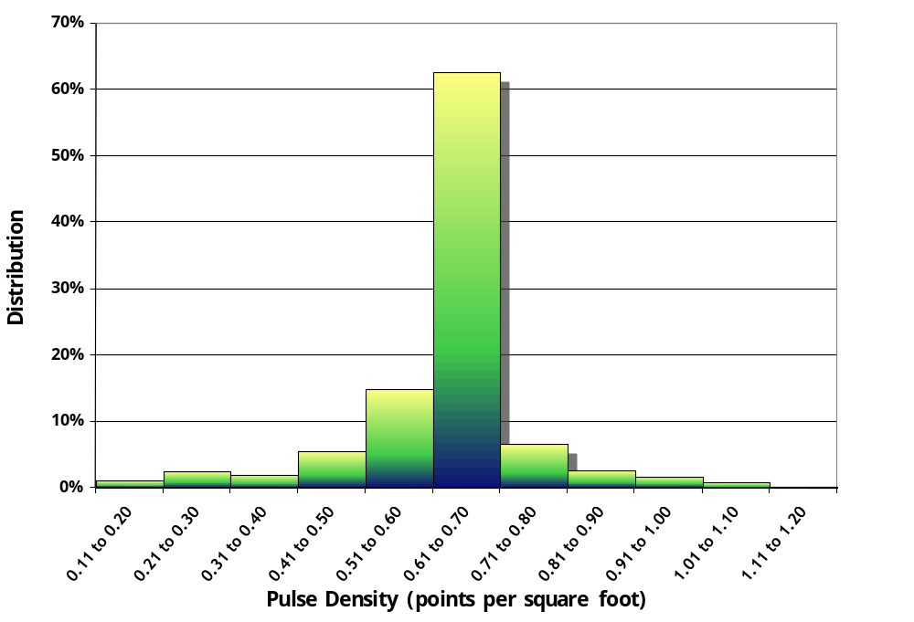
Figure 3.2. Image shows first return laser point per 0.75’ USGS Quad for the Ontario study area. High density tiles correspond with flightline overlap.
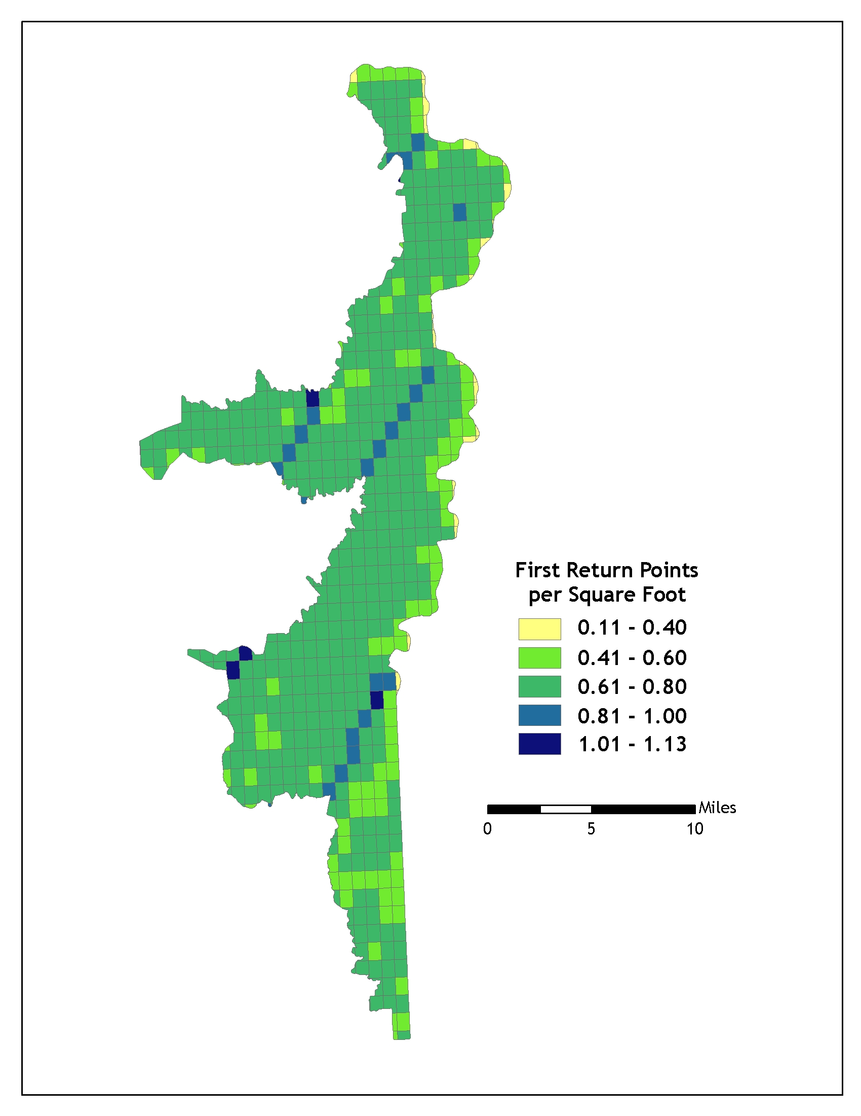
Ground classifications were derived from ground surface modeling. Supervised classifications were performed by reseeding of the ground model where it was determined that the ground model failed, usually under dense vegetation and/or at breaks in terrain, steep slopes and at bin boundaries.
Figure 3.3. Histogram of ground-classified laser point density for Ontario data.
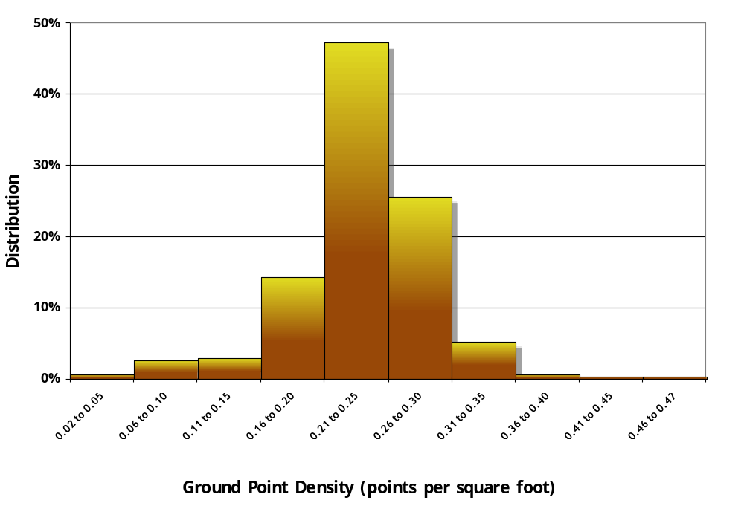

Figure 3.4. Ground-classified laser point density per 0.75’ USGS Quad for Ontario study area. 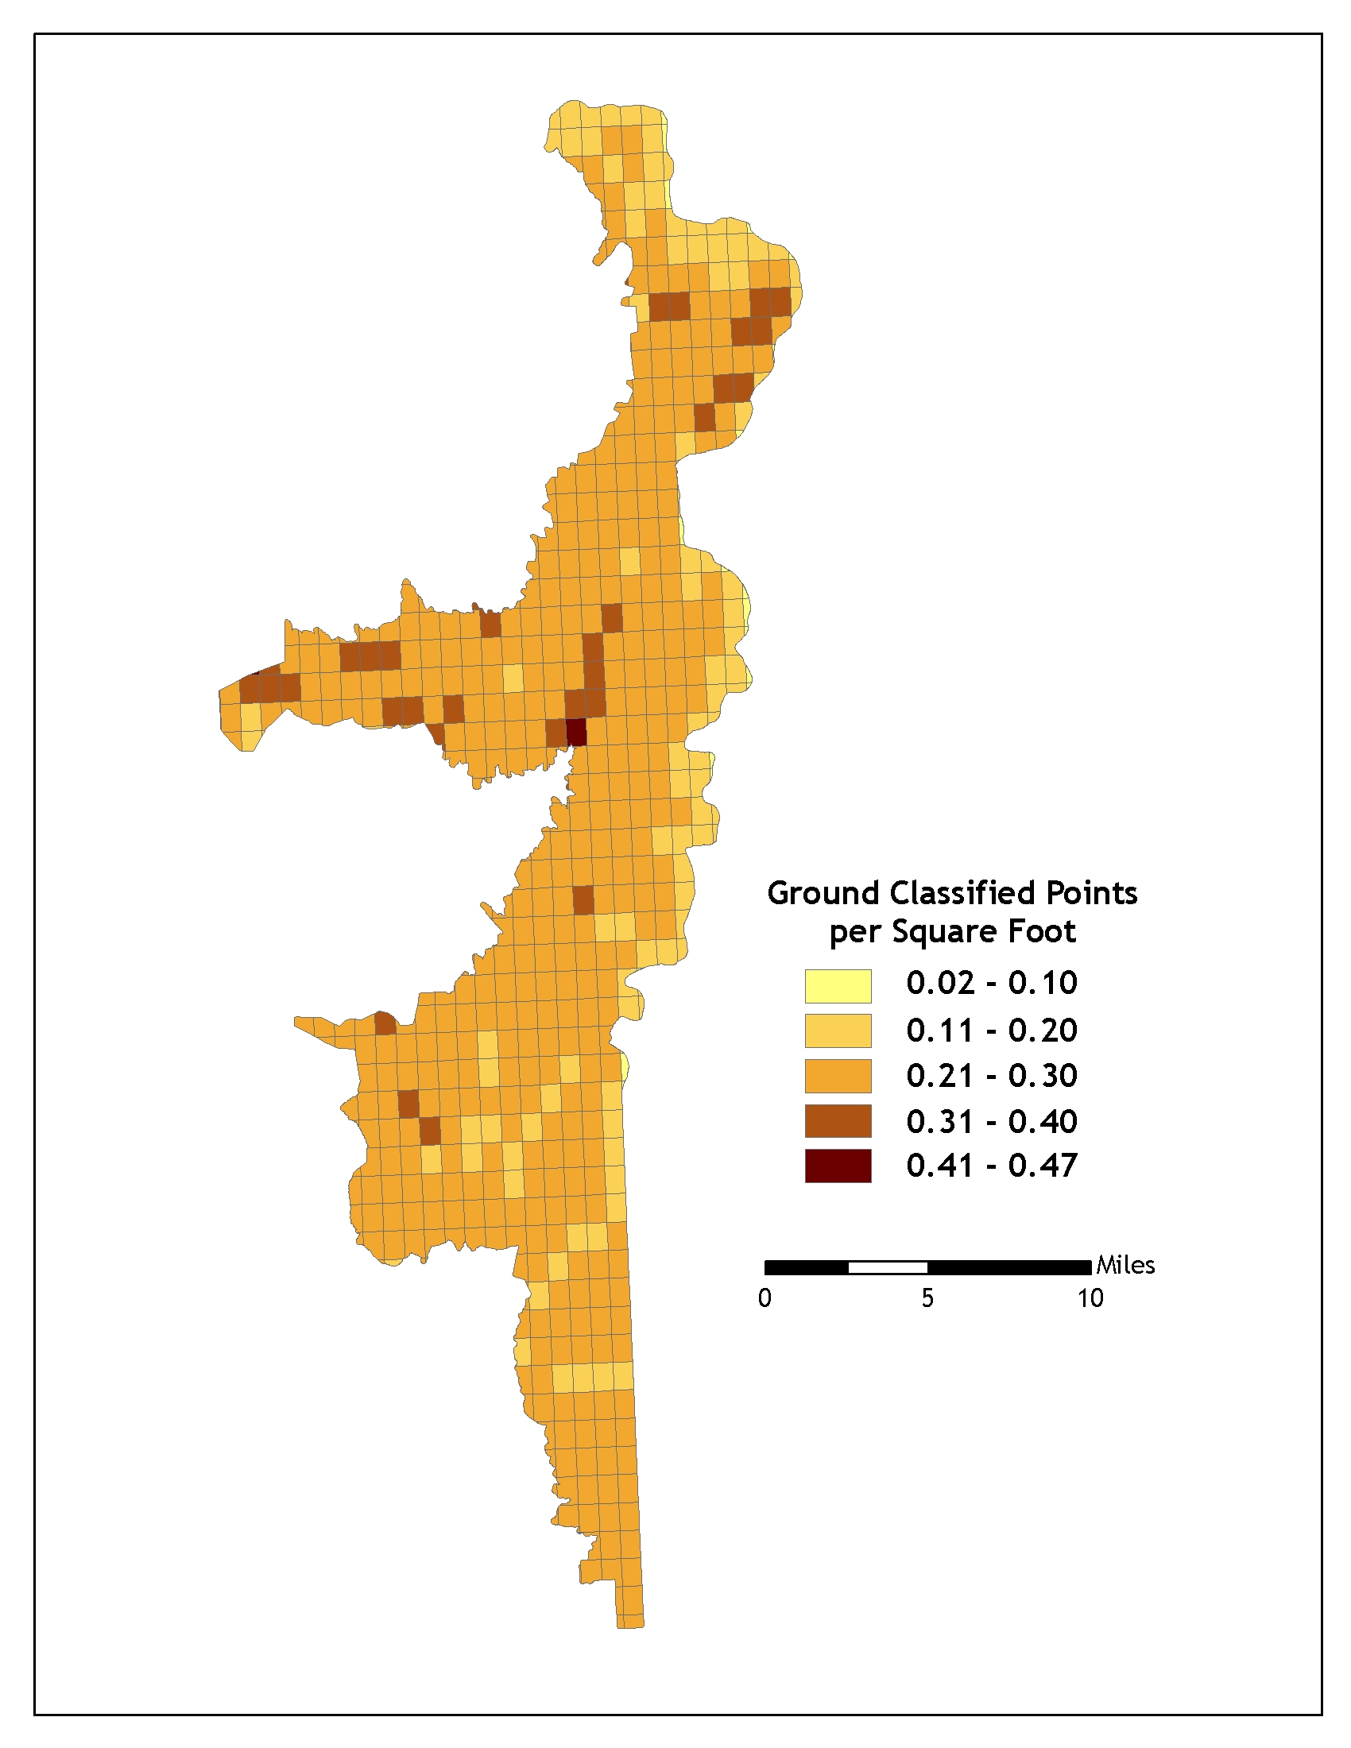

4. Selected Imagery
Figure 4.1. View of Murhpy Drain in the southern portion of the study area. Top image is a NAIP orthophoto, middle image is highest hit LiDAR, lower image represents bare earth LiDAR.
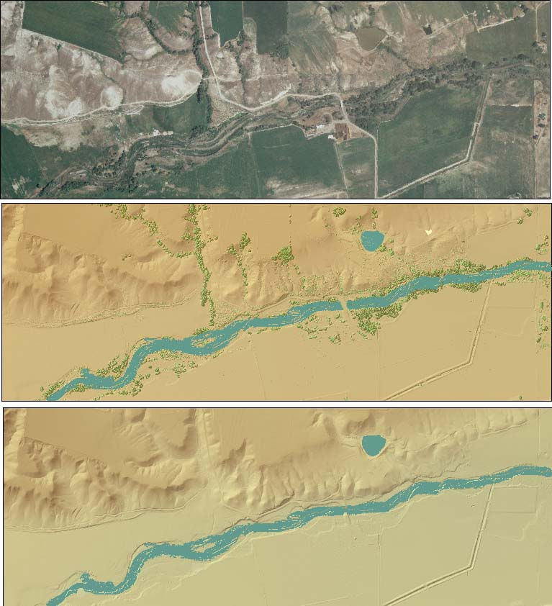
Figure 4.2. View of farmland in the southern portion of the Ontario Study Area. Top image is a NAIP orthophoto, center image derived from highest hit LiDAR, lower image is derived from bare earth LiDAR.


