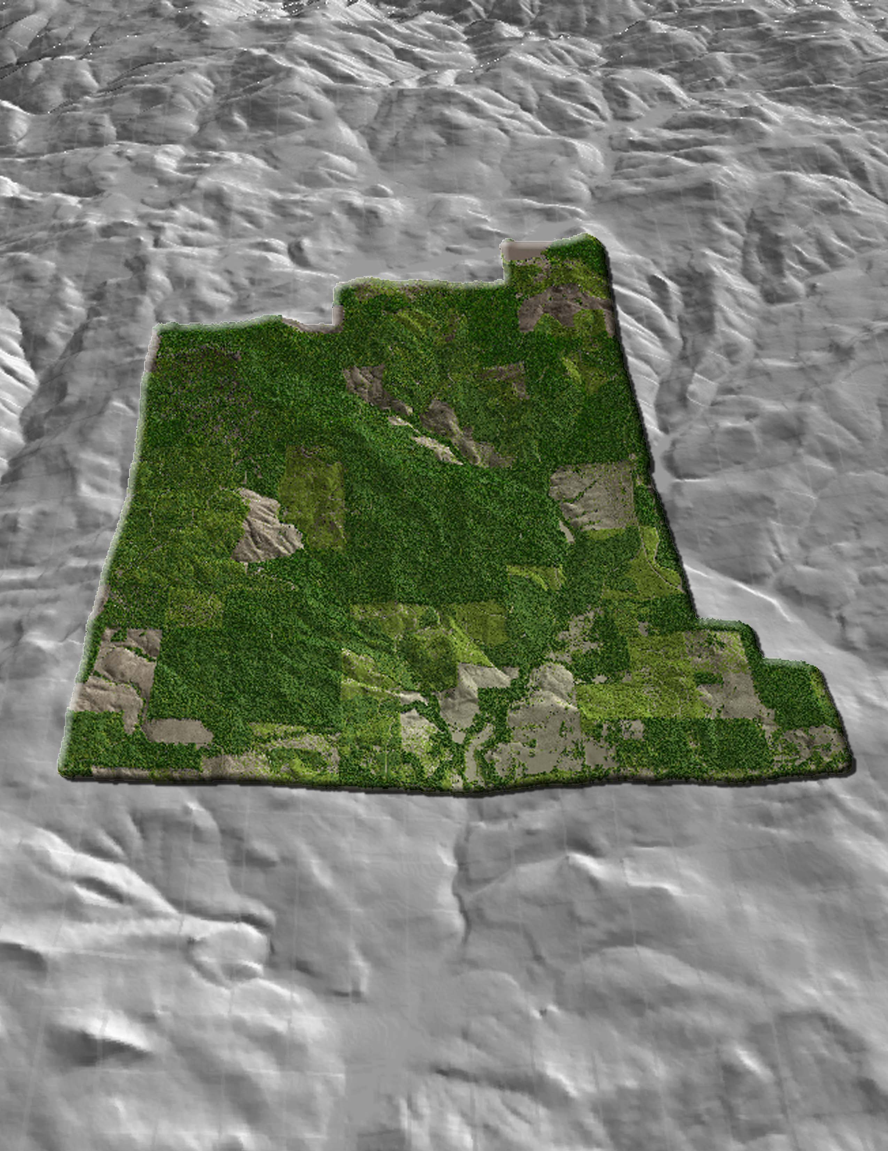
LiDAR Remote Sensing Data Collection:
Yamhill County, Oregon

Submitted to:

Susan L. Nelson
Bureau of Land Management
Mapping Sciences/Aerial Photography
333 SW First Ave.
P.O. Box 2965
Portland, OR 97204
Submitted by:

Watershed Sciences
215 SE Ninth Avenue, #106
Portland, Oregon 97214

971.223.5152

LiDAR study area, looking west.

LiDAR Remote Sensing Data Collection:
Yamhill County, Oregon

TABLE OF CONTENTS

1. Overview 5

2. Acquisition 6
2.1 Airborne Survey – Instrumentation and Methods 6
2.2 Ground Survey – Instrumentation and Methods 6

3. LiDAR Data Processing 8
3.1 Applications and Work Flow Overview 8
3.2 Aircraft Kinematic GPS and IMU Data 8
3.3 Laser Point Processing 9

4. LiDAR Accuracy and Resolution 10
4.1 Overview 10
4.2 Laser Point Accuracy 10
4.3 Relative Accuracy 10
4.4 Absolute Accuracy 13
4.4 Absolute Accuracy 14
4.5 Data Density/Resolution 17

5. Data Specifications 20

6. Projection/Datum and Units 20

7. Deliverables 20
7.1 Difference Rasters 21

8. Selected Images 22

9. Glossary 27

10. Citations 28

1. Overview
Watershed Sciences, Inc. (WS) collected Light Detection and Ranging (LiDAR) data for the U.S. Bureau of Land Management (BLM) on September 3 and December 8, 2007. These datasets capture leaf-on and leaf-off vegetative condition, respectively, in the area of interest. The Area of Interest (AOI) covers ~5,577 acres (~8.71 mi²) of the upper portion of the Panther Creek watershed in Yamhill County, Oregon. Figure 1 shows the extent of the area surveyed.

Figure 1. Area of Interest (5,577 acres)
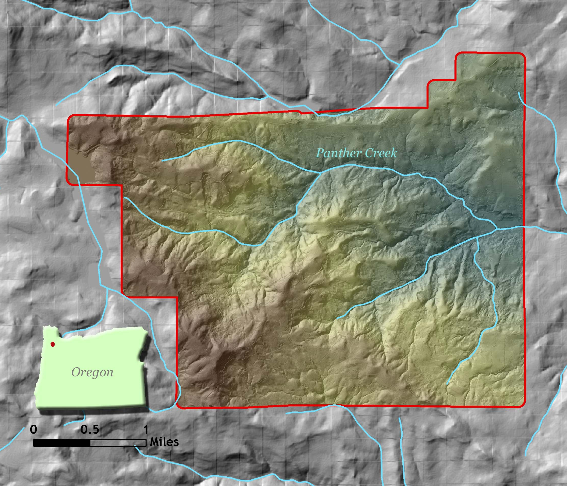

2. Acquisition

2.1 Airborne Survey – Instrumentation and Methods
Full surveys were conducted September 3, 2007 and December 8, 2007, capturing leaf-on and leaf-off vegetative conditions, respectively. The LiDAR survey utilized a Leica ALS50 Phase II laser mounted in a Cessna Caravan 208B set to acquire ≥105,000 laser pulses per second (i.e. 105 kHz pulse rate). The scan angle was ±14º from nadir. These settings are designed to yield an average native density (number of pulses emitted by the laser system) of ≥8 points per square meter over terrestrial surfaces. Some types of surfaces (e.g. dense vegetation or water) may return fewer pulses than the laser originally emitted. Therefore, the delivered density can be less than the native density and variable according to distributions of terrain, land cover and water bodies. The Leica ALS50 Phase II system allows up to four range measurements per pulse, and all discernable laser returns were processed for the output dataset.

To solve for laser point position, it is vital to have an accurate description of aircraft position and attitude. Aircraft position is described as x, y and z and measured twice per second (2 Hz) by an onboard differential GPS unit. Aircraft attitude is measured 200 times per second (200 Hz) as pitch, roll and yaw (heading) from an onboard inertial measurement unit (IMU).

2.2 Ground Survey – Instrumentation and Methods
During the LiDAR survey of the study area, a static (1 Hz recording frequency) ground survey was conducted over monuments with known coordinates (Table 1, Figure 2). After the airborne survey, the static GPS data are processed using triangulation with CORS stations and checked against the Online Positioning User Service (OPUS) to quantify daily variance. Multiple sessions are processed over the same monument to confirm antenna height measurements and reported position accuracy.

Table 1. Base Station Surveyed Coordinates.
Base Station ID | Datum NAD83 (HARN) |  |  |  | GRS80
Base Station ID | Latitude  (North) |  | Longitude  (West) |  | Ellipsoid  Height (m)
WTJR1 |  | 45º 20’ 29.83126” |  | 123º 11’ 54.91802” |  | 40.344

Multiple DGPS units are used for the ground real-time kinematic (RTK) portion of the survey. To collect accurate ground surveyed points, a GPS base unit is set up over monuments to broadcast a kinematic correction to a roving GPS unit. The ground crew uses a roving unit to receive radio-relayed kinematic corrected positions from the base unit. This method is referred to as real-time kinematic (RTK) surveying and allows precise location measurement (σ ≤ 1.5 cm ~ 0.6 in). 524 RTK ground points were collected throughout the study area and compared to LiDAR data for accuracy assessment (Figure 2).
Figure 2. RTK and base station locations for study area. RTK detail views shown over 3-foot LiDAR raster.
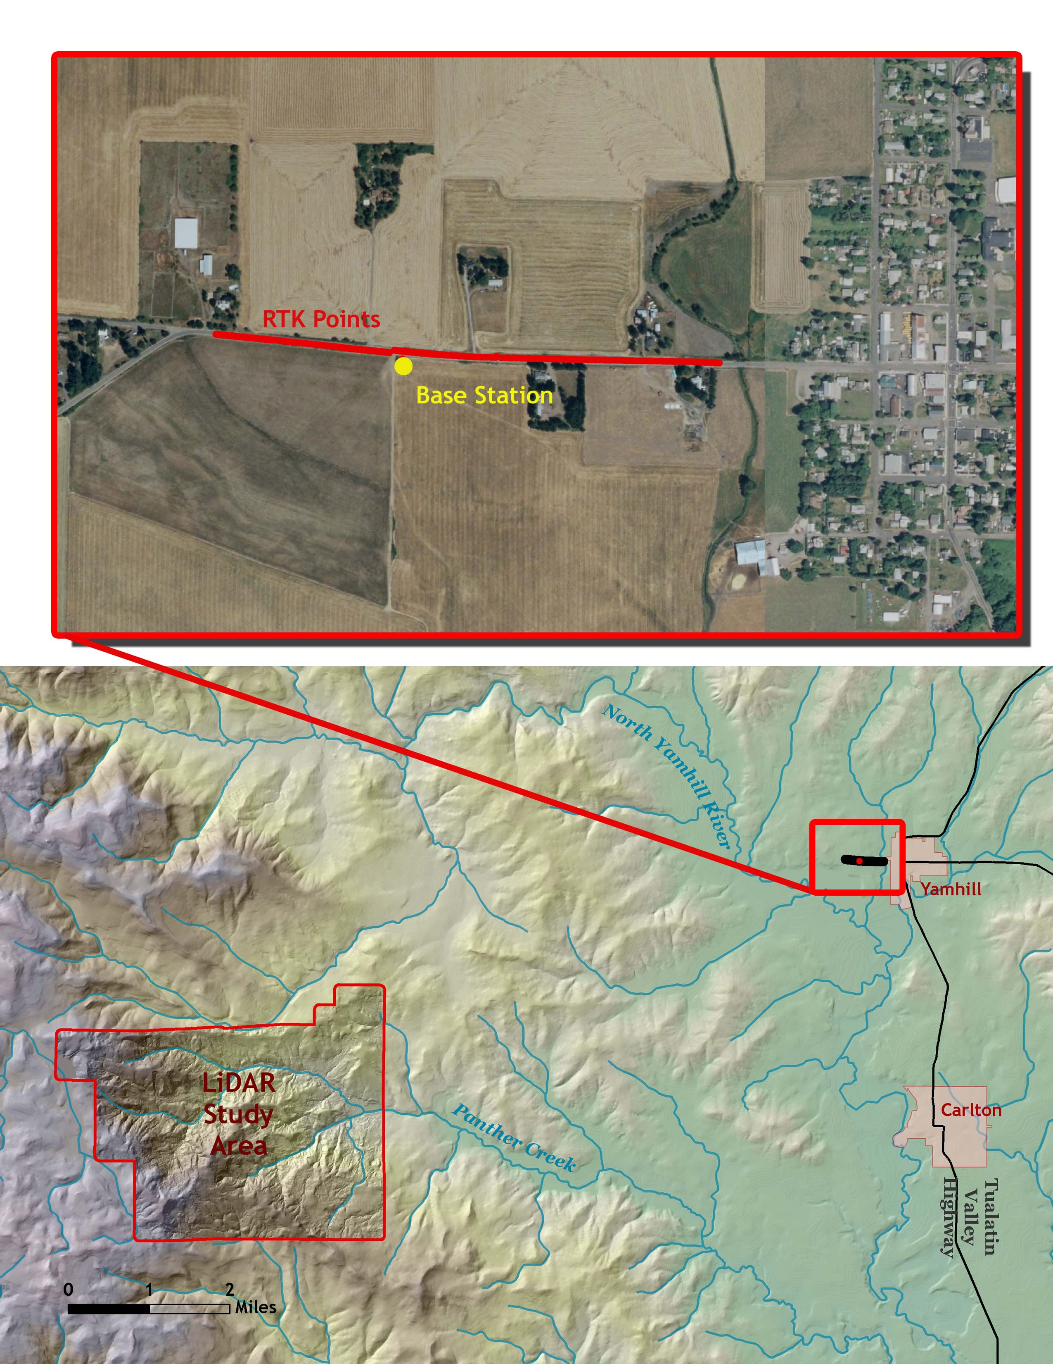

3. LiDAR Data Processing

3.1 Applications and Work Flow Overview
- Resolve kinematic corrections for aircraft position data using kinematic aircraft GPS and static ground GPS data.
Software: Waypoint GPS v.7.60
- Develop a smoothed best estimate of trajectory (SBET) file that blends post-processed aircraft position with attitude data. Sensor heading, position, and attitude are calculated throughout the survey.
Software: IPAS v.1.0
- Calculate laser point position by associating SBET position to each laser point return time, scan angle, intensity, etc. Creates raw laser point cloud data for the entire survey in *.las (ASPRS v1.1) format.
Software: ALS Post Processing Software
- Import raw laser points into subset bins (less than 500 MB, to accommodate file size constraints in processing software). Perform manual relative accuracy calibration and filter for pits/birds. Ground points are then classified for individual flight lines (to be used for relative accuracy testing and calibration).
Software: TerraScan v.6.009
- Test relative accuracy using ground classified points per each flight line. Perform automated line-to-line calibrations for system attitude parameters (pitch, roll, heading), mirror flex (scale) and GPS/IMU drift. Calibrations are performed on ground classified points from paired flight lines. Every flight line is used for relative accuracy calibration.
Software: TerraMatch v.6.009
- Import position and attitude data. Classify ground and non-ground points. Assess statistical absolute accuracy via direct comparisons of ground classified points to ground RTK survey data. Convert data to orthometric elevations (NAVD88) by applying a Geoid03 correction. Create ground model as a triangulated surface and export as ArcInfo ASCII grids at the specified pixel resolution.
Software: TerraScan v.6.009, ArcMap v9.2

3.2 Aircraft Kinematic GPS and IMU Data
LiDAR survey datasets are referenced to 1 Hz static ground GPS data collected over pre-surveyed monuments with known coordinates. While surveying, the aircraft collects 2 Hz kinematic GPS data. The onboard inertial measurement unit (IMU) collects 200 Hz aircraft attitude data. Waypoint GPS v.7.60 is used to process the kinematic corrections for the aircraft. The static and kinematic GPS data are then post-processed after the survey to obtain an accurate GPS solution and aircraft positions. IPAS v.1.0 is used to develop a trajectory file that includes corrected aircraft position and attitude information. The trajectory data for the entire flight survey session are incorporated into a final smoothed best estimated trajectory (SBET) file that contains accurate and continuous aircraft positions and attitudes.

3.3 Laser Point Processing
Laser point coordinates are computed using the IPAS and ALS Post Processor software suites based on independent data from the LiDAR system (pulse time, scan angle), and aircraft trajectory data (SBET). Laser point returns (first through fourth) are assigned an associated (x, y, z) coordinate along with unique intensity values (0-255). The data are output into large LAS v. 1.1 files; each point maintains the corresponding scan angle, return number (echo), intensity, and x, y, z (easting, northing, and elevation) information.

These initial laser point files are too large for subsequent processing. To facilitate laser point processing, bins (polygons) are created to divide the dataset into manageable sizes (< 500 MB). Flightlines and LiDAR data are then reviewed to ensure complete coverage of the study area and positional accuracy of the laser points.

Laser point data are imported into processing bins in TerraScan, and manual calibration is performed to assess the system offsets for pitch, roll, heading and scale (mirror flex). Using a geometric relationship developed by Watershed Sciences, each of these offsets is resolved and corrected if necessary.

LiDAR points are then filtered for noise, pits (artificial low points) and birds (true birds as well as erroneously high points) by screening for absolute elevation limits, isolated points and height above ground. Each bin is then manually inspected for remaining pits and birds and spurious points are removed. In a bin containing approximately 7.5-9.0 million points, an average of 50-100 points are typically found to be artificially low or high. Common sources of non-terrestrial returns are clouds, birds, vapor, and haze.

Internal calibration is refined using TerraMatch. Points from overlapping lines are tested for internal consistency and final adjustments are made for system misalignments (i.e., pitch, roll, heading offsets and scale). Automated sensor attitude and scale corrections yield 3-5 cm improvements in the relative accuracy. Once system misalignments are corrected, vertical GPS drift is then resolved and removed per flight line, yielding a slight improvement (<1 cm) in relative accuracy.

The TerraScan software suite is designed specifically for classifying near-ground points (Soininen, 2004). The processing sequence begins by ‘removing’ all points that are not ‘near’ the earth based on geometric constraints used to evaluate multi-return points. The resulting bare earth (ground) model is visually inspected and additional ground point modeling is performed in site-specific areas to improve ground detail. (This manual editing of grounds occurs in areas with known ground modeling deficiencies, such as: bedrock outcrops, cliffs, deeply incised stream banks, and dense vegetation.) In some cases, automated ground point classification includes known vegetation (i.e., understory, low/dense shrubs, etc.). These points are manually reclassified as non-grounds. Ground surface rasters are developed from triangulated irregular networks (TINs) of ground points.

4. LiDAR Accuracy and Resolution

4.1 Overview
Quality assurance for LiDAR datasets includes a real-time kinematic (RTK) survey located in the study area. The accuracy of the LiDAR data is described as standard deviations of divergence (sigma ~ σ) from RTK ground survey points and root mean square error (RMSE) which considers bias (upward or downward). These statistics are calculated cumulatively. Statements of statistical accuracy apply to fixed terrestrial surfaces only.

4.2 Laser Point Accuracy
Laser point absolute accuracy is largely a function of laser noise and internal consistency (measured as relative accuracy):

- Laser Noise: For any given target, laser noise is the breadth of the data cloud per laser return (i.e., last, first, etc.). Lower intensity surfaces (roads, rooftops, still/calm water) experience higher laser noise. The laser noise range for this study is approximately 0.02 meters.

- Relative Accuracy: Internal consistency refers to the ability to place a laser point in the same location over multiple flight lines, GPS conditions, and aircraft attitudes.

Table 2. LiDAR accuracy error sources and solutions.

Type of Error | Source | Post Processing Solution
GPS  (Static/Kinematic) | Long Base Lines | None
GPS  (Static/Kinematic) | Poor Satellite Constellation | None
GPS  (Static/Kinematic) | Poor Antenna Visibility | Reduce Visibility Mask
Relative Accuracy | Poor System Calibration | Recalibrate IMU and sensor offsets/settings
Relative Accuracy | Inaccurate System | None
Laser Noise | Poor Laser Timing | None
Laser Noise | Poor Laser Reception | None
Laser Noise | Poor Laser Power | None
Laser Noise | Irregular Laser Shape | None

4.3 Relative Accuracy
Relative accuracy refers to the internal consistency of the data set and is measured as the divergence between points from different flight lines within an overlapping area. Divergence is most apparent when flight lines are opposing. When the LiDAR system is well calibrated the line to line divergence is low (<10 cm). Internal consistency is affected by system attitude offsets, scale, and GPS/IMU drift.

Operational measures taken to improve relative accuracy:
- Low Flight Altitude: Terrain following is employed to maintain a constant above ground level (AGL). Laser horizontal errors are a function of flight altitude above ground (i.e., ~ 1/4500th AGL flight altitude).
- Focus Laser Power at narrow beam footprint: A laser return must be received by the system above a power threshold to accurately record a measurement. The strength of the laser return is a function of laser emission power, laser footprint, flight altitude and the reflectivity of the target. While surface reflectivity cannot be controlled, laser power can be increased and low flight altitudes can be maintained.
- Reduced Scan Angle: Edge-of-scan data can become inaccurate. The scan angle was reduced to a maximum of ±14º from nadir, creating a narrow swath width and greatly reducing laser shadows from trees and buildings.
- Quality GPS: Flights took place during optimal GPS conditions (e.g., 6 or more satellites and PDOP [Position Dilution of Precision] less than 3.0). Before each flight, the PDOP was determined for the survey day. During all flight times, a dual frequency DGPS base station recording at 1–second epochs was utilized and a maximum baseline length between the aircraft and the control points was less than 19 km (11.5 miles) at all times.
- Ground Survey: Ground survey point accuracy (i.e. <1.5 cm RMSE) occurs during optimal PDOP ranges and targets a minimal baseline distance of 4 miles between GPS rover and base. Robust statistics are, in part, a function of sample size (n) and distribution. Ground survey RTK points are distributed to the extent possible throughout multiple flight lines and across the study area.
- 50% Side-Lap (100% Overlap): Overlapping areas are optimized for relative accuracy testing. Laser shadowing is minimized to help increase target acquisition from multiple scan angles. Ideally, with a 50% side-lap, the most nadir portion of one flight line coincides with the edge (least nadir) portion of overlapping flight lines. A minimum of 50% side-lap with terrain-followed acquisition prevents data gaps.
- Opposing Flight Lines: All overlapping flight lines are opposing. Pitch, roll and heading errors are amplified by a factor of two relative to the adjacent flight line(s), making misalignments easier to detect and resolve.

Relative Accuracy Calibration Methodology
- Manual System Calibration: Calibration procedures for each mission require solving geometric relationships that relate measured swath-to-swath deviations to misalignments of system attitude parameters. Corrected scale, pitch, roll and heading offsets are calculated and applied to resolve misalignments. The raw divergence between lines is computed after the manual calibration is completed and reported for each study area.
- Automated Attitude Calibration: All data are tested and calibrated using TerraMatch automated sampling routines. Ground points are classified for each individual flight line and used for line-to-line testing. System misalignment offsets (pitch, roll and heading) and scale are solved for each individual mission and applied to respective mission datasets. The data from each mission are then blended when imported together to form the entire area of interest.
- Automated Z Calibration: Ground points per line are utilized to calculate the vertical divergence between lines caused by vertical GPS drift. Automated Z calibration is the final step employed for relative accuracy calibration.

Relative Accuracy Calibration Results
Relative accuracies have been determined for the study area (units: meters):
 | LEAF – ON | LEAF - OFF
Project Average | 0.098 | 0.105
Median Relative Accuracy | 0.097 | 0.096
1σ Relative Accuracy | 0.103 | 0.113
2σ Relative Accuracy | 0.120 | 0.152

Figure 3. Distribution of relative accuracies per flight line, non slope-adjusted.
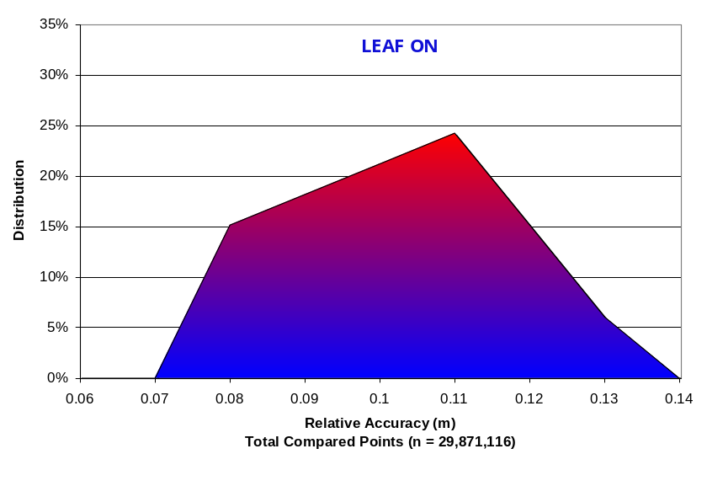

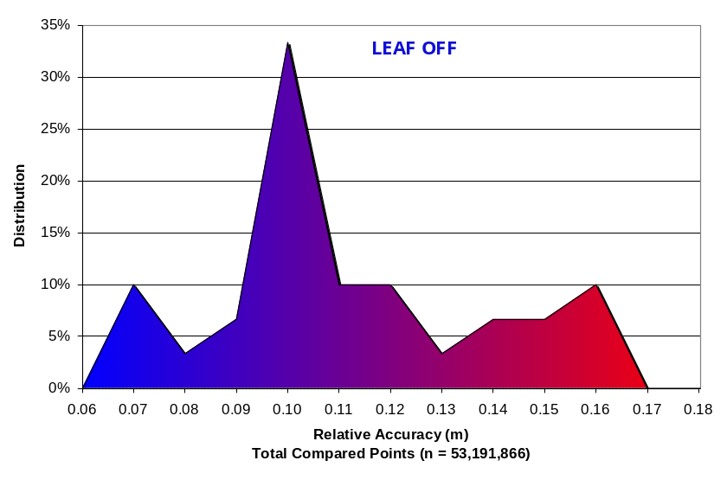

Figure 4. Statistical relative accuracies, non slope-adjusted.

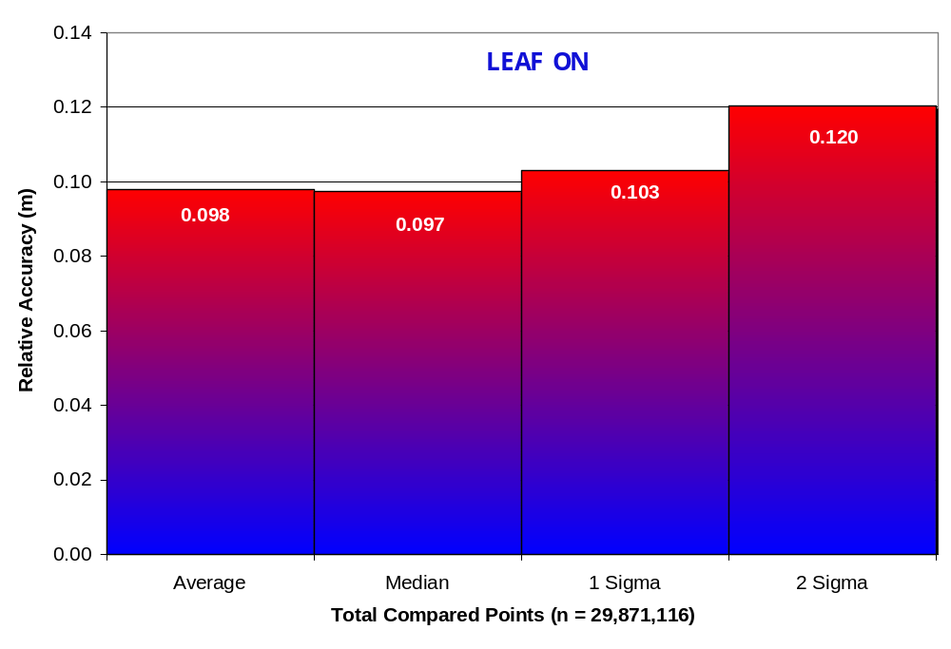

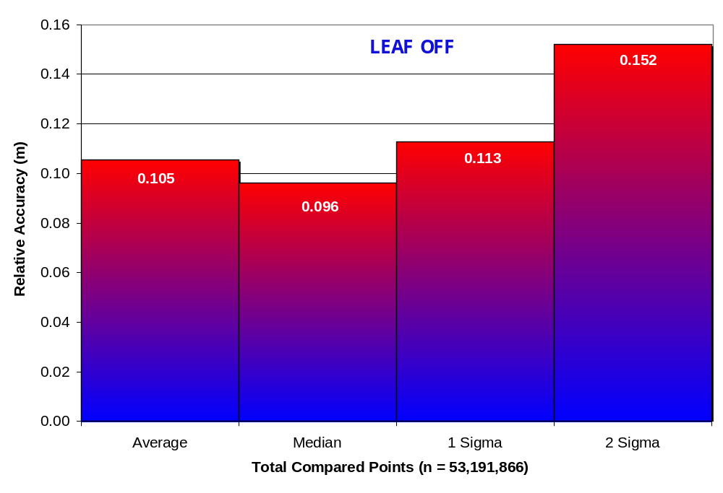

4.4 Absolute Accuracy
The final quality control measure is a statistical accuracy assessment that compares known RTK ground survey points to the closest laser point.

Table 3. Absolute Accuracy – Deviation between laser points and RTK survey points (units: meters).

RTK Survey Sample Size (n): 524
 |  | LEAF ON | LEAF OFF
Root Mean Square Error (RMSE) |  | 0.02 | 0.02
Standard  Deviations: | 1 sigma (σ) | 0.02 | 0.02
Standard  Deviations: | 2 sigma (σ) | 0.04 | 0.04
Minimum ∆z |  | -0.12 | -0.06
Maximum ∆z |  | 0.05 | 0.06
Average ∆z |  | 0.00 | 0.01

Figure 5. Absolute Accuracy Histogram Statistics
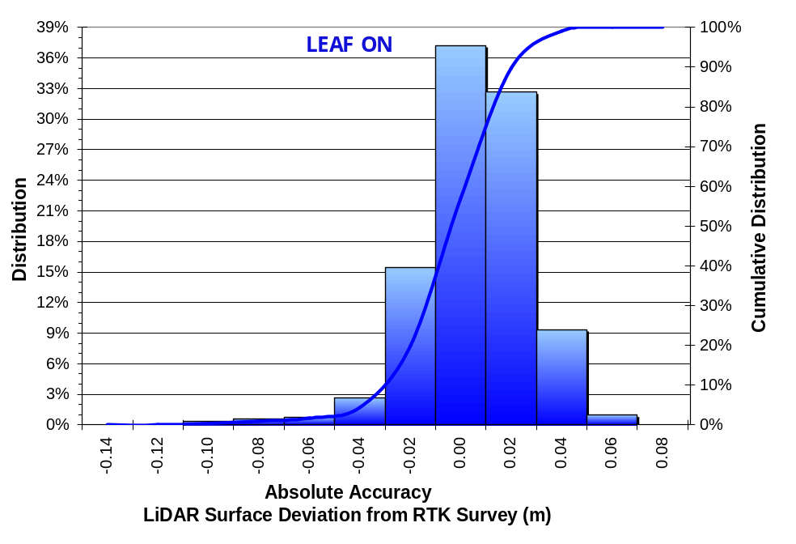

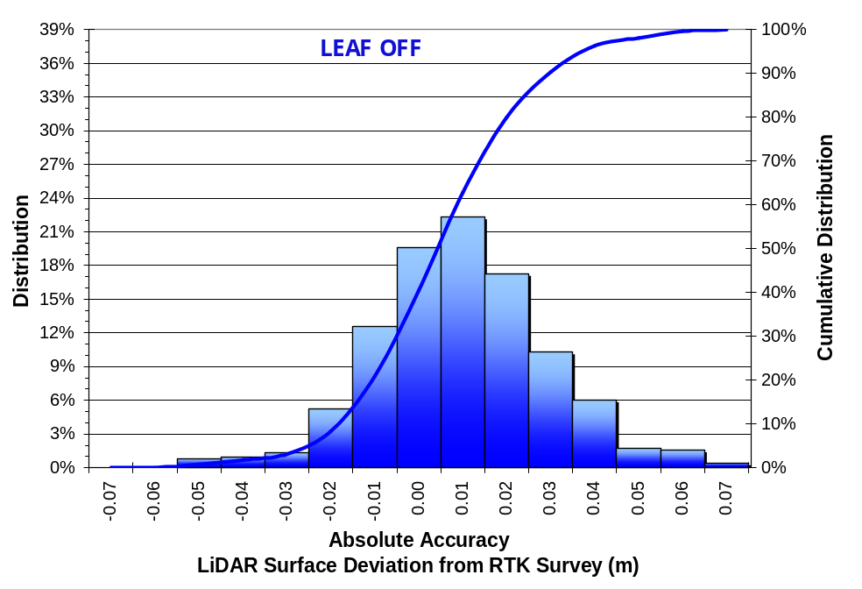

Figure 6. Absolute Accuracy Absolute Deviation

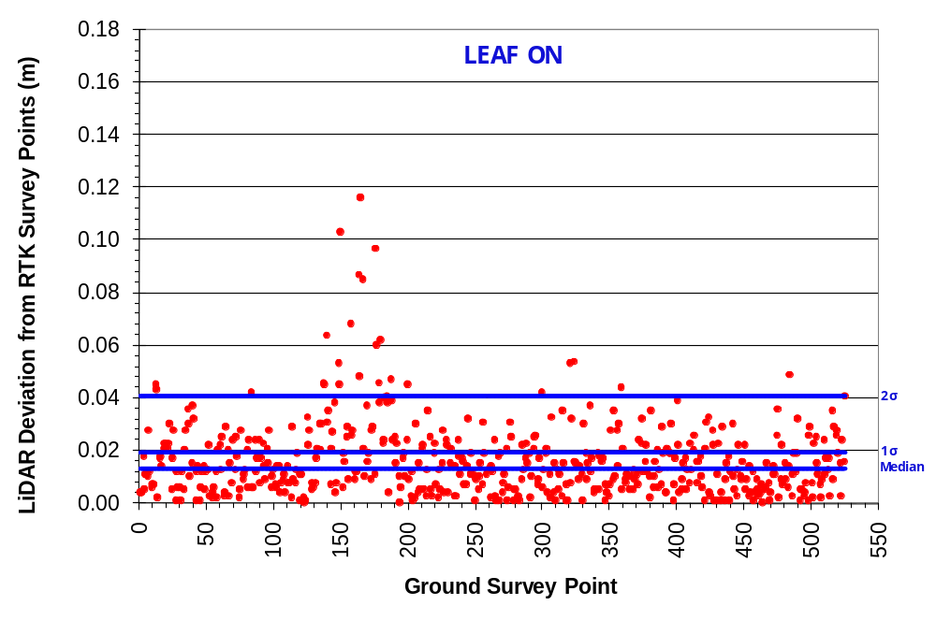

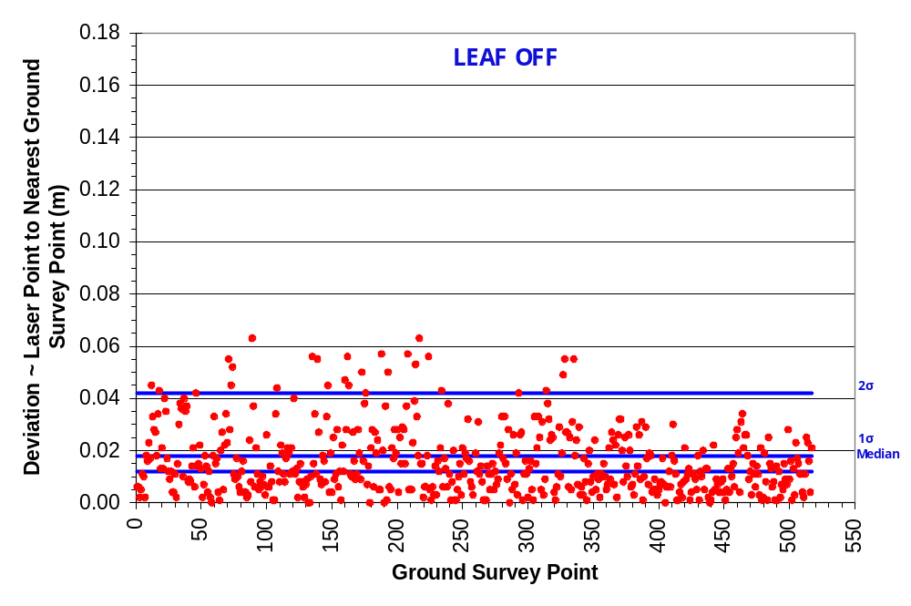

4.5 Data Density/Resolution
Some types of surfaces (i.e., dense vegetation or water) may return fewer pulses than the laser originally emitted. Therefore, the delivered density can be less than the native density and lightly variable according to distributions of terrain, land cover and water bodies. Ground classifications are derived from ground surface modeling. Supervised classifications were performed by reseeding of the ground model where it is determined that the ground model has failed, usually under dense vegetation and/or at breaks in terrain, steep slopes and at bin boundaries.

Project Specific Data Resolution:
 | LEAF ON | LEAF OFF
Average Pulse Density (pts/m²) | 9.25 | 9.15
Average Ground Density (pts/m²) | 0.52 | 0.84

Figure 7. First return laser point data density.
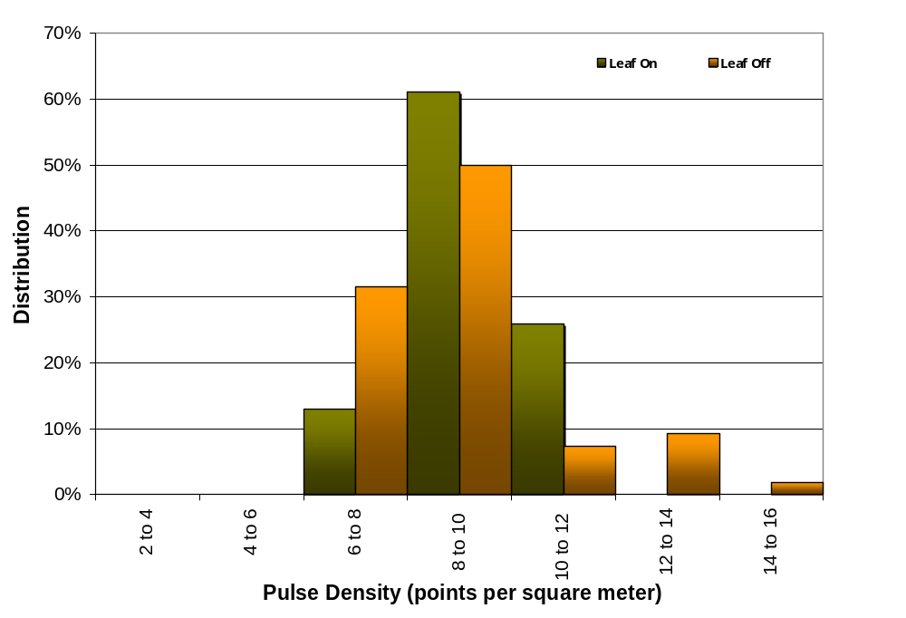

Figure 8. Ground-classified laser point data density.

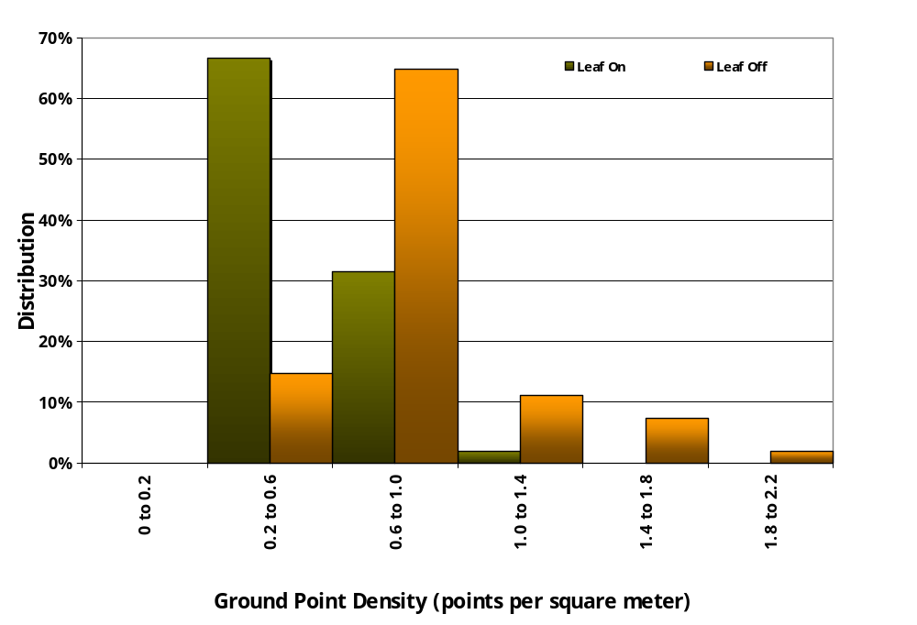

Figure 9. First return laser point data density in the study area, per processing bin.
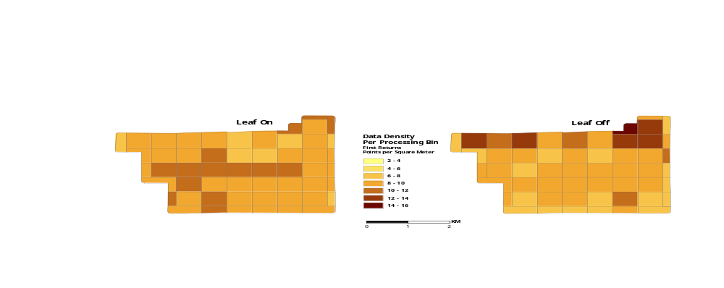

Figure 10. Ground-classified laser point data density per processing bin.

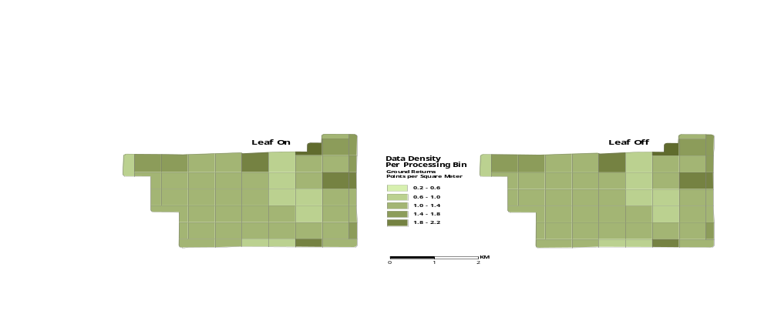

5. Data Specifications

Table 4. Resolution and Accuracy Specifications

 | Targeted | Achieved (Leaf Off)
Resolution: | >8 points/m² | 9.15 points/m²
Vertical Accuracy (1 σ) | < 13 cm | 2 cm

6. Projection/Datum and Units

Table 5. Resolution and Accuracy Specifications

Projection: |  | NAD 83 UTM Zone 10N
Datum | Vertical: | NAVD88 Geoid03
Datum | Horizontal: | NAVD88
Units: |  | Meters

7. Deliverables
Point Data: | ASCII Format – All Returns  ASCII Format – Ground-Classified Returns  LAS Files v. 1.1
Vector Data: | Shapefile for Study Area border.  Shapefile for 0.75 minute USGS quads.
Raster Data: | 7.5 minute Delineation  0.5 m Pixel Bare Earth ESRI GRID  0.5 m Pixel Highest Hit ESRI GRID  0.75 minute Delineation  0.5 m Pixel Intensity GeoTIFFs
Data Report: | Full Report containing introduction, methodology, and accuracy
Supplementary: | Difference rasters, 1 m resolution

7.1 Difference Rasters

Raster calculations were performed as supplementary analysis for Leaf On and Leaf Off datasets. These raster calculations provide insight into vegetation change between leaf on and leaf off conditions. They also demonstrate laser performance over changing vegetation conditions.

These calculations include:
Bare Earth Leaf On minus Bare Earth Leaf Off (beon_beoff)
Highest Hit Leaf On minus Highest Hit Leaf Off (hhon_hhoff)
Highest Hit Leaf On minus Bare Earth Leaf On (hhon_beon)
Highest Hit Leaf Off minus Bare Earth Leaf Off (hhoff_beoff)

8. Selected Images
Figure 11. 3-d oblique view of LiDAR-derived surfaces looking south across the upper Silver Creek watershed. (top image NAIP orthophoto, middle image derived from all points, bottom image derived from ground-classified points).

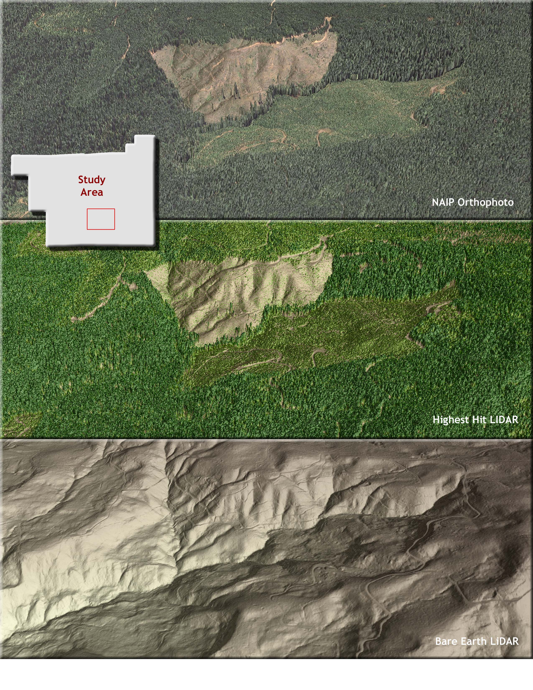

Figure 12. 3-d oblique view of LiDAR-derived surfaces looking south Panther Creek. (top image NAIP orthophoto, middle image derived from all points, bottom image derived from ground-classified points).
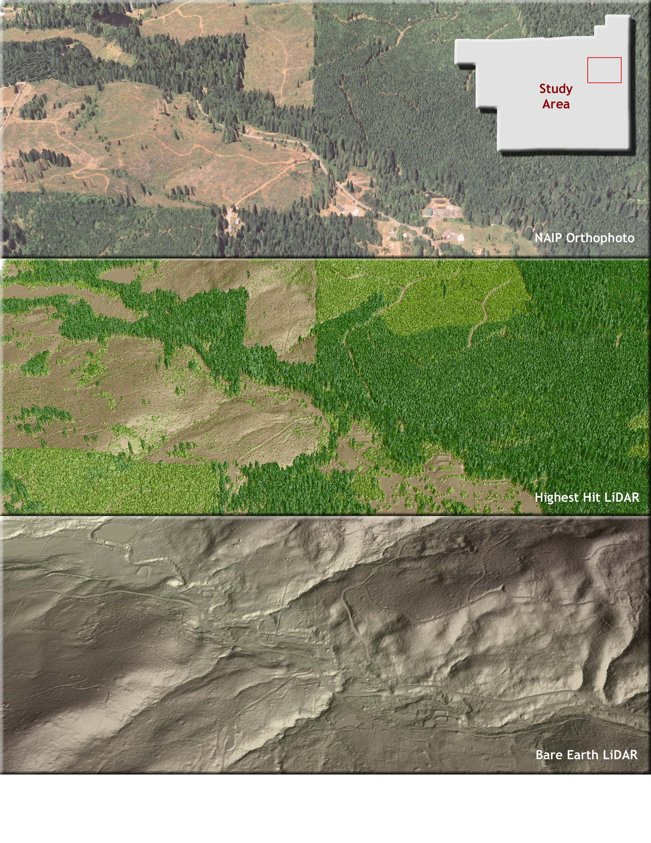
Figure 13. Detail view of an historic landslide in the upper Panther Creek watershed (top image derived from all points, bottom image derived from ground-classified points).
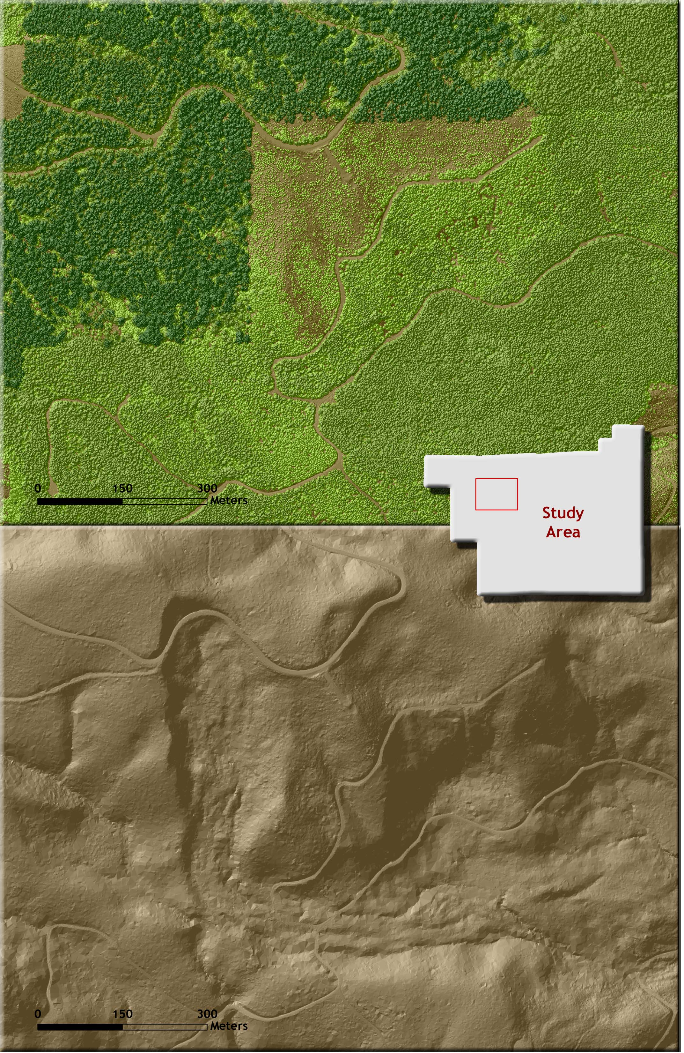
Figure 14. 3-d oblique view of LiDAR-derived surfaces looking southwest up an unnamed tributary to Panther Creek (top image derived from all points, bottom image derived from ground-classified points).
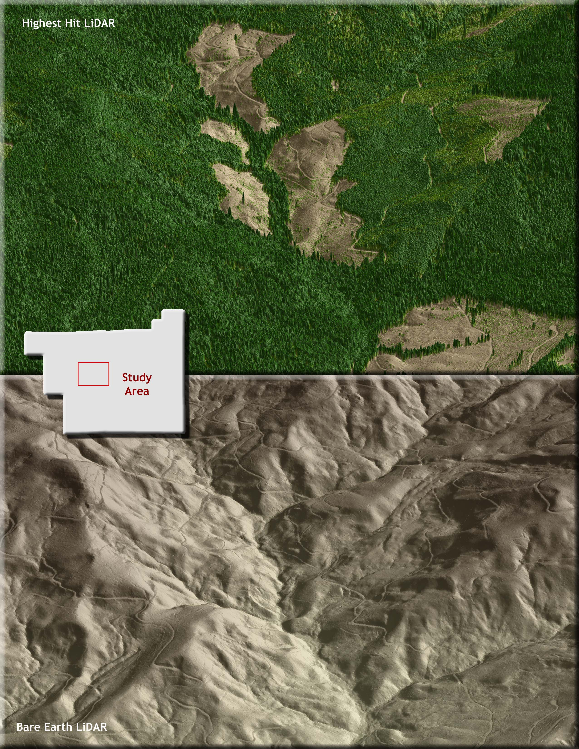

Figure 15. Cross-section views demonstrating the difference in terrain and vegetation capture dependant upon leaf on and leaf off vegetative condition during LiDAR acquisition.
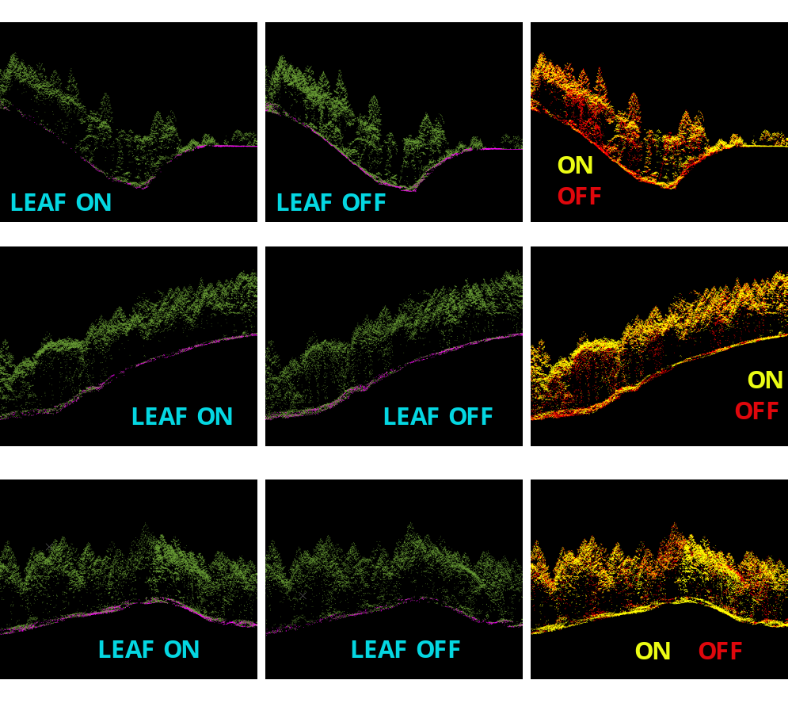

9. Glossary

1-sigma (σ) Absolute Deviation: Value for which the data are within one standard deviation (approximately 68th percentile) of a normally distributed data set.
2-sigma (σ) Absolute Deviation: Value for which the data are within two standard deviations (approximately 95th percentile) of a normally distributed data set.
Root Mean Square Error (RMSE): A statistic used to approximate the difference between real-world points and the LiDAR points. It is calculated by squaring all the values, then taking the average of the squares and taking the square root of the average.
Pulse Rate (PR): The rate at which laser pulses are emitted from the sensor; typically measured as thousands of pulses per second (kHz).
Pulse Returns: For every laser emitted, the Leica ALS 50 Phase II system can record up to four wave forms reflected back to the sensor. Portions of the wave form that return earliest are the highest element in multi-tiered surfaces such as vegetation. Portions of the wave form that return last are the lowest element in multi-tiered surfaces.
Accuracy: The statistical comparison between known (surveyed) points and laser points. Typically measured as the standard deviation (sigma, σ) and root mean square error (RMSE).
Intensity Values: The peak power ratio of the laser return to the emitted laser. It is a function of surface reflectivity.
Data Density: A common measure of LiDAR resolution, measured as points per square meter.
Spot Spacing: Also a measure of LiDAR resolution, measured as the average distance between laser points.
Nadir: A single point or locus of points on the surface of the earth directly below a sensor as it progresses along its flight line.
Scan Angle: The angle from nadir to the edge of the scan, measured in degrees. Laser point accuracy typically decreases as scan angles increase.
Overlap: The area shared between flight lines, typically measured in percents; 100% overlap is essential to ensure complete coverage and reduce laser shadows.
DTM / DEM: These often-interchanged terms refer to models made from laser points. The digital elevation model (DEM) refers to all surfaces, including bare ground and vegetation, while the digital terrain model (DTM) refers only to those points classified as ground.
Real-Time Kinematic (RTK) Survey: GPS surveying is conducted with a GPS base station deployed over a known monument with a radio connection to a GPS rover. Both the base station and rover receive differential GPS data and the baseline correction is solved between the two. This type of ground survey is accurate to 1.5 cm or less.

10. Citations

Soininen, A. 2004. TerraScan User’s Guide. Terrasolid.

Flood, M. 2004. ASPRS Guidelines: Vertical accuracy reporting for LiDAR data. Version 1.0. ASPRS LiDAR Committee. pp 1-15.

FEMA. 2002. LiDAR specifications for flood hazard mapping.

Nadir refers to the perpendicular vector to the ground directly below the aircraft. Nadir is commonly used to measure the angle from the vector and is referred to a “degrees from nadir”.
Online Positioning User Service (OPUS) is run by the National Geodetic Survey to process corrected monument positions.

