LiDAR Remote Sensing Data Collection:
Sandy River, OR
December 22nd 2008

Submitted by:

Watershed Sciences
257B SW Madison Street
Corvallis, OR 97333

215 SE 9th Ave, Suite 106
Portland, Oregon 97214

www.watershedsciences.com

Submitted to:

Gordon Grant
USDA Forest Service
3200 SW Jefferson Way
Corvallis, OR 97331



LiDAR Remote Sensing Data Collection:
Sandy River, OR

TABLE OF CONTENTS

1. Overview 1

2. Acquisition 2
2.1 Airborne Survey – Instrumentation and Methods 2
2.2 Ground Survey – Instrumentation and Methods 2
2.2.1 Survey Control 2
2.2.2 RTK Surveying 3

3. LiDAR Data Processing 4
3.1 Applications and Work Flow Overview 4
3.2 Aircraft Kinematic GPS and IMU Data 4
3.3 Laser Point Processing 5

4. LiDAR Accuracy Assessment 6
4.1 Laser Noise and Relative Accuracy 6
4.2 Absolute Accuracy 7

5. Study Area Results 7
5.1 Data Summary 7
5.2 Data Density/Resolution 7
5.3 Relative Accuracy Calibration Results 11
5.4 Absolute Accuracy 12
5.5 Projection/Datum and Units 14

6. Deliverables 14

7. Selected Images 15

8. Glossary 16

9. Citations 17

Appendix A 18

1. Overview

Watershed Sciences, Inc. (WS) collected Light Detection and Ranging (LiDAR) data from the Sandy River study area on September 29th, 30th and October 1st, 2008. The total area for this AOI is 34,021 acres. The total area of delivered LiDAR including 100 m buffer is 35,873 acres (Figure 1).

Figure 1. Sandy River study area (background data provided by ESRI)
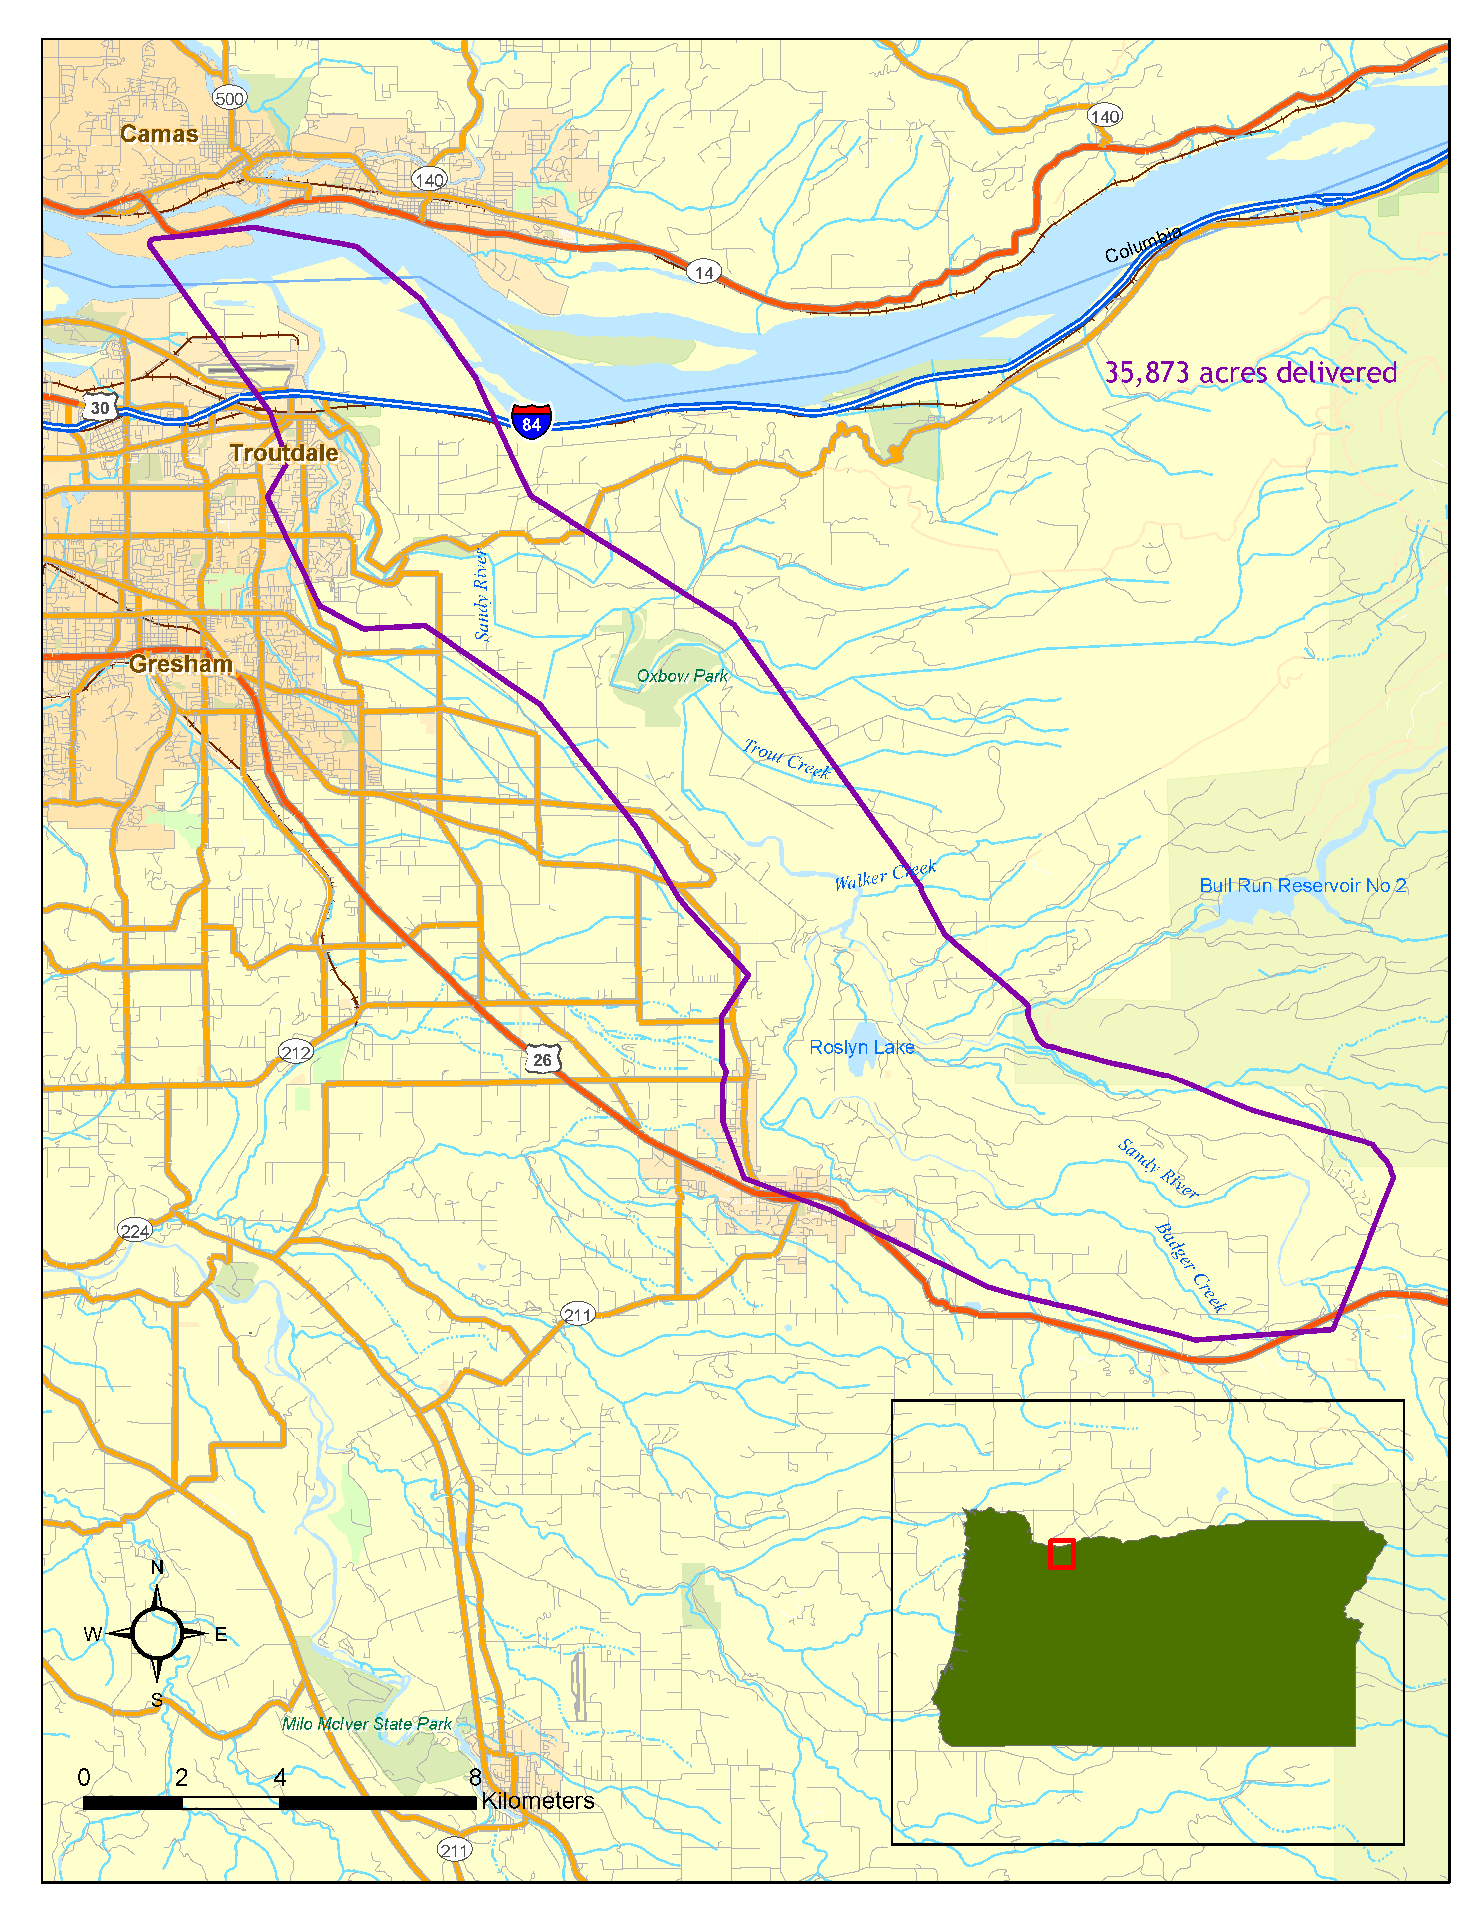

2. Acquisition

2.1 Airborne Survey – Instrumentation and Methods

The LiDAR survey uses a Leica ALS50 Phase II laser system. For the Sandy River study area, the sensor scan angle was ±14º from nadir with a pulse rate designed to yield an average native density (number of pulses emitted by the laser system) of ≥ 8 points per square meter over terrestrial surfaces. All study areas were surveyed with an opposing flight line side-lap of ≥50% (≥100% overlap) to reduce laser shadowing and increase surface laser painting. The Leica ALS50 Phase II system allows up to four range measurements (returns) per pulse, and all discernable laser returns were processed for the output dataset. It is not uncommon for some types of surfaces (e.g. dense vegetation or water) to return fewer pulses than the laser originally emitted. These discrepancies between ‘native’ and ‘delivered’ density will vary depending on terrain, land cover and the prevalence of water bodies.

To accurately solve for laser point position (geographic coordinates x, y, z), the positional coordinates of the airborne sensor and the attitude of the aircraft were recorded continuously throughout the LiDAR data collection mission. Aircraft position was measured twice per second (2 Hz) by an onboard differential GPS unit. Aircraft attitude was measured 200 times per second (200 Hz) as pitch, roll and yaw (heading) from an onboard inertial measurement unit (IMU). To allow for post-processing correction and calibration, aircraft/sensor position and attitude data are indexed by GPS time.

2.2 Ground Survey – Instrumentation and Methods

The following ground survey data were collected to enable the geo-spatial correction of the aircraft positional coordinate data collected throughout the flight, and to allow for quality assurance checks on final LiDAR data products.

2.2.1 Survey Control

Simultaneous with the airborne data collection mission, we conducted multiple static (1 Hz recording frequency) ground surveys over monuments with known coordinates (Table 1). Indexed by time, these GPS data are used to correct the continuous onboard measurements of aircraft position recorded throughout the mission. Multiple sessions were processed over the same monument to confirm antenna height measurements and reported position accuracy. After the airborne survey, these static GPS data were then processed using triangulation with Continuously Operating Reference Stations (CORS) stations, and checked against the Online Positioning User Service (OPUS) to quantify daily variance. Controls were located within 13 nautical miles of the mission area(s).

Table 1. Base Station Survey Control Coordinates for the Sandy River study area.

Base Station ID | Datum: NAD83 (CORS91) |  | GRS80
Base Station ID | Latitude | Longitude | Ellipsoid Z (meters)
PWHAP1 | 45 33 03.96625 | 122 23 44.21565 | -12.382
PWHAP2 | 45 33 03.96635 | 122 23 44.21551 | -12.398
PWHSD1 | 45 27 11.69280 | 122 17 20.83260 | 201.685
HCF1 | 45 36 9.25187 | 122 2 37.45364 | 0.149

2.2.2 RTK Surveying

To enable assessment of LiDAR data accuracy, ground truth points were collected using GPS based real-time kinematic (RTK) surveying. For an RTK survey, the ground crew uses a roving unit to receive radio-relayed corrected positional coordinates for all ground points from a GPS base station set up over a survey control monument. Instrumentation includes multiple Trimble DGPS units (R7). RTK surveying allows for precise location measurements with an error (σ) of ≤ 1.5 cm (0.6 in).

Figure 2. RTK locations used for the Sandy River study area (RTK points collected) overlayed on LiDAR derived highest-hit surface

3. LiDAR Data Processing

3.1 Applications and Work Flow Overview

- Resolve kinematic corrections for aircraft position data using kinematic aircraft GPS and static ground GPS data.
Software: Waypoint GPS v.7.60
- Develop a smoothed best estimate of trajectory (SBET) file that blends post-processed aircraft position with attitude data (sensor heading, position, and attitude are calculated throughout the survey).
Software: IPAS v.1.4
- Calculate laser point position by associating SBET position to each laser point return time, scan angle, intensity, etc. Create raw laser point cloud data for the entire survey in *.las (ASPRS v1.1) format.
Software: ALS Post Processing Software
- Import raw laser points into subset bins (less than 500 MB, to accommodate file size constraints in processing software). Perform manual relative accuracy calibration and filter for pits/birds. Classify ground points for individual flight lines (to be used for relative accuracy testing and calibration).
Software: TerraScan v.7.012
- Test relative accuracy using ground classified points per each flight line. Perform automated line-to-line calibrations for system attitude parameters (pitch, roll, heading), mirror flex (scale) and GPS/IMU drift. Perform calibrations on ground classified points from paired flight lines. Every flight line is used for relative accuracy calibration.
Software: TerraMatch v.7.004
- Import position and attitude data. Classify ground and non-ground points. Assess statistical absolute accuracy via direct comparisons of ground classified points to ground RTK survey data. Convert data to orthometric elevations (NAVD88) by applying a Geoid03 correction. Create ground model as a triangulated surface and export as ArcInfo ASCII grids at the specified pixel resolution.
Software: TerraScan v.7.012, ArcMap v9.2

3.2 Aircraft Kinematic GPS and IMU Data
LiDAR survey datasets were referenced to the 1 Hz static ground GPS data collected over pre-surveyed monuments with known coordinates. While surveying, the aircraft collected 2 Hz kinematic GPS data, and the onboard inertial measurement unit (IMU) collected 200 Hz aircraft attitude data. Realm Survey Suite was used to process the kinematic corrections for the aircraft. The static and kinematic GPS data were then post-processed after the survey to obtain an accurate GPS solution and aircraft positions. POSPAC was used to develop a trajectory file that includes corrected aircraft position and attitude information. The trajectory data for the entire flight survey session were incorporated into a final smoothed best estimated trajectory (SBET) file that contains accurate and continuous aircraft positions and attitudes.

3.3 Laser Point Processing
Laser point coordinates were computed using the REALM software based on independent data from the LiDAR system (pulse time, scan angle), and aircraft trajectory data (SBET). Laser point returns (first through fourth) were assigned an associated (x, y, z) coordinate along with unique intensity values (0-255). The data were output into large LAS v. 1.1 files; each point maintains the corresponding scan angle, return number (echo), intensity, and x, y, z (easting, northing, and elevation) information.

These initial laser point files were too large for subsequent processing. To facilitate laser point processing, bins (polygons) were created to divide the dataset into manageable sizes
(< 500 MB). Flightlines and LiDAR data were then reviewed to ensure complete coverage of the study area and positional accuracy of the laser points.

Laser point data were imported into processing bins in TerraScan, and manual calibration was performed to assess the system offsets for pitch, roll, heading and scale (mirror flex). Using a geometric relationship developed by Watershed Sciences, each of these offsets was resolved and corrected if necessary.

LiDAR points were then filtered for noise, pits (artificial low points) and birds (true birds as well as erroneously high points) by screening for absolute elevation limits, isolated points and height above ground. Each bin was then manually inspected for remaining pits and birds and spurious points were removed. In a bin containing approximately 7.5-9.0 million points, an average of 50-100 points are typically found to be artificially low or high. Common sources of non-terrestrial returns are clouds, birds, vapor, haze, decks, brush piles, etc.

Internal calibration was refined using TerraMatch. Points from overlapping lines were tested for internal consistency and final adjustments were made for system misalignments (i.e., pitch, roll, heading offsets and scale). Automated sensor attitude and scale corrections yielded 3-5 cm improvements in the relative accuracy. Once system misalignments were corrected, vertical GPS drift was then resolved and removed per flight line, yielding a slight improvement (<1 cm) in relative accuracy.

The TerraScan software suite is designed specifically for classifying near-ground points (Soininen, 2004). The processing sequence began by ‘removing’ all points that were not ‘near’ the earth based on geometric constraints used to evaluate multi-return points. The resulting bare earth (ground) model was visually inspected and additional ground point modeling was performed in site-specific areas to improve ground detail. This manual editing of grounds often occurs in areas with known ground modeling deficiencies, such as: bedrock outcrops, cliffs, deeply incised stream banks, and dense vegetation. In some cases, automated ground point classification erroneously included known vegetation (i.e., understory, low/dense shrubs, etc.). These points were manually reclassified as non-grounds. Ground surface rasters were developed from triangulated irregular networks (TINs) of ground points.

4. LiDAR Accuracy Assessment

Our LiDAR quality assurance process uses the data from the real-time kinematic (RTK) ground survey conducted in the study area. In this project, a total of 506 RTK GPS measurements were collected on asphalt points distributed among multiple flight swaths. To assess absolute accuracy, we compared the location coordinates of these known RTK ground survey points to those calculated for the closest laser points.

4.1 Laser Noise and Relative Accuracy

Laser point absolute accuracy is largely a function of laser noise and relative accuracy. To minimize these contributions to absolute error, we first performed a number of noise filtering and calibration procedures prior to evaluating absolute accuracy.

Laser Noise

For any given target, laser noise is the breadth of the data cloud per laser return (i.e., last, first, etc.). Lower intensity surfaces (roads, rooftops, still/calm water) experience higher laser noise. The laser noise range for this study was approximately 0.02 meters.

Relative Accuracy

Relative accuracy refers to the internal consistency of the data set - the ability to place a laser point in the same location over multiple flight lines, GPS conditions, and aircraft attitudes. Affected by system attitude offsets, scale, and GPS/IMU drift, internal consistency is measured as the divergence between points from different flight lines within an overlapping area. Divergence is most apparent when flight lines are opposing. When the LiDAR system is well calibrated, the line-to-line divergence is low (<10 cm). See Appendix A for further information on sources of error and operational measures that can be taken to improve relative accuracy.

Relative Accuracy Calibration Methodology
- Manual System Calibration: Calibration procedures for each mission require solving geometric relationships that relate measured swath-to-swath deviations to misalignments of system attitude parameters. Corrected scale, pitch, roll and heading offsets were calculated and applied to resolve misalignments. The raw divergence between lines was computed after the manual calibration was completed and reported for each study area.
- Automated Attitude Calibration: All data were tested and calibrated using TerraMatch automated sampling routines. Ground points were classified for each individual flight line and used for line-to-line testing. System misalignment offsets (pitch, roll and heading) and scale were solved for each individual mission and applied to respective mission datasets. The data from each mission were then blended when imported together to form the entire area of interest.
- Automated Z Calibration: Ground points per line were utilized to calculate the vertical divergence between lines caused by vertical GPS drift. Automated Z calibration was the final step employed for relative accuracy calibration.

4.2 Absolute Accuracy

The vertical accuracy of the LiDAR data is described as the mean and standard deviation (sigma ~ σ) of divergence of LiDAR point coordinates from RTK ground survey point coordinates. To provide a sense of the model predictive power of the dataset, the root mean square error (RMSE) for vertical accuracy is also provided. These statistics assume the error distributions for x, y, and z are normally distributed, thus we also consider the skew and kurtosis of distributions when evaluating error statistics. Statements of statistical accuracy apply to fixed terrestrial surfaces only and may not be applied to areas of dense vegetation or steep terrain. Additional control points are needed to assess accuracy in different land covers.

5. Study Area Results

Summary statistics for point resolution and accuracy (relative and absolute) of the LiDAR data collected in the Sandy River study area are presented below in terms of central tendency, variation around the mean, and the spatial distribution of the data (for point resolution by bin). All resulting parameters met or exceeded the specifications of the contract.

5.1 Data Summary

Table 2. Resolution and Accuracy - Specifications and Achieved Values
 | Targeted | Achieved
Resolution: | ≥ 8 points/m² | 8.04 points/m²
*Vertical Accuracy (1 σ): | <13 cm | 5.1 cm

5.2 Data Density/Resolution

The first return laser point density was above the targeted density (Table 2). However, some types of surfaces (i.e., dense vegetation, breaks in terrain, steep slopes, water) may return fewer pulses (delivered density) than the laser originally emitted (native density). Ground classifications were derived from automated ground surface modeling and manual, supervised classifications where it was determined that the automated model had failed. Ground return densities will be lower in areas of dense vegetation, water, or buildings. Figure 6 identifies areas of lower ground return densities.

Data Resolution for the Sandy River study Area:

- Average Point (First Return) Density = 8.04 points/m²
- Average Ground Point Density = 1.05 points/m²
Figure 3. Density distribution for first return laser points

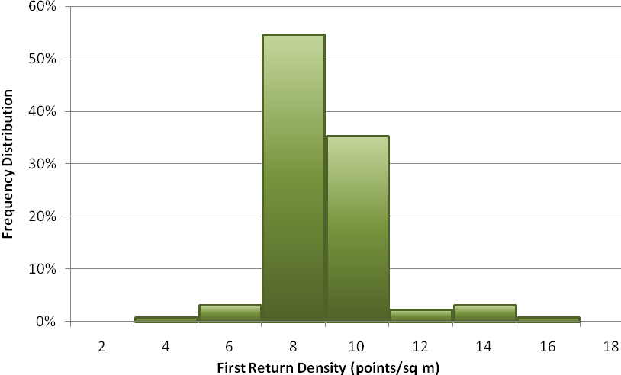

Figure 4. Density distribution for ground-classified laser points.
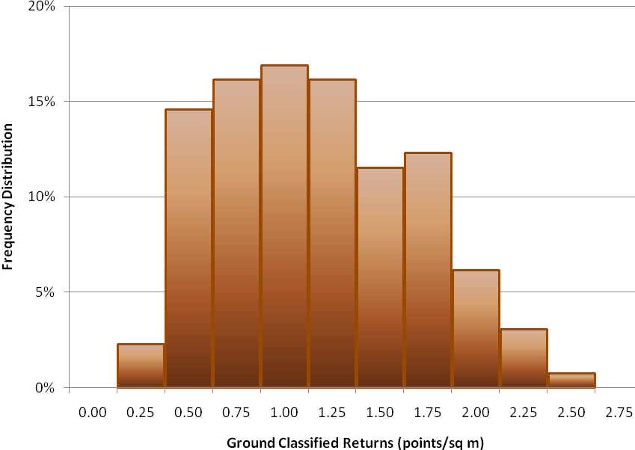
Figure 5. First return laser point data density per processing bin

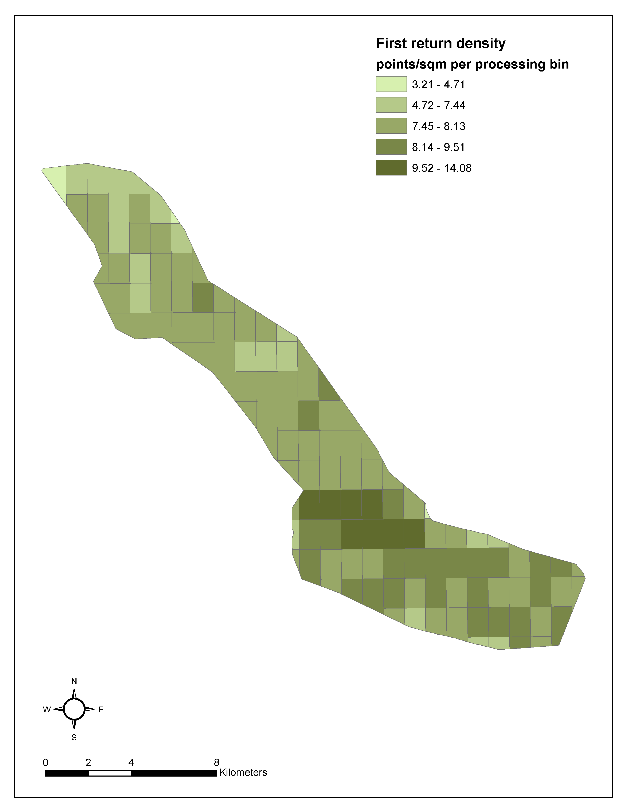

Figure 6. Ground-classified laser point data density per processing bins

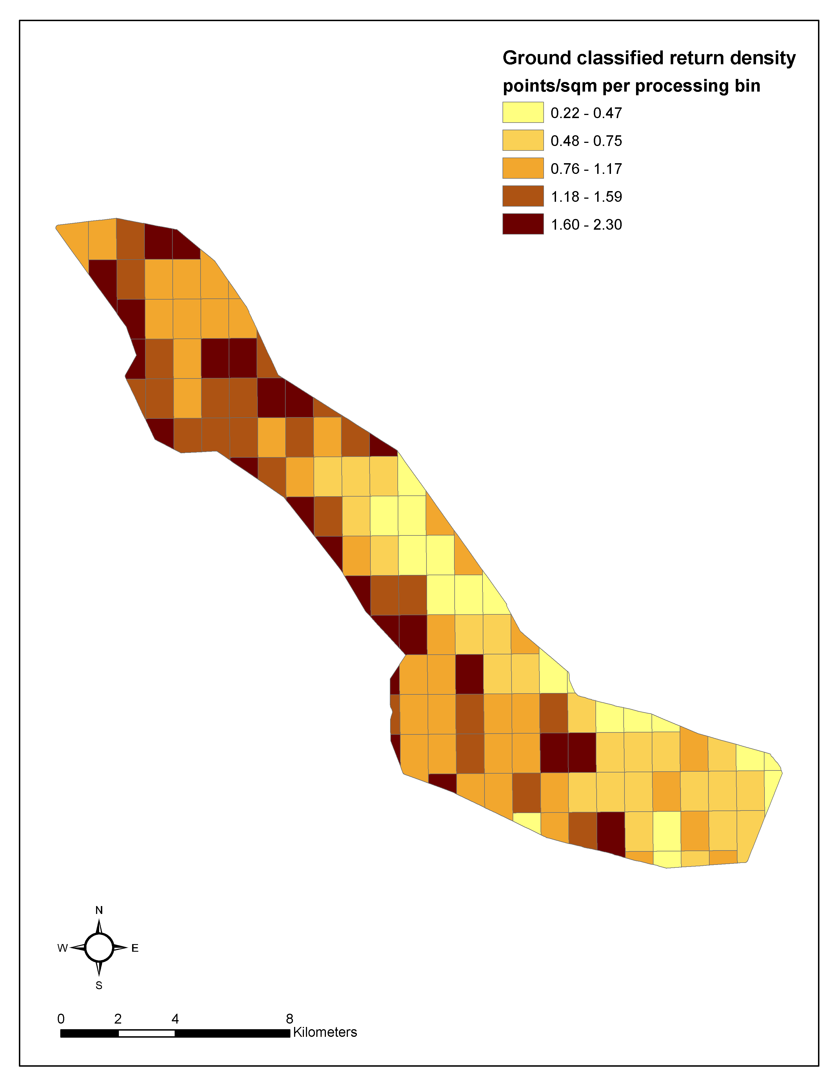

5.3 Relative Accuracy Calibration Results

Relative accuracies for the Sandy River study area:

- Project Average = 0.045 m
- Median Relative Accuracy = 0.046 m
- 1σ Relative Accuracy = 0.047 m
- 2σ Relative Accuracy = 0.052 m

Figure 7. Distribution of relative accuracies per flight line, non slope-adjusted

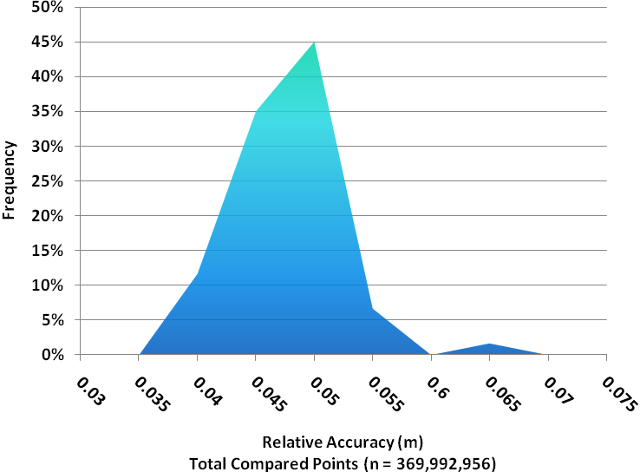

5.4 Absolute Accuracy

Absolute accuracies for the Sandy River study area:

Table 3. Absolute Accuracy – Deviation between laser points and RTK survey points

RTK Survey Sample Size (n): 506
Root Mean Square Error (RMSE) = 0.051 m |  | Minimum ∆z = -0.127 m
Standard Deviations |  | Maximum ∆z = 0.214 m
1 sigma (σ) = 0.051 m | 2 sigma (σ): 0.090 m | Average ∆z = -0.0015 m

Figure 8. Absolute Accuracy - Histogram Statistics, based on asphalt points

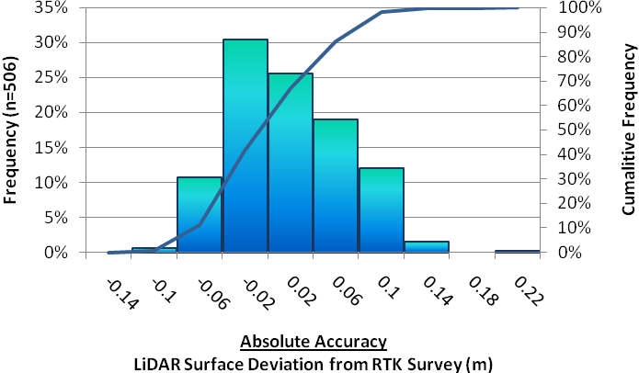

Figure 9. Absolute Accuracy - Absolute Deviation, based on asphalt points

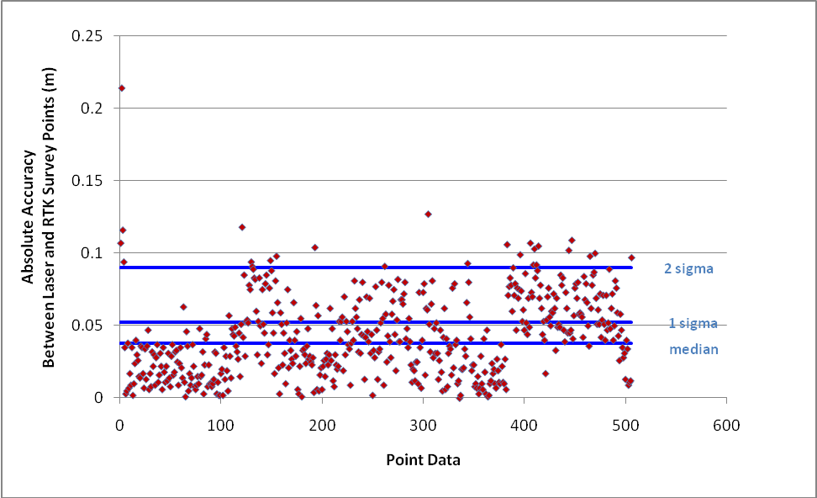

5.5 Projection/Datum and Units

Projection: |  | UTM Zone 10
Datum | Vertical: | NAVD88 Geoid03
Datum | Horizontal: | NAD83
Units: |  | Meters

Deliverables

LAS Files: | – all returns  - ground points
ASCII Points: | – all returns  - ground points
Vector Data: | Processing tile delineation (shapefile format)
Raster Data: | Elevation models (ESRI GRID format)  • Bare Earth Model (1-m resolution)  • Highest Hit Model (1-m resolution)  Intensity images (GeoTIFF format, 1-m resolution)
SBET: | ASCII format
Data Report: | Full Report containing introduction, methodology, and accuracy

7. Selected Images

Highest-hit Surface

8. Glossary

1-sigma (σ) Absolute Deviation: Value for which the data are within one standard deviation (approximately 68th percentile) of a normally distributed data set.
2-sigma (σ) Absolute Deviation: Value for which the data are within two standard deviations (approximately 95th percentile) of a normally distributed data set.
Root Mean Square Error (RMSE): A statistic used to approximate the difference between real-world points and the LiDAR points. It is calculated by squaring all the values, then taking the average of the squares and taking the square root of the average.
Pulse Rate (PR): The rate at which laser pulses are emitted from the sensor; typically measured as thousands of pulses per second (kHz).
Pulse Returns: For every laser pulse emitted, the Leica ALS 50 Phase II system can record up to four wave forms reflected back to the sensor. Portions of the wave form that return earliest are the highest element in multi-tiered surfaces such as vegetation. Portions of the wave form that return last are the lowest element in multi-tiered surfaces.
Accuracy: The statistical comparison between known (surveyed) points and laser points. Typically measured as the standard deviation (sigma, σ) and root mean square error (RMSE).
Intensity Values: The peak power ratio of the laser return to the emitted laser. It is a function of surface reflectivity.
Data Density: A common measure of LiDAR resolution, measured as points per square meter.
Spot Spacing: Also a measure of LiDAR resolution, measured as the average distance between laser points.
Nadir: A single point or locus of points on the surface of the earth directly below a sensor as it progresses along its flight line.
Scan Angle: The angle from nadir to the edge of the scan, measured in degrees. Laser point accuracy typically decreases as scan angles increase.
Overlap: The area shared between flight lines, typically measured in percents; 100% overlap is essential to ensure complete coverage and reduce laser shadows.
DTM / DEM: These often-interchanged terms refer to models made from laser points. The digital elevation model (DEM) refers to all surfaces, including bare ground and vegetation, while the digital terrain model (DTM) refers only to those points classified as ground.
Real-Time Kinematic (RTK) Survey: GPS surveying is conducted with a GPS base station deployed over a known monument with a radio connection to a GPS rover. Both the base station and rover receive differential GPS data and the baseline correction is solved between the two. This type of ground survey is accurate to 1.5 cm or less.

9. Citations

Soininen, A. 2004. TerraScan User’s Guide. TerraSolid.

Appendix A

LiDAR accuracy error sources and solutions:

Type of Error | Source | Post Processing Solution
GPS  (Static/Kinematic) | Long Base Lines | None
GPS  (Static/Kinematic) | Poor Satellite Constellation | None
GPS  (Static/Kinematic) | Poor Antenna Visibility | Reduce Visibility Mask
Relative Accuracy | Poor System Calibration | Recalibrate IMU and sensor offsets/settings
Relative Accuracy | Inaccurate System | None
Laser Noise | Poor Laser Timing | None
Laser Noise | Poor Laser Reception | None
Laser Noise | Poor Laser Power | None
Laser Noise | Irregular Laser Shape | None

Operational measures taken to improve relative accuracy:
- Low Flight Altitude: Terrain following is employed to maintain a constant above ground level (AGL). Laser horizontal errors are a function of flight altitude above ground (i.e., ~ 1/3000th AGL flight altitude).
- Focus Laser Power at narrow beam footprint: A laser return must be received by the system above a power threshold to accurately record a measurement. The strength of the laser return is a function of laser emission power, laser footprint, flight altitude and the reflectivity of the target. While surface reflectivity cannot be controlled, laser power can be increased and low flight altitudes can be maintained.
- Reduced Scan Angle: Edge-of-scan data can become inaccurate. The scan angle was reduced to a maximum of ±14º from nadir, creating a narrow swath width and greatly reducing laser shadows from trees and buildings.
- Quality GPS: Flights took place during optimal GPS conditions (e.g., 6 or more satellites and PDOP [Position Dilution of Precision] less than 3.0). Before each flight, the PDOP was determined for the survey day. During all flight times, a dual frequency DGPS base station recording at 1–second epochs was utilized and a maximum baseline length between the aircraft and the control points was less than 19 km (11.5 miles) at all times.
- Ground Survey: Ground survey point accuracy (i.e. <1.5 cm RMSE) occurs during optimal PDOP ranges and targets a minimal baseline distance of 4 miles between GPS rover and base. Robust statistics are, in part, a function of sample size (n) and distribution. Ground survey RTK points are distributed to the extent possible throughout multiple flight lines and across the study area.
- 50% Side-Lap (100% Overlap): Overlapping areas are optimized for relative accuracy testing. Laser shadowing is minimized to help increase target acquisition from multiple scan angles. Ideally, with a 50% side-lap, the most nadir portion of one flight line coincides with the edge (least nadir) portion of overlapping flight lines. A minimum of 50% side-lap with terrain-followed acquisition prevents data gaps.
- Opposing Flight Lines: All overlapping flight lines are opposing. Pitch, roll and heading errors are amplified by a factor of two relative to the adjacent flight line(s), making misalignments easier to detect and resolve.

Nadir refers to the perpendicular vector to the ground directly below the aircraft. Nadir is commonly used to measure the angle from the vector and is referred to a “degrees from nadir”.
Online Positioning User Service (OPUS) is run by the National Geodetic Survey to process corrected monument positions.

