
South Carolina Department of Natural Resources

LiDAR Campaign (Florence County, SC)
Report of Survey

2011

EXECUTIVE SUMMARY
The South Carolina Department of Natural Resources (SCDNR) contracted with Sanborn to provide LiDAR mapping services for Florence County, SC. Utilizing multi-return systems, Light Detection and Ranging (LiDAR) data in the form of 3-dimensional positions of a dense set of mass points was collected for approximately 887 square miles between March 16th and March 19th 2009. All systems consist of geodetic GPS positioning, orientation derived from high-end inertial sensors and high-accurate lasers. The sensor is attached to the aircraft’s underside and emits rapid pulses of light that are used to determine distances between the plane and terrain below.
Specifically, the Leica ALS-50 LiDAR system was used to collect data for the survey campaign. During final data processing, the calibration parameters are inserted into post-processing software.
A total of thirteen airborne GPS (Global Positioning System) base stations were used in the Florence County Project. Two new points, 501 and 502, were created to assist the accuracy of the network. The remaining 11 points were NGS stations. Together, these base stations were tied to the other point to create a GPS survey network. The coordinates of these stations were checked against each other with the three dimensional GPS baseline created at the airborne support set up and determined to be within project specifications.
The acquired LiDAR data was processed to obtain first and last return point data. The last return data was further filtered to yield a LiDAR surface representing the bare earth.
The contents of this report summarize the methods used to establish the base station coordinate check, perform the LiDAR data collection and post-processing as well as the results of these methods.
Contents
1.0 INTRODUCTION 4
1.1 Contact Information 4
1.2 Purpose of the LiDAR Acquisition 4
1.3 Project Location 4
1.4 Standard Specifications for LiDAR 5
2.0 LiDar System Report 6
2.1 Final LiDAR Processing 6
3.0 GEODETIC BASE NETWORK 8
3.1 Network Scope 8
3.2 Data Processing and Network Adjustment 8
3.3 Final LiDAR Verification 9
4.0 Coordinates and Datum 10
4.1 Introduction 10
4.2 Horizontal Datum 10
4.3 Vertical Datum 10

List of Tables

Table 1: Processing Accuracies and Requirements 6
Table 2: LiDAR Accuracy Assessment based on the Checkpoint Survey (feet) 9

List of Figures
Figure 1: Area of Collection 4
Figure 2: Survey Network Diagram 8

1.0 INTRODUCTION
This document contains the technical write-up of the LiDAR campaign, including the establishment and processing of base stations by a differential GPS network survey, and the collection and post-processing of the LiDAR data.

1.1 Contact Information
Questions regarding the technical aspects of this report should be addressed to:

Shawn Benham, PMP
Project Manager
Sanborn Map Co., Inc.
1935 Jamboree Dr. Suite 100
Colorado Springs Co 80920
719-502-1296 (Desk)
sbenham@sanborn.com

1.2 Purpose of the LiDAR Acquisition
As stated in the Statement of Work for Acquisition and Production of High Resolution Elevation data for Florence County, this LiDAR operation was designed to create high resolution data sets that will establish an authoritative source for elevation information for the State of South Carolina.

1.3 Project Location
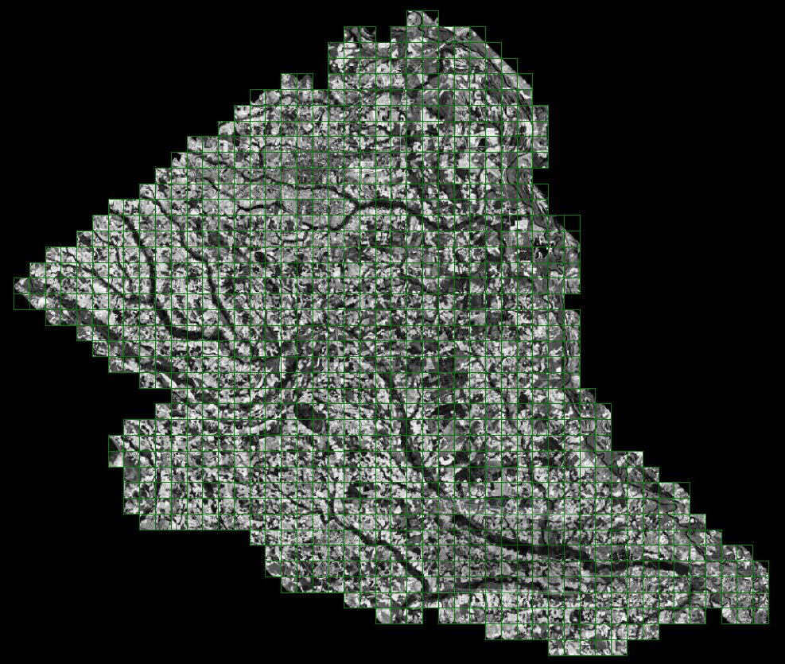
Figure 1: Area of Collection

1.4 Standard Specifications for LiDAR
Data Acquisition
Requirement | Description
Returns per pulse | LiDAR sensor shall be capable of recording up to 3 (or more) returns per pulse, including 1st and last returns
Scan angle | ≤ ±20 degrees | *
Swath overlap | Nominal sidelap on adjoining swaths, i.e., survey shall be designed for 100% double coverage at planned aircraft height above ground | 50%
Design pulse density (nominal) | Pulses/m2 (includes swath overlap; e.g., with 30% sidelap, ≥ 2 pulse/m2 in each swath) | ≥1
GPS procedures | At least 2 GPS reference stations in operation during all missions, sampling positions at 1 Hz or higher frequency. LiDAR data shall only be acquired when GPS PDOP is ≤ 3.5 and at least 6 satellites are in view. | *
Survey conditions | Leaf-off and no significant snow cover, as observed by state contract representatives. | *
Geographic Coverage and Continuity
Coverage | No voids between swaths.  No voids because of cloud cover or instrument failure.
Swath overlap | ≤ 40% no-overlap area per project.
Aggregate 1st return density | Barring non-scattering areas (e.g., open water, wet asphalt):  For entire project area, ≥ 85% design pulse density  Within any 30m x 30m area within areas of swath overlap, ≥ 50% design pulse  density

2.0 LiDar System Report

2.1 Final LiDAR Processing
Final post-processing of LiDAR data involves several steps. The airborne GPS data was post-processed using Waypoint’s GravNAVTM software (version 7.5). A fixed-bias carrier phase solution was computed in both the forward and reverse chronological directions. The data was processed for both base stations and combined. In the event that the solution worsened as a result of the combination of both solutions the best of both solutions was used to yield more accurate data. LiDAR acquisition was limited to periods when the PDOP was less than 3.2.

The GPS trajectory was combined with the raw IMU data and post-processed using Applanix Inc.’s POSPROC (version 4.3) Kalman Filtering software. This results in a two-fold improvement in the attitude accuracies over the real-time INS data. The best estimated trajectory (BET) and refined attitude data are then re-introduced into the LEICA ALS post processor for the Leica system to compute the laser point-positions. The trajectory is then combined with the attitude data and laser range measurements to produce the 3-dimensional coordinates of the mass points.

All return values are produced within ALS Post processing software for the Leica system. The multi-return information is processed to obtain the “Bare Earth Dataset” as a deliverable. All LiDAR data is processed using the binary LAS format 1.2 file format.

LiDAR filtering was accomplished using TerraSolid, TerraScan LiDAR processing and modeling software. The filtering process reclassifies all the data into classes with in the LAS formatted file based scheme set using the LAS format 1.2 specifications or by the client. Once the data is classified, the entire data set is reviewed and manually edited for anomalies that are outside the required guidelines of the product specification or contract guidelines, whichever apply. Table 1 indicates the required product specifications.

The coordinate and datum transformations are then applied to the data set to reflect the required deliverable projection, coordinate and datum systems as provided in the contract.

The client required deliverables are then generated. At this time, a final QC process is undertaken to validate all deliverables for the project. Prior to release of data for delivery, Sanborn’s quality control/quality assurance department reviews the data and then releases it for delivery.

Table 1: Processing Accuracies and Requirements

Accuracy of LiDAR Data (H) | 1m RMSE
Accuracy of LiDAR data in bare areas | 18.5 cm RMSE
Accuracy of LiDAR data in vegetated areas | 37 cm RMSE
Percent of artifacts removed (terrain and vegetation dependent) | 90%
Percent of all outliers removed | 95%
Percent of all vegetation removed | 95%
Percent of all buildings removed | 98%

3.0 GEODETIC BASE NETWORK

3.1 Network Scope
During the LiDAR campaign, the Sanborn field crew conducted a GPS field survey to establish final coordinates of the ground base stations for final processing of the base-remote GPS solutions. NGS points AE3541, EB3084, EB1786, EB4035, DD4691, DD2202, DD0317, DE2442, DD0809, CK1288, CK2745 and new points set on 501 and 502 were used for the LiDAR missions.

3.2 Data Processing and Network Adjustment
The static baselines created between points AE3541, EB3084, EB1786, EB4035, DD4691, DD2202, DD0317, DE2442, DD0809, CK1288, CK2745, 501 and 502 were processed using Trimble Geomatics OfficeTM (Ver. 1.62) software. Fixed bias solution was obtained for the baselines. The broadcast ephemeris was used, since the accuracy and extent of the network does not warrant the use of the precise ephemeris. The results were satisfactory; therefore, fulfilling project specifications for first order control network.

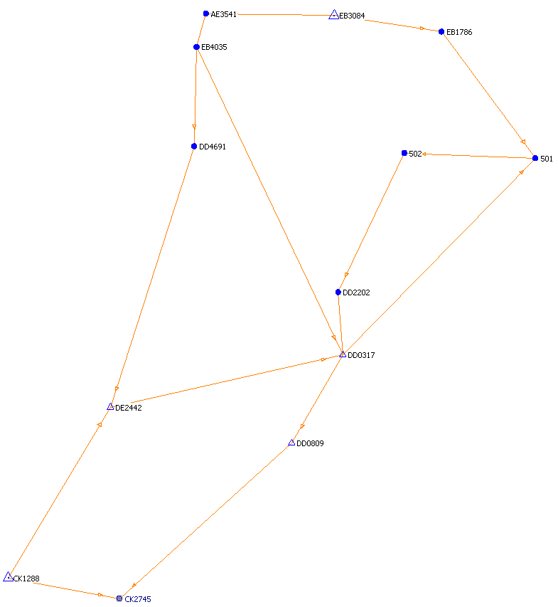

Figure 2: Survey Network Diagram

3.3 Final LiDAR Verification
The LiDAR data was evaluated using a collection of fifteen GPS surveyed checkpoints. For Florence County, South Carolina the standard deviation is 0.359 feet and the root mean squared is 0.0.343 feet. The LiDAR data was compared to each of these classes yielding much better result than was required for the project. Table 2 indicates the results for Florence County, South Carolina and each point including the overall results as it compares to the LiDAR data set.

Table 2: LiDAR Accuracy Assessment based on the Checkpoint Survey (feet)

Number | Easting |  | Northing | Known Z | Laser Z |  | Dz
1 | 12297540.970 |  | 3756514 | 4 | 4.25 |  | 0.25
2 | 12297295.270 |  | 3755576 | 5 | 4.9 |  | -0.1
3 | 12300004.030 |  | 3796950 | 44.41 | 44.53 |  | 0.12
4 | 12274872.850 |  | 3768633 | 44.6 | 44.22 |  | -0.38
5 | 12275768.350 |  | 3770768 | 45 | 45.52 |  | 0.52
6 | 12276530.960 |  | 3772992 | 45.1 | 44.52 |  | -0.58
7 | 12357394.800 |  | 3881049 | 36.98 | 37.08 |  | 0.1
8 | 12353995.850 |  | 3880961 | 34.6 | 34.89 |  | 0.29
9 | 12335638.380 |  | 3901414 | 31.27 | 30.88 |  | -0.39
10 | 12277162.510 |  | 3794215 | 6 | 5.72 |  | -0.28
11 | 12357922.790 |  | 3878903 | 33.4 | 33.76 |  | 0.36
 |  |  | Average dz: -0.008
 |  |  | Minimum dz: -0.580
 |  |  | Maximum dz: +0.520
 |  |  | Average magnitude: 0.306
 |  | Root mean square: 0.343
 |  | Std deviation: 0.359

4.0 Coordinates and Datum

4.1 Introduction
The final adjustment was constrained to the published NAD83 geodetic coordinates (φ, λ) and NAVD88 elevations. The adjustment was cross-referenced to the GEOID03 model to enable the estimation of orthometric heights.

4.2 Horizontal Datum
The final horizontal coordinates are provided in South Carolina State Plane on the North American Datum of 1983 (NAD83 adjustment of 2007) units of International feet.

4.3 Vertical Datum
The final orthometric elevations were determined for all points in the network using Geoid03 model and are provided on the North American Vertical Datum of 1988 in units of US feet.

