Elevation QA Report

Project: Contractor:

Data Delivery Date: Date Data Reviewed:
Reviewer: Total Square Miles Reviewed:
Elevation Type: Format: Grid Spacing: Tile size:
Projection: Zone: Datum: Units:

Licensing: Metadata:
Materials Received:

Vertical Accuracy Test Performed: Test Point Source: RMSE:
Vertical Accuracy Test Notes:

QA Review Summary:

07-08-2011
LiDAR Quality Assessment (QA) Review Process

Preparation:
-Metadata reviewed to determine data projection, datum, format, etc.
-If ARRA contract, check for raw .LAS files, classified .LAS files, breaklines, blind control points,
and DEM in Image or Grid format
-Open data in Global Mapper

Vertical accuracy testing:
-If ARRA contract, use Vertical Accuracy Test Worksheet to perform RMSE on 20 blind point
positions provided by contractor

Inspection and Correction of data:
-Minimum and maximum elevations in dataset; correct if in error
-Appropriate hydro flattening as specified in V12 Lidar Specification (For ARRA/GPSC Data)
-Data void areas
-Data spikes
-Tile edge seam lines
-Non-bare earth surface artifacts (structures, bridges, vegetation, etc.)
-Elevation errors - raised/lowered areas/tiles
-Other surface treatment anomalies
-Check DRGs for correct elevations and horizontal positioning (if test points not available)
-Create footprint (project boundary) shape file and establish square miles
During Inspection, identify data errors and create “error” file folder:
-Capture geo-referenced JPG or TIFF image(s) of identified errors
-Copy to Error file
During Inspection, level elevations and remove artifacts (these two steps not done for ARRA data):
-Level smoothing to remove non-bare earth surface artifacts (structures, bridges, vegetation, etc.)
-Level data spikes where possible

Export image files and create project Elevation QA Review Report:
-Export ERDAS Imagine image files in native projection and resolution
-If ARRA, Copy Vertical Accuracy Test Worksheet into QA Report
-Place QA Review Process and Project Area Extent into QA Report
-If rejected, attach sample geo-referenced JPG or TIFF error images with an explanation of reason
-If rejected, restart QA process when replacement data is received
-Provide completed Elevation A Review Report to Elevation Supervisor for final viewing
-Add QA Report, footprint, Imagine image(s), and Error file to original data file for final shipment to EROS

Shenandoah Valley Area Extent
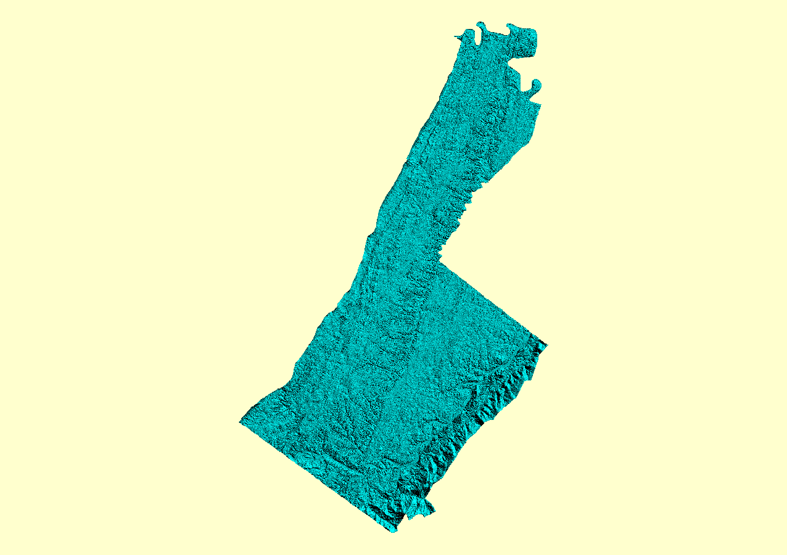

Vertical Accuracy Worksheet
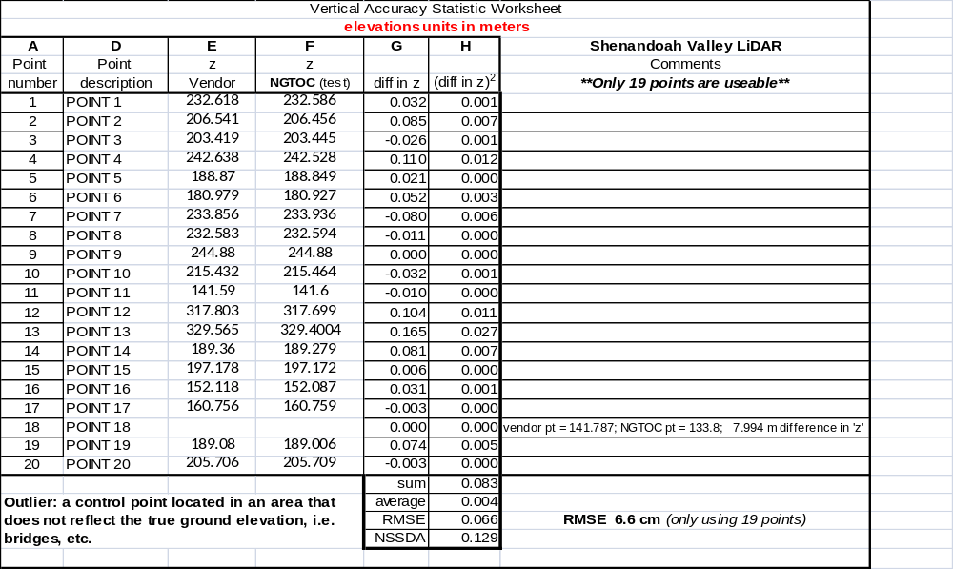

ANOMALIES…

TYPE – ‘PITS’

‘pits_house-removal_17’ – Stand-Alone house, 39° 20’ 39.5” N, 78° 00’ 34.9” W
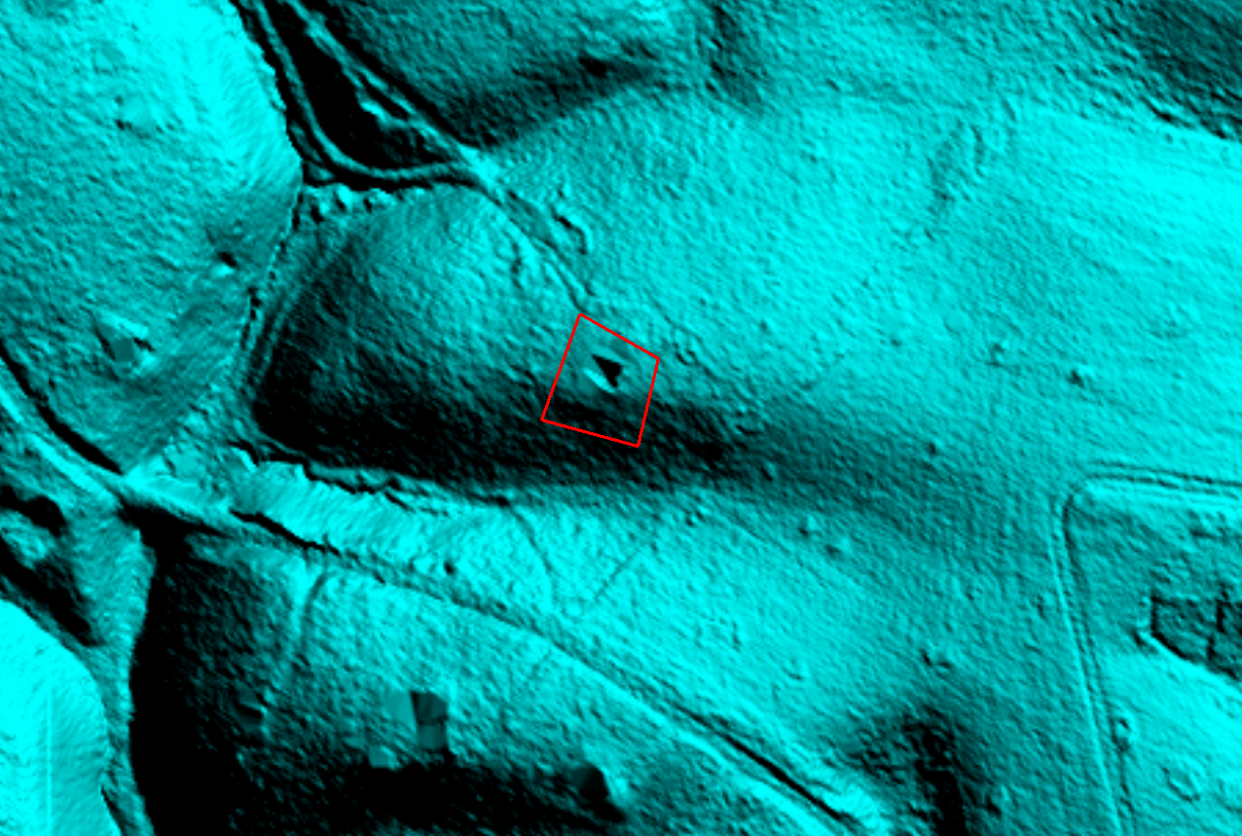

‘pits_house-removal_23’ – Small groups of houses, 39° 18’ 6.6” N, 78° 09’ 5.6” W
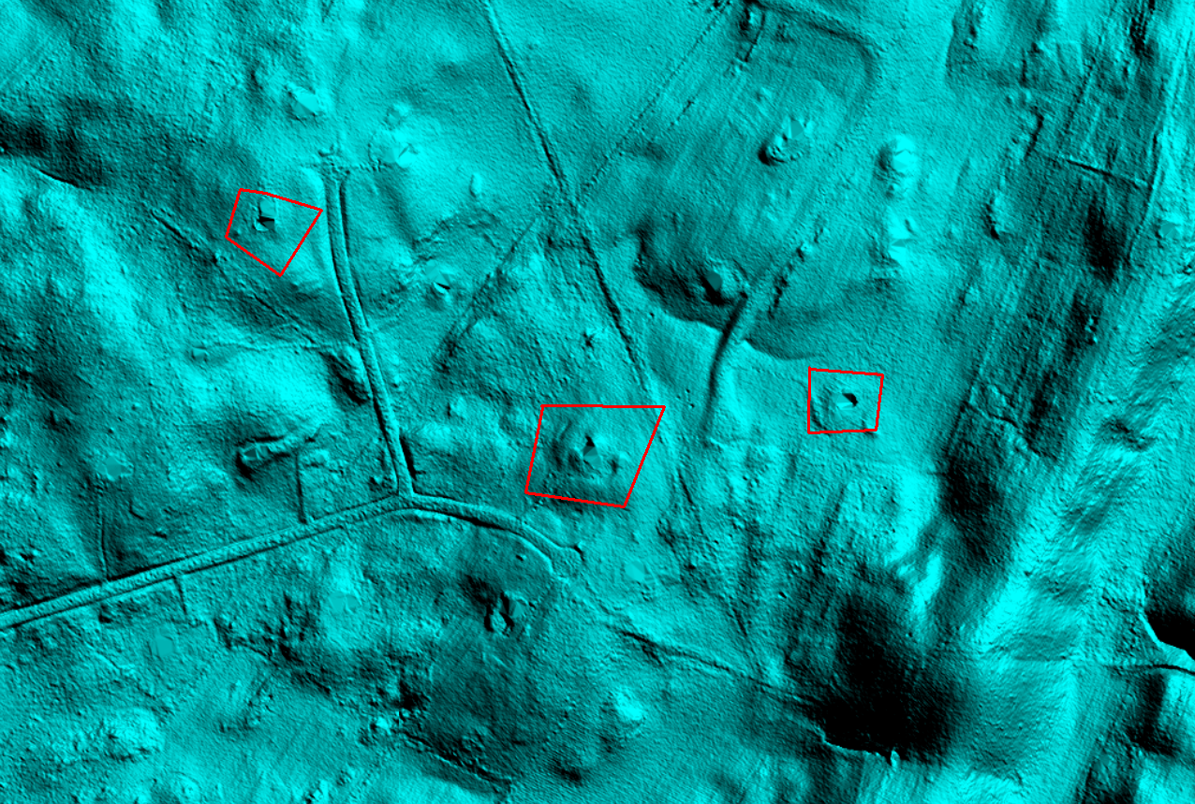

‘pits_house-removal_52’ – Subdivision, 39° 09’ 33.8” N, 78° 11’ 34” W


