

LiDAR Campaign (Accomack, VA)
Report of Survey

Spring 2010 Data Collection

EXECUTIVE SUMMARY
The Virginia Geographic Information Network contracted with Sanborn to provide LiDAR mapping services for the Accomack, VA area in spring 2010. Utilizing multi-return systems, Light Detection and Ranging (LiDAR) data in the form of 3-dimensional positions of a dense set of mass points was collected for approximately 1090 square miles. All systems consist of geodetic GPS positioning, orientation derived from high-end inertial sensors and high-accurate lasers. The sensor is attached to the aircraft’s underside and emits rapid pulses of light that are used to determine distances between the plane and terrain below.
Specifically, an Optech 3100 LiDAR system was used to collect data for the survey campaign. The LiDAR system is calibrated by conducting flight passes over a known ground surface before and after each LiDAR mission. During final data processing, the calibration parameters are inserted into post-processing software.
The acquired LiDAR data was processed to obtain first and last return point data. The last return data was further filtered to yield a LiDAR surface representing the bare earth. This data was then used to collect breaklines for generation of hydro-flattened raster DEM deliverables.
The contents of this report summarize the methods used to establish the base station coordinate check, perform the LiDAR data collection and post-processing as well as the results of these methods.

1.0 INTRODUCTION

This document contains the technical write-up of the Accomack, VA LiDAR campaign, including system calibration techniques, and the collection and post-processing of the LiDAR data.

1.1 Contact Information
Questions regarding the technical aspects of this report should be addressed to:

Shawn Benham
Project Manager
Sanborn Map Co., Inc.
1935 Jamboree Dr. Suite 100
Colorado Springs, CO 80920
719-502-1296 (Desk)
719-264-5584 (Fax)
sbenham@sanborn.com

1.2 Purpose of the LiDAR Acquisition
As stated in the statement of work, this project is a cooperative effort being funded by The Nature Conservancy – Virginia Office (TNC), the University of Virginia’s Virginia Coast Reserve Long-Term Ecological Research Project (VCR/LT ER) and the United States Geological Survey (USGS). Collection and delivery of LiDAR data for the project are3a meeting the USGS LiDAR Guidelines and Base Specifications was required. This includes creation of a hydro-flattened, bare-earth digital elevation model (DEM).

1.3 Project Location
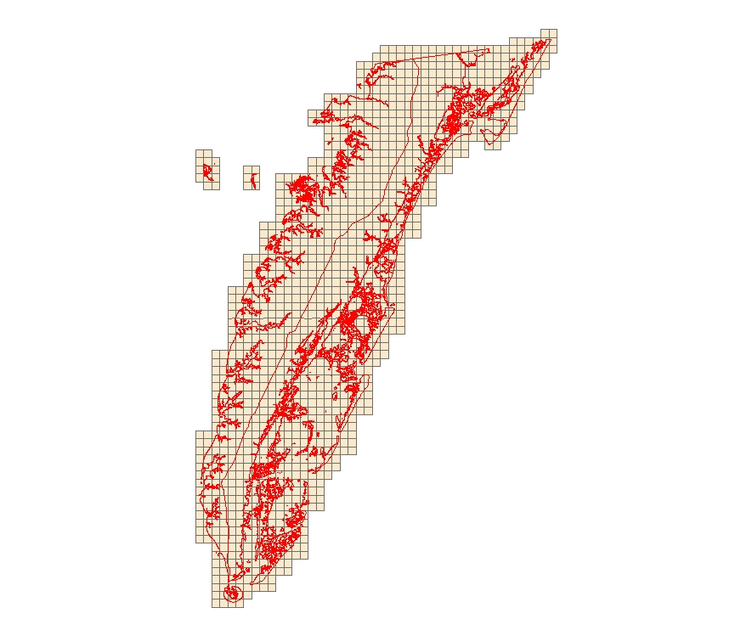

Figure 1: Area of Collection

Standard Specifications for LiDAR
Project Specifications
Area (sq. mi) | 1090 | Product type | USGS v13 Specification | Projection | HARN StatePlane Virginia South FIPS 4502
Vertical Accuracy (CM) | Bare Earth  15 | Check  Points  required | Yes | Horizontal Datum Vertical Datum | NAD 83/NAVD 88
Horizontal accuracy (M) | 1meter | Number Collected | Meets minimum requirements | Units | US Feet

2.0 LiDAR CALIBRATION

2.1 Introduction
LiDAR calibrations are performed to determine and therefore eliminate systematic biases that occur within the hardware of the Optech 3100 system. Once the biases are determined they can be modeled out. The systematic biases are corrected for include scale, roll, and pitch.
The following procedures are intended to prevent operational errors in the field and office work, and are designed to detect inconsistencies. The emphasis is not only on the quality control (QC) aspects, but also on the documentation, i.e., on the quality assurance (QA).

2.2 Calibration Procedures
Sanborn performs two types of calibrations on its LiDAR system. The first is a building calibration, and it is done any time the LiDAR system has been moved from one plane to another. New calibration parameters are computed and compared with previous calibration runs. If there is any change, the new values are updated internally or during the LiDAR post-processing. These values are applied to all data collected with the plane and the Optech system configurations.
Once final processing calibration parameters are established from the building data, a precisely-surveyed surface is observed with the LiDAR system to check for stability in the system. This is done several times during each mission. An average of the systematic biases are applied on a per mission basis.

2.3 Building Calibration
Whenever the Optech 3100 is moved to a new aircraft, a building calibration is performed. The rooftop of a large, flat, rectangular building is surveyed on the ground using conventional survey methods, and used as the LiDAR calibration target. The aircraft flies several specified passes over the building with the Optech system set first in scan mode, then in profile mode, and finally in both scan and profile modes with the scan angle set to zero degrees.
Figure 2 shows a pass over the center of the building. The purpose of this pass is to identify a systematic bias in the scale of the system.
Figure 3 demonstrates a pass along a distinct edge of the building to verify the roll compensation performed by the Inertial Navigation System, INS.
Additionally, a pass is made in profile mode across the middle of the building to compensate for any bias in pitch.
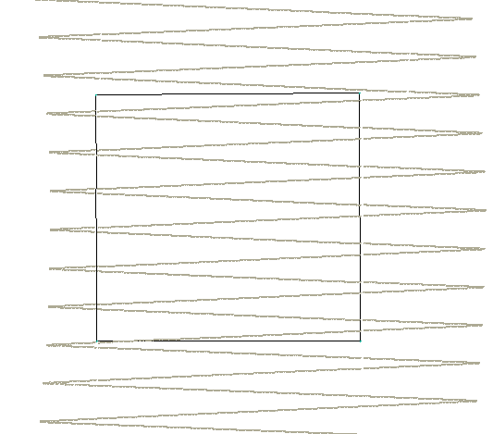  Figure 2: Calibration Pass 1 | 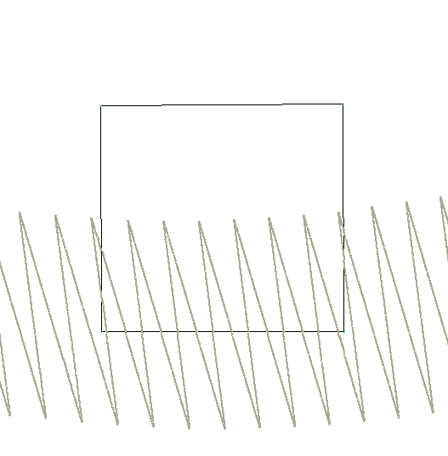  Figure 3: Calibration Pass 2

2.4 Runway Calibration, System Performance Validation
An active asphalt runway was precisely-surveyed at the Accomack County Airport for Accomack, Virginia using kinematic GPS survey techniques (accuracy: ±3cm at 1σ, along each coordinate axis) to establish an accurate digital terrain model of the runway surface. The LiDAR system is flown at right angles over the runway several times and residuals are generated from the processed data. Figure 4 shows a typical pass over the runway surface.
Approximately 25,000 LiDAR points are observed with each pass. A Triangulated Irregular Network (TIN) surface is created from these passes. The ground control x,y,z points are then compared with the z of the LiDAR surface to compute vertical residuals of the LiDAR data. After careful analysis of noise associated with non-runway returns, any system bias is documented and removed from the process.
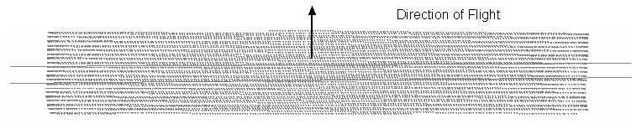
Figure 4: Runway Calibration

3.0 RUNWAY CALIBRATION and SYSTEM PERFORMANCE VALIDATION

3.1 Calibration Results
The LiDAR data captured over the building is used to determine whether there have been any changes to the alignment of the Inertial Measurement Unit, IMU, with respect to the laser system. The parameters are designed to eliminate systematic biases within certain system parameters.
The runway over-flights are intended to be a quality check on the calibration and to identify any system irregularities and the overall noise. IMU misalignments and internal system calibration parameters are verified by comparing the collected LiDAR points with the runway surface.
Figure 5 shows the typical results of a runway over-flight analysis. The X-axis represents the position along the runway. The overall statistics from this analysis provides evidence of the overall random noise in the data (typically, 7 cm standard deviation – an unbiased estimator, and 8 cm RMSE which includes any biases) and indicates that the system is performing within specifications. As described in later sections of this report, this analysis will identify any peculiarities within the data along with mirror-angle scale errors (identified as a “smile” or “frown” in the data band) or roll biases.
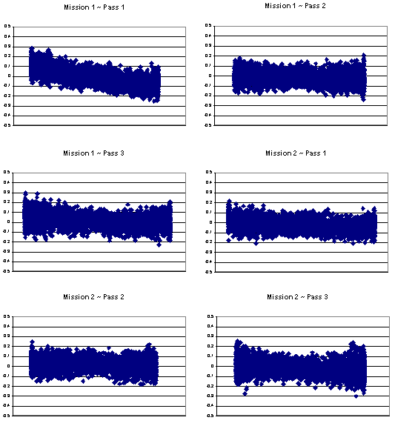
The calibration is done based on a kinematic survey on the runway. Given that the Kinematic survey RMSE is no better than 4 centimeters as a result of none exact height of the antenna and weight of the aircraft. Sanborn was required to do additional check points in the project area to meet the 15 centimeter vertical accuracy requirement knowing that the calibration site is only good to 4 centimeters RMSE. A z bump adjustment was made to the entire data set based on the survey points in the project area and the relative accuracy of the data to itself and in all areas.

Figure 5: Runway Calibration Results

4.0 LiDAR FLIGHT AND SYSTEM REPORT

4.1 Introduction
This section addresses LiDAR system, flight reporting and data acquisition methodology used during the collection of the Accomack LiDAR campaign. Although Sanborn conducts all LiDAR with the same rigorous and strict procedures and processes, all LiDAR collections are unique.

4.2 Field Work Procedures
Pre-flight checks such as cleaning the sensor head glass are performed. A four minute INS initialization is conducted on the ground, with the engines running, prior to flight, to establish fine-alignment of the INS. GPS ambiguities are resolved by flying within ten kilometers of the base stations.

The flight missions were typically four or five hours in duration including runway calibration flights flown at the beginning and the end of each mission. During the data collection, the operator recorded information on log sheets which includes weather conditions, LiDAR operation parameters, and flight line statistics. Near the end of the mission GPS ambiguities are again resolved by flying within ten kilometers of the base stations, to aid in post-processing.

Preliminary data processing was performed in the field immediately following the missions for quality control of GPS data and to ensure sufficient overlap between flight lines. Any problematic data could then be re-flown immediately as required. Final data processing was completed in the Colorado Springs office.

Table 3: Collection Dates, Times, Average Per Flight Collection Parameters and PDOP
Mission | Date | Start Time | End Time | Altitude (m) | Airspeed (Knots) | Scan Angle | Scan Rate | Pulse  Rate | PDOP
Day084A | 3/25/10 | 21:42 | 02:12 | 1600 | 120 | 20˚ | 34 | 70000 | 1.8
Day086A | 3/27/10 | 12:36 | 17:06 | 1600 | 120 | 20˚ | 34 | 70000 | 1.8
Day086B | 3/27/10 | 20:52 | 01:50 | 1600 | 120 | 20˚ | 34 | 70000 | 1.8
Day087A | 3/28/10 | 16:32 | 21:21 | 1600 | 120 | 20˚ | 34 | 70000 | 1.8
Day087B | 3/28/10 | 21:58 | 01:10 | 1600 | 120 | 20˚ | 34 | 70000 | 1.8
Day089A | 3/30/10 | 22:30 | 00:09 | 1600 | 120 | 20˚ | 34 | 70000 | 1.8

4.3 Final LiDAR Processing
Final post-processing of LiDAR data involves several steps. The airborne GPS data was post-processed using Waypoint’s GravNAVTM software (version 7.5). A fixed-bias carrier phase solution was computed in both the forward and reverse chronological directions. The data was processed for both base stations and combined. In the event that the solution worsened as a result of the combination of both solutions the best of both solutions was used to yield more accurate data. LiDAR acquisition was limited to periods when the PDOP was less than 3.2.

The GPS trajectory was combined with the raw IMU data and post-processed using Applanix Inc.’s POSPROC (version 4.3) Kalman Filtering software. This results in a two-fold improvement in the attitude accuracies over the real-time INS data. The best estimated trajectory (BET) and refined attitude data are then re-introduced into the Dashmap post processor for the Optech system to compute the laser point-positions. The trajectory is then combined with the attitude data and laser range measurements to produce the 3-dimensional coordinates of the mass points.

All return values are produced within Dashmap processing software for the Optech system. The multi-return information is processed to obtain the “Bare Earth Dataset” as a deliverable. All LiDAR data is processed using the binary LAS format 1.2 file format.

LiDAR filtering was accomplished using TerraSolid, TerraScan LiDAR processing and modeling software. The filtering process reclassifies all the data into classes with in the LAS formatted file based scheme set using the LAS format 1.2 specifications or by the client. Once the data is classified, the entire data set is reviewed and manually edited for anomalies that are outside the required guidelines of the product specification or contract guidelines, whichever apply. Table 4 indicates the required product specifications.

The coordinate and datum transformations are then applied to the data set to reflect the required deliverable projection, coordinate and datum systems as provided in the contract.

The client required deliverables are then generated. At this time, a final QC process is undertaken to validate all deliverables for the project. Prior to release of data for delivery, Sanborn’s quality control/quality assurance department reviews the data and then releases it for delivery

Table 4: Processing Accuracies and Requirements

Accuracy of LiDAR Data (H) | 1 m RMSE
Accuracy of LiDAR data in bare areas | 15 cm RMSE
Accuracy of LiDAR data in vegetated areas | 30 cm RMSE
Percent of artifacts removed (terrain and vegetation dependent) | 95%
Percent of all outliers removed | 98%
Percent of all vegetation removed | 97%
Percent of all buildings removed | 99%

5.0 Final LiDAR Verification
The LiDAR data was evaluated using a collection of 15 GPS surveyed checkpoints. For Accomack County, the root mean squared is 0.343 meters. The LiDAR data was compared to each of these checkpoints yielding much better result than was required for the project. Table 5 indicates the overall results for Accomack County as it compares to the LiDAR data set.

Table 5: LiDAR Accuracy Assessment based on the Checkpoint Survey (ft.)
Number | Easting | Northing |  | Known Z |  | Laser Z | Dz
1 | 12297541 | 3756514 |  | 4 |  | 4.25 | 0.25
2 | 12297295 | 3755576 |  | 5 |  | 4.9 | -0.1
3 | 12300004 | 3796950 |  | 44.41 |  | 44.53 | 0.12
4 | 12274873 | 3768633 |  | 44.6 |  | 44.22 | -0.38
5 | 12275768 | 3770768 |  | 45 |  | 45.52 | 0.52
6 | 12276531 | 3772992 |  | 45.1 |  | 44.52 | -0.58
7 | 12357395 | 3881049 |  | 36.98 |  | 37.08 | 0.1
8 | 12353996 | 3880961 |  | 34.6 |  | 34.89 | 0.29
9 | 12335638 | 3901414 |  | 31.27 |  | 30.88 | -0.39
10 | 12277163 | 3794215 |  | 6 |  | 5.72 | -0.28
11 | 12205690 | 3835147 |  | 4.3 |  | removed | *
12 | 12357923 | 3878903 |  | 33.4 |  | 33.76 | 0.36
13 | 12360580 | 3879168 |  | 7.2 |  | removed | *
14 | 12205418 | 3831446 |  | 4.2 |  | removed | *
15 | 12205613 | 3833361 |  | 3.7 |  | removed | *
Average dz: |  |  | -0.008
Minimum dz: |  |  | -0.58
Maximum dz: |  |  | 0.52
Average magnitude: |  |  | 0.306
Root mean square: |  |  | 0.343
Std deviation: |  |  | 0.359

Of the four NGS points that show as removed, the three points at Tangier Island Airport were removed due to repaving and the after effects of Hurricane Isabel as noted in the NGS datasheets. Point AJ7761 was removed due to description ambiguity.

6.0 Coordinates and Datum

6.1 Introduction
The final adjustment was constrained to the published NAD83 geodetic coordinates (φ, λ) and NAVD88 elevations. The adjustment was cross-referenced to the GEOID09 model to enable the estimation of orthometric heights.

6.2 Horizontal Datum
The final horizontal coordinates are provided in HARN StatePlane on the North American Datum of 1983 (NAD83 adjustment of 1992) units of feet.

6.3 Vertical Datum
The final orthometric elevations were determined for all points in the network using Geoid09 model and are provided on the North American Vertical Datum of 1988 in units of feet.

