

Kittitas

Post-Flight Aerial Acquisition

Report

August 2011

# Post-Flight Aerial Acquisition and Calibration Report

**FEMA REGION 10**

## Kittitas County, WA

August 2011

Contents

1.0 Overview 3

1.1. Contact Information: 3

1.2. Purpose and Location 3

2.0 LiDAR Acquisition 3

2.1 System Parameters 3

2.2 Base Station Information 4

2.3 Time Period: 5

2.4 PDOP 6

3.0Processing Summary 8

3.1 Airborne GPS 8

3.2 LIDAR Calibration 15

3.3 LIDAR Processing 16

3.4Flight Log Overview: 16

4.0 Data Verification 17

Appendix A Original Flight Logs 18

# 1.0 Overview

## 1.1. Contact Information:

Questions regarding the technical aspects of this report should be addressed to:

AeroMetric, Inc.

4020 Technology Parkway

Sheboygan, WI 53081

Attn: Robert Merry (Geomatics Manager)

Telephone: 920-457-3631

FAX: 920-457-0410

Email: [rmerry@aerometric.com](mailto:rmerry@aerometric.com)

## 1.2. Purpose and Location

AeroMetric, Inc acquired highly accurate Light Detection and Ranging (LiDAR) data for an area that comprised of approximately 185 square miles of Kittitas County, Washington for STARR as a part of FEMAs RiskMAP program. A graphic of the location is provided in Figure 1.1.

Figure 1.1 Project Area - Kittitas County, WA

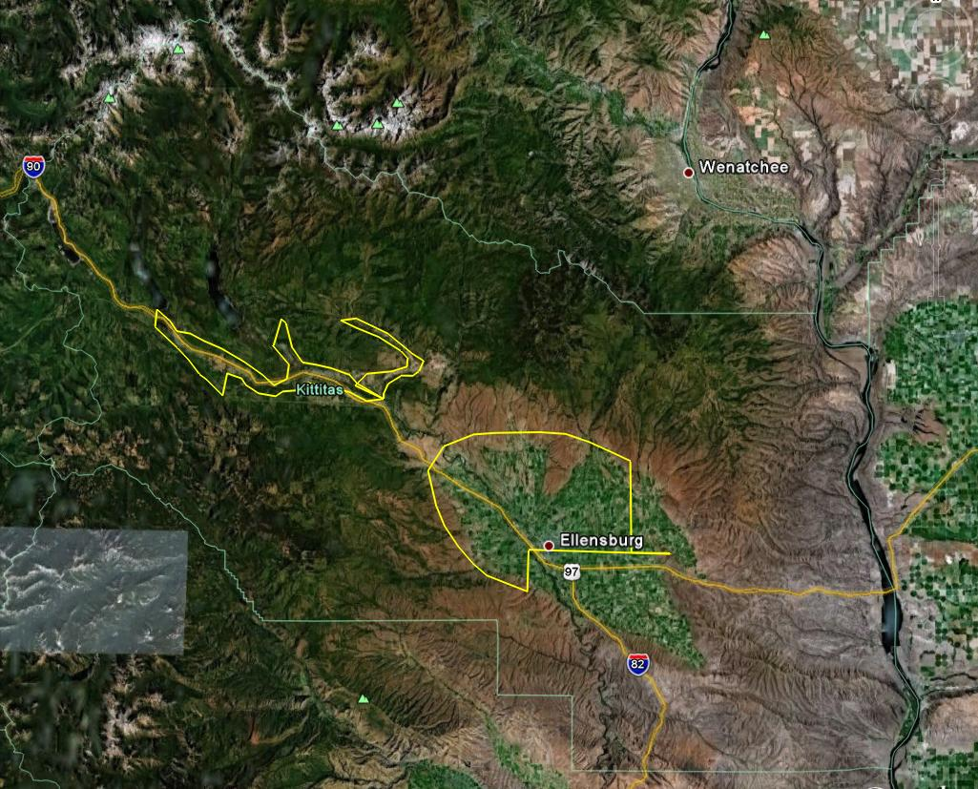

# 2.0 LiDAR Acquisition

## 2.1 System Parameters

LiDAR was collected to the ‘Highest’ FEMA specification which is equivalent to the 2 foot contour equivalency accuracy requirement. This requires a nominal post spacing of 1 meter. The LiDAR system parameters to meet this requirement are found in Table 2.1.

Table 2.1 LiDAR System Specifications

|  |  |
| --- | --- |
| Flying Height | 1500 meters |
| Laser Pulse Rate | 70 kHz |
| Mirror Scan Frequency | 41 Hz |
| Scan Angle | (+/-) 16° |
| Side Lap | 50% |
| Ground Speed | 160 knots |
| Nominal Point Spacing | 1 meter |

2.2 Base Station Information:

All missions originated and terminated at Bowers Airport in Ellensburg, WA. A GPS base station was operating at the airport during every lift. Table 2.1 is the Base Station information for the project area. Figure 2.1 provides a graphic representation of the Base Station locations. In the figure the Green Stick Pin represents Base Station 39471080.t01. The maximum extent of the collection area was approximately 22 km from Base Station 39471080.t01. The Yellow Stick Pin represents Base Station 82571071. The maximum extent of the collection area was approximately 20 km from Base Station 82571071. Shapefiles of the Base Stations can be found in the Control.zip file attached to this report.

Table 2.2 Base Station Locations

|  |  |  |  |
| --- | --- | --- | --- |
| POINT ID | LAT | LONG | HEIGHT (M) |
| 39471080.t01 | 47 11 39.9373 | 120 56 33.6098 | 584.027 |
| 82571071 | 47 01 51.11424 | 120 31 14.92835 | 513.293 |

Figure 2.1 Base Station Location Map

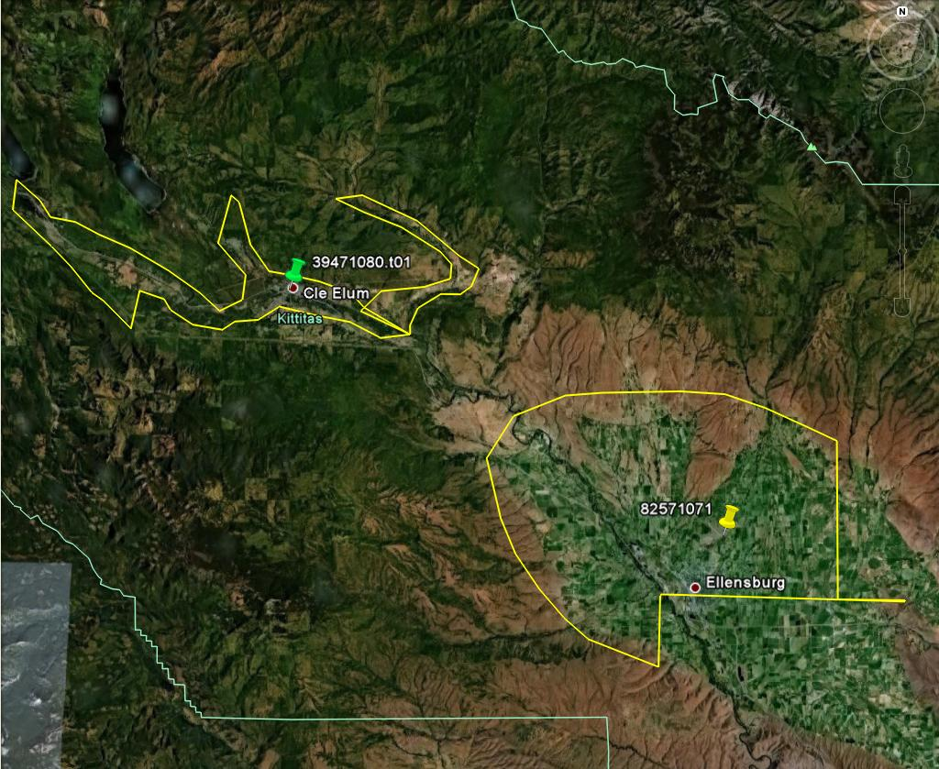

## 2.3 Time Period:

LiDAR data acquisition was completed between April 17, 2011 and April 19, 2011. A total of 4 flight missions were required to cover the project area. Table 2.3 provides the acquisition parameters. Figure 2.2 depicts the flightlines over the project area. Shapefiles of the flightline swath can be found in the Coverage.zip file attached to this report.

Table 2.3 LiDAR Acquisition Flight Summary

|  |  |
| --- | --- |
| Acquisition Date, Mission, and Time | 20110417 107B 12:15-17:00 PDT |
|  | 20110418 108A 09:15-12:15 PDT |
|  | 20110419 109A/109B 07:55-17:00 PDT |
| Area of Acquisition | 185 square miles |
| Aircraft | PA 31 Navajo N59984 |
| Planned Altitude | 1,500 meters AGL |
| Planned Airspeed | 160 knots |
| Planned Number of Flight Lines | Block 1 - 49 lines; Block 2 - 20 lines; Block 3 – 30 Lines |
| Flight Line Spacing | 430 meters |
| Flight Line Coverage | 860 meters |
| Sidelap | 50% |
| System PRF | 70 kHz |
| Mirror Scan Half Angle | 16 degrees |
| Mirror Scan Rate | 42 Hz |
| Nominal Point Density | 0.7 points per square meter per pass |
| Datum | NAD83(NSRS2007) Epoch of 2007.0 |
|  | NAVD88 via Geoid09 |
| Projection and Units | U.S. State Plane WA North Zone, U.S. Survey Foot |

Figure 2.2 Flight Line Map

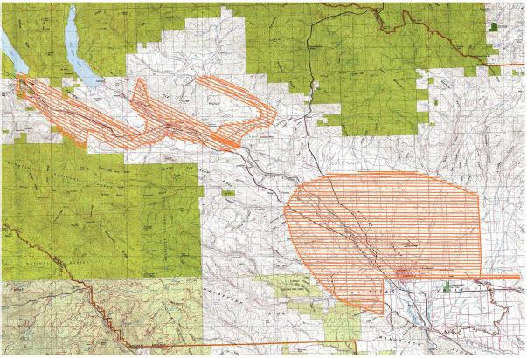

## 2.4 PDOP

## The maximum planned PDOP for the LiDAR collection was set at < 3.0. The PDOP plots are provided in Figures 2.3-2.6

**PDOP Plots**

Figure 2.3

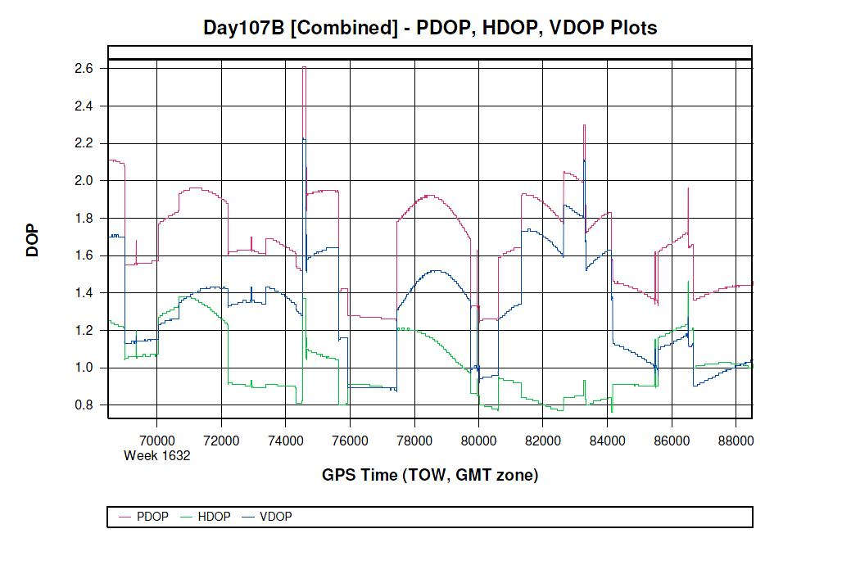

Figure 2.4

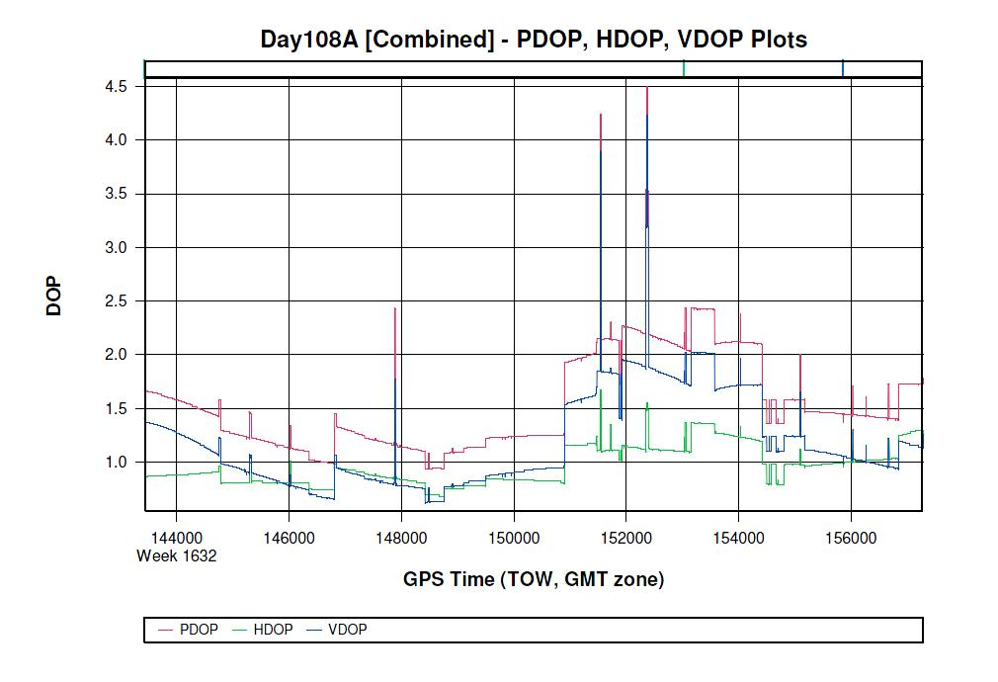

Figure 2.5

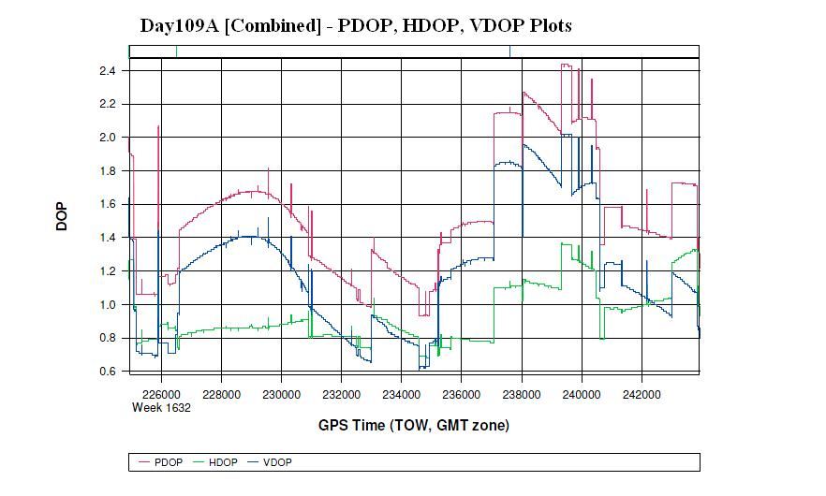

Figure 2.6

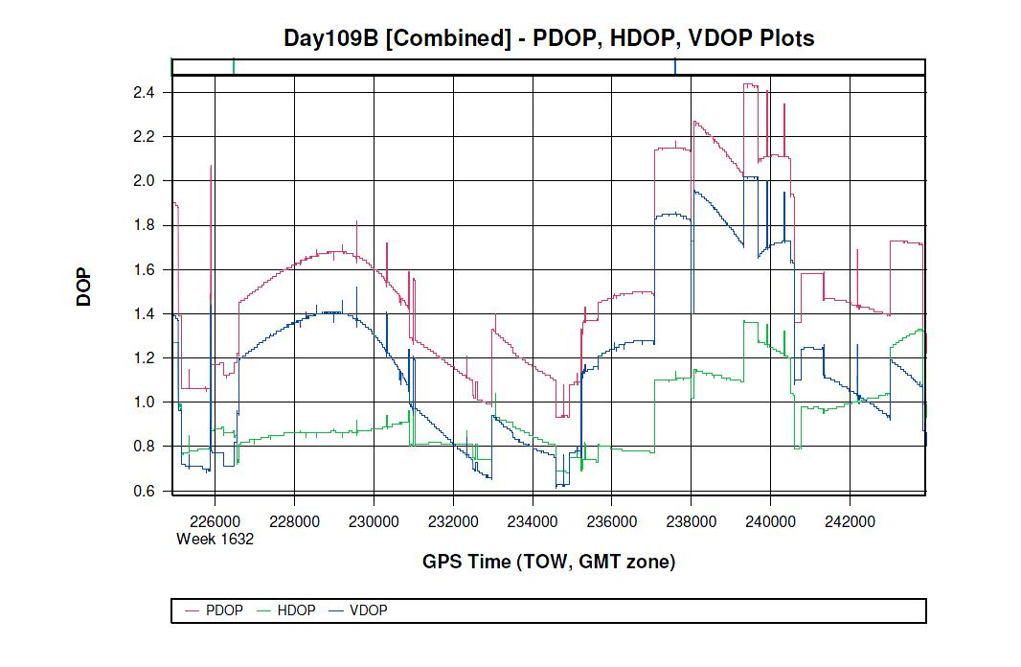

# 3.0Processing Summary

## 3.1 Airborne GPS

Applanix - POSGPS

Utilizing carrier phase ambiguity resolution on the fly (i.e., without initialization), the solution to sub-decimeter kinematic positioning without the operational constraint of static initialization as used in semi-kinematic or stop-and-go positioning was utilized for the airborne GPS post-processing.

The processing technique used by Applanix, Inc. for achieving the desired accuracy is Kinematic Ambiguity Resolution (KAR). KAR searches for ambiguities and uses a special method to evaluate the relative quality of each intersection (RMS). The quality indicator is used to evaluate the accuracy of the solution for each processing computation. In addition to the quality indicator, the software will compute separation plots (Figures 3.1-3.4)between any two solutions, which will ultimately determine the acceptance of the airborne GPS post processing.

**GPS Separation Plots**

Figure 3.1

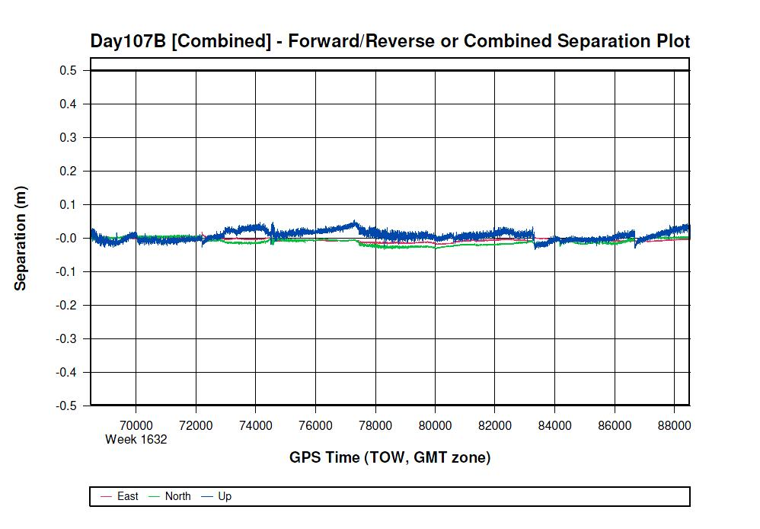

Figure 3.2

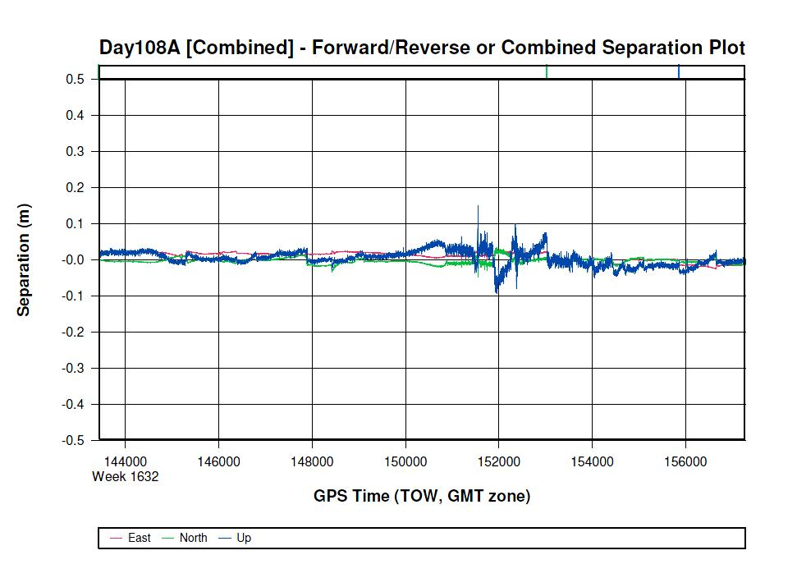

Figure 3.3

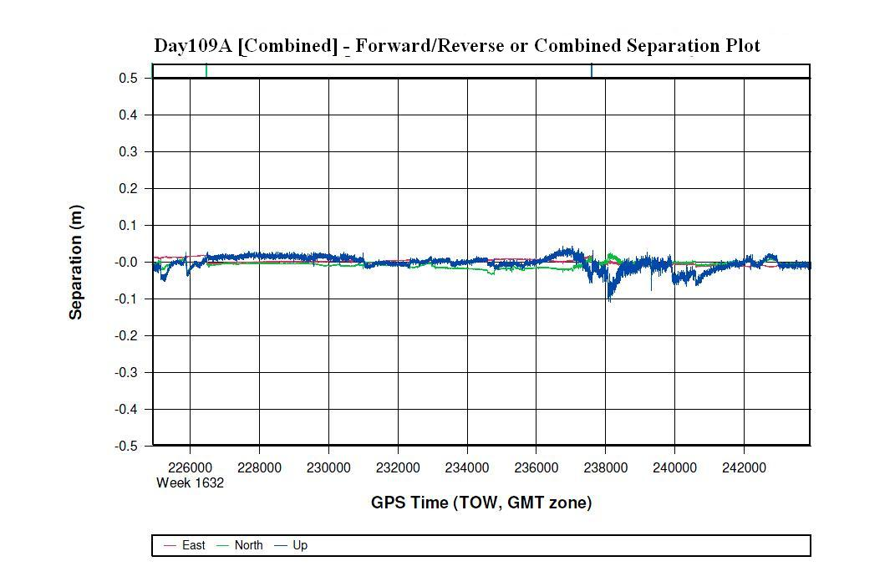

Figure 3.4

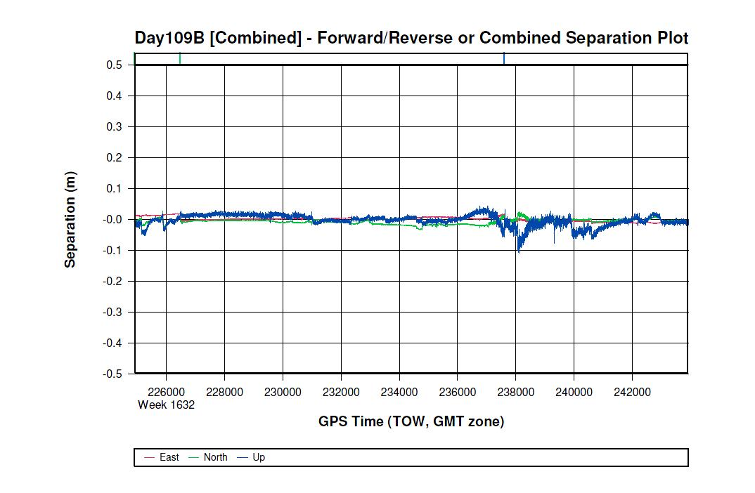

Inertial Data

The post-processing of inertial and aiding sensor data (i.e. airborne GPS post processed data) is to compute an optimally blended navigation solution. The Kalman filter-based aided inertial navigation algorithm generates an accurate (in the sense of least-square error) navigation solution that will retain the best characteristics of the processed input data. An example of inertial/GPS sensor blending is the following: inertial data is smooth in the short term. However, a free-inertial navigation solution has errors that grow without bound with time. A GPS navigation solution exhibits short-term noise but has errors that are bounded. This optimally blended navigation solution will retain the best features of both, i.e. the blended navigation solution has errors that are smooth and bounded. The GPS Altitude Plots are presented in Figures 3.5 – 3.8.

**GPS Altitude Plots**

**Figure 3.5 107B GPS Altitude Plot**

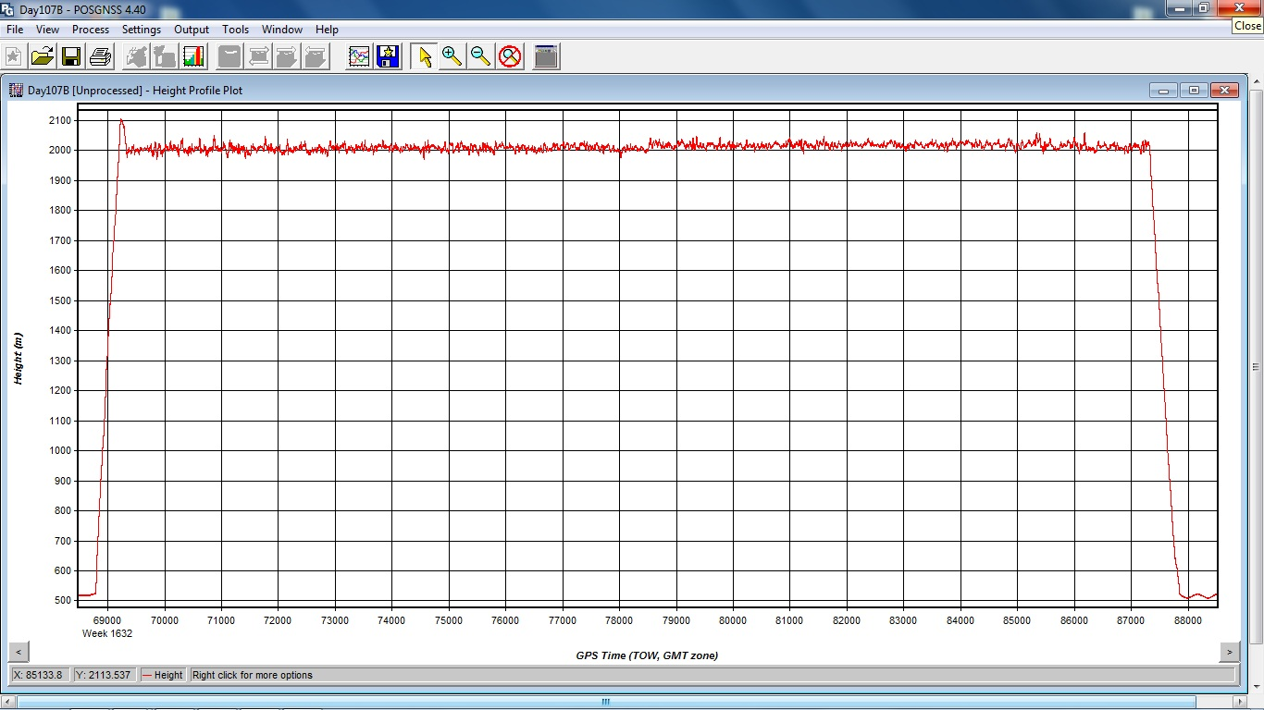

**Figure 3.6 108A GPS Altitude Plot**

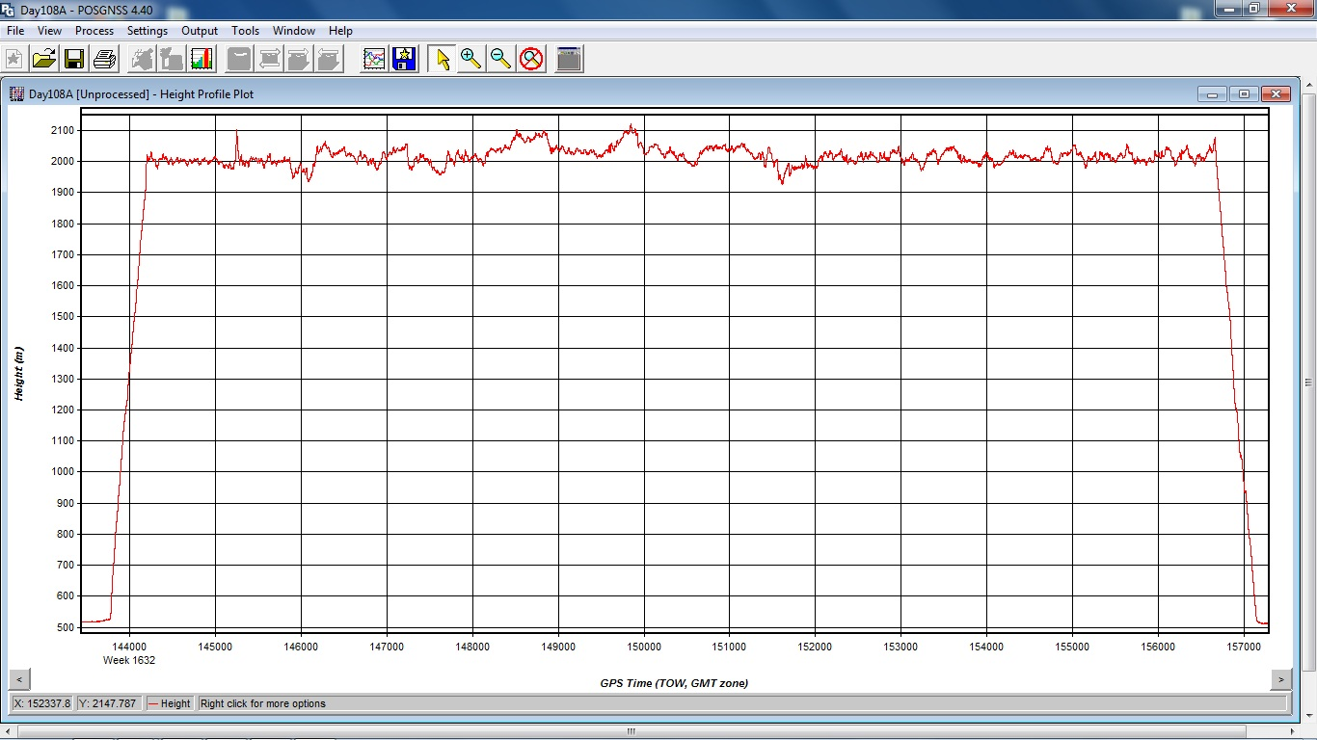

**Figure 3.7 109A GPS Altitude Plot**

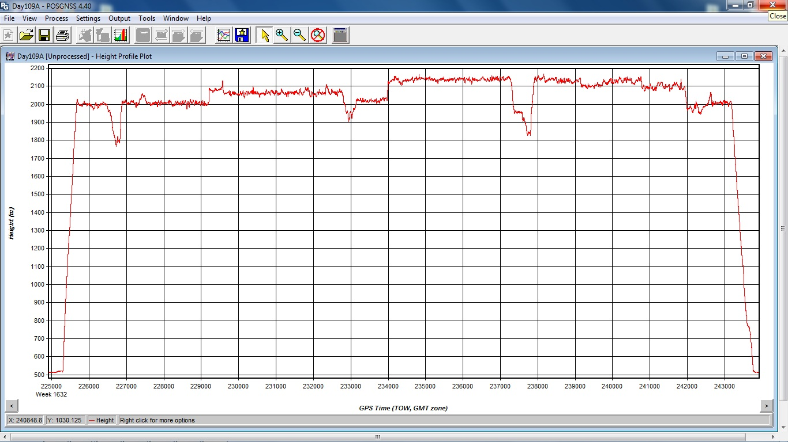

**Figure 3.8 109B GPS Altitude Plot**

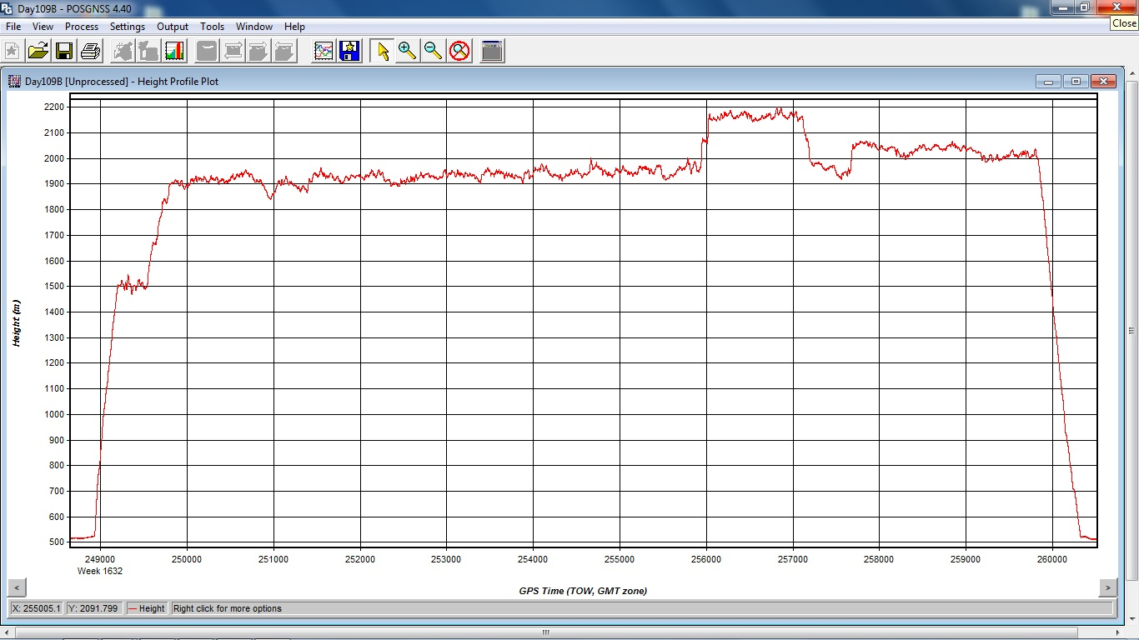

The resultant processing generates the following data:

* Position: Latitude, Longitude, Altitude
* Velocity: North, East, and Down components
* 3-axis attitude: roll, pitch, true heading
* Acceleration: x, y, z components
* Angular rates: x, y, z components

The airborne GPS and blending of inertial and GPS post-processing were completed in multiple steps.

1. The collected data was transferred from the field data collectors to the main computer. Data was saved under the project number and separated between LiDAR mission dates. Inside each mission date, a sub-directory was created with the aircraft’s tail number and an A or B suffix was attached to record which mission of the day the data is associated with. Inside the tail number sub-directory, five sub-directories were also created: EO, GPS, IMU, PROC, and RAW.
2. The aircraft raw data (IMU and GPS data combined) was run through a data extractor program. This separated the IMU and GPS data. In addition to the extraction of data, it provided the analyst the first statistics on the overall flight. The program was POSPac (POS post-processing PACkage).
3. Executing POSGPS program to derive accurate GPS positions for all flights:

Applanix POSGPS

The software utilized for the data collected was PosGPS, a kinematic on-the-fly (OTF) processing software package. Post processing of the data is computed from each base station (Note: only base stations within the flying area were used) in both a forward and backward direction. This provides the analyst the ability to Quality Check (QC) the post processing, since different ambiguities are determined from different base stations and also with the same data from different directions.

The trajectory separation program is designed to display the time of week that the airborne or roving antenna traveled, and compute the differences found between processing runs. Processed data can be compared between a forward/reverse solution from one base station, a reverse solution from one base station and a forward solution from the second base station, etc. For the Applanix POSGPS processing, this is considered the final QC check for the given mission. If wrong ambiguities were found with one or both runs, the analyst would see disagreements from the trajectory plot, and re-processing would continue until an agreement was determined.

Once the analyst accepts a forward and reverse processing solution, the trajectory plot is analyzed and the combined solution is stored in a file format acceptable for the IMU post processor.

1. When the processed trajectory (either through POSGPS) data was accepted after quality control analysis, the combined solution is stored in a file format acceptable for the IMU post processor (i.e. POSProc). Shapefiles of the trajectories are found in the Coverage.zip attachment to this document.
2. Execute POSProc.

POSProc comprises a set of individual processing interface tools that execute and provide the following functions:

Figure 3.9 shows the organization of these tools, and the function of the POSProc processing components.

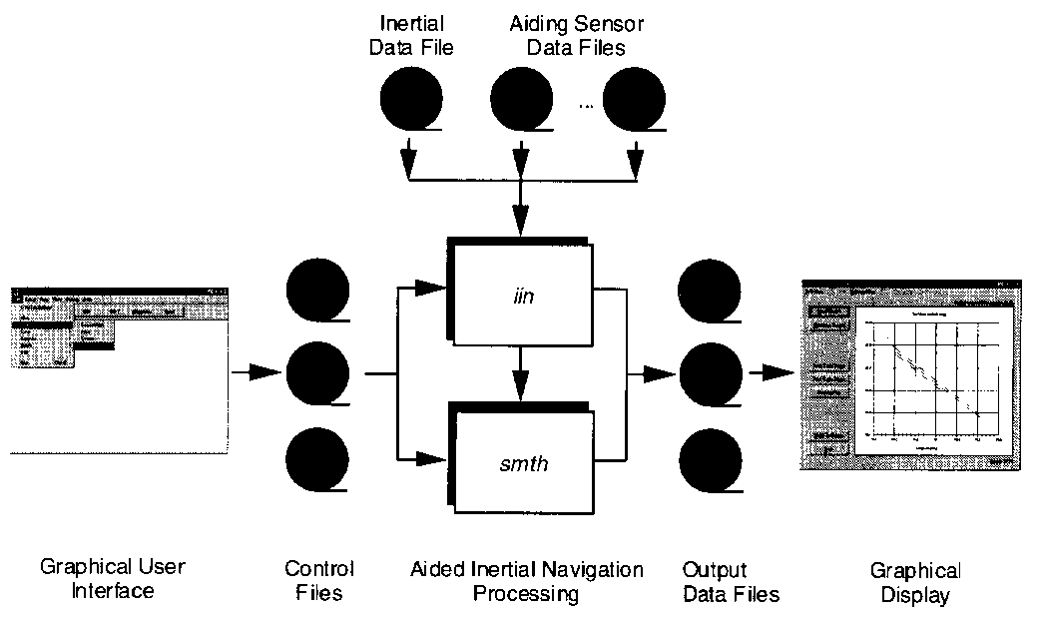

**Figure 3.9 POSProc Processing Components**

Integrated Inertial Navigation (*iin*) Module.

The name *iin* is a contraction of Integrated Inertial Navigation. *iin* reads inertial data and aiding data from data files specified in a processing environment file and computes the aided inertial navigation solution. The inertial data comes from a strapdown IMU. *iin* outputs the navigation data between start and end times at a data rate as specified in the environment file. *iin* also outputs Kalman filter data for analysis of estimation error statistics and smoother data that the smoothing program *smth* uses to improve the navigation solution accuracy.

*iin* implements a full strapdown inertial navigator that solves Newton’s equation of motion on the earth using inertial data from a strapdown IMU. The inertial navigator implements coning and sculling compensation to handle potential problems caused by vibration of the IMU.

Smoother Module (*smth*)

*smth* is a companion processing module to *iin*. *smth* is comprised of two individual functions that run in sequence. *smth* first runs the *smoother function* and then runs the *navigation correction function*.

The *smth* smoother function performs backwards-in-time processing of the forwards-in-time blended navigation solution and Kalman filter data generated by *iin* to compute smoothed error estimates. *smth* implements a modified Bryson-Frazier smoothing algorithm specifically designed for use with the *iin* Kalman filter. The resulting smoothed strapdown navigator error estimates at a given time point are the optimal estimates based on all input data before and after the given time point. In this sense, *smth* makes use of all available information in the input data. *smth* writes the smoothed error estimates and their RMS estimation errors to output data files.

The *smth* navigation correction function implements a feedforward error correction mechanism similar to that in the *iin* strapdown navigation solution using the smoothed strapdown navigation errors. s*mth* reads in the smoothed error estimates and with these, corrects the strapdown navigation data. The resulting navigation solution is called a Best Estimate of Trajectory (BET), and is the best obtainable estimate of vehicle trajectory with the available inertial and aiding sensor data.

The above mentioned modules provide the analyst the following statistics to ensure that the most optimal solution was achieved: a log of the *iin* processing, the Kalman filter Measurement Residuals, Smoothed RMS Estimation Errors, and Smoothed Sensor Errors and RMS.

## 3.2 LIDAR Calibration

The purpose of the LiDAR system calibration is to refine the system parameters in order for the post-processing software to produce a “point cloud” that best fits the actual ground.

For each mission, LiDAR data for at least one cross flight is acquired over the mission’s acquisition site. The processed data of the cross flight is compared to the perpendicular flight lines using either the Optech proprietary software or TerraSolid's TerraMatch software to determine if any systematic errors are present. In this calibration, the data of individual flight lines are compared against each other and their systematic errors are corrected in the final processed data.

## 3.3 LIDAR Processing

The LAS files were then imported, verified, and parsed into manageable, tiled grids using GeoCue.

The first step after the data has been processed and calibrated is to perform a relative accuracy assessment on the flightline to flightline comparisons and also a data density test prior any further processing. To determine a proper accuracy assessment between flightlines, Aerometric uses GeoCue to create Orthos by elevation differences. The generated orthos have assigned elevation ranges that allow the technician to evaluate if the data passes the accuracy assessment and also determine if additional calibration efforts are needed based on the bias trends. Figure 3.10 is the screen capture of the elevation orthos where green indicates a flightline comparison of less than 0.2 feet; yellow is 0.2-0.4 feet; orange is 0.4-0.6 feet, and red is greater than 0.6 feet.

**Figure 3.10 DZ Raster Image**

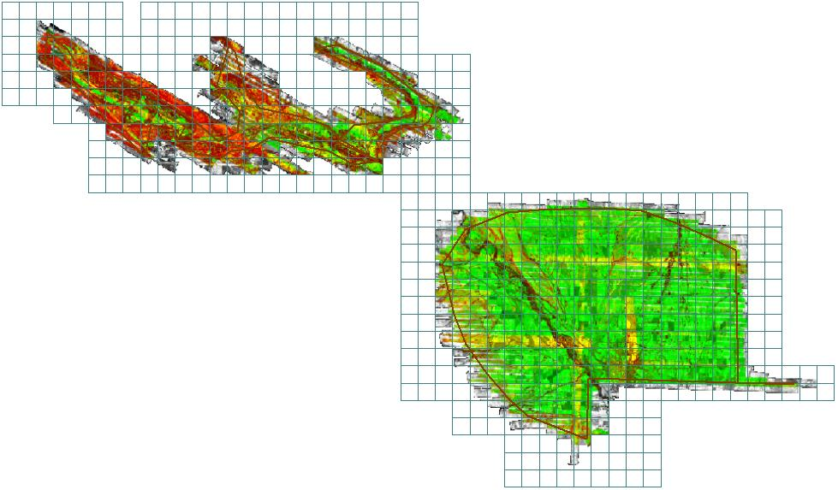

## 3.4Flight Log Overview:

-Post Spacing – 1 meter

-AGL (Above Ground Level) average flying height – 1500 meters

-MSL (Mean Sea Level) average flying height – 2100 meters

-Average Ground Speed – 160 knots

-Field of View – 30°

-Pulse Rate – 70 kHz

-Scan Rate – 41 Hz

-Side Lap (Average) – 50%

Flight logs are located in Appendix A of this document.

# 4.0 Data Verification

The data was verified using the ground control data collected by Compass Data, Inc. 21 points were distributed throughout the project area and the points were compared to the LIDAR data using TerraScan. TerraScan computes the vertical differences between the surveyed elevation and the LiDAR derived elevation for each point. Table 4.1 provides this vertical accuracy test. RMSE = 0.1feet.

The Fundamental Vertical Accuracy (FVA) was tested by Compass Data, Inc. This test consisted of 20 vertical checkpoints reported at the 95% confidence level RMSE. FVA= 0.117 meters

The Supplemental Vertical Accuracy (SVA) was tested by Compass Data, Inc. This test consisted of 20 vertical checkpoints reported at the 95th Percentile RMSE. CVA= 0.152 meters

**Table 4.1 Vertical Accuracy Test Results**

|  |  |  |  |
| --- | --- | --- | --- |
|  | |  |  |
| **Point** | **Surveyed Elev.** | **Lidar Elev.** | **Difference** |
| (U.S. Survey Foot) | (U.S. Survey Foot) | (U.S. Survey Foot) |
| CP50 | 1734.91 | 1734.85 | -0.06 |
| CP51 | 1923.59 | 1923.64 | 0.05 |
| CP52 | 1823.89 | 1823.87 | -0.02 |
| CP53 | 1678.68 | 1678.85 | 0.17 |
| CP54 | 2078.41 | 2078.55 | 0.15 |
| CP55 | 1714.18 | 1714.17 | -0.01 |
| CP56 | 2310.98 | 2311.15 | 0.17 |
| CP57 | 1995.45 | 1995.23 | -0.22 |
| CP58 | 1685.77 | 1685.75 | -0.02 |
| CP59 | 1540.66 | 1540.69 | 0.03 |
| CP70 | 2303.73 | 2303.72 | -0.01 |
| CP71 | 2205.49 | 2205.35 | -0.14 |
| CP72 | 2092.45 | 2092.39 | -0.06 |
| CP73 | 2038.72 | 2038.79 | 0.07 |
| CP74 | 1841.34 | 1841.16 | -0.18 |
| CP75 | 1910.75 | 1910.73 | -0.02 |
| CP76 | 2193.97 | 2193.99 | 0.02 |
| CP77 | 2048.34 | 2048.29 | -0.05 |
| Cleelum | 1916.10 | 1916.18 | 0.08 |
| SX0873 | 2076.54 | 2076.52 | -0.02 |
| SX1547 | 1750.17 | 1750.25 | 0.08 |
|  |  |  |  |
|  |  |  |  |
| Average dz | |  | 0.00 |
| Standard deviation | |  | 0.10 |
| Root mean square (RMS) | | | 0.10 |

# Appendix A Original Flight Logs

**Flight Log 107B Page 1**

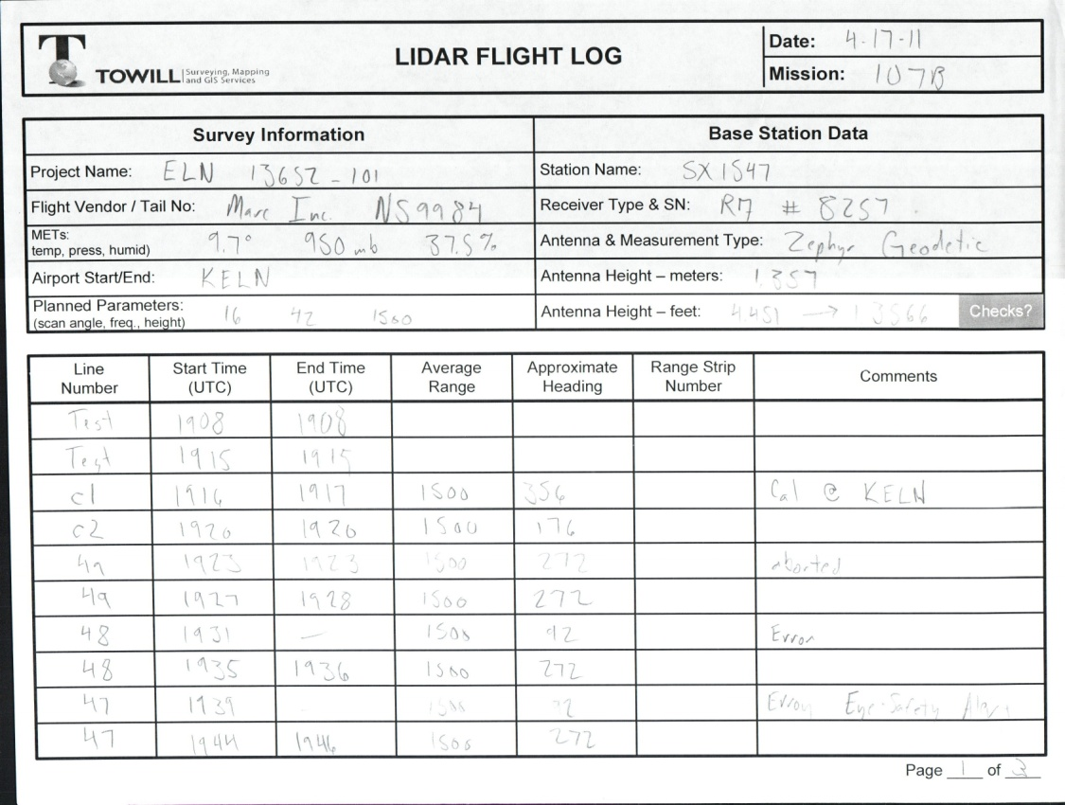

**Flight Log 107B Page 2**

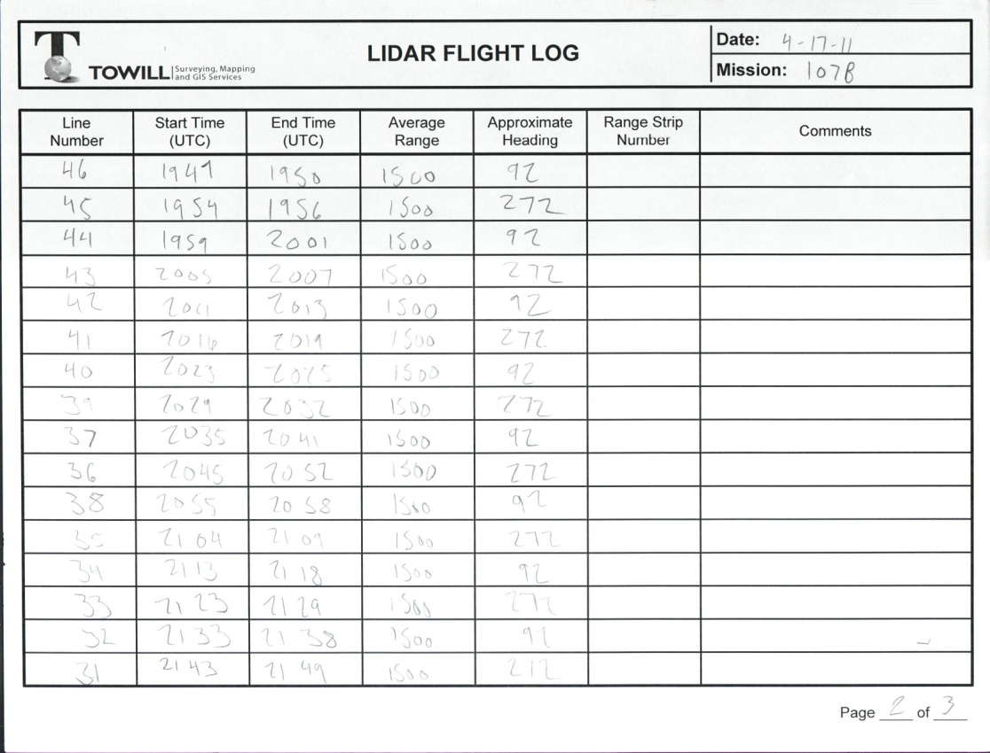

**Flight Log 107B Page 3**

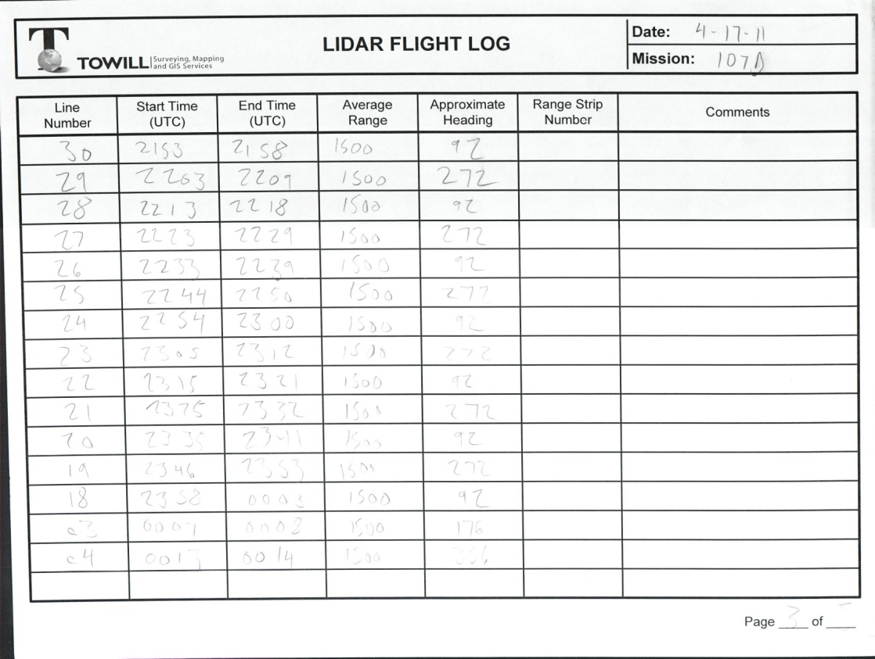

**Flight Log 108A Page 1**

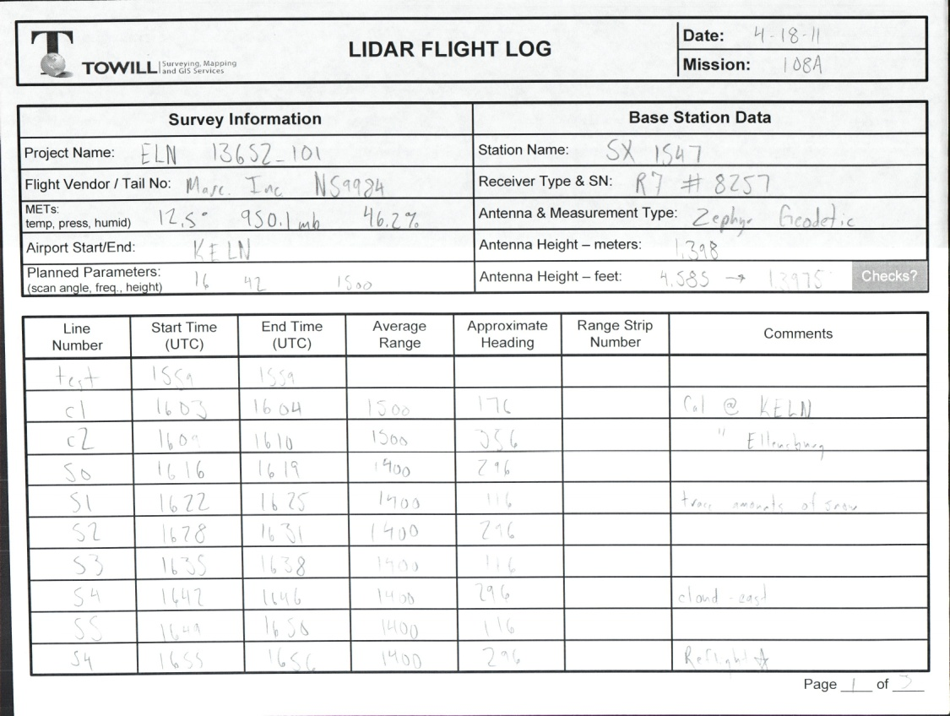

**Flight Log 108A Page 2**

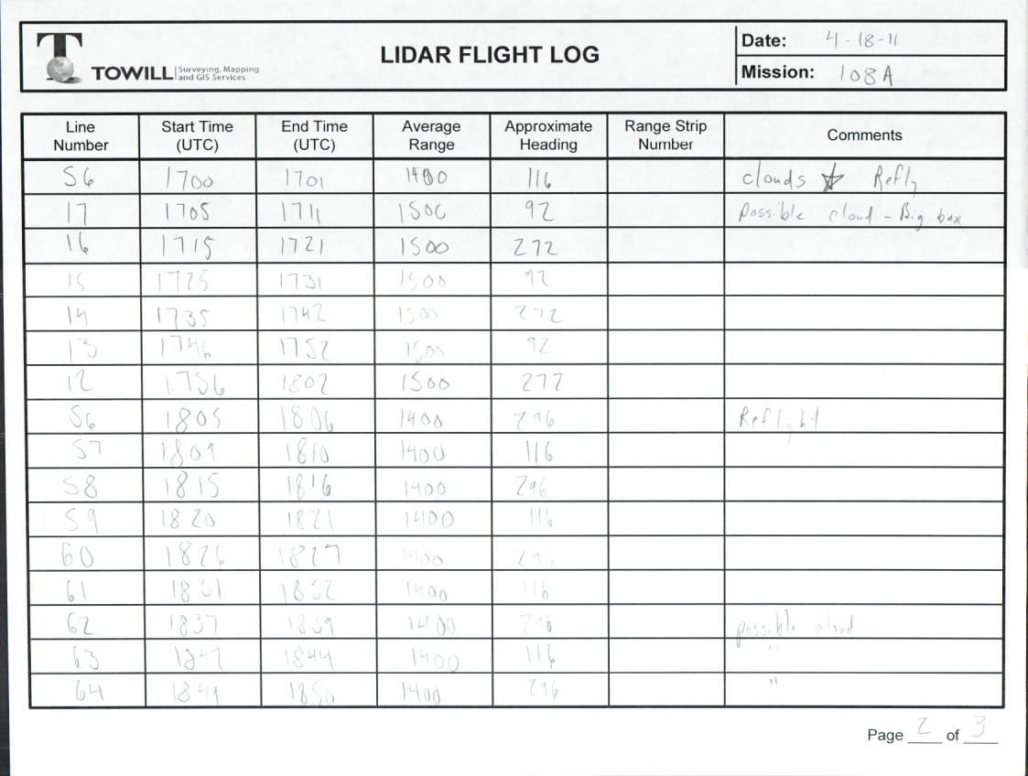

**Flight Log 108A Page3**

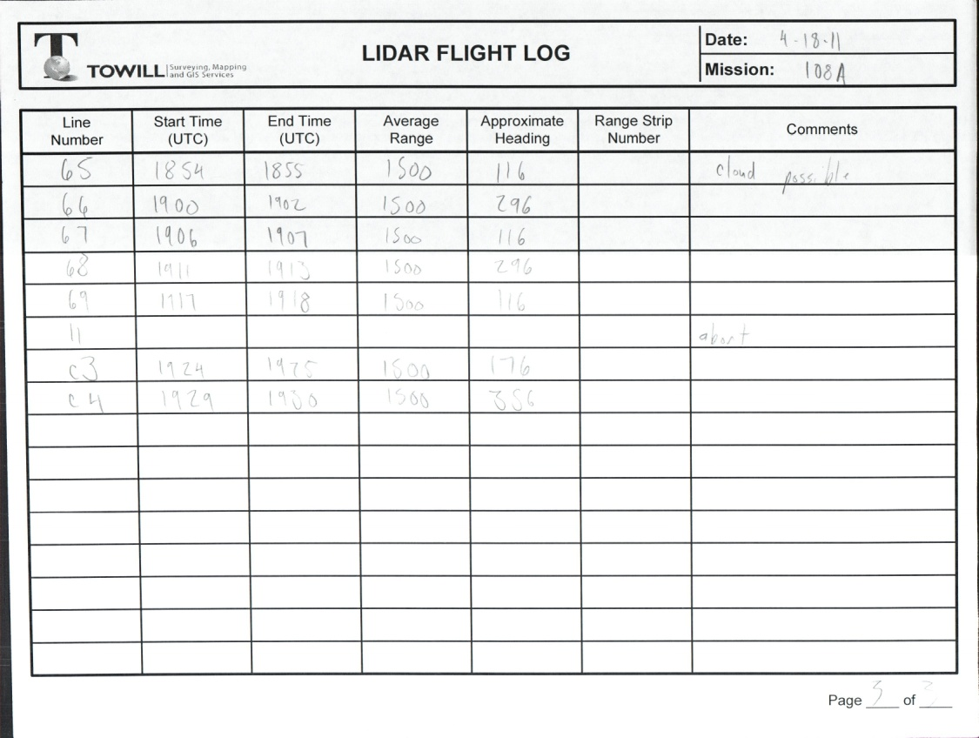

**Flight Log 109A Page 1**

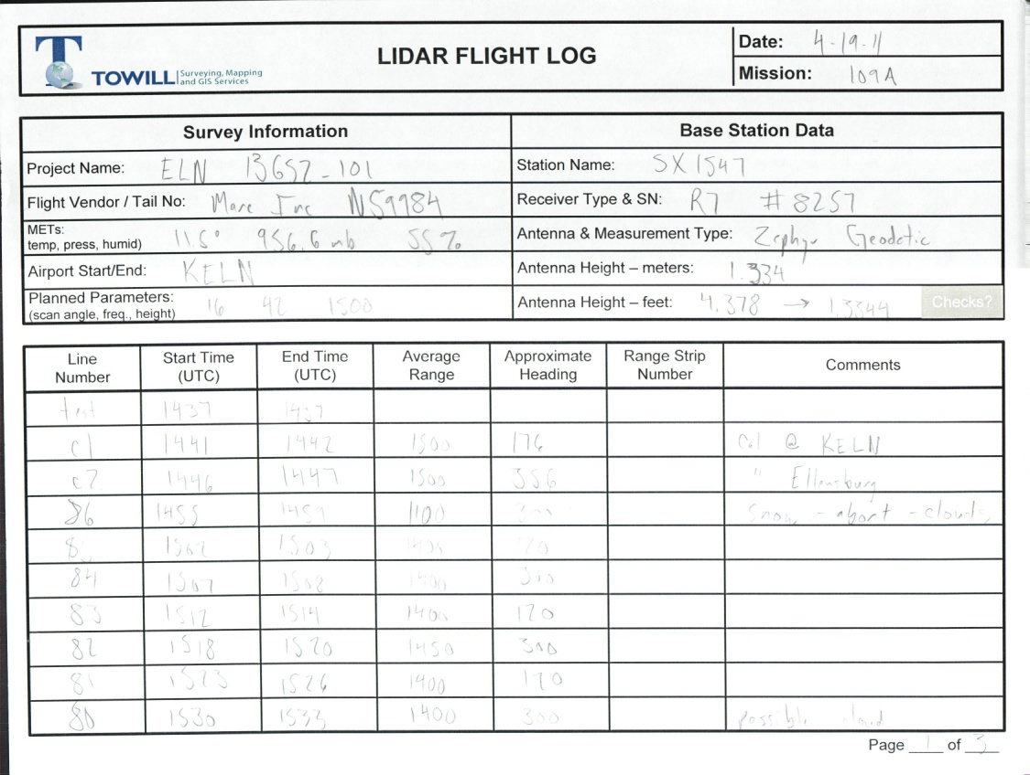

**Flight Log 109A Page 2**

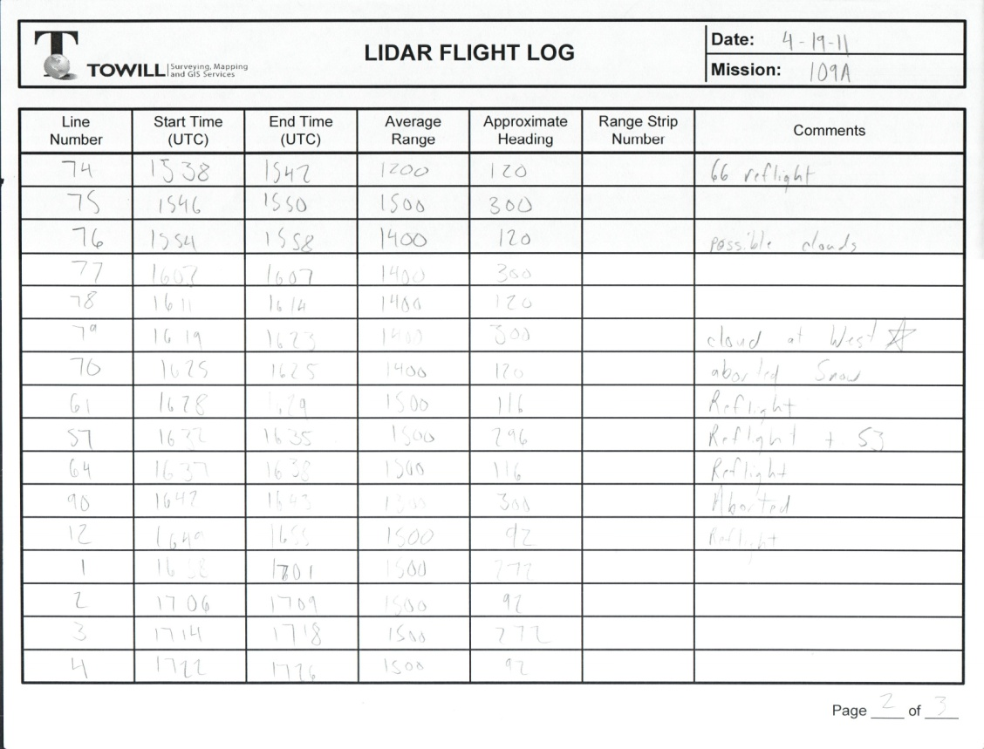

**Flight Log 109A Page 3**

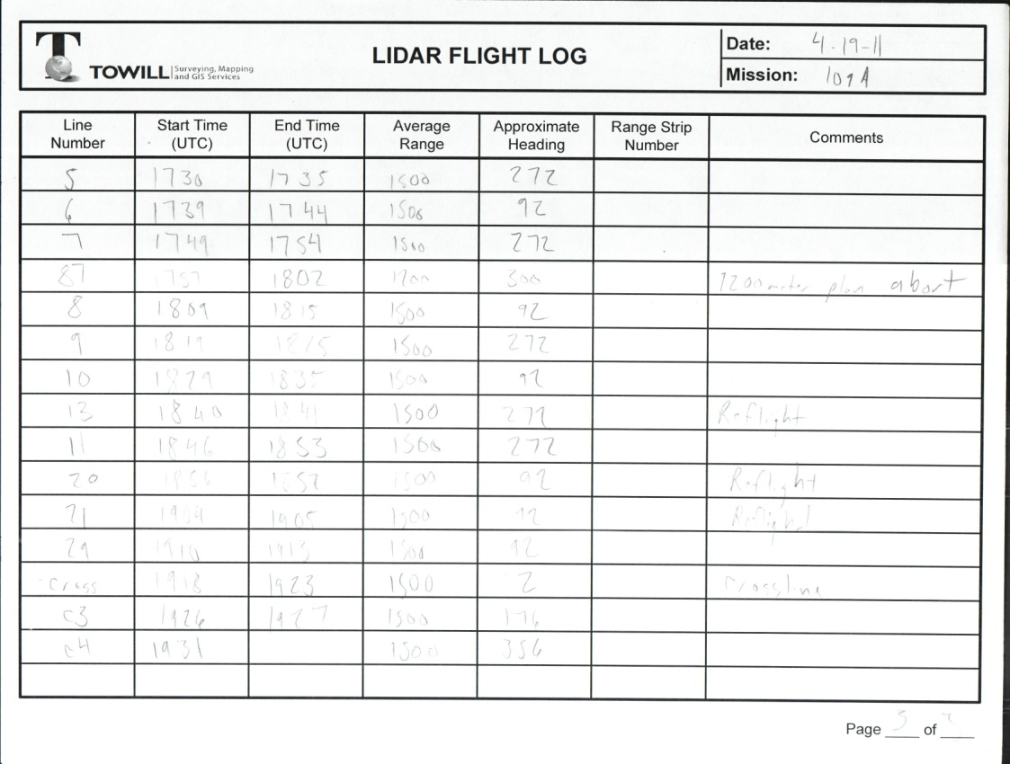

**Flight Log 109B Page 1**

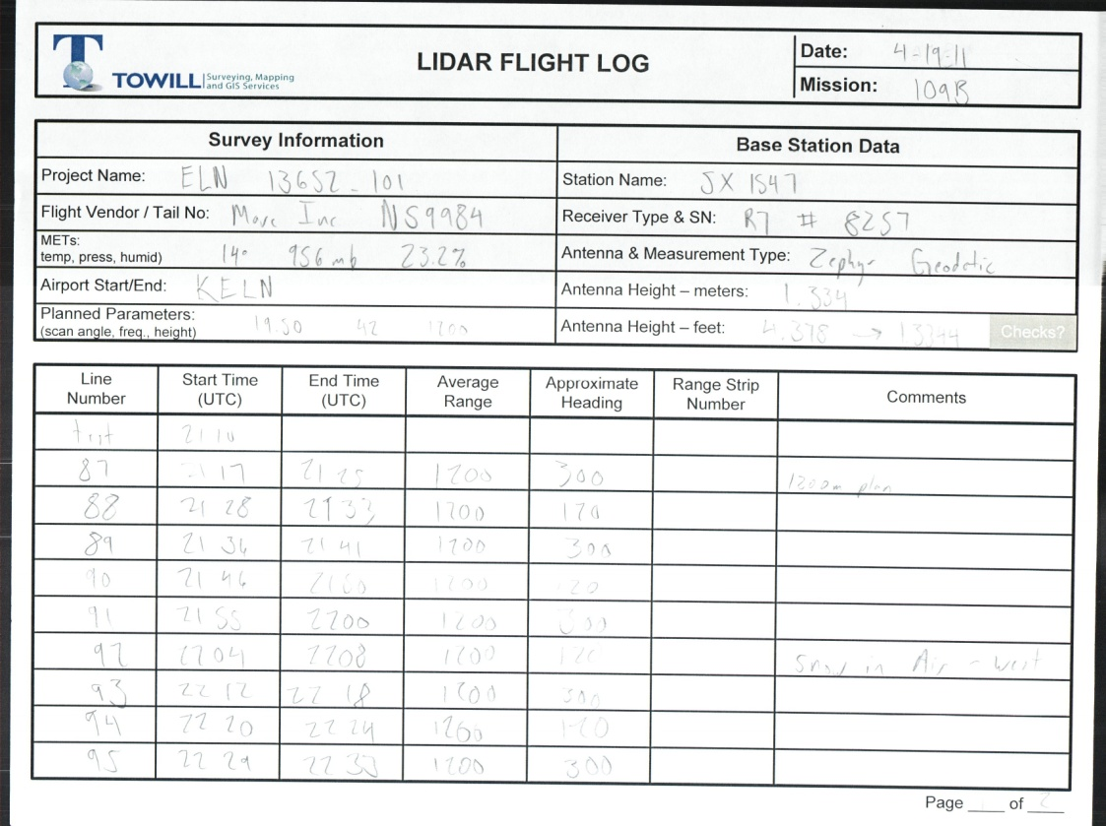

**Flight Log 109B Page 2**

