From: DAS
To: USGS (QC Team)
Date: 10/20/2016
Subject: Replacement DEM: FY16_NRCS Arkansas-QL2 LiDAR-Delivery One
The dataset located on drive: IN0030:\FY16_NRCS_Arkansas_QL2_LiDAR\First_Deliverable_Update are replacement BareEarth-DEM for four tiles affected by erroneous Breakline (pond) elevation in the first delivery dataset. This error has been fixed, hence the need to replace the four affected DEM & Breakline (Ponds_Lakes).
Image 01: DEM Artifact due to Erroneous Pond Elevation
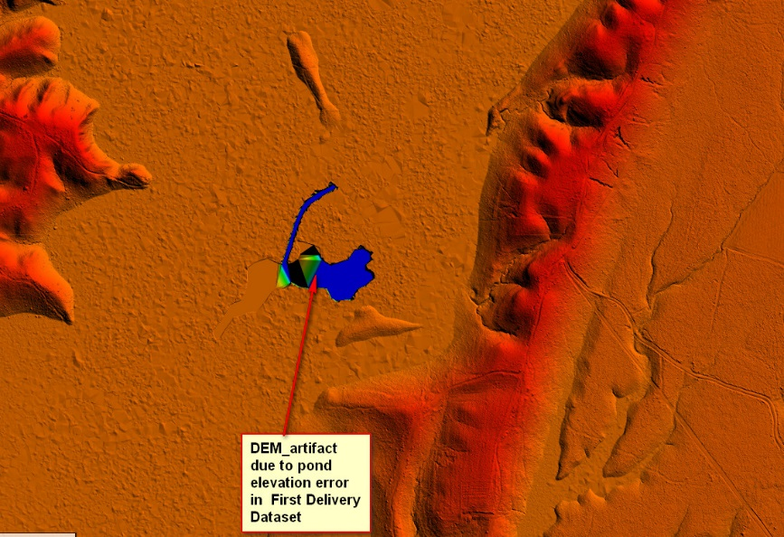
Image02: DEM Error Fixed
