140G0219F0013-AZ_BrawleyRillito_2018_D19
USGS Contract: G16PC00051

Lidar Report

August, 2019

EXECUTIVE SUMMARY
The U.S. Geological Survey (USGS) contracted with The Sanborn Map Company, Inc. (Sanborn) to provide remote sensing services for USGS AZ BrawleyRillito in the form of Lidar. Utilizing a multi-return system, Light Detection and Ranging (Lidar) detects 3-dimensional positions and attributes to form a point cloud. The high accuracy airborne system is integrated with both Global Navigation Satellite System (GNSS) and an Inertial Measure Unit (IMU) for accurate position and orientation. Acquisition of the project area’s ~2,232mi² was completed on June 1st, 2019.

The Optech Galaxy Prime and Optech Orion H300 were used to collect data for the aerial survey campaign. The sensor is attached to the aircraft’s underside and emits rapid laser pulses that are used to calculate ranges between the aircraft and subsequent terrain below. The Airborne Lidar System (ALS) is boresighted by completing multiple passes over a known ground surface before the project acquisition. During data processing, the calibration parameters are updated and used during post-processing of the lidar point cloud.

Differential GNSS unit in aircraft sampled positions at 2Hz or higher frequency. Lidar data was only acquired when GNSS PDOP is ≤4 and at least 6 satellites are in view. Collection conditions were for leaf-off vegetation. The atmosphere was free of clouds and fog between the aircraft and ground. The ground was free of snow and extensive flooding or any other type of inundation

The contents of this report summarize the methods used to establish the base station coordinates, perform the lidar data acquisition and processing as well as the results of these methods.

Contents
EXECUTIVE SUMMARY 1
Contents 2
1.0 INTRODUCTION 3
1.1 Contact Information 3
1.2 Purpose of Lidar Acquisition 3
2.0 Acquisition 4
2.1 Introduction 4
2.2 Acquisition Parameters 4
3.0 Processing 8
3.1 Introduction 8
3.2 Coordinate Reference System 9
3.3 Calibration 9
3.5 Accuracy Assessment 15
4.0 Product Generation 17

1.0 INTRODUCTION
This document contains the technical write-up of the lidar campaign, including system calibration techniques, and the collection and processing of the lidar data.

1.1 Contact Information
Questions regarding the technical aspects of this report should be addressed to:

Shawn Benham, PMP
Program Manager Director
The Sanborn Map Company, Inc.
1935 Jamboree Drive, Suite 100
Colorado Springs, CO 80920
(719) 502-1296
sbenham@sanborn.com

1.2 Purpose of Lidar Acquisition
The objective of this project is to collect accurate measurements of the bare-earth surface as well as above ground features to be provided as geometric inputs for surface and/or change modeling as is relates survey assessments.

1.3 Project Location
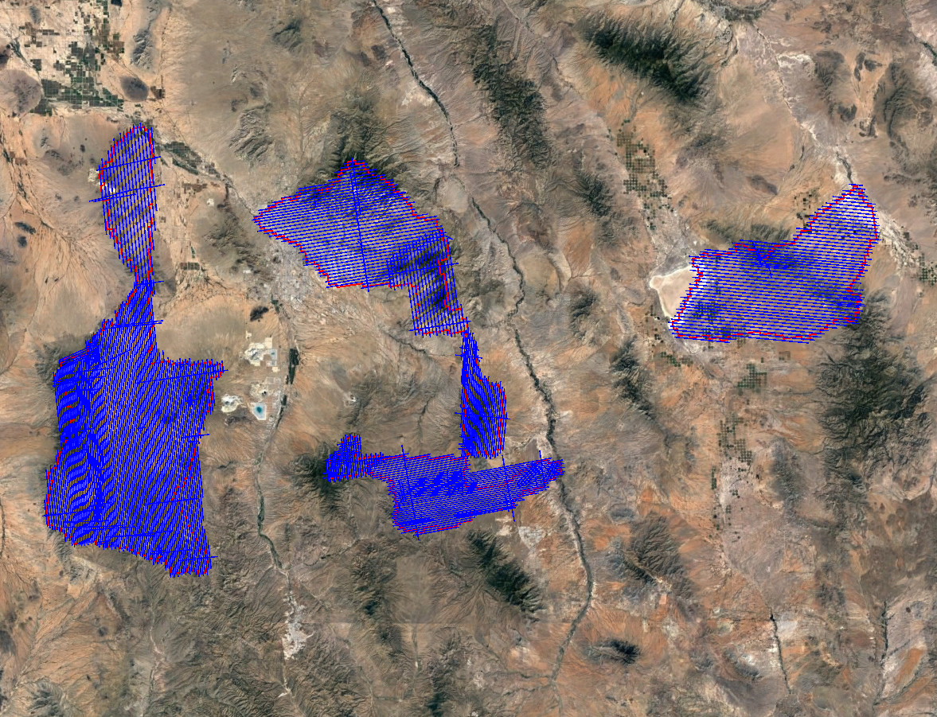
Figure 1: AOI and Trajectories As-Flown

2.0 Acquisition

2.1 Introduction
This section outlines the lidar system, flight reporting and data acquisition methodology used during the collection of the Presque Isle County campaign. Although Sanborn conducts all lidar missions with the same rigorous and strict procedures and processes, all lidar collections are unique.

2.2 Acquisition Parameters
Sanborn specifically defined the collection parameters to accomplish the desired project specifications. Tables 1-3 shows the planned acquisition parameters utilized for this aerial survey with the sensor(s) installed.

Planned Acquisition Parameters
Sensor | Optech Galaxy Prime
Aircraft | N7269T - CESSNA T206H
Flying Height (AGL) | 1600
Air Speed (kts) | 120
Field of View (degrees) | 46
Overlap (%) | 30
Pulse Rate (kHz) | 250
Scan Rate (Hz) | 52
Laser Footprint (m) | 0.25
Mode (PIA) | Yes
Point Spacing (m) | 0.61
Point Density (pls/m²) | 2.73
Swath Width (m) | 1358
Table 1: Lidar Acquisition Parameters

Acquisition Parameters
Sensor | Optech Galaxy Prime
Aircraft | N27DV - CESSNA T206H
Flying Height (AGL) (m) | 1600
Air Speed (kts) | 120
Field of View (degrees) | 46
Overlap (%) | 30
Pulse Rate (kHz) | 250
Scan Rate (Hz) | 52
Laser Footprint (m) | 0.25
Multi-Pulse | Yes
Point Spacing (m) | 0.61
Point Density (pls/m²) | 2.73
Swath Width (m) | 1358
Table 2: Lidar Acquisition Parameters

Acquisition Parameters
Sensor | Optech Orion H300
Aircraft | N7269T - CESSNA T206H
Flying Height (AGL) (m) | 1500
Air Speed (kts) | 120
Field of View (degrees) | 34
Overlap (%) | 30
Pulse Rate (kHz) | 150
Scan Rate (Hz) | 46
Laser Footprint (m) | 0.25
Multi-Pulse | Yes
Point Spacing (m) | 0.67
Point Density (pls/m²) | 2.23
Swath Width (m) | 917
Table 3: Lidar Acquisition Parameters

2.3 Field Work Procedures
Sanborn’s standard procedure before every mission is to perform pre-flight checks to ensure correct operation of all systems. All cables were checked and the sensor head glass was cleaned. A five minute static session was conducted on the ground with the engines running prior to take-off in order to establish fine-alignment of the IMU and to resolve GNSS ambiguities.

The project acquisition consisted of forty (40) missions. During the data collection, the operator recorded information on log sheets which includes weather conditions, lidar operation parameters, flight line statistics and PDOP. Near the end of each mission, GNSS ambiguities are again resolved by flying within ten kilometers of the base stations to aid in post-processing.

Preliminary data processing was performed in the field immediately following the missions for quality control of GNSS data and to ensure sufficient coverage of the project AOI. Any problematic data could then be re-flown immediately as required. Final data processing was completed in the Colorado Springs, CO office. Table 4 below shows the flight acquisition metrics for the entire collection. Table 5 contains the base station names and locations in operation during acquisition. Base station coordinates are provided in NAD83 (2011), Geographic Coordinate System, Ellipsoid, Meters.

Date | Sensor | Serial # | Tail # | MissionID | PDOP | Start (UTC) | End (UTC)
03/05/19 | Optech Galaxy Prime | 5060410 | N7269T | 20190305A | 1.4 | 22:38:04 | 1:17:22
03/06/19 | Optech Galaxy Prime | 5060410 | N7269T | 20190306A | 1.5 | 17:06:24 | 20:59:31
03/09/19 | Optech Galaxy Prime | 5060410 | N7269T | 20190309A | 1.5 | 15:36:23 | 20:32:36
03/09/19 | Optech Galaxy Prime | 5060410 | N7269T | 20190309B | 1.5 | 22:23:32 | 23:42:12
03/14/19 | Optech Galaxy Prime | 5060410 | N7269T | 20190314A | 1.4 | 15:03:04 | 18:39:54
03/14/19 | Optech Galaxy Prime | 5060410 | N7269T | 20190314B | 1.4 | 20:58:04 | 1:07:55
03/15/19 | Optech Galaxy Prime | 5060410 | N7269T | 20190315A | 1.4 | 15:07:42 | 18:15:04
03/20/19 | Optech Galaxy Prime | 5060410 | N7269T | 20190320A | 1.5 | 16:58:04 | 18:59:57
03/21/19 | Optech Galaxy Prime | 5060410 | N7269T | 20190321A | 1.5 | 15:44:44 | 20:08:02
04/05/19 | Optech Orion H300 | 12SEN315 | N7269T | 20190405A | 1.5 | 16:28:04 | 19:24:40
04/07/19 | Optech Orion H300 | 12SEN315 | N7269T | 20190407A | 1.5 | 15:11:24 | 19:52:38
04/08/19 | Optech Orion H300 | 12SEN315 | N7269T | 20190408A | 1.4 | 14:32:42 | 17:15:05
04/14/19 | Optech Galaxy Prime | 5060410 | N27DV | 20190414A | 1.4 | 16:33:04 | 18:32:42
04/14/19 | Optech Galaxy Prime | 5060410 | N27DV | 20190414B | 1.4 | 22:34:44 | 0:51:06
04/16/19 | Optech Orion H300 | 12SEN315 | N7269T | 20190416A | 1.5 | 13:36:24 | 17:16:22
04/18/19 | Optech Orion H300 | 12SEN315 | N7269T | 20190418A | 1.5 | 13:28:04 | 17:26:27
04/19/19 | Optech Orion H300 | 12SEN315 | N7269T | 20190419A | 1.6 | 13:11:24 | 17:36:12
04/20/19 | Optech Orion H300 | 12SEN315 | N7269T | 20190420A | 1.7 | 14:49:44 | 16:38:52
04/21/19 | Optech Orion H300 | 12SEN315 | N7269T | 20190421A | 1.5 | 13:21:24 | 16:25:15
04/21/19 | Optech Orion H300 | 12SEN315 | N7269T | 20190421B | 1.5 | 17:42:47 | 21:01:16
04/23/19 | Optech Orion H300 | 12SEN315 | N7269T | 20190423A | 1.6 | 12:43:56 | 16:35:46
04/24/19 | Optech Orion H300 | 12SEN315 | N7269T | 20190424A | 1.4 | 12:39:44 | 16:05:14
04/26/19 | Optech Orion H300 | 12SEN315 | N7269T | 20190426A | 1.8 | 18:11:15 | 20:45:01
04/27/19 | Optech Orion H300 | 12SEN315 | N7269T | 20190427A | 1.6 | 12:43:44 | 17:58:08
04/27/19 | Optech Orion H300 | 12SEN315 | N7269T | 20190427B | 1.6 | 20:14:44 | 23:55:21
04/28/19 | Optech Orion H300 | 12SEN315 | N7269T | 20190428A | 1.4 | 12:31:11 | 15:10:13
05/04/19 | Optech Orion H300 | 12SEN315 | N7269T | 20190504A | 1.7 | 18:56:24 | 20:48:39
05/05/19 | Optech Orion H300 | 12SEN315 | N7269T | 20190505A | 1.7 | 12:49:44 | 16:14:42
05/05/19 | Optech Orion H300 | 12SEN315 | N7269T | 20190505B | 1.7 | 17:36:52 | 18:24:02
05/25/19 | Optech Orion H300 | 12SEN315 | N7269T | 20190525A | 1.6 | 19:37:26 | 20:45:42
05/26/19 | Optech Orion H300 | 12SEN315 | N7269T | 20190526A | 1.7 | 12:45:16 | 16:07:35
05/27/19 | Optech Orion H300 | 12SEN315 | N7269T | 20190527A | 1.6 | 12:27:52 | 17:01:34
05/28/19 | Optech Orion H300 | 12SEN315 | N7269T | 20190528A | 1.6 | 12:22:49 | 16:59:58
06/01/19 | Optech Orion H300 | 12SEN315 | N7269T | 20190601A | 1.6 | 12:32:56 | 14:32:32
Table 4: Collection Date Time by Mission

Designation | Type | PID | Latitude (N) | Longitude (W) | Elevation (m)
P014 | CORS | DL7716 | 31 58 22.40596 | 111 05 54.90211 | 1068.881
AZAM | SmartNet | n/a | 31 43 48.10295 | 111 04 16.85142 | 929.866
AZCA | SmartNet | n/a | 32 30 04.85037 | 110 55 36.56764 | 933.485
AZDT | SmartNet | n/a | 31 57 37.55400 | 110 46 16.09602 | 993.593
AZMA | SmartNet | n/a | 32 34 05.88196 | 111 20 37.29340 | 536.858
AZSM | SmartNet | n/a | 32 35 45.50213 | 110 37 28.12226 | 1018.045
AZWX | SmartNet | n/a | 32 15 27.62170 | 109 49 46.89617 | 1249.837
TUCS | SmartNet | n/a | 32 12 49.80399 | 110 56 36.89758 | 721.399
Table 5: GNSS Reference Station Coordinates
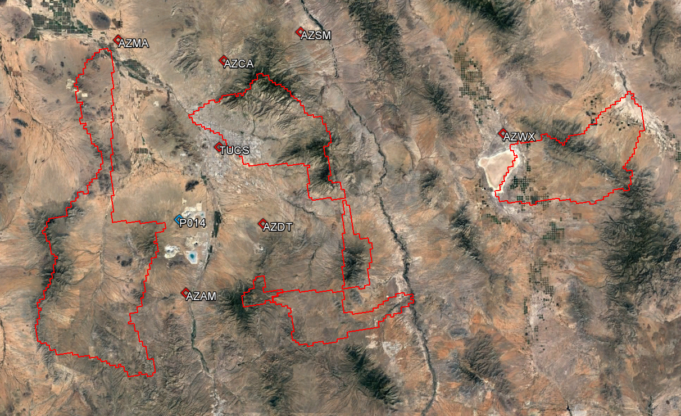
Figure 2: GNSS Reference Stations

3.0 Processing

3.1 Introduction
The ABGNSS/IMU data was post-processed using Applanix POSPac MMS software to create Smoothed Best Estimate Trajectory (SBET) file(s). The SBET was then combined with the laser range measurements in Optech-LMS software to produce the 3-dimensional coordinates resulting in an accurate set of Raw Point Cloud (RPC) mass points. These raw swath (*.las) files are output in WGS84, UTM, Ellipsoid, Meters and transformed to the project Coordinate Reference System (CRS) upon ingest into GeoCue before project wide calibration.

The Optech-LMS pre-processing software created raw swath files with all return values. This multi-return information was processed and classified to obtain the required feature for delivery. All lidar data is processed using the ASPRS binary LAS format version 1.4. Table 6 illustrates the achieved point cloud statistics.

Category | Value
Aggregate Total Points | 37,718,169,448
Aggregate Nominal Pulse Spacing (m) | 0.45
Aggregate Nominal Pulse Density (pls/m²) | 4.9
Aggregate Nominal Pulse Spacing (m) | 1.48
Aggregate Nominal Pulse Density (pls/m²) | 0.5
Table 6: Point Cloud Statistics

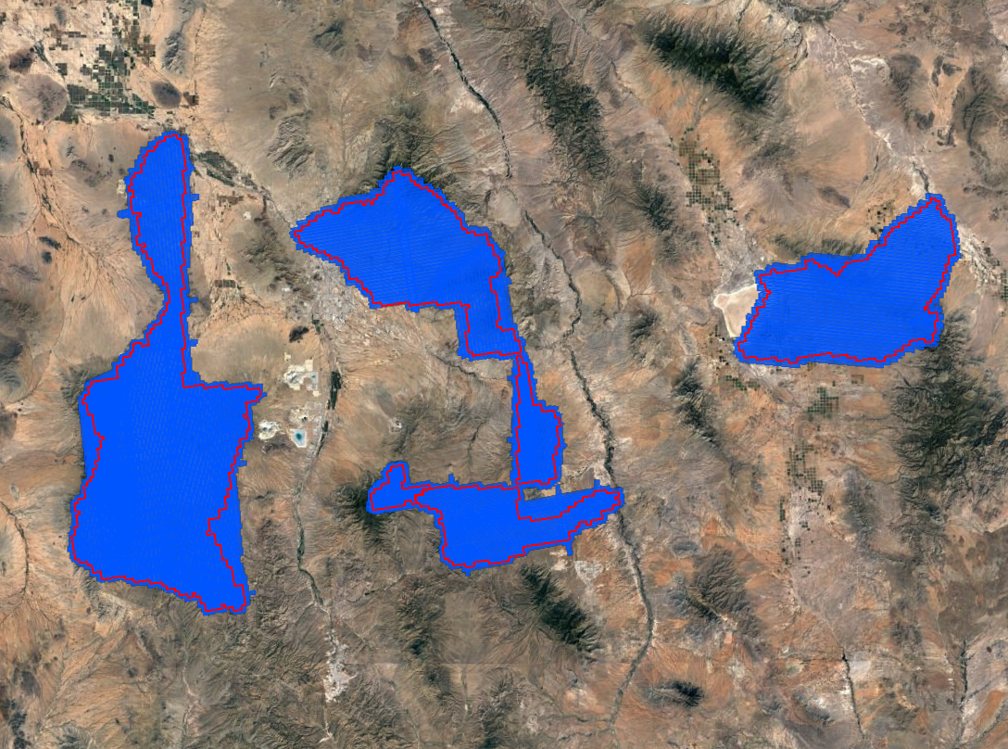
Figure 3: Raw Point Cloud Coverage

3.2 Coordinate Reference System
Horizontal Datum: North American Datum of 1983 (2011)
Projection: UTM Zone 12
Vertical Datum: North American Vertical Datum of 1988
Geoid Model: Geoid12B
Units: Meters

3.3 Calibration
Sanborn uses Optech-LMS and the latest boresight values to combine the processed SBET with the laser scan files to produce the lidar point cloud. The data is processed by mission and is output in ASPRS LASv1.4 Point Data Record Format (PDRF) 6 with 16bit linearly scaled intensities to the nearest 0.001 3D position. Each mission is produced in WGS84, UTM, Ellipsoid, Meters and transformed to the project CRS upon import into GeoCue.
Each mission in imported into GeoCue where each individual flight line is assigned a unique flight line number. The SBET is cut per mission into TerraScan Trajectory files based on flight line number and timestamp to be utilized during the calibration process. The project area(s) are broken into logical blocks based on AOIs or predetermined delivery blocks and the individual flight lines are populated into calibration tile grids. These calibration tile grids are prepared for scanner, line, mission, block and eventual project wide calibration routines by first running point cloud filters to identify ground and building features to be used during TerraMatch processes.
After successful point cloud filters have been run on the calibration dataset TerraMatch is used to extract Tie Line Observations. TerraMatch Tie Lines are 3D vectors extracted from the lidar points cloud intended to reduce the overwhelming data size to a more manageable amount. Each Tie Line is extracted using a series of parameters designed to identify features such a flat or sloping ground or roofline apexes that geospatially correlates to the same observation of an overlapping flight line. These collected 3D vectors are then utilized across multiple iterations to reduce the average offset from line to line, mission to mission, and block to block. TerraMatch Solutions are calculated to adjust Roll, Heading, Pitch, X, Y and Z in combination to reduce the Root Mean Square Deviation (RMSDr and RMSDz). These solutions are calculated, applied, and checked throughout the calibration process.
Sanborn takes advantage of both visual and statistical validation methodologies to review and ensure overlap consistency of the lidar data meets and/or exceeds project specifications. Differential Elevation (dZ) rasters are color ramp (Dark Green, Green, Yellow, Orange, Red) based visual representations produced to identify vertical offsets between flight lines. The dZ rasters are reviewed in their entirety for flight lines and areas that exceed the required RMSDz. Furthermore, an additional set of TerraMatch Tie Lines are produced after corrections are applied and a Tie Line Report is produced to assess the X. Y. and Z offset averages for each line and the project. This visual and statistical review guarantees the relative accuracy of the lidar dataset. Table 7 outlines the relative accuracy requirements of the project. Tables 8 – 11 are the relative accuracies achieved.
Category | Value
Smooth Surface Repeatability (m) | ≤0.060
Swath overlap difference, RMSDz (m) | ≤0.080
Swath overlap difference, Maximum (m) | ±0.160
Table 7: Relative Accuracy Requirements
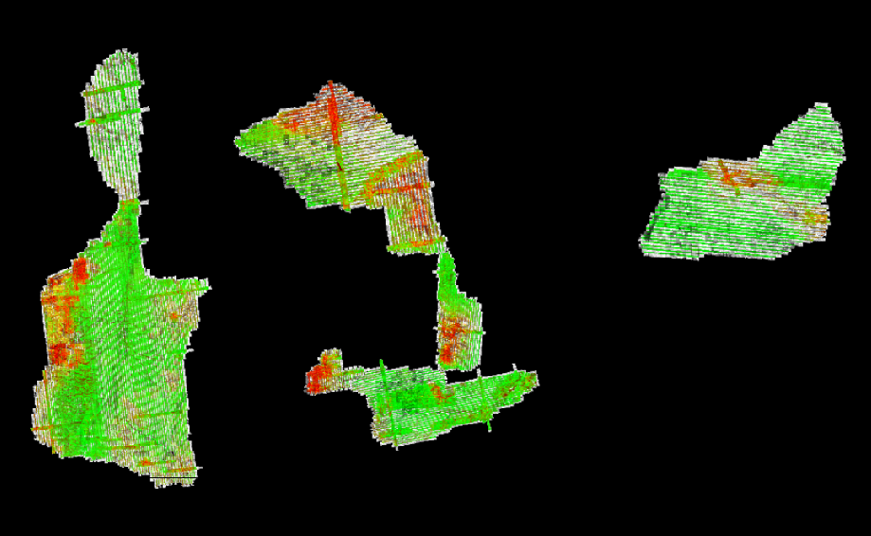
No Data | 0m to 0.04m | 0.04m to 0.08m | 0.08m to 0.12m | 0.12m to 0.16m | > 0.16m
Figure 4: dZ Rasters

Line | X | Y | Z | Line | X | Y | Z | Line | X | Y | Z
1 | - | - | 0.015 | 426 | 0.022 | 0.031 | 0.015 | 721 | 0.020 | 0.036 | 0.013
2 | - | - | 0.016 | 427 | 0.027 | 0.034 | 0.016 | 722 | 0.018 | 0.033 | 0.014
3 | - | - | 0.015 | 428 | - | - | 0.014 | 723 | 0.018 | 0.031 | 0.015
4 | - | - | 0.015 | 429 | 0.031 | 0.034 | 0.016 | 724 | 0.022 | 0.026 | 0.014
5 | - | - | 0.015 | 430 | - | - | 0.020 | 725 | 0.025 | 0.033 | 0.013
6 | - | - | 0.014 | 431 | 0.030 | 0.031 | 0.017 | 726 | 0.023 | 0.027 | 0.014
7 | - | - | 0.013 | 432 | 0.030 | 0.033 | 0.018 | 727 | 0.021 | 0.026 | 0.014
8 | - | - | 0.013 | 433 | 0.064 | 0.057 | 0.022 | 728 | 0.026 | 0.020 | 0.017
9 | - | - | 0.014 | 434 | 0.031 | 0.033 | 0.022 | 729 | 0.031 | 0.020 | 0.016
10 | - | - | 0.014 | 435 | 0.035 | 0.034 | 0.022 | 730 | 0.027 | 0.023 | 0.015
11 | 0.023 | 0.053 | 0.014 | 436 | 0.031 | 0.034 | 0.024 | 731 | 0.026 | 0.016 | 0.024
12 | 0.018 | 0.063 | 0.015 | 437 | 0.012 | 0.060 | 0.022 | 732 | 0.028 | 0.033 | 0.014
13 | 0.013 | 0.068 | 0.016 | 438 | 0.026 | 0.015 | 0.022 | 733 | 0.029 | 0.037 | 0.013
14 | 0.000 | 0.071 | 0.016 | 439 | 0.042 | 0.019 | 0.023 | 734 | 0.026 | 0.037 | 0.013
15 | 0.017 | 0.070 | 0.017 | 440 | 0.043 | 0.032 | 0.020 | 735 | 0.053 | 0.070 | 0.013
16 | 0.063 | 0.038 | 0.018 | 441 | 0.021 | 0.033 | 0.023 | 736 | 0.034 | 0.073 | 0.012
17 | 0.077 | 0.025 | 0.018 | 442 | 0.018 | 0.031 | 0.030 | 737 | 0.028 | 0.057 | 0.012
18 | 0.056 | 0.011 | 0.018 | 443 | - | - | 0.043 | 738 | 0.039 | 0.038 | 0.012
19 | 0.066 | 0.013 | 0.019 | 444 | 0.015 | 0.061 | 0.031 | 739 | 0.020 | 0.043 | 0.013
21 | - | - | 0.020 | 445 | 0.016 | 0.043 | 0.036 | 740 | 0.027 | 0.039 | 0.012
22 | - | - | 0.020 | 446 | 0.025 | 0.029 | 0.018 | 741 | 0.026 | 0.032 | 0.012
23 | 0.062 | 0.010 | 0.020 | 447 | 0.023 | 0.028 | 0.015 | 742 | 0.022 | 0.010 | 0.012
24 | 0.057 | 0.009 | 0.019 | 448 | 0.027 | 0.033 | 0.017 | 743 | 0.032 | 0.027 | 0.012
25 | - | - | 0.016 | 449 | 0.008 | 0.027 | 0.021 | 744 | 0.032 | 0.039 | 0.012
26 | - | - | 0.019 | 450 | - | - | 0.019 | 745 | 0.027 | 0.049 | 0.015
27 | - | - | 0.019 | 451 | 0.076 | 0.031 | 0.020 | 746 | 0.024 | 0.020 | 0.013
28 | 0.030 | 0.007 | 0.019 | 452 | 0.075 | 0.031 | 0.021 | 747 | 0.001 | 0.025 | 0.013
29 | 0.033 | 0.008 | 0.020 | 453 | - | - | 0.022 | 748 | - | - | 0.014
30 | 0.013 | 0.136 | 0.021 | 454 | - | - | 0.025 | 800 | - | - | 0.012
31 | 0.032 | 0.065 | 0.020 | 455 | - | - | 0.027 | 801 | - | - | 0.012
32 | 0.041 | 0.061 | 0.016 | 456 | 0.114 | 0.019 | 0.023 | 802 | - | - | 0.013
33 | 0.018 | 0.007 | 0.017 | 457 | 0.115 | 0.019 | 0.022 | 803 | - | - | 0.012
34 | 0.039 | 0.001 | 0.011 | 458 | 0.009 | 0.028 | 0.020 | 804 | - | - | 0.014
37 | - | - | 0.019 | 459 | 0.013 | 0.023 | 0.019 | 805 | - | - | 0.015
38 | 0.027 | 0.067 | 0.018 | 460 | 0.033 | 0.040 | 0.018 | 806 | 0.121 | 0.014 | 0.015
39 | 0.034 | 0.062 | 0.017 | 461 | 0.029 | 0.039 | 0.019 | 807 | 0.121 | 0.014 | 0.014
40 | 0.055 | 0.080 | 0.015 | 462 | 0.022 | 0.031 | 0.018 | 808 | - | - | 0.015
41 | 0.054 | 0.073 | 0.015 | 463 | 0.033 | 0.027 | 0.018 | 809 | - | - | 0.015
42 | 0.039 | 0.067 | 0.014 | 464 | 0.036 | 0.028 | 0.018 | 810 | - | - | 0.014
43 | 0.026 | 0.029 | 0.016 | 465 | - | - | 0.018 | 811 | - | - | 0.014
44 | 0.030 | 0.037 | 0.017 | 466 | - | - | 0.020 | 812 | 0.010 | 0.006 | 0.014
45 | 0.021 | 0.048 | 0.016 | 467 | - | - | 0.019 | 813 | 0.073 | 0.031 | 0.015
46 | 0.016 | 0.045 | 0.015 | 468 | - | - | 0.018 | 814 | 0.048 | 0.030 | 0.014
47 | 0.026 | 0.036 | 0.015 | 469 | - | - | 0.019 | 815 | 0.030 | 0.021 | 0.013
48 | 0.031 | 0.013 | 0.014 | 470 | - | - | 0.027 | 816 | - | - | 0.017
49 | 0.025 | 0.024 | 0.014 | 471 | 0.008 | 0.018 | 0.023 | 817 | 0.022 | 0.022 | 0.016
50 | 0.019 | 0.045 | 0.014 | 472 | 0.012 | 0.033 | 0.027 | 818 | - | - | 0.015
51 | 0.029 | 0.040 | 0.015 | 473 | - | - | 0.034 | 819 | 0.028 | 0.027 | 0.019
52 | 0.031 | 0.037 | 0.015 | 500 | 0.037 | 0.042 | 0.016 | 820 | 0.034 | 0.024 | 0.015
53 | 0.028 | 0.037 | 0.014 | 501 | - | - | 0.015 | 821 | 0.045 | 0.027 | 0.016
54 | 0.038 | 0.023 | 0.019 | 502 | - | - | 0.017 | 822 | 0.052 | 0.026 | 0.018
55 | 0.045 | 0.010 | 0.012 | 503 | - | - | 0.016 | 823 | 0.052 | 0.026 | 0.016
59 | - | - | 0.017 | 504 | - | - | 0.014 | 824 | 0.048 | 0.045 | 0.015
60 | 0.011 | 0.001 | 0.017 | 505 | 0.025 | 0.033 | 0.016 | 825 | 0.039 | 0.045 | 0.013
61 | - | - | 0.012 | 506 | 0.016 | 0.022 | 0.010 | 826 | 0.048 | 0.061 | 0.013
62 | - | - | 0.032 | 507 | 0.020 | 0.035 | 0.021 | 827 | 0.007 | 0.030 | 0.012
63 | - | - | 0.022 | 508 | 0.018 | 0.032 | 0.017 | 828 | 0.012 | 0.047 | 0.015
64 | - | - | 0.014 | 509 | 0.019 | 0.032 | 0.016 | 829 | - | - | 0.014
100 | 0.044 | 0.097 | 0.010 | 510 | 0.016 | 0.042 | 0.017 | 830 | 0.025 | 0.048 | 0.014
101 | 0.034 | 0.047 | 0.011 | 511 | - | - | 0.015 | 831 | 0.034 | 0.038 | 0.013
102 | 0.035 | 0.028 | 0.011 | 512 | 0.023 | 0.036 | 0.015 | 832 | - | - | 0.015
103 | - | - | 0.011 | 513 | 0.026 | 0.033 | 0.015 | 833 | 0.033 | 0.025 | 0.013
104 | - | - | 0.011 | 514 | 0.045 | 0.026 | 0.016 | 834 | 0.037 | 0.031 | 0.015
105 | - | - | 0.011 | 515 | 0.016 | 0.023 | 0.013 | 835 | 0.020 | 0.029 | 0.013
106 | - | - | 0.012 | 516 | 0.024 | 0.010 | 0.014 | 836 | 0.025 | 0.033 | 0.013
107 | - | - | 0.012 | 517 | 0.038 | 0.058 | 0.014 | 837 | 0.034 | 0.037 | 0.013
108 | - | - | 0.013 | 518 | 0.031 | 0.043 | 0.015 | 838 | 0.032 | 0.025 | 0.013
109 | - | - | 0.013 | 519 | - | - | 0.014 | 839 | 0.049 | 0.029 | 0.013
110 | - | - | 0.013 | 520 | 0.022 | 0.033 | 0.019 | 840 | 0.054 | 0.029 | 0.013
111 | - | - | 0.012 | 521 | 0.037 | 0.032 | 0.017 | 841 | 0.053 | 0.025 | 0.014
112 | 0.019 | 0.086 | 0.012 | 522 | 0.025 | 0.025 | 0.014 | 842 | 0.052 | 0.018 | 0.013
113 | 0.009 | 0.047 | 0.013 | 523 | 0.021 | 0.023 | 0.014 | 843 | 0.028 | 0.013 | 0.013
114 | 0.032 | 0.038 | 0.013 | 524 | 0.077 | 0.112 | 0.013 | 844 | 0.040 | 0.028 | 0.013
115 | 0.023 | 0.022 | 0.014 | 525 | 0.020 | 0.013 | 0.013 | 845 | 0.047 | 0.022 | 0.014
116 | 0.028 | 0.024 | 0.014 | 526 | 0.029 | 0.025 | 0.013 | 846 | 0.021 | 0.019 | 0.013
117 | 0.025 | 0.024 | 0.014 | 527 | 0.022 | 0.019 | 0.011 | 847 | 0.016 | 0.017 | 0.014
118 | 0.029 | 0.023 | 0.014 | 528 | 0.026 | 0.029 | 0.016 | 848 | 0.067 | 0.038 | 0.014
119 | 0.026 | 0.022 | 0.015 | 529 | 0.047 | 0.029 | 0.019 | 849 | 0.052 | 0.043 | 0.014
120 | 0.020 | 0.021 | 0.014 | 530 | 0.030 | 0.023 | 0.016 | 850 | 0.010 | 0.023 | 0.013
121 | 0.028 | 0.028 | 0.013 | 531 | 0.034 | 0.021 | 0.017 | 851 | 0.039 | 0.026 | 0.014
122 | 0.026 | 0.019 | 0.016 | 532 | - | - | 0.013 | 852 | 0.035 | 0.020 | 0.015
123 | 0.030 | 0.027 | 0.012 | 533 | - | - | 0.014 | 853 | 0.026 | 0.010 | 0.014
124 | 0.023 | 0.028 | 0.013 | 534 | - | - | 0.012 | 854 | 0.027 | 0.004 | 0.013
125 | 0.018 | 0.043 | 0.015 | 535 | - | - | 0.013 | 855 | 0.002 | 0.014 | 0.013
126 | 0.030 | 0.033 | 0.021 | 536 | - | - | 0.012 | 856 | 0.059 | 0.010 | 0.013
127 | 0.032 | 0.025 | 0.017 | 537 | - | - | 0.012 | 857 | 0.118 | 0.008 | 0.012
128 | 0.019 | 0.031 | 0.021 | 538 | - | - | 0.012 | 858 | 0.006 | 0.011 | 0.012
129 | 0.026 | 0.022 | 0.015 | 539 | - | - | 0.013 | 859 | 0.005 | 0.012 | 0.013
130 | 0.026 | 0.025 | 0.014 | 540 | - | - | 0.013 | 860 | - | - | 0.013
131 | 0.027 | 0.026 | 0.015 | 541 | - | - | 0.014 | 861 | - | - | 0.013
132 | 0.029 | 0.023 | 0.013 | 542 | - | - | 0.012 | 862 | - | - | 0.013
133 | 0.024 | 0.020 | 0.014 | 543 | - | - | 0.012 | 863 | 0.056 | 0.010 | 0.014
134 | - | - | 0.010 | 544 | - | - | 0.013 | 864 | 0.011 | 0.002 | 0.014
135 | - | - | 0.015 | 545 | - | - | 0.017 | 865 | - | - | 0.013
136 | - | - | 0.014 | 546 | - | - | 0.013 | 866 | - | - | 0.013
137 | - | - | 0.014 | 547 | - | - | 0.019 | 867 | - | - | 0.015
138 | - | - | 0.017 | 548 | - | - | - | 868 | 0.054 | 0.017 | 0.015
139 | - | - | 0.012 | 549 | - | - | - | 869 | 0.050 | 0.016 | 0.014
140 | - | - | 0.014 | 550 | - | - | - | 870 | - | - | 0.014
141 | - | - | 0.023 | 551 | - | - | - | 871 | 0.082 | 0.010 | 0.014
142 | - | - | 0.021 | 552 | - | - | - | 872 | 0.069 | 0.009 | 0.014
143 | - | - | 0.017 | 553 | - | - | - | 873 | - | - | 0.014
200 | 0.091 | 0.007 | 0.013 | 554 | - | - | - | 874 | 0.005 | 0.021 | 0.014
201 | - | - | 0.012 | 555 | - | - | 0.014 | 875 | 0.022 | 0.036 | 0.014
202 | - | - | 0.017 | 556 | - | - | 0.014 | 876 | 0.042 | 0.027 | 0.014
203 | 0.004 | 0.002 | 0.017 | 557 | - | - | 0.016 | 877 | - | - | 0.015
204 | 0.022 | 0.026 | 0.014 | 558 | - | - | 0.014 | 878 | - | - | 0.015
205 | 0.058 | 0.044 | 0.017 | 559 | 0.002 | 0.035 | 0.014 | 879 | 0.003 | 0.018 | 0.015
206 | 0.061 | 0.039 | 0.016 | 560 | - | - | 0.015 | 880 | - | - | 0.015
207 | 0.016 | 0.051 | 0.015 | 561 | - | - | 0.014 | 881 | 0.025 | 0.013 | 0.015
208 | 0.053 | 0.039 | 0.014 | 562 | - | - | 0.014 | 882 | 0.030 | 0.033 | 0.015
209 | 0.010 | 0.013 | 0.012 | 563 | - | - | 0.013 | 883 | 0.034 | 0.019 | 0.013
210 | 0.031 | 0.029 | 0.015 | 564 | - | - | 0.014 | 884 | 0.031 | 0.017 | 0.014
211 | 0.030 | 0.036 | 0.015 | 565 | - | - | 0.013 | 885 | 0.025 | 0.014 | 0.014
212 | - | - | 0.014 | 566 | - | - | 0.014 | 886 | - | - | 0.013
213 | 0.000 | 0.001 | 0.014 | 567 | - | - | 0.013 | 887 | - | - | 0.014
214 | 0.000 | 0.002 | 0.012 | 568 | - | - | 0.013 | 888 | - | - | 0.014
215 | - | - | 0.012 | 569 | - | - | 0.013 | 889 | 0.074 | 0.045 | 0.015
216 | 0.057 | 0.043 | 0.012 | 570 | - | - | 0.013 | 890 | 0.074 | 0.046 | 0.016
217 | 0.057 | 0.043 | 0.012 | 571 | - | - | 0.013 | 891 | - | - | 0.009
218 | - | - | 0.011 | 572 | - | - | 0.012 | 892 | - | - | 0.008
219 | 0.091 | 0.007 | 0.013 | 573 | - | - | 0.012 | 893 | - | - | 0.014
220 | 0.029 | 0.038 | 0.013 | 574 | - | - | 0.013 | 894 | - | - | 0.013
221 | 0.022 | 0.019 | 0.012 | 575 | - | - | 0.013 | 895 | - | - | 0.014
300 | 0.039 | 0.033 | 0.013 | 576 | - | - | 0.012 | 896 | - | - | 0.014
301 | 0.058 | 0.044 | 0.014 | 577 | - | - | 0.015 | 897 | - | - | 0.015
302 | - | - | 0.013 | 578 | - | - | 0.011 | 898 | - | - | 0.018
303 | - | - | 0.013 | 579 | 0.013 | 0.003 | 0.014 | 899 | - | - | 0.016
304 | - | - | 0.012 | 580 | - | - | 0.015 | 900 | 0.011 | 0.034 | 0.011
305 | - | - | 0.013 | 581 | - | - | 0.011 | 901 | 0.021 | 0.029 | 0.012
306 | - | - | 0.012 | 582 | - | - | 0.011 | 902 | 0.006 | 0.012 | 0.013
307 | 0.000 | 0.020 | 0.012 | 583 | - | - | 0.013 | 903 | 0.001 | 0.000 | 0.016
308 | 0.064 | 0.063 | 0.012 | 584 | - | - | 0.012 | 904 | 0.007 | 0.066 | 0.012
309 | 0.075 | 0.071 | 0.013 | 585 | - | - | 0.012 | 905 | 0.000 | 0.031 | 0.012
310 | - | - | 0.014 | 586 | - | - | 0.012 | 906 | 0.018 | 0.092 | 0.015
311 | - | - | 0.014 | 587 | - | - | 0.015 | 907 | 0.017 | 0.053 | 0.016
312 | - | - | 0.015 | 588 | - | - | 0.013 | 908 | - | - | 0.016
313 | - | - | 0.014 | 589 | - | - | 0.013 | 909 | - | - | 0.015
314 | - | - | 0.014 | 590 | - | - | 0.013 | 910 | - | - | 0.017
315 | - | - | 0.013 | 591 | - | - | 0.013 | 911 | - | - | 0.014
316 | - | - | 0.012 | 592 | - | - | 0.013 | 912 | - | - | 0.009
317 | - | - | 0.014 | 593 | - | - | 0.024 | 913 | - | - | 0.016
318 | - | - | 0.015 | 594 | 0.018 | 0.000 | 0.016 | 914 | - | - | 0.016
319 | - | - | 0.014 | 595 | 0.010 | 0.034 | 0.017 | 915 | - | - | 0.018
320 | - | - | 0.014 | 596 | - | - | 0.013 | 916 | - | - | 0.017
321 | - | - | 0.016 | 597 | - | - | 0.013 | 917 | - | - | 0.016
322 | - | - | 0.020 | 598 | 0.025 | 0.017 | 0.015 | 918 | - | - | 0.013
323 | - | - | 0.013 | 599 | 0.030 | 0.026 | 0.011 | 919 | 0.049 | 0.033 | 0.014
324 | - | - | 0.020 | 600 | 0.015 | 0.016 | 0.013 | 920 | 0.045 | 0.009 | 0.015
325 | - | - | 0.009 | 601 | 0.020 | 0.018 | 0.011 | 921 | - | - | 0.014
326 | 0.027 | 0.042 | 0.013 | 602 | 0.011 | 0.016 | 0.013 | 922 | - | - | 0.015
327 | - | - | 0.012 | 603 | - | - | 0.013 | 923 | - | - | 0.014
400 | 0.038 | 0.022 | 0.026 | 604 | - | - | 0.011 | 924 | 0.001 | 0.066 | 0.014
401 | 0.036 | 0.042 | 0.024 | 605 | 0.020 | 0.023 | 0.015 | 925 | - | - | 0.015
402 | 0.020 | 0.034 | 0.018 | 606 | 0.032 | 0.045 | 0.014 | 926 | - | - | 0.014
403 | 0.020 | 0.039 | 0.016 | 607 | 0.016 | 0.032 | 0.015 | 927 | 0.006 | 0.012 | 0.016
404 | 0.020 | 0.043 | 0.016 | 608 | 0.015 | 0.023 | 0.017 | 928 | 0.002 | 0.123 | 0.018
405 | 0.031 | 0.038 | 0.015 | 700 | - | - | 0.015 | 929 | - | - | 0.013
406 | 0.029 | 0.030 | 0.013 | 701 | - | - | 0.014 | 930 | - | - | 0.015
407 | 0.032 | 0.034 | 0.014 | 702 | - | - | 0.014 | 931 | - | - | 0.011
408 | 0.029 | 0.035 | 0.014 | 703 | 0.026 | 0.018 | 0.013 | 932 | - | - | 0.010
409 | 0.028 | 0.036 | 0.014 | 704 | 0.028 | 0.024 | 0.013 | 933 | - | - | 0.014
410 | 0.026 | 0.042 | 0.014 | 705 | 0.018 | 0.032 | 0.013 | 934 | - | - | 0.013
411 | 0.017 | 0.044 | 0.015 | 706 | 0.021 | 0.024 | 0.013 | 935 | - | - | 0.010
412 | 0.017 | 0.046 | 0.016 | 707 | 0.020 | 0.021 | 0.012 | 936 | - | - | 0.009
413 | - | - | 0.024 | 708 | 0.031 | 0.028 | 0.013 | 937 | - | - | 0.010
414 | 0.019 | 0.039 | 0.016 | 709 | 0.029 | 0.028 | 0.012 | 938 | - | - | 0.014
415 | 0.023 | 0.036 | 0.019 | 710 | 0.019 | 0.027 | 0.012 | 939 | - | - | 0.013
416 | 0.022 | 0.039 | 0.019 | 711 | 0.020 | 0.032 | 0.012 | 940 | - | - | 0.013
417 | 0.019 | 0.037 | 0.016 | 712 | 0.023 | 0.056 | 0.013 | 941 | - | - | 0.011
418 | 0.019 | 0.034 | 0.016 | 713 | 0.031 | 0.040 | 0.013 | 942 | - | - | 0.015
419 | 0.021 | 0.034 | 0.017 | 714 | 0.028 | 0.042 | 0.013 | 943 | - | - | 0.014
420 | 0.020 | 0.036 | 0.017 | 715 | 0.028 | 0.043 | 0.013 | 944 | - | - | 0.011
421 | 0.020 | 0.034 | 0.017 | 716 | 0.022 | 0.024 | 0.016 | 945 | - | - | 0.017
422 | 0.030 | 0.035 | 0.019 | 717 | 0.027 | 0.016 | 0.020 | 946 | - | - | 0.012
423 | 0.027 | 0.036 | 0.018 | 718 | 0.016 | 0.032 | 0.012 | 947 | - | - | 0.012
424 | 0.024 | 0.035 | 0.016 | 719 | 0.015 | 0.038 | 0.013 | 948 | - | - | 0.013
425 | 0.024 | 0.032 | 0.015 | 720 | 0.021 | 0.043 | 0.012
Table 8: Average Magnitudes by Line (Meters)

Category | X | Y | Z
Average Magnitude | 0.024 | 0.035 | 0.015
RMS Values | 0.038 | 0.052 | 0.020
Maximum Values | 0.160 | 0.160 | 0.160
Observation Weight | 99814.0 | 99814.0 | 1613675.0
Table 9: Internal Observation Statistics (Meters)

Category | Mismatch
Average 3D Mismatch | 0.01811
Average XY Mismatch | 0.05209
Average Z Mismatch | 0.01541
Table 10: Overall Relative Accuracy (Meters)

Category | Observations
Section Lines | 715,965
Roof Lines | 46,689
Table 11: Vector Observations

3.4 Lidar Classification
Lidar filtering was accomplished using GeoCue with TerraSolid processing and modeling software. The filtering process reclassifies all the data into classes with in the point cloud file based scheme. Once the data is classified, the entire dataset is reviewed and manually edited for anomalies that are outside the required guidelines of the product specification or contract requirements. This can include, but is not limited to, removing bridges, structures, filling culverts, and manually analyzing the bare-earth surface by classifying features that belong in non-extraneous classification codes. Table 12 outlines the point classes leveraged in the lidar dataset.
Code | Description | Definition
1 | Unclassified | Processed, but unclassified
2 | Ground | Bare-earth surface
3 | Low Veg | 0-3 meters (Automated), *NRCS AOI Only
4 | Medium Veg | 3-7 meters (Automated), *NRCS AOI Only
5 | High Veg | >7 meters (Automated), *NRCS AOI Only
6 | Building | (Automated), *NRCS AOI Only
7 | Low Noise | Erroneous returns below bare-earth surface
9 | Water | Hydrologically identified water surface points
17 | Bridge Decks | Structure carrying a means of transit of higher elevation
18 | High Noise | Erroneous atmospheric returns above bare-earth surface
20 | Ignored Ground | Bare-earth points near breaklines excluded from DEM
Flag | Overlap | Overage points lying within overlapping areas of two or more swaths
Flag | Withheld | Outliers, blunders, noise points, geometrically unreliable points near the extreme edge of the swath
Table 12: Lidar Classification Scheme

3.5 Accuracy Assessment
The lidar dataset was evaluated using a total of 132 check points (74 NVA + 58 VVA). The end result provided an RMSEz that fell within project specifications. Please see the Attachment A for the full Vertical Accuracy Report and the project Metadata for an in-depth accuracy assessment. Table 13 outlines the absolute accuracy requirements of the project. Table 14 shows high level statistics and mean errors for the area processed by Sanborn.
Category | Value
RMSEz (m) | ≤0.10
@ 95-percent confidence level (m) | ≤0.30
Table 13: Absolute Accuracy Requirements

Broad Land Cover Type | # of Points | RMSEz | 95% Confidence Level | 95th Percentile
NVA of Point Cloud | 74 | 0.039 | 0.077
NVA of Bare Earth | 74 | 0.039 | 0.077
NVA of DEM | 74 | 0.039 | 0.076
VVA of Bare Earth | 58 | 0.057 |  | 0.100
VVA of DEM | 58 | 0.057 |  | 0.094
Table 14: Vertical Accuracy Assessment of Check Points (Meters)

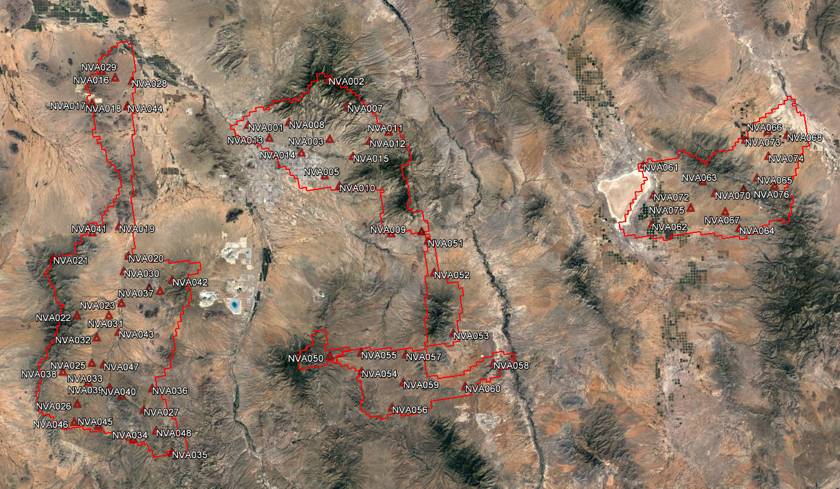
Figure 5: Non-vegetated Check Point Distribution

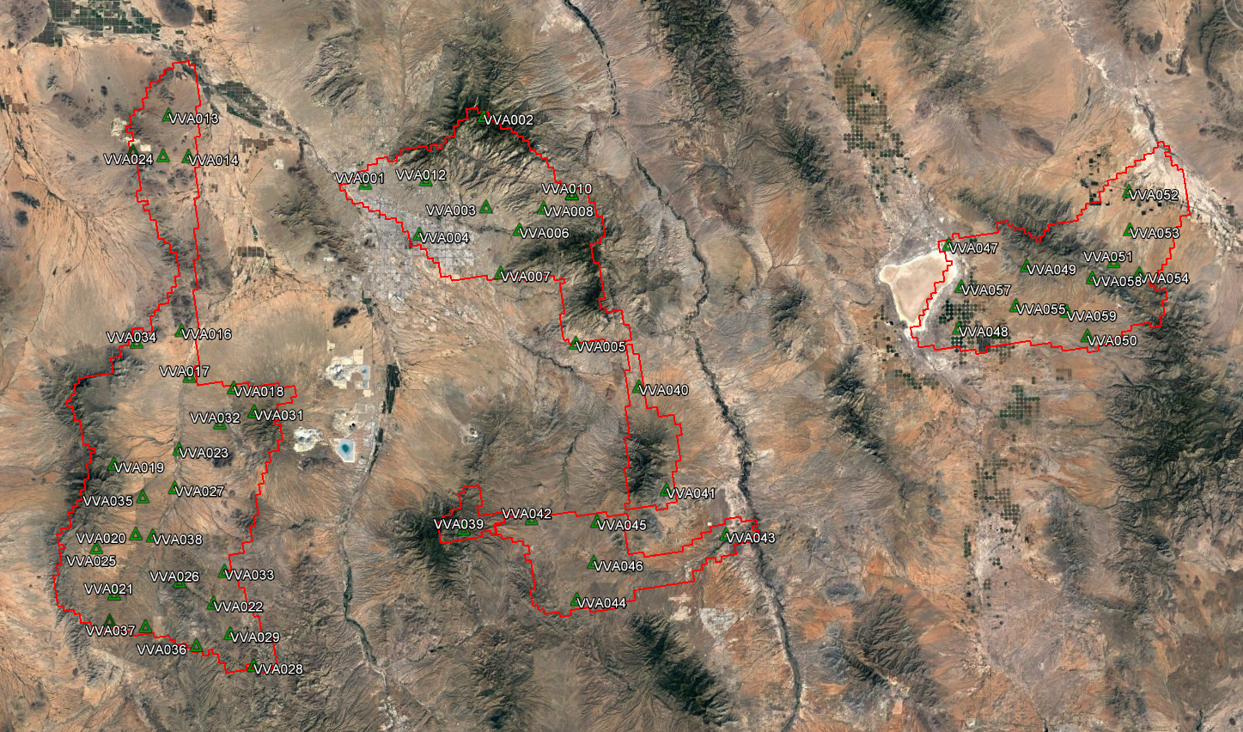
Figure 6: Vegetated Check Point Distribution

4.0 Product Generation
Once the lidar surface was finalized and manually QC’d for anomalies, the required deliverables were then generated and/or organized. The following products were generated using the final coordinate system as defined in the contract, and provided in section 4.0 of this report.

Classified Point Cloud
The Classified Point Cloud, containing all returns, is delivered in LASv1.4 (*.las) format and meets project specifications. The Classified Point Cloud contains file names referencing the tile index.

Bare-Earth Digital Terrain Model
32-bit ERDAS Imagine (*.img) 2 ft elevation rasters were created from the bare-earth points in the processed lidar dataset. Each pixel contains an elevation value interpolated from the lidar.

Intensity Rasters
8-bit GeoTIFF (*.tiff) 2 ft intensity rasters were created from the first-return points in the processed lidar dataset.

Biomass Inventory/Canopy
Esri Geodatabase (*.gdb) of tree canopy polygons and tree crown points.

Other Deliverables
Vertical Accuracy Report
Metadata

A final QC process was undertaken to validate all deliverables for the project. Prior to release of data for delivery, Sanborn’s Quality control/quality assurance department reviews the data and then releases it for delivery.

