Review of Data for Southeast Counties, Alabama

We received a portable hard drive with data on it for Southeast Counties. It has LAS files, DEM, Breaklines, Process Boundary, and Tile Index as separate folders and containing the respective data of each. The entire dataset is 355 GB in size with the LAS files being 330 GB of that.

We received only the checked items with this delivery.

- Pre-Flight Operations Plan
- Post-Flight Aerial Acquisition and Calibration Report
- Classified Point Cloud
- Processing Report
- Bare Earth Surface (Raster DEM)
- Report of Vertical Accuracy Assessment for Bare Earth Surface
- Breaklines
- Low Confidence Areas Polygons (when produced)

I found 2,209 LAS files that have point data covering the county and was able to process the boundary information in these files to verify their coverage.

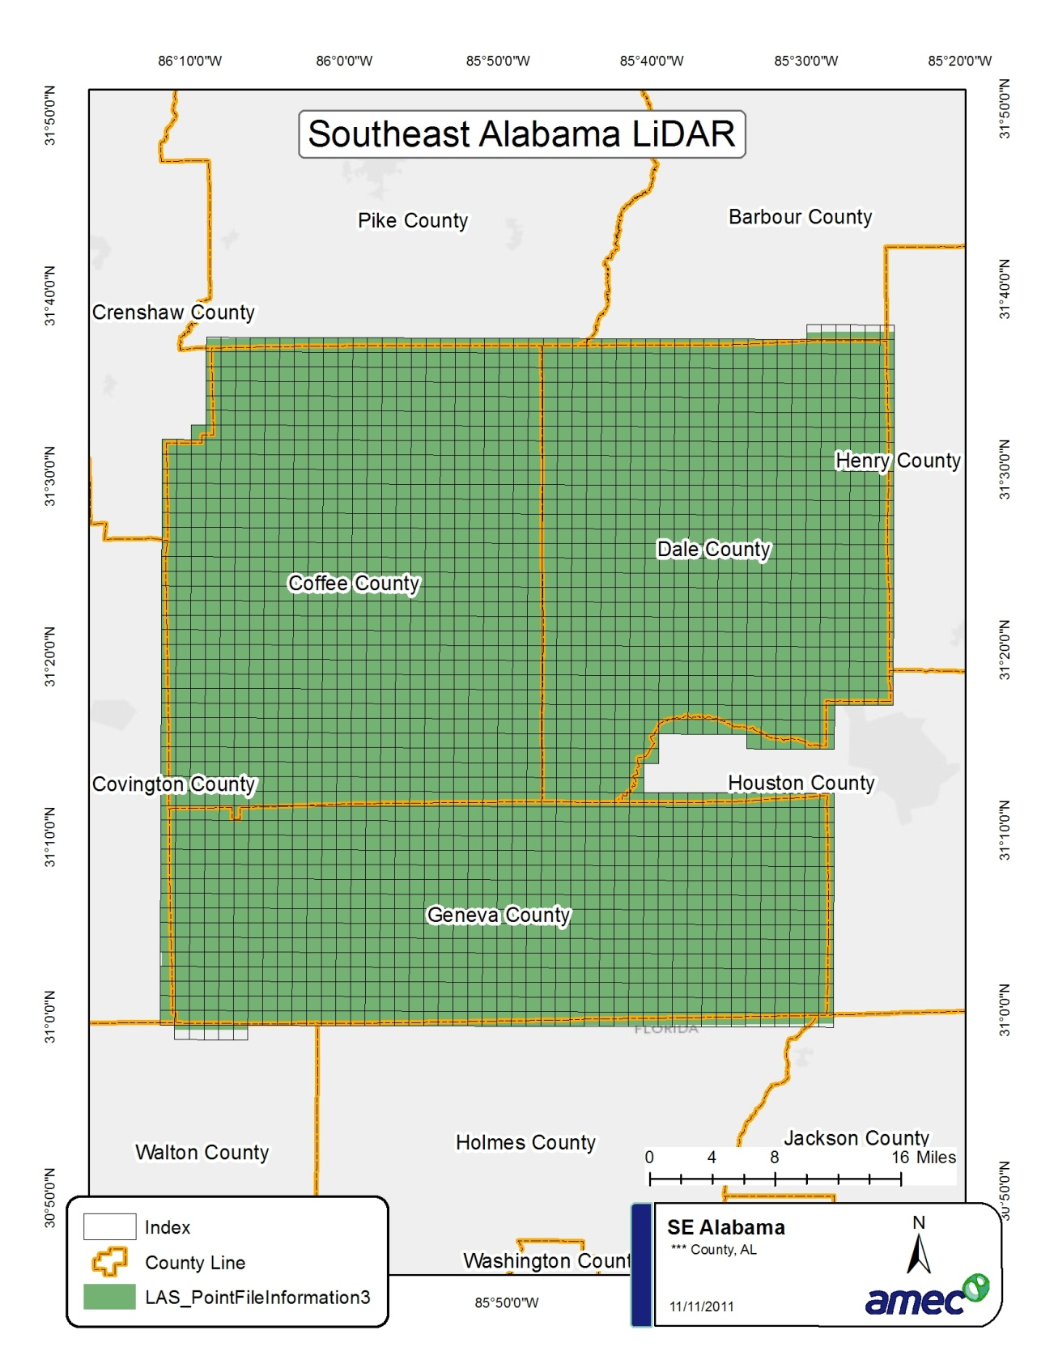

The DEM LAS and Break line files matched the metadata provided. The Index, Boundary, Breaklines, and LAS files had a spatial reference of UTM Zone 16, Northern Hemisphere Meters, WGS84 Datum.

Since we are only concerned with the ground points and these are typically class 2 in LAS files I was able to analyze these points in the files with these results.

Total points | 3,748,415,171 | class 2 only
Average points | 1,696,883 | per tile
Average pt spacing | 1.16 | Meters
Min Z Value | 18.83 | Meters
Max Z Value | 170.97 | Meters

