Illinois Twelve Counties
LiDAR Report

Prepared For:

United States Geological Survey
National Geospatial Technical Operations Center
1400 Independence Road
Rolla, Missouri 65401

Prepared By:

Quantum Spatial
(Formerly Aero-Metric, Inc.)
4020 Technology Parkway
Sheboygan, WI 53083
P: 920.457.3631
F:920.457.0410

Contract ID: G10PC00025
Task Order: G13PD00753
Quantum Spatial Project No: 1130113

Table of Contents
United States Geological Survey
Illinois Twelve Counties LiDAR

TITLE SECTION
Introduction 1
Geodetic Control 2
LiDAR Acquisition and Procedures 3
Quality Control Surveys 4
LiDAR Processing 5
Conclusion 6

1. Introduction
This report contains a summary of the Light Detection and Ranging (LiDAR) data acquisition and processing of the Illinois Twelve Counties project area, to include the following counties: Carroll, Champaign, Grundy, Henry, Jo Davies, Kane, Lee, McHenry, Ogle, Rock Island, Stephenson, and Whiteside.

1.1 Contact Info
Questions regarding the technical aspects of this report should be addressed to:
Quantum Spatial
4020 Technology Parkway
Sheboygan, WI 53083
Attention: Chris Guy (LiDAR Manager)
FAX: 920-457-0410
Email: cguy@quantumspatial.com

1.2 Purpose
Quantum Spatial acquired high accuracy LiDAR data of the Illinois Twelve Counties for the USGS in accordance with requirements specified in contract ID G10PC00025 and as defined by United States Geological Survey National Geospatial Program Base LiDAR Specification, Version 1.0 (ILMF) to the extent that is possible.

1.3 Project Locations
The project includes approximately 7567 square miles of twelve counties in the state of Illinois. The counties include Carroll, Champaign, Grundy, Henry, Jo Davies, Kane, Lee, McHenry, Ogle, Rock Island, Stephenson, and Whiteside. Image 1.3a shows a graphic of the areas of acquisition.

1.4 Time Period
LiDAR data acquisition for complete coverage of the project was acquired on three separate occasions between April 16th, 2008 and May 12, 2009.

1.5 Project Scope
Airborne LiDAR data collection was accomplished by the staff of Quantum Spatial. Per Section C of task order G13PD00753, Quantum Spatial completed two tasks for the USGS:
- Data previously collected under contracts PTB146-041 & PTB 151 and IDNR 1-080208 was processed with deliverables outlined in Section 5.7. Any variations from the “U.S. Geological Survey National Geospatial Program LiDAR Base Specification, Version 1.0” are noted in the following report.
- High Resolution LiDAR data for the twelve counties listed in Section 1.3 was collected, as well as Classified LAS Point Cloud data, existing breakline data collected per the contracts listed above, and new breakline collection for Carroll, Jo Davies, and Stephenson counties.
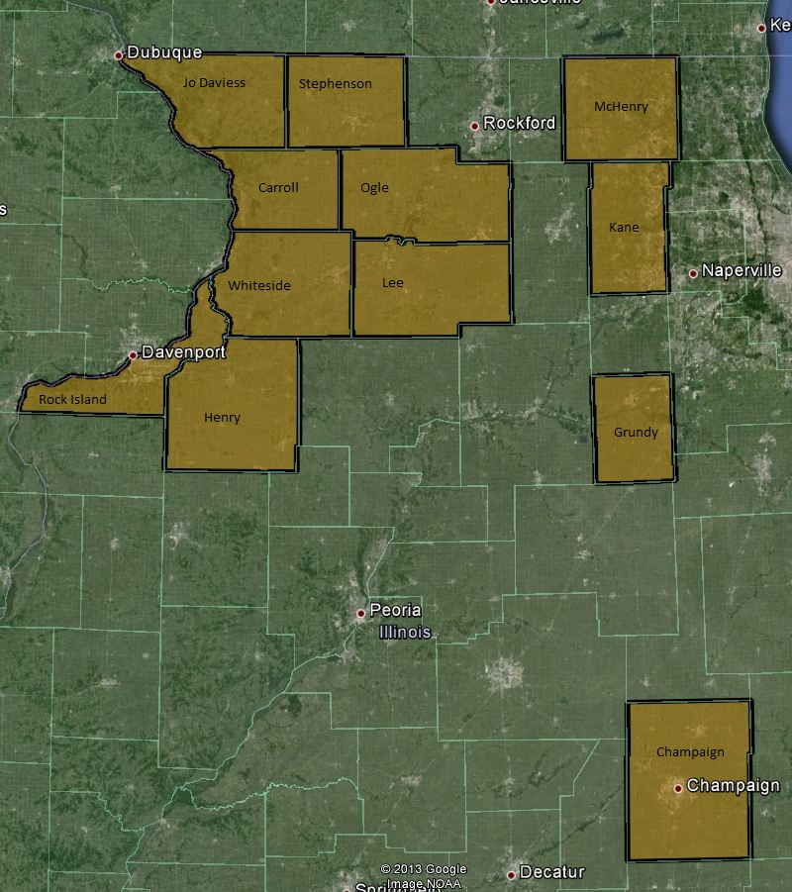
Image 1.3a: The twelve counties included in this project are highlighted for reference.
Horizontal Datum: NAD83 (HARN). Vertical Datum: NAVD88

2. Geodetic Control
Quantum Spatial (previously Aero-Metric, Inc.) performed ground surveys of four counties (Champaign, Grundy, Kane, McHenry) per contract W912P9-08-D-0503 between April 14, 2009 and June 19, 2008. Ground control data for the remaining eight counties included in this project was collected by the Illinois Department of Transportation (IDOT), and resulting accuracy data is included in this report. See Section 5.6 for final ground survey results and accuracy data for all twelve counties.

2.1 Ground Computations for Quantum Spatial Surveys
GPS measurements were done in two stages. Initial computations were done with LEICA Geo Office (LGO), version 4.0. LGO permits the conversion of raw satellite data collected by the receivers to a meaningful coordinate difference between points (baseline solutions). Once the baseline solutions were determined, they were input into the GeoSurv-GeoLab2 series of programs (Geolab version 2.4d). An adjustment was performed for analysis and quality closure.
Quantum Spatial surveyed each county independently using existing control stations located within or nearby each county. An adjustment was performed for analysis and quality closure holding the position and elevation of a fixed National Geodetic Survey base station. The unconstrained control closure adjustment results for each county are on the following page.

Horizontal Closures (m)
County | Fixed Station | Station | Northing | Easting | Linear | Distance | Proportion
Champaign | GRAY | Bellinger | 0.099 | 0.029 | 0.103 | 16720.6 | 1:162,000
 |  | Pesotum | 0.089 | 0.006 | 0.089 | 44228.8 | 1:495,000
Grundy | KA17 | Brace | 0.014 | 0.011 | 0.018 | 37824.6 | 1:2,101,000
 |  | Danish | 0.010 | 0.005 | 0.011 | 36420.2 | 1:3,257,000
 |  | Gardner | 0.000 | 0.019 | 0.021 | 36346.4 | 1:1,692,000
 |  | KA11 | 0.006 | 0.003 | 0.003 | 42436.0 | 1:14,145,000
 |  | KA6 | 0.010 | 0.010 | 0.012 | 51503.2 | 1:4,416,000
Kane | K131 | Ka11 | 0.001 | 0.012 | 0.012 | 48552.0 | 1:4,046,000
 |  | KA15 | 0.001 | 0.021 | 0.021 | 31766.1 | 1:1,513,000
 |  | W 19 | 0.000 | 0.006 | 0.006 | 32430.9 | 1:5,405,000
 |  | ZAU B | 0.001 | 0.004 | 0.004 | 36316.4 | 1:9,079,000
McHenry | NUNDARM1 | Blissdale | 0.018 | 0.001 | 0.018 | 31198.6 | 1:1,730,000
 |  | Veen | 0.001 | 0.011 | 0.011 | 27038.3 | 1:2,458,000

Vertical Closures (m)
County | Fixed Station | Station | Published Elevation | Computed Elevation | Closure | 3rd Order Allowable
Champaign | GRAY | Bellinger | 260.581 | 260.609 | 0.028 | 0.049
 |  | C 173 Reset | 226.731 | 226.676 | 0.055 | 0.056
 |  | H 301 | 210.217 | 210.195 | 0.022 | 0.066
 |  | Pesotum | 211.286 | 211.285 | 0.001 | 0.080
Grundy | KA17 | Brace | 178.542 | 178.586 | 0.044 | 0.074
 |  | Danish | 181.976 | 181.938 | 0.038 | 0.072
 |  | Gardner | 178.928 | 178.886 | 0.042 | 0.072
 |  | KA11 | 199.954 | 199.948 | 0.006 | 0.078
 |  | KA6 | 197.286 | 197.273 | 0.013 | 0.086
Kane | K131 | Ka11 | 199.954 | 199.979 | 0.025 | 0.084
 |  | KA15 | 247.300 | 247.214 | 0.086 | 0.068
 |  | W 17 | 221.339 | 221.330 | 0.009 | 0.054
 |  | W 19 | 218.764 | 218.764 | 0.000 | 0.068
 |  | ZAU B | 211.213 | 211.217 | 0.004 | 0.072
McHenry | NUNDARM1 | E 17 | 245.969 | 245.932 | 0.037 | 0.047
 |  | Veen | 293.637 | 293.641 | 0.004 | 0.062

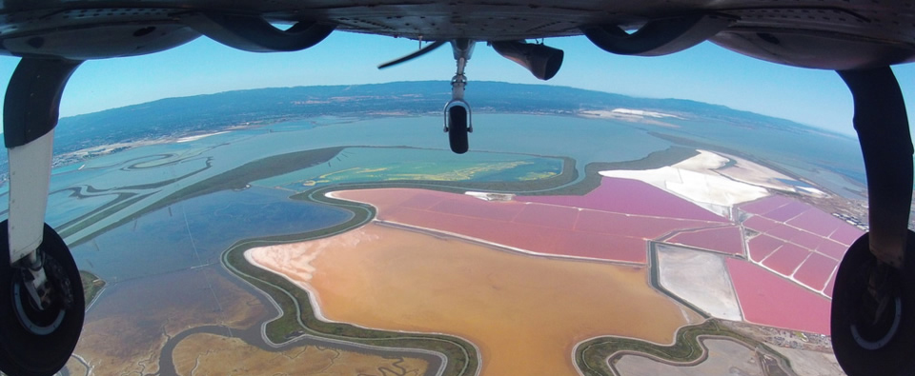
3. LiDAR Acquisition and Procedures

3.1 Acquisition Time Period
LiDAR data acquisition and Airborne GPS control were completed on three occasions between April 16th, 2008 and May 12, 2009.

3.2 LiDAR Planning
The LiDAR data for this project was collected with aircraft operated by Quantum Spatial. The aircraft is equipped with LiDAR sensor systems as well as systems to collect GPS and IMU positioning data during flight. All flight planning and flights were completed using Optech ALTM-Nav flight planning and LiDAR control software.

3.3 LiDAR Acquisition
Airborne GPS and IMU position and trajectory data of the LiDAR sensor were acquired during the time of flight. The LiDAR system as well as the Airborne GPS and IMU system were initialized before takeoff and after landing for a period of five minutes. The missions acquired data according to the planned flight lines and included a minimum of one (usually two) cross flights. The cross flights were flown perpendicular to the planned flight lines and their data used in the in-situ calibration of the sensor.

Table 3.3a: Acquisition Parameters*
Date | 04/16/2008 | 03/20/2009 | 05/12/2009
Flying Height (Above mean sea level) | 1700m | 1500 | 1500
Scan Angle (degrees) | 36 | 32 | 32
Nominal Point Spacing/meter | 1.2m | 1.0m | 1.0m
Sensor | Optech ALTM 3100 | Optech ALTM Gemini | Optech ALTM Gemini
* Refer to Section 5.8 for explanation of missing data per U.S. Geological Survey National Geospatial Program LiDAR Base Specification, Version 1.0 requirements.

Table 3.3b: County Acquisition by Date
04/16/2008 | 03/20/2009 | 05/12/2009
Champaign | Carroll | Henry
Grundy | Jo Daviess | Rock Island
Kane | Lee
McHenry | Ogle
 | Stephenson
 | Whiteside

3.4 LiDAR Trajectory Processing
Flights utilized at least two base stations during each mission lift for airborne processing.

4 Quality Control Surveys
Field surveys were performed by Quantum Spatial between April 14, 2008 and June 19, 2008 as well as by IDOT (dates unavailable). Three thousand five hundred and eighty four (3584) total check points were collected and used to calibrate and evaluate airborne LiDAR data in various land coverage categories throughout the twelve counties included in this project.

County | Number of Checkpoints
Carroll | 112
Champaign | 166
Grundy | 103
Kane | 100
Lee | 344
McHenry | 126
Jo Daviess | 148
Henry | 863
Rock Island | 443
Stephenson | 123
Ogle | 409
Whiteside | 647
Total | 3584

5 LiDAR Processing

5.1 ABGPS and IMU Processing
Airborne GPS
Applanix - POSGPS
Utilizing carrier phase ambiguity resolution on the fly (i.e., without initialization), the solution to sub-decimeter kinematic positioning without the operational constraint of static initialization as used in semi-kinematic or stop-and-go positioning was utilized for the airborne GPS post-processing.
The processing technique used by Applanix, Inc. for achieving the desired accuracy is Kinematic Ambiguity Resolution (KAR). KAR searches for ambiguities and uses a special method to evaluate the relative quality of each intersection (RMS). The quality indicator is used to evaluate the accuracy of the solution for each processing computation. In addition to the quality indicator, the software will compute separation plots between any two solutions, which will ultimately determine the acceptance of the airborne GPS post processing.
Inertial Data
The post-processing of inertial and aiding sensor data (i.e. airborne GPS post processed data) is to compute an optimally blended navigation solution. The Kalman filter-based aided inertial navigation algorithm generates an accurate (in the sense of least-square error) navigation solution that will retain the best characteristics of the processed input data. An example of inertial/GPS sensor blending is the following: inertial data is smooth in the short term. However, a free- inertial navigation solution has errors that grow without bound with time. A GPS navigation solution exhibits short-term noise but has errors that are bounded. This optimally blended navigation solution will retain the best features of both, i.e. the blended navigation solution has errors that are smooth and bounded. The resultant processing generates the following data:
- Position: Latitude, Longitude, Altitude
- Velocity: North, East, and Down components
- 3-axis attitude: roll, pitch, true heading
- Acceleration: x, y, z components
- Angular rates: x, y, z components

The Applanix software, version 4.4, was used to determine both the ABGPS trajectory and the blending of inertial data.
The airborne GPS and blending of inertial and GPS post-processing were completed in multiple steps.
1. The collected data was transferred from the field data collectors to the main computer. Data was saved under the project number and separated between LiDAR mission dates. Inside each mission date, a sub-directory was created with the aircraft’s tail number and an A or B suffix was attached for the time of when the data was collected. Inside the tail number sub-directory, five sub- directories were also created EO, GPS, IMU, PROC, and RAW.
2. The aircraft raw data (IMU and GPS data combined) was run through a data extractor program. This separated the IMU and GPS data. In addition to the extracting of data, it provided the analyst the first statistics on the overall flight. The program was POSPac (POS post-processing PACkage).
3. Executing POSGPS program to derive accurate GPS positions for all flights: Applanix POSGPS
The software utilized for the data collected was PosGPS, a kinematic on- the-fly (OTF) processing software package. Post processing of the data is computed from each base station (Note: only base stations within the flying area were used) in both a forward and backward direction. This provides the analyst the ability to Quality Check (QC) the post processing, since different ambiguities are determined from different base stations and also with the same data from different directions.
The trajectory separation program is designed to display the time of week that the airborne or roving antenna traveled, and compute the differences found between processing runs. Processed data can be compared between a forward/reverse solution from one base station, a reverse solution from one base station and a forward solution from the second base station, etc. For the Applanix POSGPS processing, this is considered the final QC check for the given mission. If wrong ambiguities were found with one or both runs, the analyst would see disagreements from the trajectory plot, and re-processing would continue until an agreement was determined.
Once the analyst accepts a forward and reverse processing solution, the trajectory plot is analyzed and the combined solution is stored in a file format acceptable for the IMU post processor.
4. When the processed trajectory (either through POSGPS) data was accepted after quality control analysis, the combined solution is stored in a file format acceptable for the IMU post processor (i.e. POSProc).
5. Execute POS Proc. POS Proc comprises a set of individual processing interface tools that execute and provide the following functions:

The diagram below shows the organization of these tools, and is a function of the POSProc processing components.

Integrated Inertial Navigation (iin) Module.
The name iin is a contraction of Integrated Inertial Navigation. iin reads inertial data and aiding data from data files specified in a processing environment file and computes the aided inertial navigation solution. The inertial data comes from a strapdown IMU. iin outputs the navigation data between start and end times at a data rate as specified in the environment file. iin also outputs Kalman filter data for analysis of estimation error statistics and smoother data that the smoothing program smth uses to improve the navigation solution accuracy.
iin implements a full strapdown inertial navigator that solves Newton’s equation of motion on the earth using inertial data from a strapdown IMU. The inertial navigator implements coning and sculling compensation to handle potential problems caused by vibration of the IMU.
Smoother Module (smth).
smth is a companion processing module to iin. smth is comprised of two individual functions that run in sequence. smth first runs the smoother function and then runs the navigation correction function.
The smth smoother function performs backwards-in-time processing of the forwards-in-time blended navigation solution and Kalman filter data generated by iin to compute smoothed error estimates. smth implements a modified Bryson-Frazier smoothing algorithm specifically designed for use with the iin Kalman filter. The resulting smoothed strapdown navigator error estimates at a given time point are the optimal estimates based on all input data before and after the given time point. In this sense, smth makes use of all available information in the input data. smth writes the smoothed error estimates and their RMS estimation errors to output data files.
The smth navigation correction function implements a feedforward error correction mechanism similar to that in the iin strapdown navigation solution using the smoothed strapdown navigation errors. smth reads in the smoothed error estimates and with these, corrects the strapdown navigation data. The resulting navigation solution is called a Best Estimate of Trajectory (BET), and is the best obtainable estimate of vehicle trajectory with the available inertial and aiding sensor data.
The above mentioned modules provide the analyst the following statistics to ensure that the most optimal solution was achieved: a log of the iin processing, the Kalman filter Measurement Residuals, Smoothed RMS Estimation Errors, and Smoothed Sensor Errors and RMS,

5.2 LiDAR “Point Cloud” Processing
The ABGPS/IMU post processed data along with the LiDAR raw measurements were processed using Optech Incorporated’s ASDA software. This software was used to match the raw LiDAR measurements with the computed ABGPS/IMU positions and attitudes of the LiDAR sensor. The result was a “point cloud” of LiDAR measured points referenced to the ground control system.

5.3 LiDAR CALIBRATION
Introduction
The purpose of the LiDAR system calibration is to refine the system parameters in order for the post-processing software to produce a “point cloud” that best fits the actual ground.
The following report outlines the calibration techniques employed for this project.
Calibration Procedures
All Companies involved in collection routinely performs two types of calibrations on its airborne LiDAR system. The first calibration, system calibration, is performed whenever the LiDAR system is installed in the aircraft. This calibration is performed to define the system parameters affected by the physical misalignment of the system versus aircraft. The second calibration, in-situ calibration, is performed for each mission using that missions data. This calibration is performed to refine the system parameters that are affected by the on-site conditions as needed.
System Calibration
The system calibration is performed whenever the LiDAR system is installed in the aircraft. This calibration is performed to define the system parameters affected by the physical misalignment of the system versus aircraft. The main system parameters that are affected are the heading, pitch, roll, and mirror scale.
The system calibration is performed by collecting data over a known test site that incorporates a flat surface and a large, flat roofed building. A ground survey is completed to define the flat surface and the building corners. The processed LiDAR data and ground survey data is input into TerraSolid's TerraMatch software to determine the systematic errors. The system parameters are then corrected according to the determined errors and used in the processing of future LiDAR acquisition missions.
In-situ Calibration
The in-situ calibration is performed as needed using the mission’s data. This calibration is performed to refine the system parameters that are affected by the on-site conditions.
For each mission, LiDAR data for at least one cross flight is acquired over the mission’s acquisition site. The processed data of the cross flight is compared to the perpendicular flight lines using either the Optech proprietary software or TerraSolid's TerraMatch software to determine if any systematic errors are present. In this calibration, the data of individual flight lines are compared against each other and their systematic errors are corrected in the final processed data.

5.4 LiDAR Processing
The LAS files are imported, verified, and parsed into manageable, tiled grids. A few tiles are evaluated to ensure that the desired point density has been met. Quantum Spatial utilizes proprietary software to complete this task. A grid, sized according to the USGS version 1.0 specifications, based on the nominal post spacing, is used for point analysis. The USGS version 1.0 specification allows that a grid size up to 2 times the nominal post spacing be used. Point density is analyzed on the basis of this grid space size or cell and the result indicates the point density of the sampled tiles.
Once both the accuracy between swaths and data density is accepted, an automated classification algorithm is performed using TerraSolid’s TerraScan. This produces the majority of the bare-earth datasets. Further, the data is processed to classify specific vegetation classes and man-made structures. The remainder of the data is classified using manual classification techniques. The majority of the manual editing involves changing points initially classified as ground (class 2), to unclassified or non-ground (class 1). Erroneous low points and high points, including clouds, are classified to Noise (class 7).
5.5 Check Point Validation
Because this is legacy data from an old project, there is not a separate set of points that was used to index the data. Control checks were done based on all checkpoints.

5.6 Vertical Accuracy Assessment
Vertical accuracy assessment is conducted by comparing ground survey check point z values to processed LiDAR data z values by horizontal proximity. Differences in z values are calculated to express an RMSEz value. LiDAR data as a TIN was used in vertical assessments. Refer to the following pages for RMSEz values for each county.

County | Ground Cover Category | # of Points | FVA (Fundamental Vertical Accuracy) Spec = 1.19 ft | CVA (Consolidated Vertical Accuracy) Spec = 1.19 ft | SVA (Supplemental Vertical Accuracy) Spec = 1.19 ft | RMSE_{z} (ft)
Carroll | Total Combined | 112 |  | 1.08 ft
 | Open Terrain | 30 | 0.64 ft |  | 0.65 ft | 0.33 ft
 | Short Grass | 20 |  |  | 0.62 ft
 | Tall Grass | 22 |  |  | 1.06 ft
 | Brush | 20 |  |  | 1.46 ft
 | Woods | 20 |  |  | 1.41 ft
Champaign | Total Combined | 166 |  | 0.67 ft
 | Open Terrain | 35 | 0.63 ft |  | 0.71 ft | 0.32 ft
 | Short Grass | 38 |  |  | 0.63 ft
 | Tall Grass | 30 |  |  | 0.63 ft
 | Brush | 4 |  |  | 0.56 ft
 | Woods | 22 |  |  | 0.62 ft
Grundy | Total Combined | 103 |  | 0.57 ft
 | Open Terrain | 21 | 0.35 ft |  | 0.31 ft | 0.18 ft
 | Short Grass | 21 |  |  | 0.40 ft
 | Tall Grass | 22 |  |  | 0.41 ft
 | Brush | 20 |  |  | 0.63 ft
 | Woods | 19 |  |  | 0.63 ft
Henry | Total Combined | 863 |  | 0.91 ft
 | Open Terrain | 41 | 0.71 ft |  | 0.65 ft | 0.36 ft
 | Short Grass | 166 |  |  | 0.62 ft
 | Tall Grass | 175 |  |  | 1.04 ft
 | Brush | 26 |  |  | 1.21 ft
 | Woods | 34 |  |  | 1.19 ft
JoDaviess | Total Combined | 148 |  | 0.75 ft
 | Open Terrain | 19 | 0.63 ft |  | 0.59 ft | 0.32 ft
 | Short Grass | 31 |  |  | 0.41 ft
 | Tall Grass | 36 |  |  | 0.69 ft
 | Brush | 24 |  |  | 0.72 ft
 | Woods | 38 |  |  | 0.97 ft
Kane | Total Combined | 100 |  | 0.61 ft
 | Open Terrain | 20 | 0.34 ft |  | 0.30 ft | 0.17
 | Short Grass | 20 |  |  | 0.33 ft
 | Tall Grass | 21 |  |  | 0.58 ft
 | Brush | 20 |  |  | 0.55 ft
 | Woods | 19 |  |  | 0.90 ft
County | Ground Cover Category | # of Points | FVA (Fundamental Vertical Accuracy) Spec = 1.19 ft | CVA (Consolidated Vertical Accuracy) Spec = 1.19 ft | SVA (Supplemental Vertical Accuracy) Spec = 1.19 ft | RMSE_{z} (ft)
Lee | Total Combined | 344 |  | 0.38 ft
 | Open Terrain | 25 | 0.33 ft |  | 0.29 ft | 0.17 ft
 | Short Grass | 198 |  |  | 0.32 ft
 | Tall Grass | 73 |  |  | 0.42 ft
 | Brush | 26 |  |  | 0.43 ft
 | Woods | 22 |  |  | 0.45 ft
McHenry | Total Combined | 126 |  | 0.45 ft
 | Open Terrain | 26 | 0.27 ft |  | 0.24 ft | 0.14 ft
 | Short Grass | 16 |  |  | 0.33 ft
 | Tall Grass | 22 |  |  | 0.28 ft
 | Brush | 23 |  |  | 0.62 ft
 | Woods | 20 |  |  | 0.45 ft
Ogle | Total Combined | 409 |  | 0.45 ft
 | Open Terrain | 23 | 0.26 ft |  | 0.26 ft | 0.13 ft
 | Short Grass | 199 |  |  | 0.33 ft
 | Tall Grass | 132 |  |  | 0.56 ft
 | Brush | 31 |  |  | 0.64 ft
 | Woods | 24 |  |  | 0.57 ft
Rock Island | Total Combined | 443 |  | 0.81 ft
 | Open Terrain | 11 | 0.50 ft |  | 0.46 ft | 0.26 ft
 | Short Grass | 140 |  |  | 0.46 ft
 | Tall Grass | 84 |  |  | 0.79 ft
 | Brush | 18 |  |  | 1.37 ft
 | Woods | 30 |  |  | 1.99 ft
Stephenson | Total Combined | 123 |  | 0.77 ft
 | Open Terrain | 26 | 0.60 ft |  | 0.66 ft | 0.31
 | Short Grass | 31 |  |  | 0.57 ft
 | Tall Grass | 31 |  |  | 0.67 ft
 | Brush | 19 |  |  | 0.66 ft
 | Woods | 16 |  |  | 1.22 ft
Whiteside | Total Combined | 647 |  | 0.56 ft
 | Open Terrain | 63 | 0.55 ft |  | 0.54 ft | 0.28 ft
 | Short Grass | 256 |  |  | 0.45 ft
 | Tall Grass | 172 |  |  | 0.79 ft
 | Brush | 55 |  |  | 0.64 ft
 | Woods | 45 |  |  | 0.56 ft
5.7 LiDAR Data Deliveries
Raw point cloud data supplied is in the following format:
- LAS, version 1.2
- GPS times adjusted to GPS Absolute
- Full swaths and delivered as 1 file per swath which did not exceed 2 gigabytes.

Classified point cloud data is also being supplied using the following criteria:
- LAS, version 1.2 in 2000 ft. grid
- GPS times adjusted to GPS Absolute
- Classification scheme:
  - 1 – Processed, but unclassified
  - 2 – Bare Earth, Ground
  - 7 – Noise (Low or High, Manually identified, if needed)
  - 8 – Model Key Points
  - 9 – Water
  - 10 – Ignored Ground (Breakline proximity)

Deliverables:
- Break line polygons are collected in a Microstation environment to the project specifications using heads up and stereo techniques for collection of drainage and hydro features. They are checked for QC/QA. Upon acceptance the breaklines, either polygons or lines, are translated into ARC and imported to the final geo-database as separate features in ESRI format.
- Calibrated LiDAR points as full swaths per flight line, to the extent the original LiDAR data was not trimmed.
- Classified points as LAS following the standard established by The American Society for Photogrammetry and Remote Sensing (ASPRS) for LAS data on a per tile basis to include a 1-tile buffer beyond the county boundary for each of the twelve counties; to the extent the original LiDAR data was not trimmed.
- Bare Earth Digital Elevation Models (DEM), hydro-flattened on a per tile basis.

5.8 Conditions Affecting Final Data
Due to the dates of data collection, certain information such as flight logs, various instrument settings, and control settings were unavailable at the time of report submittal. Also, a few notes regarding data missing per United States Geological Survey National Geospatial Program Base LiDAR Specification, Version 1.0:
- Kane and McHenry counties, only first and last returns are available and no scan angle was provided in the LAS files at the time of this report submittal.
- Separation and PDOP plots are unavailable for the eight (8) counties flown on March 20 and May 12, 2008. These counties are Carroll, Henry, Jo Davies Lee, Ogle, Rock Island, Stephenson, and Whiteside. Separation and PDOP plots are available for the initial four (4) counties flown, and are included in the LiDAR Airborne GPS/IMU Survey Report attached in Appendix A.

Per task order G13PD00753, Quantum Spatial was to provide the most accurate and up-to-date data with the materials and LiDAR information available and such tasks were completed.

6 Conclusion

Data in this project was collected and processed in 2008 and 2009. It is reclassed to current classifications The models produced are accurate and representative of surface conditions at the time of data acquisition.

