Project Report

TASK ORDER NAME: 2018 Kansas QL2 LiDAR

CONTRACT ID: 0000000000000000000039891

EVENT ID: EVT0003259

ATLANTIC PROJECT NUMBER: 18006

PROJECT BLOCK NUMBER: Block 7A

Table of Contents
Section I: Project Overview & Purpose 4
1. Aerial LiDAR Project 4
a. Project Overview 4
b. Project Purpose 4
c. Client Contact Information 5
d. Contract Deliverables 5
Section II: Field Operations 6
1. Aerial LiDAR Project – Aerial Acquisition 6
a. Aircraft & Sensor Information 6
b. Sensor Acquisition Information 6
c. Flight Plan Execution 7
d. GNSS Reference Stations 7
2. Aerial LiDAR Project – Ground Acquisition 9
a. Ground Control Survey 9
Section III: Data Production 13
3. Aerial LiDAR Project – Calibration/Classification 13
a. LiDAR Point Cloud Generation 13
b. Coordinate Reference System 13
c. LiDAR Point Cloud Statistics 13
d. Smooth Surface Repeatability (Interswath) 13
e. LiDAR Calibration 13
f. LiDAR Classification 14
g. LiDAR Intensity Imagery 14
h. Hydro-line Collection/Conflation 14
i. Bare-Earth Surface – Digital Elevation Model (DEM) 14
j. Surface-Digital Elevation Model (DSM) 14
Section IV: Accuracy Assessment 15
1. Aerial LiDAR Project – Vertical Accuracy Assessment 15
a. Requirements 15
b. Results 15
Section V: Certification Statements 16
1. Aerial LiDAR Project 16
Section VI: Control Point Assessments 17
1. Aerial LiDAR Project 17
a. Point Cloud Check Point Assessment 17
b. Digital Elevation Model (DEM) Check Point Assessment 18

Project Overview & Purpose

Aerial LiDAR Project

Project Overview
The State of Kansas Contract 0000000000000000000039891 required Leaf-off 2018 QL 2 LiDAR surveys to be collected over 54,663 square miles covering part or all of 86 counties in Kansas in support of the Kansas Department of Agriculture and Kansas Data Access and Support Center. Aerial LiDAR data for this task order was planned, acquired, processed and produced at an aggregate nominal pulse spacing (ANPS) of 0.71 meters and in compliance with USGS National Geospatial Program LiDAR Base Specification version 1.2. Project Block 7A encompasses part or all of 7 counties in Southern Kansas and covers 1,940.2 square miles.

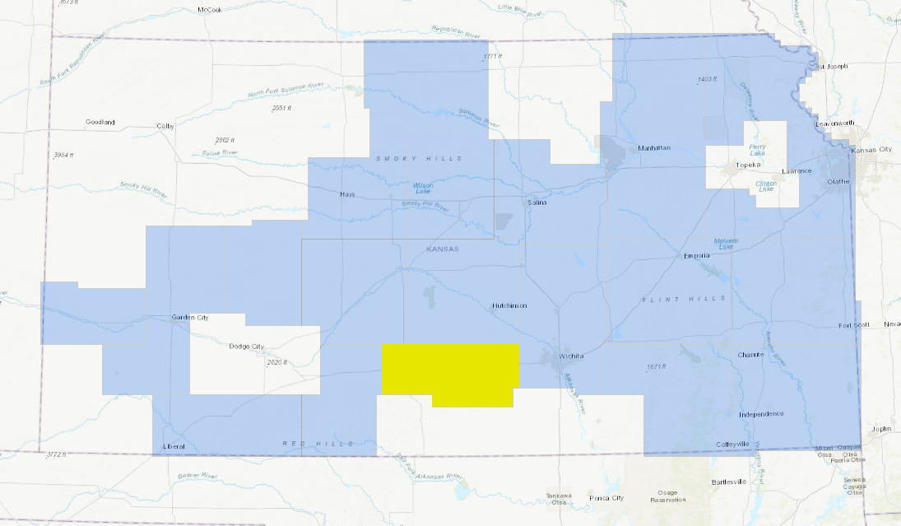
- Aerial LiDAR Project Overview – Defined Project Area (DPA) and Associated Areas of Interest (AOIs)

Project Purpose

The State of Kansas, on behalf of the Kansas Department of Agriculture and Kansas Data Access and Support Center, has contracted with Atlantic for professional services related to the development of Light Detection and Ranging (LiDAR). Additional partners include the USDA Natural Resource Conservation Service, the U.S. Geological Survey, the Kansas GIS Policy Board, the Kansas Department of Transportation and the Kansas Water Office. These LiDAR elevation data will be used for conservation planning, design, research, floodplain mapping, wetlands identification, dam safety assessments, hydrologic modeling, and subsidence monitoring.

Client Contact Information
Client Contact Information
Name of Contact | Tara Lanzrath, CFM
Organization | Kansas Department of Agriculture
Position | Floodplain Mapping Coordinator
Telephone | 785-296-2513
E-Mail Address | Tara.Lanzrath@ks.gov
Mailing Address | 6531 SE Forbes Ave., Suite B
City | Topeka
State or Province | Kansas
Postal Code | 66619
Table 1: Aerial LiDAR Client Contact Information

Contract Deliverables
Item | Specification/Format
Metadata | FGDC compliant, xml format
Project Report | .pdf format
Raw Point Cloud | Swaths, LAS 1.4
Classified Point Cloud | LAS 1.4
Bare Earth DEM | ERDAS .IMG format, Hydroflattened
First Return DSM | ERDAS .IMG format
Hydro Polygon Breaklines | .gdb format
Intensity Imagery | ERDAS .IMG format
Table 2: Aerial LiDAR Contract Deliverables

Field Operations

Aerial LiDAR Project – Aerial Acquisition

Aircraft & Sensor Information
Atlantic operated a Cessna (N732JE) outfitted with a Leica ALS70-HP LiDAR system during the collection of the project area. The specifications of this system are presented in the following table:
Parameter | Specification
Model | ALS70-HP
Manufacturer | Leica
Platform | Fixed-Wing
Scan Pattern | Sine, Triangle, Raster
Maximum Scan Rate (Hz) | Sine: 200  Triangle: 158  Raster: 120
Field of View (°) | 0 – 75 (Full Angle, User Adjustable)
Maximum Pulse Rate (kHz) | 500
Maximum Flying Height (m AGL) | 3500
Number of Returns | Unlimited
Number of Intensity Measurements | 3 (First, Second, Third)
Roll Stabilization (Automatic Adaptive, °) | 75 - Active FOV
Storage Media | Removable 500 GB SSD
Storage Capacity (Hours @ Max Pulse Rate) | 6
Size (cm) | Scanner: 37 W x 68 L x 26 H  Control Electronics: 45 W x 47 D x 36 H
Weight (kg) | Scanner: 43  Control Electronics: 45
Operation Temperature (°C) | 0 – 40
Flight Management | FCMS
Power Consumption | 927 @ 22.0 – 30.3 VDC
Table 6: System Specifications – ALS70-HP

Sensor Acquisition Information
The following table illustrates project specific system parameters for LiDAR acquisition on this project:
Parameter | Specification
System | Leica ALS70-HP
Nominal Pulse Spacing (m) | 0.71
Nominal Pulse Density (pls/m²) | 2.2
Nominal Flight Height (AGL meters) | 2000
Nominal Flight Speed (kts) | 130
Pass Heading (°) | 0
Sensor Scan Angle (°) | 45
Scan Frequency (Hz) | 33.9
Pulse Rate of Scanner (kHz) | 256,400
Line Spacing (m) | 1,171
Pulse Duration of Scanner (ns) | 4
Pulse Width of Scanner (m) | .35
Central Wavelength of Sensor Laser (nm) | 1064
Sensor Operated with Multiple Pulses | 2
Beam Divergence (mrad) | .15
Nominal Swath Width (m) | 1,740
Nominal Swath Overlap (%) | 20
Scan Pattern | TRIANGLE
Table 10: Aerial LiDAR Sensor Acquisition Parameters

Flight Plan Execution
Atlantic acquired 79 passes of the AOI as a series of perpendicular and/or adjacent flight-lines executed in 7 flight missions conducted between February 11, 2018 and April 29, 2018. Onboard differential Global Navigation Satellite System (GNSS) unit(s) recorded sample aircraft positions at 2 hertz (Hz) or more frequency. LiDAR data was only acquired when a minimum of six (6) satellites were in view.
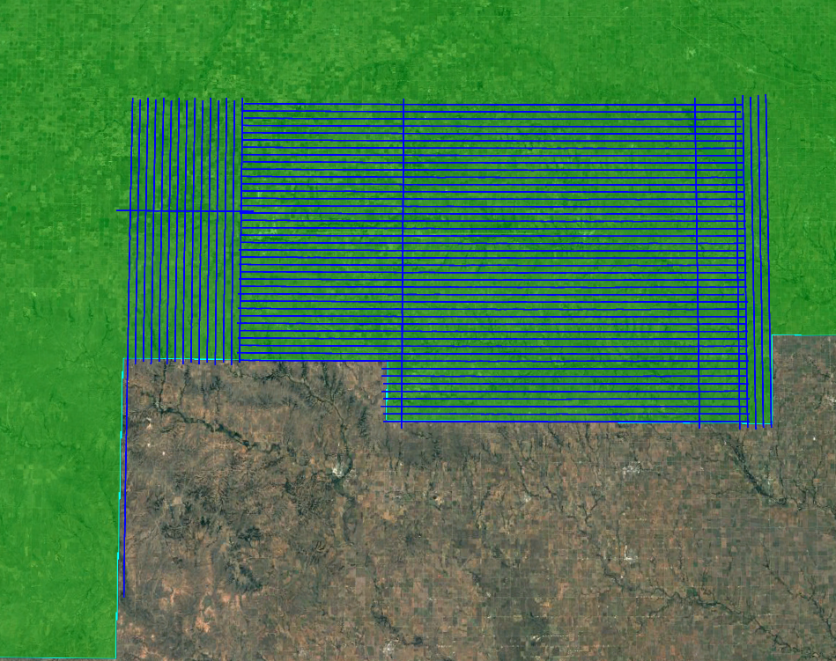
- Orientation of Executed Flight-lines and LiDAR DPA

GNSS Reference Stations
Eleven (11) Continuously Operating Reference Stations (CORS) were used to control the LiDAR acquisition for the defined project area. The coordinates provided in below are in NAD83 (2011), Geographic Coordinate System, Ellipsoid, Meters.
Designation | Type | PID | Latitude (N) | Longitude (W) | Elevation
ICT3 | CORS | ICT3 | 37°45'09.33297" | 97°12'58.42230 | 401.242m
ICT4 | CORS | ICT4 | 37°37'08.57671" | 97°37'57.00056" | 392.172m
ICT5 | CORS | ICT5 | 37°47'12.04062" | 97°37'32.73360" | 411.107m
KSPR | CORS | KSPR | 37°41'26.44138" | 98°44'27.53387" | 573.45m
KSBK | CORS | KSBK | 37°33'03.90852" | 99°38'06.26885" | 717.084m
KSCW | CORS | KSCW | 37°16'24.87324" | 99°19'39.34067" | 624.848m
KSAY | CORS | KSAY | 37°08'40.33068" | 98°01'49.57453" | 383.653m
KSKY | CORS | KSKY | 37°54'40.30614" | 99°24'21.76286" | 641.963m
KSGB | CORS | KSGB | 38°21'16.83108" | 98°45'53.40654" | 545.627m
KSHU | CORS | KSHU | 38°01'52.62370" | 97°54'08.45874" | 440.099m
OKBF | CORS | OKBF | 36°49'40.90146' | 99°38'28.88423" | 538.779m
Table 11: GNSS Reference Stations

Aerial LiDAR Project – Ground Acquisition

Ground Control Survey
A total of 72 ground survey points were collected in support of this project, including 19 LiDAR Control Points (LCP), 32 Non-vegetated Vertical Accuracy (NVA) and 21 Vegetated Vertical Accuracy (VVA).

Point cloud data accuracy was tested against a Triangulated Irregular Network (TIN) constructed from LiDAR points in clear and open areas. A clear and open area can be characterized with respect to topographic and ground cover variation such that a minimum of five (5) times the Nominal Pulse Spacing (NPS) exists with less than 1/3 of the RMSEZ deviation from a low-slope plane. Slopes that exceed ten (10) percent were avoided.

Each land cover type representing ten (10) percent or more of the total project area were tested and reported with a VVA. In land cover categories other than dense urban areas, the tested points did not have obstructions forty-five (45) degrees above the horizon to ensure a satisfactory TIN surface. The VVA value is provided as a target. It is understood that in areas of dense vegetation, swamps, or extremely difficult terrain, this value may be exceeded.

The NVA value is a requirement that must be met, regardless of any allowed “busts” in the VVA(s) for individual land cover types within the project. Checkpoints for each assessment (NVA & VVA) are required to be well-distributed throughout the land cover type, for the entire project area.

The following tables and figures outline the coordinate values and distribution of LCP, NVA and VVA points collected in support of this project:
ID | Easting | Northing | Elevation
LCP321 | 606210.033 | 4187082.513 | 455.845
LCP322 | 594831.41 | 4172026.541 | 448.235
LCP323 | 596362.922 | 4165699.367 | 431.984
LCP324 | 591670.856 | 4159295.112 | 469.519
LCP325 | 598946.951 | 4151226.583 | 451.276
LCP326 | 581289.478 | 4149311.527 | 462.226
LCP327 | 571165.951 | 4181298.778 | 500.931
LCP330 | 566924.722 | 4166995.726 | 478.873
LCP485 | 508595.759 | 4156757.143 | 626.714
LCP489 | 525478.462 | 4153610.773 | 585.306
LCP490 | 535955.422 | 4156893.632 | 564.632
LCP491 | 539097.479 | 4161139.446 | 559.994
LCP492 | 527622.785 | 4164847.925 | 552.055
LCP503 | 532516.214 | 4180857.97 | 580.136
LCP506 | 562158.14 | 4153861.914 | 517.347
LCP528 | 589405.33 | 4142953.445 | 425.579
LCP593 | 511666.019 | 4182225.826 | 612.006
LCP595 | 534013.414 | 4186386.102 | 571.254
LCP596 | 558547.915 | 4157577.762 | 520.247
Table 19: LiDAR Control Point Coordinates
- LiDAR Control Point Distribution
ID | Easting | Northing | Elevation
NVA423 | 513360.175 | 4175581.513 | 609.667
NVA429 | 508595.483 | 4156766.924 | 626.159
NVA431 | 539107.888 | 4161131.726 | 559.7
NVA432 | 581297.054 | 4149310.246 | 462.072
NVA433 | 591669.623 | 4159289.817 | 469.432
NVA434 | 525473.381 | 4153619.375 | 585.603
NVA435 | 594831.127 | 4172022.511 | 448.216
NVA436 | 562163.824 | 4153853.365 | 517.197
NVA437 | 532532.335 | 4180866.795 | 580.111
NVA438 | 571170.511 | 4181324.275 | 500.728
NVA624 | 506846.106 | 4174567.157 | 621.707
NVA630 | 571346.327 | 4173465.495 | 503.532
NVA631 | 554465.202 | 4156950.709 | 537.302
NVA632 | 560257.867 | 4143261.957 | 514.592
NVA633 | 544807.822 | 4174646.514 | 547.691
NVA634 | 539610.153 | 4152040.402 | 563.467
NVA635 | 584174.165 | 4175053.893 | 464.203
NVA636 | 581199.577 | 4156147.195 | 487.595
NVA637 | 581512.388 | 4139450.92 | 483.178
NVA638 | 599169.825 | 4138242.699 | 413.39
NVA822 | 511655.96 | 4182226.555 | 611.865
NVA831 | 578315.191 | 4166269.884 | 457.697
NVA832 | 585576.328 | 4182043.222 | 477.028
NVA833 | 550027.967 | 4166721.485 | 520.288
NVA834 | 523443.642 | 4175789.798 | 595.141
NVA835 | 551198.077 | 4143906.093 | 532.569
NVA836 | 601859.293 | 4146426.619 | 454.032
NVA837 | 550499.762 | 4184408.781 | 536.096
NVA838 | 574003.32 | 4144603.049 | 458.775
NVA862 | 578287.422 | 4160670.032 | 485.515
NVA891 | 508367.645 | 4166397.624 | 618.562
NVA896 | 554464.48 | 4156958.18 | 537.539
Table 20: Non-Vegetated Vertical Accuracy (NVA) Point Coordinates
- Non-Vegetated Vertical Accuracy (NVA) Point Distribution
ID | Easting | Northing | Elevation
VVA301 | 596382.884 | 4165699.025 | 431.654
VVA302 | 598966.078 | 4151227.612 | 451
VVA303 | 527621.588 | 4164827.308 | 551.926
VVA304 | 606208.687 | 4187097.111 | 455.658
VVA305 | 534021.941 | 4186371.282 | 571.279
VVA434 | 531488.635 | 4174607.375 | 565.538
VVA435 | 580112.487 | 4176585.733 | 482.048
VVA436 | 558541.507 | 4157576.384 | 520.198
VVA437 | 568920.424 | 4137008.804 | 515.151
VVA439 | 578295.718 | 4160680.123 | 485.636
VVA567 | 515065.905 | 4152665.405 | 608.343
VVA571 | 506333.034 | 4150297.285 | 605.72
VVA573 | 568800.623 | 4182894.52 | 485.314
VVA574 | 545109.205 | 4181110.437 | 555.618
VVA576 | 565519.228 | 4145918.081 | 485.03
VVA577 | 590741.481 | 4160331.974 | 445.227
VVA578 | 524706.043 | 4149167.207 | 556.731
VVA595 | 581533.723 | 4139460.171 | 482.696
VVA628 | 515067.158 | 4152653.016 | 608.321
VVA631 | 523448.467 | 4175794.954 | 594.971
VVA632 | 565508.182 | 4145915.077 | 485.084
Table 21: Vegetated Vertical Accuracy (VVA) Point Coordinates
- Vegetated Vertical Accuracy (VVA) Point Distribution

Data Production

Aerial LiDAR Project – Calibration/Classification

LiDAR Point Cloud Generation
Atlantic used Leica software products to download the IPAS ABGNSS/IMU data and raw laser scan files from the airborne system. Waypoint Inertial Explorer is used to extract the raw IPAS ABGNSS/IMU data, which is further processed in combination with controlled base stations to provide the final Smoothed Best Estimate Trajectory (SBET) for each mission. The SBETs are combined with the raw laser scan files to export the LiDAR ASCII Standard (*.las) formatted swath point clouds.

Coordinate Reference System
Horizontal Datum: NAD83(ITRF96)
Coordinate System: UTM, 14N
Vertical Datum: NAVD88
Geoid Model: 12B
Units of Reference: Meter

LiDAR Point Cloud Statistics
Category | Value
Total Points | 16,900,751,813
Nominal Pulse Spacing (m) | 0.6470
Nominal Pulse Density (pls/m²) | 2.3891
Nominal Pulse Spacing (ft) | 2.1226
Nominal Pulse Density (pls/ft²) | 0.2220
Aggregate Total Points | 15,747,366,343
Aggregate Nominal Pulse Spacing (m) | 0.5650
Aggregate Nominal Pulse Density (pls/m²) | 3.1329
Aggregate Nominal Pulse Spacing (ft) | 1.8536
Aggregate Nominal Pulse Density (pls/ft²) | 0.2911
Table 23: LiDAR Point Cloud Statistics

Smooth Surface Repeatability (Interswath)
Departures from planarity of first returns within single swaths in non-vegetated areas were assessed at multiple locations with hard surface areas (parking lots or large rooftops) inside the project area. Each area was evaluated using signed difference rasters (maximum elevation – minimum elevation) at a cell size equal to 2 x ANPS, rounded to the next integer. The following figure depicts a sample of the assessment.

LiDAR Calibration
Using a combination of GeoCue, TerraScan and TerraMatch; overlapping swath point clouds are corrected for any orientation or linear deviations to obtain the best fit swath-to-swath calibration. Relative calibration was evaluated using advanced plane-matching analysis and parameter corrections derived. This process was repeated interactively until residual errors between overlapping swaths, across all project missions, was reduced to ≤2cm. A final analysis of the calibrated lidar is preformed using a TerraMatch tie line report for an overall statistical model of the project area. Individual control point assessments for this project can be found in Section VI of this report.

Upon completion of the data calibration, a complete set of elevation difference intensity rasters (dZ Orthos) are produced. A user-defined color ramp is applied depicting the offsets between overlapping swaths based on project specifications. The dZ orthos provide an opportunity to review the data calibration in a qualitative manner. Atlantic assigns green to all offset values that fall below the required RMSDz requirement of the project. A yellow color is assigned for offsets that fall between the RMSDz value and 1.5x of that value. Finally, red values are assigned to all values that fall beyond 1.5x of the RMSDz requirements of the project.

LiDAR Classification
Multiple automated filtering routines are applied to the calibrated LiDAR point cloud identifying and extracting bare-earth and above ground features. GeoCue, TerraScan, and TerraModeler software was used for the initial batch processing, visual inspection and any manual editing of the LiDAR point clouds. Atlantic utilized collected breakline data to preform classification for classes 9 (Water) and 10 (Ignored Ground).
Code | Description
1 | Unclassified
2 | Ground
7 | Low point (noise)
9 | Water
10 | Ignored ground (breakline proximity)
`17 | Bridge
18 | High point (noise)
Table 24: LiDAR Point Classification Codes and Descriptions

LiDAR Intensity Imagery
LiDAR intensity imagery was created from the final calibrated and classified lidar point cloud. Intensity images were produced from all classified points and posted to a 0.5-meter cell size. Intensity images were cut to match the tile index and its corresponding tile names and delivered in .img format.

Hydro-line Collection/Conflation
Hydro breaklines were compiled using LiDAR intensity data and surface terrain models of the entire project area. After the collection, all delineated hydro features were validated for monotonicity and vertical variance. This procedure ensures that no points were floating above ground. Hydro-lines were then encoded into the LiDAR surface and used to hydro-enforce/flatten all significant water bodies. These final hydro-lines were then used in the production of bare Earth digital models to hydro flatten significant water bodies. This product was delivered as an ESRI geodatabase for the entire project area.

Bare-Earth Surface – Digital Elevation Model (DEM)
Bare earth Digital Elevation Models (DEMs) were derived using the hydro-lines and bare earth (ground) LiDAR points. All DEMs were created with a grid spacing of 1 meter. DEMs for this project were cut to match the tile index and its corresponding tile names and delivered in 32-bit floating point .img format.

Surface-Digital Elevation Model (DSM)
Surface digital elevation models (DSMs) were derived using all first return LiDAR points, excluding LiDAR points classified as high or low noise. All DSMs were created with a grid spacing of 1 meter. DSMs for this project were cut to match the tile index and its corresponding tile names and delivered in 32-bit floating point .img format.

Accuracy Assessment

Aerial LiDAR Project – Vertical Accuracy Assessment

Requirements
Per the table below, the Vertical Accuracy Assessment utilized the required parameters for Vertical Data Accuracy Class IV.
Vertical Data Accuracy Class | RMSEz in Non-Vegetated Terrain (cm) | Non-Vegetated Vertical Accuracy (NVA) at 95% Confidence Level (cm) | Vegetated Vertical Accuracy (VVA) at 95th Percentile (cm)
I | 1.0 | 2.0 | 2.9
II | 2.5 | 4.9 | 7.4
III | 5.0 | 9.8 | 14.7
IV | 10.0 | 19.6 | 29.4
V | 12.5 | 24.5 | 36.8
VI | 20.0 | 39.2 | 58.8
VII | 33.3 | 65.3 | 98.0
VIII | 66.7 | 130.7 | 196.0
IX | 100.0 | 196.0 | 294.0
X | 333.3 | 653.3 | 980.0
Table 25: Vertical Accuracy Standards, Source: ASPRS Positional Accuracy Standards for Digital Geospatial Data v1.0 (2014)
*The terms NVA and VVA are from the American Society for Photogrammetry and Remote Sensing (ASPRS) Positional Accuracy Standards for Digital Geospatial Data v1.0 (2014). The term NVA refers to assessments in clear, open areas (which typically produce only single LiDAR returns); the term VVA refers to assessments in vegetated areas (typically characterized by multiple return LiDAR).

Results
An overall statistical assessment of the check points can be found in the following two tables (values provided in meters):
Broad Land Cover Type | # of Points | RMSEz | 95% Confidence Level | 95th Percentile
NVA of Point Cloud | 32 | 0.0975 | 0.1912 | 0.1530
VVA of Point Cloud | 21 | 0.1035 | 0.2029 | 0.1770
NVA of DEM | 32 | 0.1022 | 0.2003 | 0.1596
VVA of DEM | 19 | 0.0983 | 0.1926 | 0.1608
Table 26: NVA/VVA Accuracies
PointID | Easting | Northing | KnownZ | LaserZ | Description | DeltaZ
Table 27: Outlier Check Points

Certification Statements

Aerial LiDAR Project
This accuracy assessment confirms that the data may be used for the intended applications stated in Section I of this document. This dataset may also be used as a topographic input for other applications, but the user should be aware that this LiDAR dataset was designed with a specific purpose and was not intended to meet specifications and/or requirements of users outside of the United States Geological Survey.

It should also be noted that LiDAR points do not represent a continuous surface model. LiDAR points are discrete measurements of the surface and any values derived within a triangle of three LiDAR points are interpolated. As such, the user should not use the resultant LiDAR dataset for vertical placement of a planimetric feature such as a headwall, building footprint or any other planimetric feature unless there is an associated LiDAR point that can be reasonably located on this structure.

Consideration should be given by the end user of this dataset to the fact that this LiDAR dataset was developed differently and separately than previous LiDAR datasets that may be available for this geographic location. It is likely that the data in this project was created using different geodetic control, a different Geoid, newer LiDAR technology and more up-to-date processing techniques. As such, any direct comparative analysis performed between this dataset and previous datasets could result in misleading or inaccurate results. Users are encouraged to proceed with caution while performing this type of comparative analysis and to completely understand the variables that make each of these datasets unique and not corollary.
It is encouraged that the user refers to the full FGDC Metadata and project reports for a complete understanding on the content of this dataset.
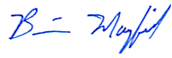
I, hereby, certify to the extent of my knowledge that the statements and statistics represented in this document are true and factual.

___________________________________________________
Brian J. Mayfield, ASPRS Certified Photogrammetrist #R1276

Control Point Assessments

Aerial LiDAR Project

Point Cloud Check Point Assessment
Point ID | Easting | Northing | KnownZ | LaserZ | Description | DeltaZ
NVA433 | 591669.623 | 4159289.817 | 469.4320 | 469.4370 | BARE EARTH | 0.0050
NVA432 | 581297.054 | 4149310.246 | 462.0720 | 462.0580 | BARE EARTH | (0.0140)
NVA631 | 554465.202 | 4156950.709 | 537.3020 | 537.2830 | BARE EARTH | (0.0190)
NVA831 | 578315.191 | 4166269.884 | 457.6970 | 457.6780 | BARE EARTH | (0.0190)
NVA637 | 581512.388 | 4139450.920 | 483.1780 | 483.1530 | BARE EARTH | (0.0250)
NVA833 | 550027.967 | 4166721.485 | 520.2880 | 520.2630 | BARE EARTH | (0.0250)
NVA638 | 599169.825 | 4138242.699 | 413.3900 | 413.4160 | BARE EARTH | 0.0260
NVA822 | 511655.960 | 4182226.555 | 611.8650 | 611.8910 | BARE EARTH | 0.0260
NVA630 | 571346.327 | 4173465.495 | 503.5320 | 503.5040 | BARE EARTH | (0.0280)
NVA633 | 544807.822 | 4174646.514 | 547.6910 | 547.7320 | BARE EARTH | 0.0410
NVA837 | 550499.762 | 4184408.781 | 536.0960 | 536.0520 | BARE EARTH | (0.0440)
NVA431 | 539107.888 | 4161131.726 | 559.7000 | 559.6460 | BARE EARTH | (0.0540)
NVA832 | 585576.328 | 4182043.222 | 477.0280 | 476.9660 | BARE EARTH | (0.0620)
NVA434 | 525473.381 | 4153619.375 | 585.6030 | 585.6750 | BARE EARTH | 0.0720
NVA436 | 562163.824 | 4153853.365 | 517.1970 | 517.1250 | BARE EARTH | (0.0720)
NVA635 | 584174.165 | 4175053.893 | 464.2030 | 464.2760 | BARE EARTH | 0.0730
NVA423 | 513360.175 | 4175581.513 | 609.6670 | 609.7420 | BARE EARTH | 0.0750
NVA632 | 560257.867 | 4143261.957 | 514.5920 | 514.5160 | BARE EARTH | (0.0760)
NVA636 | 581199.577 | 4156147.195 | 487.5950 | 487.5160 | BARE EARTH | (0.0790)
NVA435 | 594831.127 | 4172022.511 | 448.2160 | 448.1320 | BARE EARTH | (0.0840)
NVA862 | 578287.422 | 4160670.032 | 485.5150 | 485.4160 | BARE EARTH | (0.0990)
NVA896 | 554464.480 | 4156958.180 | 537.5390 | 537.4320 | BARE EARTH | (0.1070)
NVA634 | 539610.153 | 4152040.402 | 563.4670 | 563.3580 | BARE EARTH | (0.1090)
NVA437 | 532532.335 | 4180866.795 | 580.1110 | 579.9970 | BARE EARTH | (0.1140)
NVA891 | 508367.645 | 4166397.624 | 618.5620 | 618.6790 | BARE EARTH | 0.1170
NVA438 | 571170.511 | 4181324.275 | 500.7280 | 500.6070 | BARE EARTH | (0.1210)
NVA835 | 551198.077 | 4143906.093 | 532.5690 | 532.4410 | BARE EARTH | (0.1280)
NVA836 | 601859.293 | 4146426.619 | 454.0320 | 453.8730 | BARE EARTH | (0.1590)
NVA838 | 574003.320 | 4144603.049 | 458.7750 | 458.6140 | BARE EARTH | (0.1610)
NVA834 | 523443.642 | 4175789.798 | 595.1410 | 594.9710 | BARE EARTH | (0.1700)
NVA624 | 506846.106 | 4174567.157 | 621.7070 | 621.9040 | BARE EARTH | 0.1970
NVA429 | 508595.483 | 4156766.924 | 626.1590 | 626.3580 | BARE EARTH | 0.1990
VVA436 | 558541.507 | 4157576.384 | 520.1980 | 520.1990 | BRUSH | 0.0010
VVA439 | 578295.718 | 4160680.123 | 485.6360 | 485.6350 | BRUSH | (0.0010)
VVA302 | 598966.078 | 4151227.612 | 451.0000 | 451.0050 | BRUSH | 0.0050
VVA437 | 568920.424 | 4137008.804 | 515.1510 | 515.1460 | BRUSH | (0.0050)
VVA632 | 565508.182 | 4145915.077 | 485.0840 | 485.0670 | BRUSH | (0.0170)
VVA573 | 568800.623 | 4182894.520 | 485.3140 | 485.2950 | BRUSH | (0.0190)
VVA631 | 523448.467 | 4175794.954 | 594.9710 | 594.9940 | BRUSH | 0.0230
VVA434 | 531488.635 | 4174607.375 | 565.5380 | 565.5620 | BRUSH | 0.0240
VVA304 | 606208.687 | 4187097.111 | 455.6580 | 455.6320 | BRUSH | (0.0260)
VVA576 | 565519.228 | 4145918.081 | 485.0300 | 485.0020 | BRUSH | (0.0280)
VVA303 | 527621.588 | 4164827.308 | 551.9260 | 551.9600 | BRUSH | 0.0340
VVA595 | 581533.723 | 4139460.171 | 482.6960 | 482.6320 | BRUSH | (0.0640)
VVA435 | 580112.487 | 4176585.733 | 482.0480 | 482.1260 | BRUSH | 0.0780
VVA301 | 596382.884 | 4165699.025 | 431.6540 | 431.7410 | BRUSH | 0.0870
VVA577 | 590741.481 | 4160331.974 | 445.2270 | 445.1080 | BRUSH | (0.1190)
VVA628 | 515067.158 | 4152653.016 | 608.3210 | 608.4630 | BRUSH | 0.1420
VVA571 | 506333.034 | 4150297.285 | 605.7200 | 605.8940 | BRUSH | 0.1740
VVA578 | 524706.043 | 4149167.207 | 556.7310 | 556.9060 | BRUSH | 0.1750
VVA305 | 534021.941 | 4186371.282 | 571.2790 | 571.4560 | BRUSH | 0.1770
VVA567 | 515065.905 | 4152665.405 | 608.3430 | 608.5250 | BRUSH | 0.1820
VVA574 | 545109.205 | 4181110.437 | 555.6180 | 555.4100 | BRUSH | (0.2080)
Table 28: Point Cloud Check Point Assessment

Digital Elevation Model (DEM) Check Point Assessment
Point ID | Easting | Northing | KnownZ | DEMZ | Description | DeltaZ
NVA423 | 513360.175 | 4175581.513 | 609.6670 | 609.7401 | BARE EARTH | 0.0731
NVA429 | 508595.483 | 4156766.924 | 626.1590 | 626.3511 | BARE EARTH | 0.1921
NVA431 | 539107.888 | 4161131.726 | 559.7000 | 559.6214 | BARE EARTH | (0.0786)
NVA432 | 581297.054 | 4149310.246 | 462.0720 | 462.0567 | BARE EARTH | (0.0153)
NVA433 | 591669.623 | 4159289.817 | 469.4320 | 469.4247 | BARE EARTH | (0.0073)
NVA434 | 525473.381 | 4153619.375 | 585.6030 | 585.6706 | BARE EARTH | 0.0676
NVA435 | 594831.127 | 4172022.511 | 448.2160 | 448.1437 | BARE EARTH | (0.0723)
NVA436 | 562163.824 | 4153853.365 | 517.1970 | 517.1327 | BARE EARTH | (0.0643)
NVA437 | 532532.335 | 4180866.795 | 580.1110 | 579.9829 | BARE EARTH | (0.1281)
NVA438 | 571170.511 | 4181324.275 | 500.7280 | 500.5981 | BARE EARTH | (0.1299)
NVA624 | 506846.106 | 4174567.157 | 621.7070 | 621.9096 | BARE EARTH | 0.2026
NVA630 | 571346.327 | 4173465.495 | 503.5320 | 503.5085 | BARE EARTH | (0.0235)
NVA631 | 554465.202 | 4156950.709 | 537.3020 | 537.2589 | BARE EARTH | (0.0431)
NVA632 | 560257.867 | 4143261.957 | 514.5920 | 514.5243 | BARE EARTH | (0.0677)
NVA633 | 544807.822 | 4174646.514 | 547.6910 | 547.7393 | BARE EARTH | 0.0483
NVA634 | 539610.153 | 4152040.402 | 563.4670 | 563.3516 | BARE EARTH | (0.1154)
NVA635 | 584174.165 | 4175053.893 | 464.2030 | 464.2645 | BARE EARTH | 0.0615
NVA636 | 581199.577 | 4156147.195 | 487.5950 | 487.4974 | BARE EARTH | (0.0976)
NVA637 | 581512.388 | 4139450.920 | 483.1780 | 483.1360 | BARE EARTH | (0.0420)
NVA638 | 599169.825 | 4138242.699 | 413.3900 | 413.3119 | BARE EARTH | (0.0781)
NVA822 | 511655.960 | 4182226.555 | 611.8650 | 611.8717 | BARE EARTH | 0.0067
NVA831 | 578315.191 | 4166269.884 | 457.6970 | 457.6367 | BARE EARTH | (0.0603)
NVA832 | 585576.328 | 4182043.222 | 477.0280 | 476.9286 | BARE EARTH | (0.0994)
NVA833 | 550027.967 | 4166721.485 | 520.2880 | 520.2308 | BARE EARTH | (0.0572)
NVA834 | 523443.642 | 4175789.798 | 595.1410 | 594.9860 | BARE EARTH | (0.1550)
NVA835 | 551198.077 | 4143906.093 | 532.5690 | 532.4413 | BARE EARTH | (0.1277)
NVA836 | 601859.293 | 4146426.619 | 454.0320 | 453.8644 | BARE EARTH | (0.1676)
NVA837 | 550499.762 | 4184408.781 | 536.0960 | 536.0607 | BARE EARTH | (0.0353)
NVA838 | 574003.320 | 4144603.049 | 458.7750 | 458.6139 | BARE EARTH | (0.1611)
NVA862 | 578287.422 | 4160670.032 | 485.5150 | 485.4175 | BARE EARTH | (0.0975)
NVA891 | 508367.645 | 4166397.624 | 618.5620 | 618.6951 | BARE EARTH | 0.1331
NVA896 | 554464.480 | 4156958.180 | 537.5390 | 537.4212 | BARE EARTH | (0.1178)
VVA301 | 596382.884 | 4165699.025 | 431.6540 | 431.6944 | BRUSH | 0.0404
VVA302 | 598966.078 | 4151227.612 | 451.0000 | 451.0360 | BRUSH | 0.0360
VVA303 | 527621.588 | 4164827.308 | 551.9260 | 551.9445 | BRUSH | 0.0185
*VVA304 | 606208.687 | 4187097.111 | 455.6580 | - | BRUSH | -
*VVA305 | 534021.941 | 4186371.282 | 571.2790 | - | BRUSH | -
VVA434 | 531488.635 | 4174607.375 | 565.5380 | 565.5243 | BRUSH | (0.0137)
VVA435 | 580112.487 | 4176585.733 | 482.0480 | 482.0746 | BRUSH | 0.0266
VVA436 | 558541.507 | 4157576.384 | 520.1980 | 520.1881 | BRUSH | (0.0099)
VVA437 | 568920.424 | 4137008.804 | 515.1510 | 515.1326 | BRUSH | (0.0184)
VVA439 | 578295.718 | 4160680.123 | 485.6360 | 485.6233 | BRUSH | (0.0127)
VVA567 | 515065.905 | 4152665.405 | 608.3430 | 608.5057 | BRUSH | 0.1627
VVA571 | 506333.034 | 4150297.285 | 605.7200 | 605.8786 | BRUSH | 0.1586
VVA573 | 568800.623 | 4182894.520 | 485.3140 | 485.2908 | BRUSH | (0.0232)
VVA574 | 545109.205 | 4181110.437 | 555.6180 | 555.4124 | BRUSH | (0.2056)
VVA576 | 565519.228 | 4145918.081 | 485.0300 | 484.8910 | BRUSH | (0.1390)
VVA577 | 590741.481 | 4160331.974 | 445.2270 | 445.1120 | BRUSH | (0.1150)
VVA578 | 524706.043 | 4149167.207 | 556.7310 | 556.8768 | BRUSH | 0.1458
VVA595 | 581533.723 | 4139460.171 | 482.6960 | 482.6575 | BRUSH | (0.0385)
VVA628 | 515067.158 | 4152653.016 | 608.3210 | 608.4816 | BRUSH | 0.1606
VVA631 | 523448.467 | 4175794.954 | 594.9710 | 594.9155 | BRUSH | (0.0555)
VVA632 | 565508.182 | 4145915.077 | 485.0840 | 485.0919 | BRUSH | 0.0079
*Points VVA304 & VVA305 were outside the DEM delivery boundary.
Table 30: DEM Check Point Assessment

