MN_Southern-Area_2012
Lidar Editing Document – January 31, 2014
Reviewer: Leslie Lansbery
DEM
The two errors noted below are for a project that has been accepted by QA. Please review for editing process. The project is located on the Rolla Server in Maine – MN_Southern-Area_2012.
Error labeled water_2: DEM grid 19tdk275020
The above error shows a drop of about 2.3 feet. There is no dam located at this point, but there is a section of rapids here. What we did notice when looking at this error is the series of polygon/polyline breaklines (see image below). By all accounts, the elevation goes downhill/downstream and there are impoundments along the way. The vendor has created polyline features along the river sections that flow downhill and polygons along the wider sections that maintain a constant elevation. There are two dams located along the waterway in this stretch (shown on image below looking at ancillary data). Per the specs (v 13 and 1.0) under Inland Ponds and Lakes, “long impoundments such as reservoirs, inlets, and fjords, whose water surface elevations drop when moving downstream, are required to be treated as rivers”. Does this qualify for the error, which we thought it may have. If so, breaklines will need to be corrected to be polyline features. There is a corrected tile for this DEM, but there is a tile mismatch between the old tiles and the new ones.

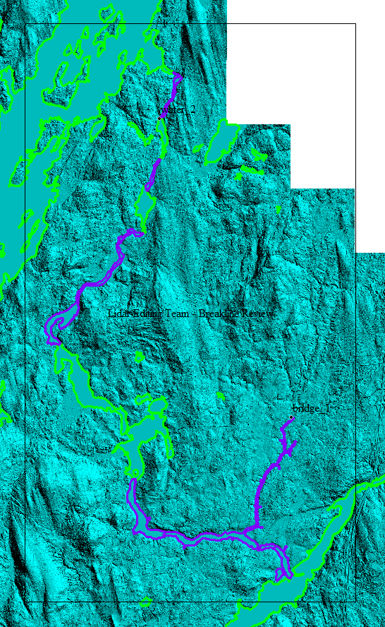
The purple shapefiles represent Polyline Breaklines from the vendor. These delineate the rivers and maintain a downhill gradient.
The green shapefiles represent Polygon Breaklines from the vendor. These delineate the lakes/ponds and maintain a constant elevation.
Yellow arrows indicate places that dams are located using ancillary data.

Error labeled missing_data_1: DEM grid 19tdk290035
The original error shows missing data near the shore of a lake. The vendor corrected the error, but in review, there is a tile has a mismatch that appears only in the water:
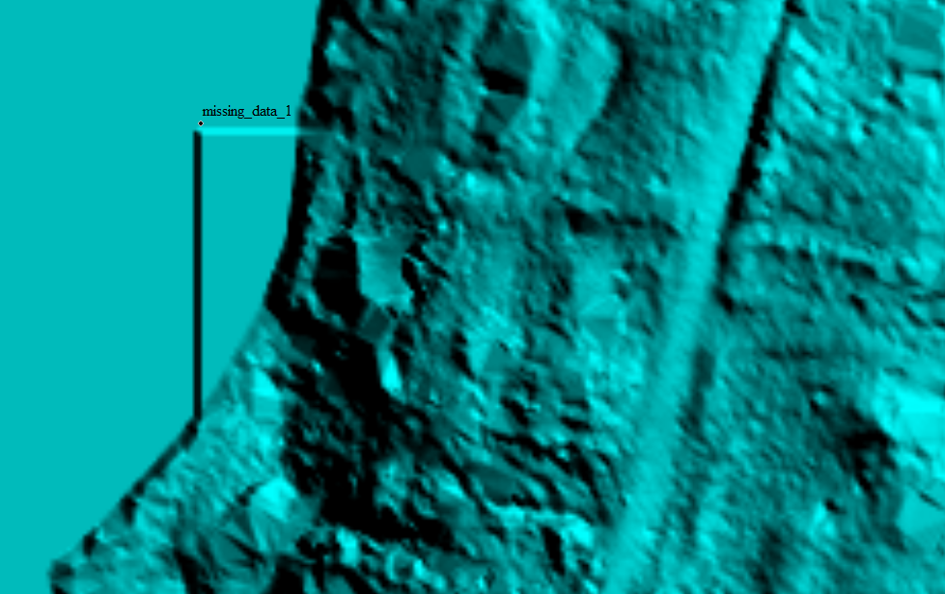
Figure 1: Tile mismatch seen at location of error
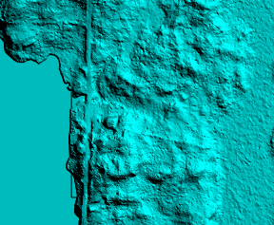
Figure 2: Bottom left-hand edge of corrected tile. Mismatch appears in water.
Misclassification – Footprint
From Tom in QA Report: Upon fixing some water errors, the contractor classified ground as water in a few areas (on the eastern edge of project), thus affecting the topography. The NGTOC-created footprint removed those areas from the DEM. The Final-to-NED was created from the loaded (new) DEMs with the other, existing DEM tiles.None of the re-delivered tiles (DEMs) were altered.
The footprint is located in NGTOC_Created_Metadata folder. The errors relating to bad edges and ground classified as water are located in NEDerrorsupdated_errors folder. The footprint has been altered to cut out the bad edge and water that should be ground. The DEMs were not clipped to the footprint to remove the bad areas. At the time, a mosaic was created to remove the areas, but since we no longer create mosaics, the DEMs may need clipped instead. A review of the DEM edge and footprint show that a majority of the DEM’s have been clipped back a little for bad edges; more than just the errors indicate. A review of the DEM boundary with footprint is needed to determine how best to handle the bad edges.
Raw Swath
Point Cloud Statistics for the Swath data shows 4 classes used in classification (probably due to sensor used in acquisition).
Project Folder Notes
The project folder is located on the V: drive. There is a folder labeled DO_NOT_USE which contains the original DEM grids and swath along with the re-delivered classified .las files. I have already run Point Cloud Statistics on the re-delivered classified .las and replaced the old .las tiles in the CLICKLAS_1.2 folder. However, if a problem is seen, I have a back-up copy of the original classified .las on an external hard drive.

