LiDAR Quality Assessment Report
State: AR Project Name: AR_LAnguille_2011
Project ID: XXXX Project Type: LiDAR QA/QC
Year Funded: XXXX Materials Received Date: XXXX
Project Description: LiDAR was collected at a 0.5 m nominal post spacing (NPS) for approximately 955 mi² of an area generally encompassing the L'Anguille watershed in parts of Craighead, Cross, Lee, Poinsett, St. Francis, and Woodruff Counties, Arkansas. Data was acquired during leaf-off conditions while no snow was on the ground and rivers were at or below normal levels. The project area required a 0.5 m NPS and a required 9.25 cm vertical accuracy (VA). Lifts are planned to meet project specifications and are flown under cloud-free conditions in order to collect LIDAR points at an average of 0.5 m point spacing.
Project Alias(es): none
Year of Collection: ___2011____
Lot ___1,2, & 3__ of __1,2, & 3___
Project Extent: (Insert below)

(Insert below)

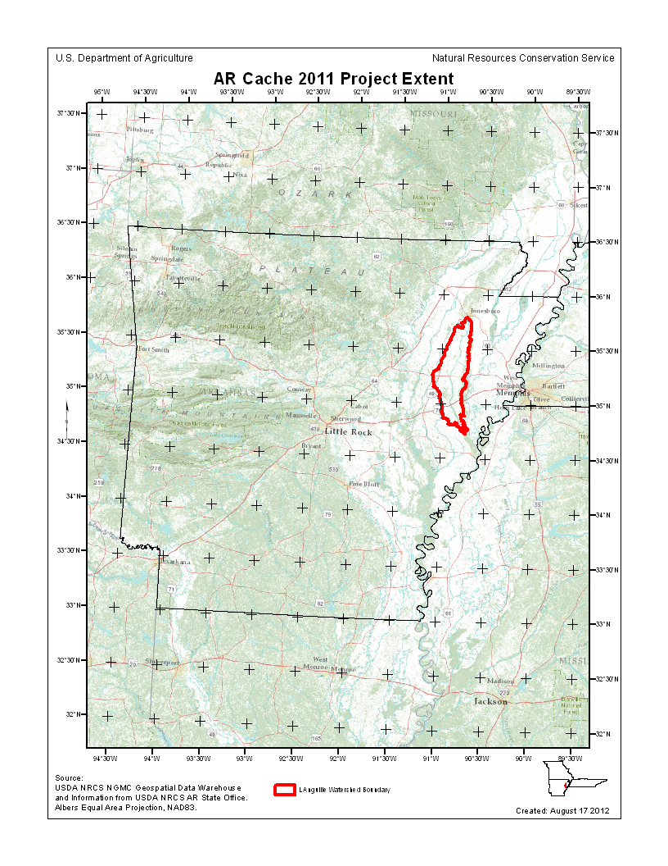

Project Tiling Scheme:
Project Tiling Scheme Image? (Insert below)
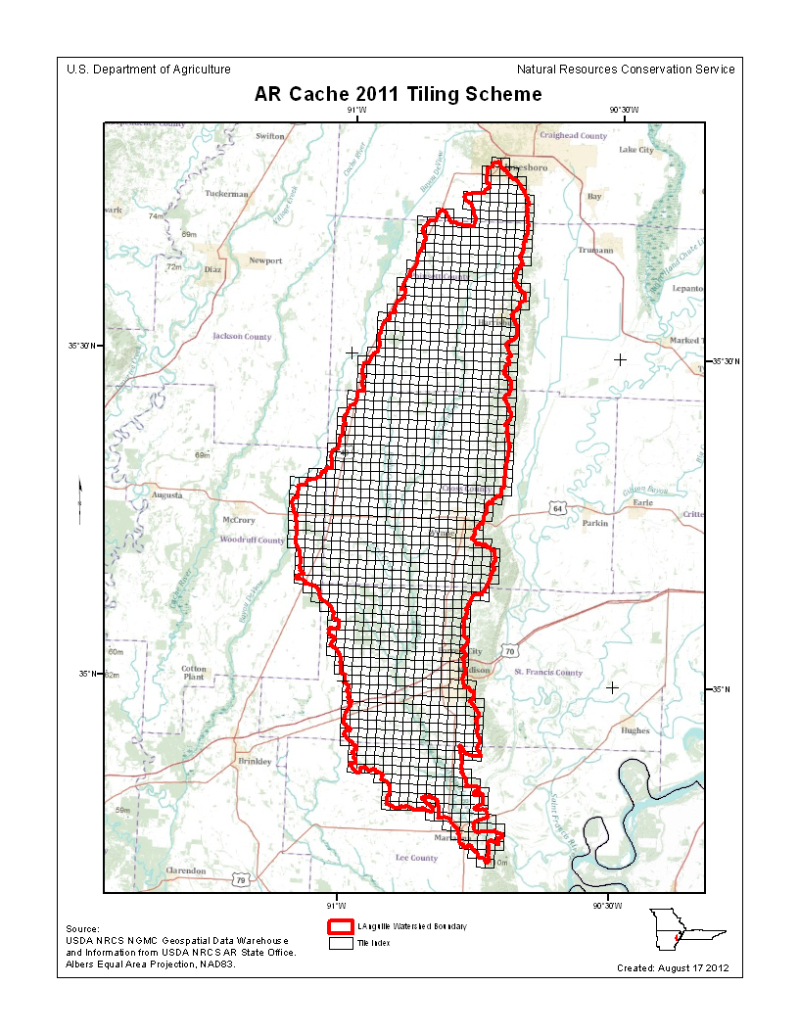

Contractor: | Applicable Specification:
PhotoScience

Licensing Restrictions:
Third Party Performed QA?
Project Points of Contact:
POC Name | Type: | Primary Phone: | E-Mail:
Mark Meade | Click here to enter text. | 859-277-8700 | mmeade@photoscience.com

:

Project Deliverables:
All project deliverables must be supplied according to collection and processing specifications. The NRCS will postpone the QA process when any of the required deliverables are missing. When deliverables are missing, the Contracting Officer Technical Representative (COTR) will be contacted by the Elevation/Ortho imagery Section supervisor and informed of the problem. Processing will resume after the COTR has coordinated the deposition of remaining deliverables.

Collection Report Project Tiling Scheme Shapefile/Gdb
Survey Report Breakline Shapefile/Gdb
Processing Report Project XML Metadata
QA/QC Report Swath LAS SML Metadata
Control and Calibration Points Classified LAS Metadata
Project Shapefile/ Geodatabase Breakline XML Metadata
Control Point Shapefile/Gdb Bare-Earth DEM XML Metadata

Multi-File Deliverables:
File Type Quantity
Classified LAS Files 1,239
Intensity Image Files 1,239
Tiled LAS Files 1,239
Breakline Files 3 shape files
Bare-Earth DEM Files 1,239
Additional Deliverables:
Are there Errors, Anomalies, and Other Issues to document?

Comments: __________________________________________________________________________

Project Geographic Information:
Aerial Extent: 955 mi²
Grid Size: 1 m
Tile Size: 1,500 x 1,500 ft
NPS Required: 0.5 m
NPS Reported: 0.63 pt/m²
Vertical Datum: NAVD 88 ft
Horizontal Datum: NAD 83 m

Project Projection/Coordinate Reference System: UTM Zone 15N

File Type | Datum | Coordinate System | Units (x,y) | Units (z)
Classified LAS (.LAS) | NAD 83 | UTM Zone 15N | m | ft
Deliverable Boundary (.shp) | NAD 83 | UTM Zone 15N | m | NA
First Return DEM (.img) | NAD 83 | UTM Zone 15N | m | ft
Hydro-Flattened Breaklines (.shp) | NAD 83 | UTM Zone 15N | m | NA
Hydro-Flattened DEM (.img) | NAD 83 | UTM Zone 15N | m | ft
Intensity Images (.tif) | NAD 83 | UTM Zone 15N | m | NA
Control Points (.shp) | NAD 83 | State Plane AR North | m | ft
Tile Index (.shp) | NAD 83 | UTM Zone 15 N | m | NA

Review Cycle
Reviewer: | Review Start Date:
Brent Duncan, … | 5/30/2012

Metadata Review

Provided metadata files have been parsed using 'mp' metadata parser. Any errors generated by the parser are documented below for reference and/or corrective action. Indicate Validation status as ‘with’ or ‘without’ errors.

The Project XML Metadata file parsed with/without no errors.
The Swath LAS XML Metadata file parsed with/without NA.
The Classified LAS XML Metadata file parsed with/without no errors.
The Breakline XML Metadata file parsed with/without no errors.
(Document Parser Errors here)

Project QA/QC Report Review
Verify that the following recommendations/guidelines were followed:

ASPRS recommends that checkpoint surveys be used to verify the vertical accuracy of LiDAR data sets. Checkpoints are to be collected by an independent survey firm licensed in the particular state(s) where the project is located. While subjective, checkpoints should be well distributed throughout the dataset. National Standards for Spatial Data Accuracy (NSSDA) guidance states that checkpoints may be distributed more densely in the vicinity of important features and more sparsely in areas that are of little or no interest. Checkpoints should be distributed so that points are spaced at intervals of at least ten percent of the diagonal distance across the dataset and at least twenty percent of the points are located in each quadrant of the dataset. NSSDA and ASPRS require that a minimum of twenty checkpoints (thirty is preferred) are collected for each major land cover category represented in the LiDAR data. Checkpoints should be selected on flat terrain, or on uniformly sloping terrain in all directions from each checkpoint. They should not be selected near severe breaks in slope, such as bridge abutments, edges of roads, or near river bluffs. Checkpoints are an important component of the NRCS QA process. There is the presumption that the checkpoint surveys are error free and the discrepancies are attributable to the LiDAR dataset supplied.
For this dataset, NRCS checked the spatial distribution of checkpoints with an emphasis on the bare-earth (open terrain) points; the number of points per class; the methodology used to collect these points; and the relationship between the data supplier and checkpoint collector. When independent control data are available, NRCS has incorporated this into the analysis.

Checkpoint Shapefile or Geodatabase:
Checkpoint/Distribution Image? (Insert below)
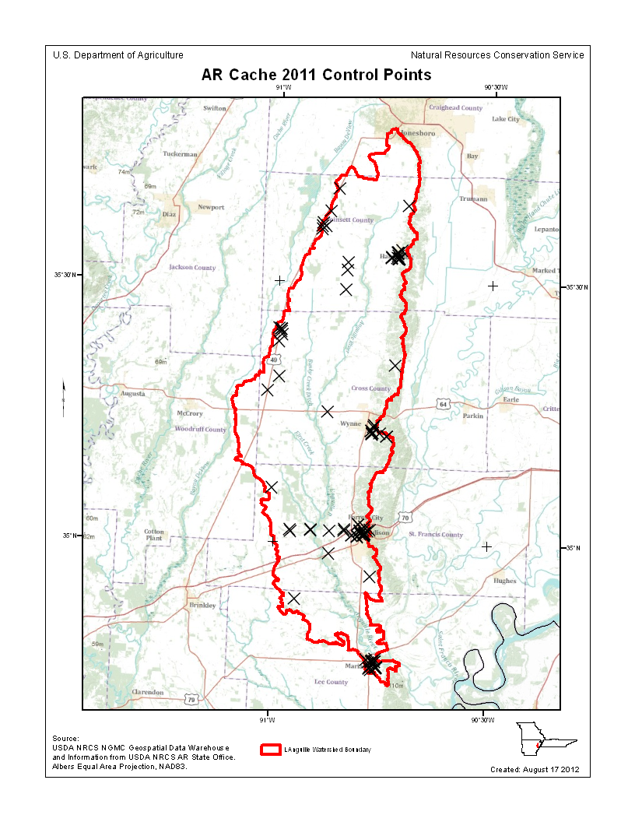

The following land cover classes are represented in this dataset (uncheck any that do not apply):
Bare Earth
Tall Weeds and Crops
Brush Lands and Low Trees
Forested Areas Fully Covered by Trees
Urban Areas with Dense Man-Made Structures

There are a minimum of _7 (“urban- cnc”)_ checkpoints for each land cover class represented.

Are the points within each class uniformly distributed throughout the dataset?

Was NRCS able to locate independent checkpoints for this analysis?

Did NRCS accept the quality of the checkpoint data for these LiDAR datasets?

Are there Errors, Anomalies, and Other Issues to document?

Comments: __________________________________________________________________________

Image? (Insert below)

Appendix A, Guidance for Aerial Mapping and Surveying, to FEMA’s “Guidelines and Specifications for Flood Hazard Mapping Partners” requires a minimum of 60 test points -- 20 each in a minimum of three land cover categories representative of the floodplain. FEMA’s Procedure Memorandum No. 61 – “Standards for LiDAR and Other High Quality Digital Topography” -- specifies that the positional accuracy of LiDAR shall be in accordance with ASPRS/NDEP standards for accuracy testing as well as the USGS “LiDAR Guidelines and Base Specifications, v13.” All of these standards and guidelines require testing for Fundamental Vertical Accuracy (FVA), Supplemental Vertical Accuracy (SVA), and Consolidated Vertical Accuracy (CVA), using a minimum of 20 checkpoints each in a minimum of three land cover categories for a minimum
total of 60 QA/QC checkpoints. Although tentative tests are performed on smaller subareas with fewer than 20 QA/QC checkpoints, Dewberry’s final results will not be official until all areas are merged for testing of the total area with all project checkpoints. Accuracy values are reported in terms of Fundamental Vertical Accuracy (FVA), Supplemental Vertical Accuracy(s) (SVA), and Consolidated Vertical Accuracy (CVA).

Accuracy values are reported in: (example: U.S. feet): cm
Required FVA Value is 18.3 cm or less.
Target SVA Value is or less.
Required CVA Value is or less.

The reported FVA of the LAS data is 15.8 cm (NOTE: only nine bare earth points were provided).
The reported FVA of the Bare-Earth DEM data is .

SVA are required for each land cover type present in the data set with the exception of bare-earth. SVA is calculated and reported as a 95th Percentile Error.
Land Cover Type | SVA Value | Units
Brush | 17.5 | cm
“CP” | 15.6 | cm
Plowed field | Data is non-normal and cannot be tested & only 12 points available | cm
Short grass | Data is non-normal and cannot be tested | cm
Tall grass | 21.2 | cm
Urban asphalt | 19.9 | cm
Urban concrete | Data is non-normal and cannot be tested & only 7 points available | cm
Urban gravel | Data is non-normal and cannot be tested & only 12 points available | cm
Woods | Data is non-normal and cannot be tested | cm

The reported CVA of this data set is: 21.7 cm.

LAS Swath File Review

LAS swath files or raw unclassified LiDAR data are reviewed to assess the quality control used by the data supplier during collection. Furthermore, LAS swath data are checked for positional accuracy. The data supplier should have calculated the Fundamental Vertical Accuracy using ground control checkpoints measured in clear open terrain. The following was determined for LAS swath data for this project:

LAS Version:
Swath File Characteristics:
Separate folder for LAS swath files
Each swath files <= 2GB
*If specified, *.wdp files for full waveform have been provided

The reported FVA of the LAS swath data is .

Based on this review, can NRCS accept the LAS swath file data?

Are there Errors, Anomalies, and Other Issues in this document?

Image? (Insert Below)

LAS Tile File Review
Classified LAS tile files are used to build digital terrain models using the points classified as ground. Therefore, it is important that the classified LAS are of sufficient quality to ensure that the derivative product accurately represents the landscape that was measured. The following was determined for classified LAS files for this project:

Classified LAS Tile File Characteristics

Separate folder for Classified LAS tile
Classified LAS tile files conform to Project Tiling Scheme

Quantity of Classified LAS tile files conforms to Project Tiling Scheme
Classified LAS tile files do not overlap
Classified LAS tile files are uniform in size (Note: minus some perimeter files based on AOI)
Classified LAS tile files have no points classified as '12'

Point classifications are limited to the standard values listed below:
(Example below – Extra table to populate if values DIFFERENT than those below)

Code | Description
1 | Processed, but unclassified
2 | Bare-earth ground
7 | Noise (low or high, manually identified, if needed)
9 | Water
10 | Ignored ground (breakline proximity)
11 | Withheld (if the “Withheld” bit is not implemented in processing software)

Code | Description
8 | Model Key Points

Buy Up?

Based on this review, can NRCS accept the classified LAS tile file data?

Are there Errors, Anomalies, and Other Issues to document?

There are complications with the 3D profile window such that it will not display the data in TIN fashion. Therefore, I had to view the cloud as points only.

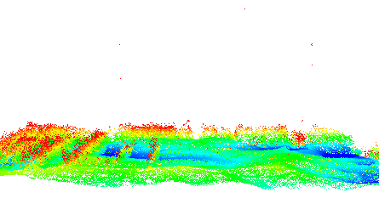

Figure 1. Spikes example (record 1) - NOTE: During Cache QAQC it was discovered that the spikes could be unclassified or “noise.” These spikes were discovered to be noise.

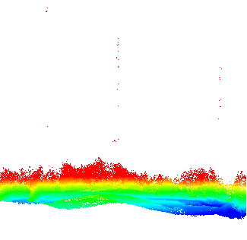

Figure 2. Spikes example within the area for record 1 - NOTE: During Cache QAQC it was discovered that the spikes could be unclassified or “noise.” These spikes were discovered to be noise.

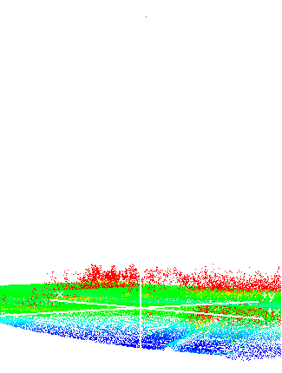
Figure 3. Spike example (record 2) – NOTE: This spike belongs to Class 11. Class 11 was not requested in the SOW.

Breakline File Review

Breaklines are vector feature classes that are used to hydro-flatten the bare earth
Digital Elevation Models.
Breakline File Characteristics:
Separate folder for breakline files
All breaklines captured as PolylineZ or PolygonZ features
No missing or misplaced breaklines

Based on this review, can NRCS accept the breakline files.

Are there Errors, Anomalies, and Other Issues in this document?

None or Describe

Bare-Earth DEM Tile File Review
The derived bare-earth DEM file receives a review of the vertical accuracies provided by the data supplier, vertical accuracies calculated by NRCS using supplied and independent checkpoints, and a manual check of the appearance of the DEM layer.

Bare-Earth DEM files provided in the following format: X ERDAS Imagine *.img or .

Bare-Earth DEM Tile File Characteristics:
Separate folder for bare-earth DEM files
DEM files conform to Project Tiling Scheme
Quantity of DEM files conforms to Project Tiling Scheme
DEM files do not overlap
DEM files are uniform in size
DEM files properly edge match
Independent check points are well distributed

All accuracy values reported in (units) .

Reported Accuracies (Example – use empty form below example to populate)

Land Cover Category | # of Points | Fundamental  Vertical Accuracy  @95% Confidence  Interval (Accuracyz)  Required FVA = .06  or less. | Supplemental Vertical Accuracy  @95th Percentile  Error  Target SVA =  1.195 or less. | Consolidated  Vertical  Accuracy @95th  Percentile Error  Required CVA =  1.195 or less.
Open Terrain
Tall Weeds and Crops
Brush Lands and Low
Trees
Forested Areas Fully
Covered by Trees
Urban Areas with Dense
Man-Made Structures
Consolidated

Populate form below:
Land Cover Category | # of Points | Fundamental  Vertical Accuracy  @95% Confidence  Interval (Accuracyz)  Required FVA =  or less. | Supplemental Vertical Accuracy  @95th Percentile  Error  Target SVA =  or less. | Consolidated  Vertical  Accuracy @95th  Percentile Error  Required CVA =  or less.

QA performed Accuracy Calculations?

Based on this review, can NRCS recommend the bare-earth DEM files for inclusion in the 1/3 Arc-Second National Elevation Dataset?

Based on this review, can NRCS accept the bare-earth DEM files?

Bare-Earth DEM Anomalies, Errors, Other Issues:
Are there Errors, Anomalies, and Other Issues in this document?

Based on this review, do the deliverables provided meet the Task Order requirements?

