NGMC LiDAR Quality Assessment Report

State: AR Project Name: AR_LAnguillee_2011 Project Type: LiDAR QA
Year Funded: Materials Received Date: 1/12/2012, 06/15/2012 Project ID:

Project Description: LIDAR and Derivative Products for L’Anguille Watershed, AR for USDA Natural Resources Conservation Service (NRCS).

LiDAR was collected at a 0.5 meter nominal post spacing for approximately 955 square miles of an area generally encompassing the L'Anguille watershed in parts of Craighead, Cross, Lee, Poinsett, St. Francis and Woodruff Counties, Arkansas. Data was acquired during leaf-off conditions while no snow was on the ground and rivers were at or below normal levels. The project area required a 0.5 meter nominal post spacing and a required 9.25cm Vertical Accuracy. Lifts are planned to meet project specifications and are flown under cloud-free conditions in order to collect LIDAR points at an average of 0.5 meter point spacing. This allows the user to create Intensity Images, Breaklines, and fully Classified LiDAR LAS files
Project Alias(es):
Year of Collection: 2011
AR_LAnguille_2011 Project Extent: West Bounding Coordinates: -91.104250 North Bounding Coordinates: 35.797262
East Bounding Coordinates: -90.696861 South Bounding Coordinates: 34.728640
Project Extent Locator Image:
AR_LAnguillee_2011 is part of a three project area collection encompassing 955 square miles of L’Anguille (shown in pink in the graphic below) , 2007 square miles of the Cache Watershed, and 1140 square miles of Lake Conway-Point Removed Area .
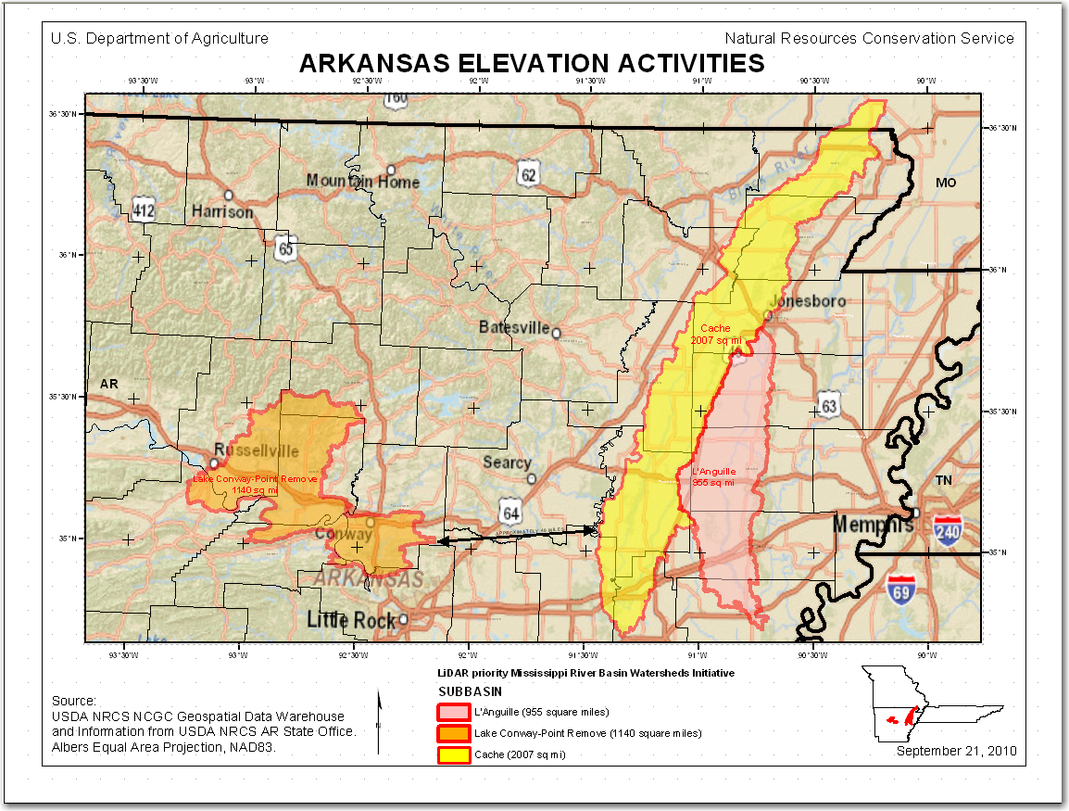

Project Extent ‘Overview’ showing L’Anguille Watershed over 2010 NAIP Imagery and seamless ERDAS Imagine mosaics of the 1st Return DEM and the Hydro Flattened DEM (HF DEM) in order to display project wide elevation ranges.
The 1st Return DEM ranges from 178.85 to 526.987. The HF DEM ranges from 178.28 to 470.232
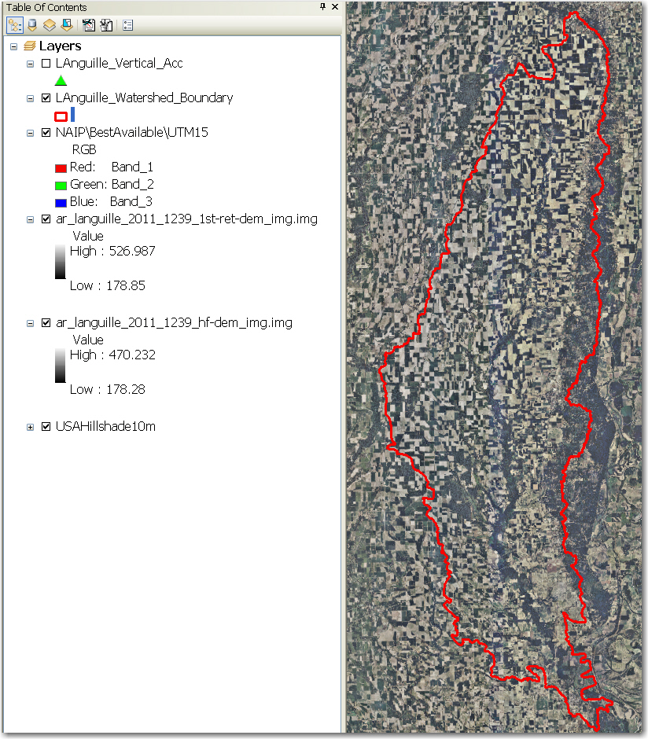

Project Tiling Scheme:

AR_LAnguille_2011 includes three tiles indexes: LAnguille_Lot1_Tile_Index, LAnguille_Lot2_Tile_Index and LAnguille_Lot3_Tile_Index dated 1/19/12 which combined have 1239 tiles.

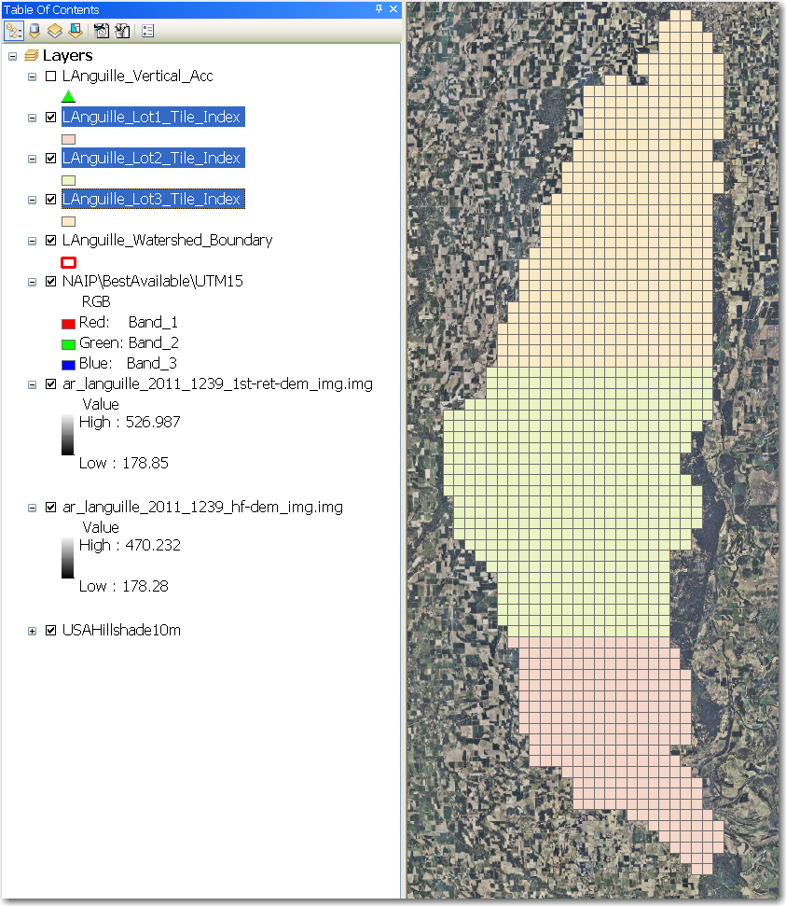

Contractor: Photo Science, Inc. products.

Applicable Specification: LAS 1.2 files

Licensing Restrictions: N/A

Third Party Performed QA? No. All previous QA was performed by vendor Photo Science, Inc.

Project Points of Contact:

POC Name | Primary Phone: | E-Mail:
Mark Meade | 859-277-8700 | mmeade@photoscience.com

Project Deliverables Received:
N - Collection Report – N/A Not Requested, Not Received
Y Project Tiling Scheme Shapefile – 3 shapefiles
Y - Survey Report – ‘LAnguille Vertical Accuracy’
Y - Hydro Flattened Breakline (HFB) Shapefiles (3)
N - Processing Report – N/A Not Requested, Not Received
Y - Project XML Metadata - ‘NRCS_ LAnguille _Arkansas_Project_Metadata’
N - QA/QC Report – N/A Not Requested, Not Received
N - Swath LAS Metadata – N/A Not Requested, Not Received
Y- Control and Calibration Points Shapefile ‘All_AR_Survey_Project’ with separate ‘LAnguille’ tab
Y - Classified LAS Metadata - NRCS_LAnguille_Arkansas_Classified_LAS_Metadata’
Y - Project Shapefiles – ‘LAnguille_Watershed_Boundary’
Y – Hydro Breakline XML Metadata – ‘NRCS_LAnguille_Arkansas_Hydro_Breakline_Metadata’
Y - Control Point Shapefile – ‘LAnguille Vertical Accuracy’ (Survey Report .shp)
Y - Bare-Earth DEM XML Metadata ‘NRCS_ LAnguille _Arkansas_Hydro_Breakline_Metadata’
Multi-File Deliverables:

File Type Quantity
N - Swath LAS Files 0
Y - Intensity Image Files 1239
Y- CLASSIFIED LAS Files 1239
Y – Hydro Flattened Breakline Files 3 Shapefiles (LAnguille_Lot1_Hydro_Flattened_Breaklines,
LAnguille_Lot2_Hydro_Flattened_Breaklines, and
LAnguille_Lot3_Hydro_Flattened_Breaklines,
Y Bare Earth DEM Files 1239 Hydro Flattened DEM files
Y – First Return DEM 1239

Additional Deliverables - Geodatabases:
BareEarth_Terrain_final_delivery.gdb – “LAnguille_Watershed_BareEarth_LiDAR.gdb’

Errors, Anomalies, Other Issues to documents:

Project Geographic Information:
Areal Extent: 955 Sq. Mi.
DEM Grid Size: 1 Meter (metadata says 2m but measured at 1 M per requirement)
Tile Size: 1500 m X 1500 m
NPS required: 0.5 meters
NPS calculated <>> meters
Vertical Datum: NAVD88 U.S. Feet
Horizontal Datum: NAD 1983 U.S. Feet
Requested Project Projection/Coordinate Reference System: NAD 1983 UTM Zone 15N Meters
The Projection Coordinate Ref. System Delivered: : UTM Zone 15N

File Type | Datum | Coordinate System | Units-XY | Units-Z
Classified LAS (.las) | NAD 1983 | UTM Zone 15N | m
Deliverable_Boundary (.shp) | NAD 1983 | UTM Zone 15N | m | N/A
Bare Earth Terrain (LAnguille_BE_DEM.gdb) | NAD 1983 | UTM Zone 15N | m
First Return Terrain (.gdb) <need CHECK> | NAD 1983 | UTM Zone 15N | m
LiDAR Bare Earth DEM (.img) | NAD 1983 | UTM Zone 15N | m
LiDAR First Return (.img) | NAD 1983 | UTM Zone 15N | m
Hydro-Flattened Breaklines (.shp) | NAD 1983 | UTM Zone 15N | m
Hydro Flattened DEM (.img) | NAD 1983 | UTM Zone 15N | m
Intensity Images (.tif) | NAD 1983 | UTM Zone 15N | m | N/A
Control Survey (LAnguille_V_A.shp) | NAD 1983 | UTM Zone 15N | m | U.S. Survey Ft
Tile Index | NAD 1983 | UTM Zone 15N | m | N/A

Review Cycle
Reviewer: | Review Start Date:
Charlotte Odom, Brent Duncan, LiDAR team | 08/15 /2012

Metadata Review
Provided 4 metadata files provided consist of:
NRCS_LAnguille_Arkansas_Classified_LAS_Metadata.xml
NRCS_ LAnguille_Arkansas _Hydro_Breakline_Metadata.xml
NRCS_ LAnguille_Arkansas _Project_Metadata.xml
NRCS_ LAnguille_Arkansas _RasterDEM_Metadata.xml

NRCS_ LAnguille_Arkansas _Project_Metadata file parsed without errors.
NRCS_LAnguille_Arkansas_Classified_LAS_Metadata file parsed without errors.
NRCS_ LAnguille_Arkansas _Hydro_Breakline_Metadata file parsed without errors.
NRCS_ LAnguille_Arkansas _RasterDEM_Metadata FAILED TO PARSE

Errors, Anomalies, Other Issues to document? Yes:
- NRCS LAnguille Arkansas RasterDEM Metadata FAILED TO PARSE giving the following error message: mismatched tag at line 88 column 4 Trying another XML Parser to check well-formedness: XML error on line 81: Mismatched tag
- The Abscissa and Ordinate Resolution shown in the Spatial Reference section of all four metadata files is give as 2 meters. The data delivered is 1-m data.

Project QA/QC Report Review
Checkpoint Shapefile: Y - Checkpoint/Distribution Image (Shown below displayed on NED10_relief)
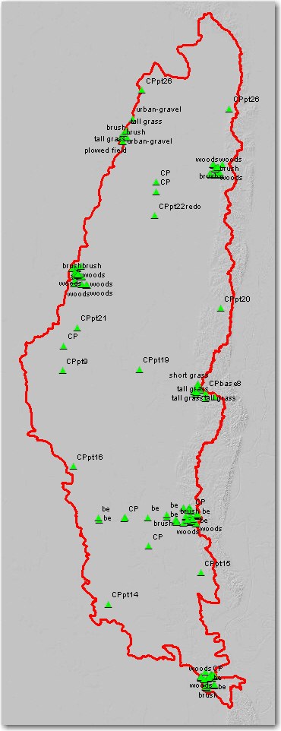

The land cover classes listed in the layer properties classification tab of the LAS layer include:
Class Value | Label
 | <all other Values>
2 | Ground
3 | Low Vegetation
4 | Medium Vegetation
5 | High Vegetation
6 | Building
7 | Low Point (noise)
8 | Model Keypoint (mass point)

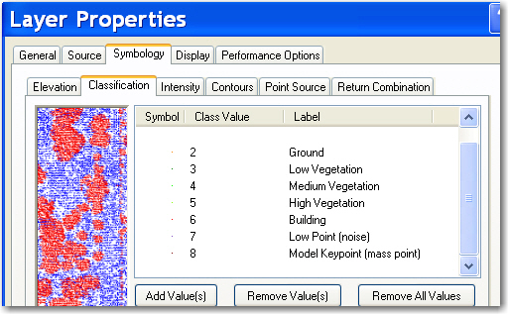

No independent checkpoints were located for this analysis.

Errors, Anomalies, Other Issues to document? Yes. Reports generated using USGS Vertical Accuracy Tools and LP360 QAQC tools in ArcGIS need further evaluation and documentation.
LP360 All Class Cts report showed 27 cts of Class 12 as shown in the graphic below:
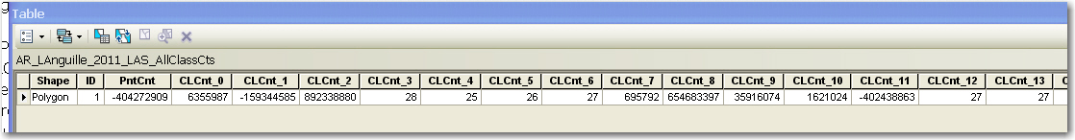
NOTE: Checkpoint collection has at least 60 test points -- 20 each in a minimum of three land cover categories representative of the floodplain (BE-CkPts, short grass, urban asphalt.

Accuracy values are reported in terms of Fundamental Vertical Accuracy (FVA),
Supplemental Vertical Accuracy(s) (SVA), and Consolidated Vertical Accuracy (CVA).

Accuracy values are reported in: (example: U.S. feet): cm
Required FVA Value is 0.595’ ft or less.
Target SVA Value is 0.595’ ft or less.
Required CVA Value is or less. 0.595’ ft or less.

Results from the Control Point Report generated by using LP360 to compare Control Points to the LiDAR data are shown below:
--------- Report Summary ---------
Error Mean: -1.624
Error Range: [-55.380,0.748]
Skew*: -5.022
RMSE(z): 7.080
NMAS/VMAS
Accuracy(z) (90% CI): ±11.647
ASPRS/NSSDA
Accuracy(z) (95% CI): ±13.877

* The skew exceeds ±0.5.
Further investigation of the error values are recommended to determine
if vertical errors follow a normal error distribution.

240 control points included in summary out of 240
- 0 control points turned off
- 0 control points returned no-data

--------- End Report Summary ---------
--------- Surface Definition ---------
Surface Method: Triangulation (TIN)

Classification Filter Used:
-ALL classification values used in filter

Return Combination Filter Used:
-ALL return combinations used in filter
--------- End LP360 Control Point Report Surface Definition ---------

The reported FVA of the LAS data is ft .
The reported FVA of the LAS Swath data is .
The reported FVA of the Bare-Earth DEM data is .

USGS SVA tool results

SVA are required for each land cover type present in the data set with the exception of bare-earth. SVA is calculated and reported as a 95th Percentile Error.

* The skew exceeds ±0.5. Further investigation of the error values are recommended to determine if vertical errors follow a normal error distribution.

The reported CVA of this data set is: .

LAS Swath File Review:
The following was determined for LAS swath data for this project: not requested/not delivered

LAS Swath Version: N/A
Swath File Characteristics: Received ONLY classified LAS, No Swath files
N -Separate folder for LAS swath files (No Swath files delivered)
N - Each swath files <= 2GB
N/A *If specified, *.wdp files for full waveform have been provided

The reported FVA of the LAS swath data is N/A.

LAS Tile File Review
The following Classified LAS Tile File Characteristics were determined for this project:

Y - Separate folder for Classified LAS tile
Y - Classified LAS tile files conform to Project Tiling Scheme
Y - Quantity of Classified LAS tile files conforms to Project Tiling Scheme
Y- Classified LAS tile files do not overlap
Y - Classified LAS tile files have no points classified as '12'

Classifications present in the LAS files:

Code | Description
1 | “All Other Values” (processed but not classified)
2 | Ground
3 | Low Vegetation
4 | Medium Vegetation
5 | High Vegetation
6 | Building
7 | Low Point (Noise)
8 | Model Keypoint (mass point)

Errors, Anomalies, Other Issues to document?

None or Describe: a ‘Data Void’ measuring approximately 339-acres was found in 15_07053849 as shown in the following two graphics.

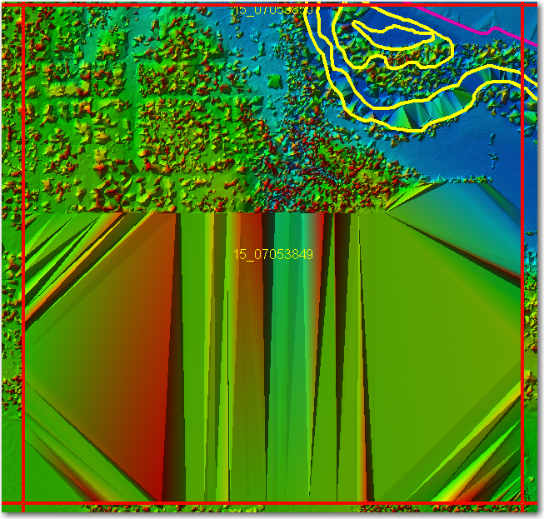

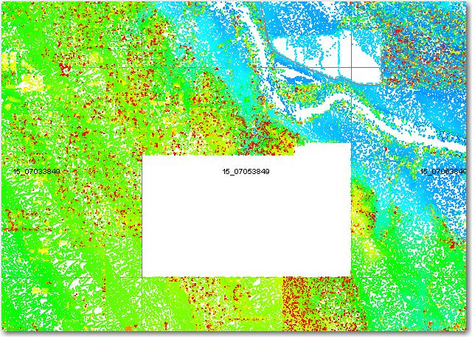

Additional concern Issues were detected during QAQC review including numerous instances of ‘thin signal’ as shown in the graphic below of the thin signal across seven tiles in one column 15_07083948-07083957.
USGS NGP LiDAR Guidelines and Base Specification Version 13- - ILMF 2010 requires that no Data Void (areas=>(4*NPS)sq within a single swath are acceptable. Further evaluation is recommended to determine whether areas of ‘thin signal’ meet this requirement.
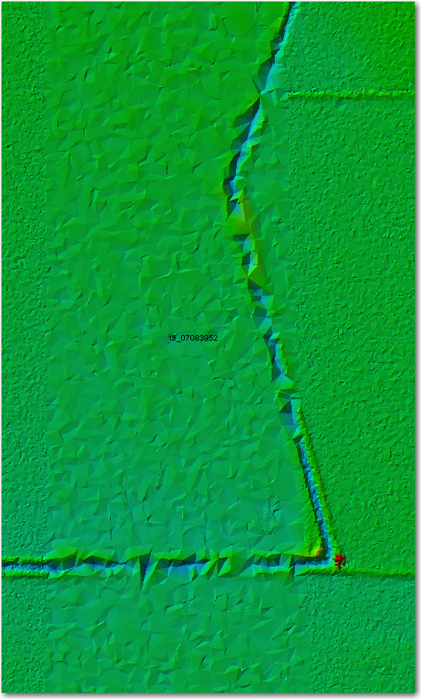

LP360 software was used to generate a QA/QC Feature Class Shapefile “AR_LAnguille_2011_QAQC.shp” which geolocates the concern issues encountered.
‘Spikes‘ and ‘Dips’ which were located in the AR_LAnguille_2011 dataset (examples shown below) were determined to be sensor noise and were classified as such.
<See Brent Duncan report >

Breakline File Review
Characteristics of Breakline Files provided :
Separate folder for breakline files? Yes
All breaklines captured as PolylineZ? Yes (Polyline ZM)

Review of the 2011 LAnguille Watershed Project data raised numerous Hydro Flattened Breakline
(HFB) placement concerns. No HFB were created in instances which would seem to require them. The following 2 graphics illustrate this concern.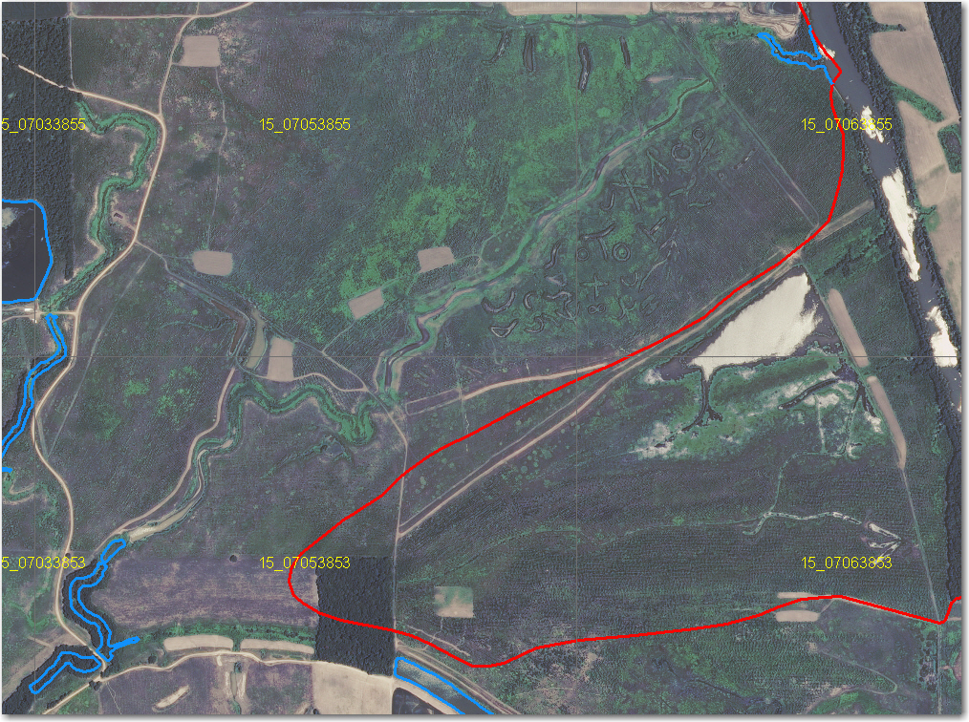

No HFB have been created to connect ‘hanging’ stream portions to the flow source.

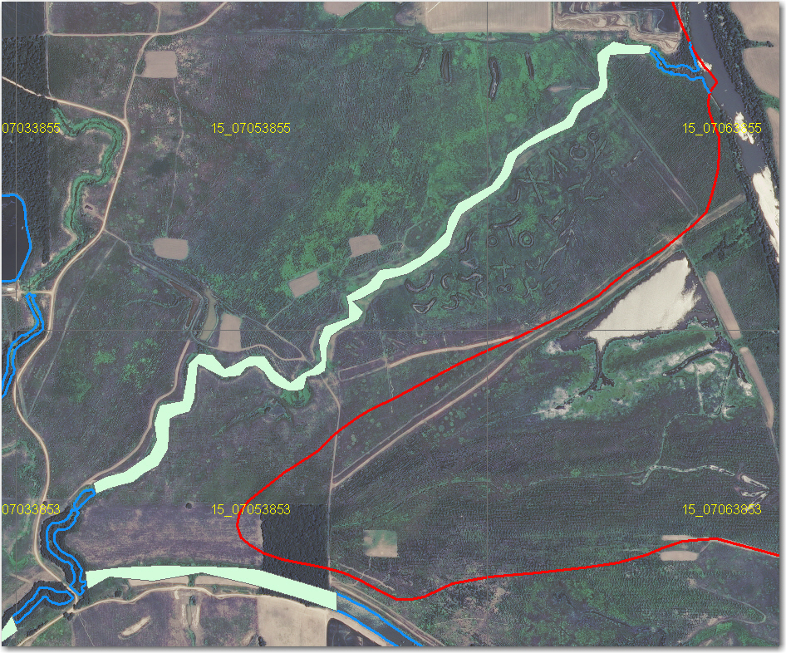
Example from previous with suggested HFB placement.

HFBs WERE generated in some areas which would appear not to need HFB such as in saturated fields. (one example from 15_06963859 shown below first with the HFB over the intensity image mosaic and then over the USDA Best Available NAIP layer.)

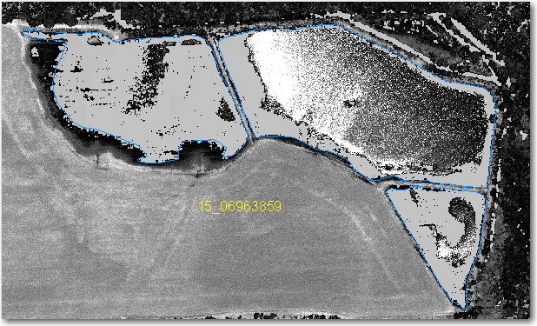

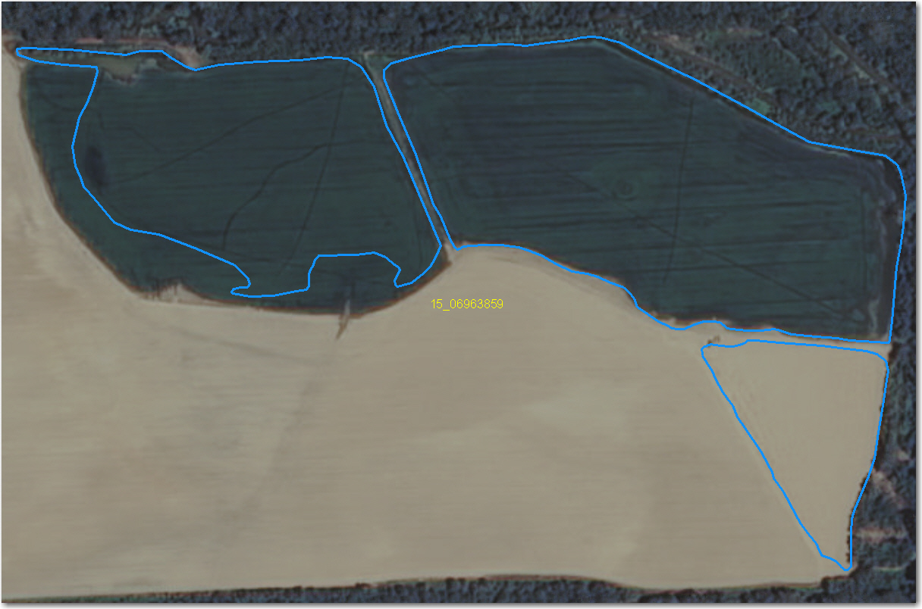

It has been suggested that a hydro flattened DEM should provide the same detail as that of 7.5’ USGS topographic quadrangles; that the degree to which hydrographic features are hydro flattened in a LiDAR delivery should be consistent with the standards used by USGS for compiling 1:24,000 scale topographic quadrangles.

Rivers, Ditches and Sloughs which are considered major enough to be shown on DRGs in which are include in the NHD layers have not been hydro flattened in the AR_LAnguille_2011 dataset provided to NRCS. Neither do the HFB feature class shapefiles received include some of the ‘Major Streams’ as determined by Arkansas Water Org and depicted on their interactive Watershed and County maps available at:
http://arkansaswater.org/index.php?option=com_content&task=view&id=127
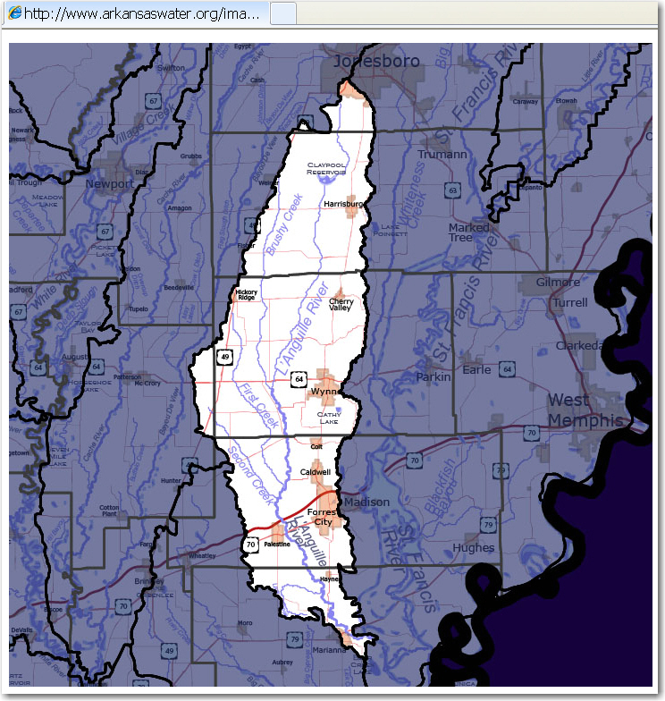

Overview of AR_LAnguille_2011 Hydro Flattened Breaklines (HFB) displayed over an ERDAS Imagine 2010 seamless mosaic of the Hydro Flattened DEMs provided.

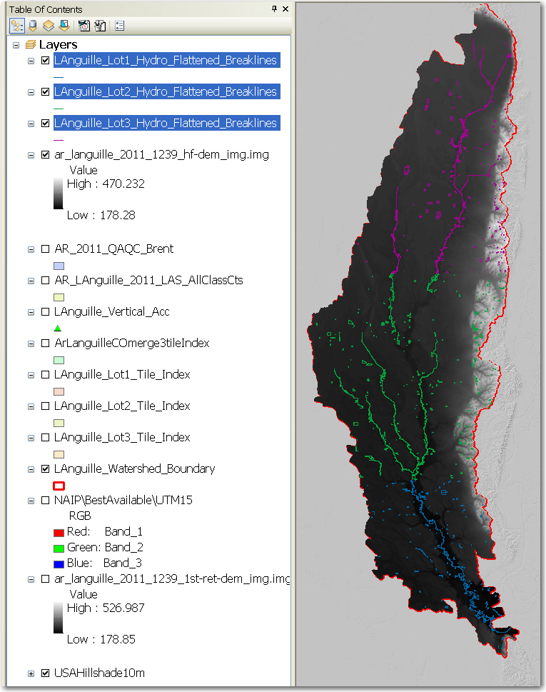
Bare-Earth DEM Tile File Review
The derived bare-earth DEM file receives a review of the vertical accuracies provided by the data supplier, vertical accuracies calculated by NRCS using supplied and independent checkpoints, and a manual check of the appearance of the DEM layer.

Bare-Earth DEM files provided in the following format: ERDAS Imagine *.img. ERDAS Imagine 2010 seamless mosaic of Bare Earth (Hydro Flattened) DEMS shown below:

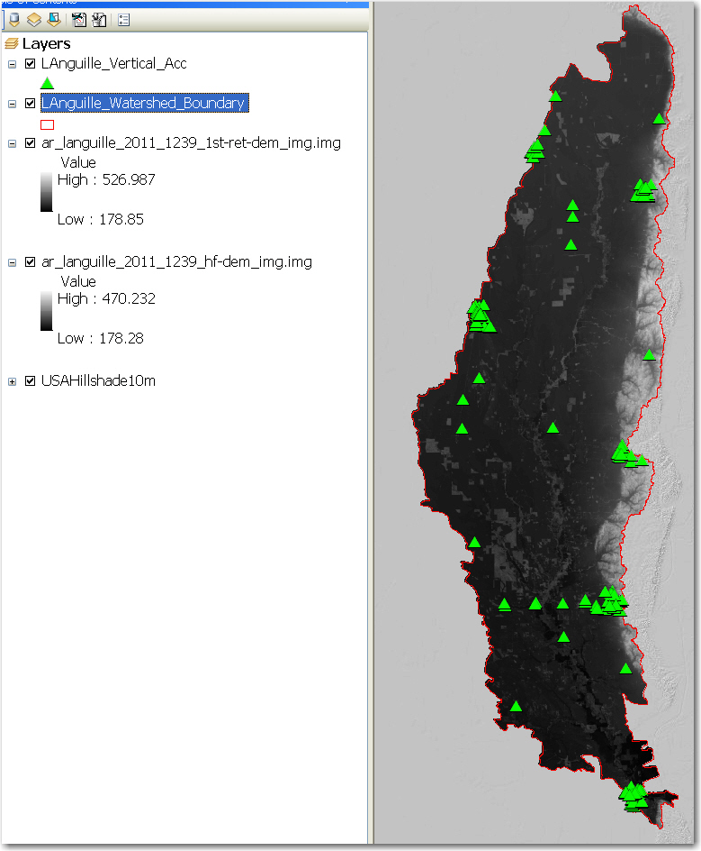

Bare-Earth DEM Tile File Characteristics:
Y- Separate folder for bare-earth DEM files
Y - DEM files conform to Project Tiling Scheme
Y - Quantity of DEM files conforms to Project Tiling Scheme
Y - DEM files do not overlap
N - DEM files are uniform in size
check - DEM files properly edge match
N/A - Independent check points are well distributed

All accuracy values reported in decimal feet with 2-decimal point precision.

Reported Accuracies

Land Cover Category | # of Points | Fundamental  Vertical Accuracy  @95% Confidence  Interval (Accuracyz)  Required FVA = 0.595'  or less. | Supplemental Vertical Accuracy  @95th Percentile  Error  Target SVA =  0.595' or less. | Consolidated  Vertical  Accuracy @95th  Percentile Error  Required CVA =  0.595' or less.
Open Terrain
Low Vegetation
High Vegetation
Trees
All Points

