**New York State**

**Airborne LiDAR Acquisition Report**

*for*

**New York State Office of Information Technology Services**

**10B Airline Drive**

**Albany, New York 12235**

**Erie, Genesee, and Livingston Counties**

*by*

**Axis Geospatial, LLC**

**28640 Mary’s Court, STE 200**

**Easton, Maryland 21601**

**Axis Project 13367-1916**

**July 2019**



# Table of Contents

July 2015

Section 1: Table of Contents 2

Section 2: Introduction 3

Section 3: LiDAR Acquisition 5

3.1 Acquisition 5

A. LiDAR Sensors 5

B. Aircraft 6

3.2 Acquisition Details 6

3.3 LiDAR System Acquisition Limitations 10

3.4 Acquisition Issues and Resolutions 10

3.5 CORS Reference Stations 11

3.6 Airborne GPS Kinematic and Processing 13

Section 4: Flight Logs 16

Section 5: GPS Processing 16

Section 6: Acquisition Swath Shapefiles 16

# Introduction

The New York State Office of Information Technology Services requested delivery of three-dimensional classified point cloud and terrain data derived from LiDAR (Light Detection and Ranging) technology for the New York State LiDAR project area covering Erie, Genesee, and Livingston Counties. The data must meet Quality B standards as defined by the State. See Table 1: “NYS ITS LiDAR Quality Specification”.

|  |  |  |
| --- | --- | --- |
| NYS ITS LiDAR Quality Specification | | |
| Parameter | **Quality A** | **Quality B** |
| Nominal Point Spacing (m) | 1.5 | 0.7 |
| Vertical Accuracy (cm) | 18.5 | 9.25 |
| Final DEM Spacing (m) | 2.0 | 1.0 |

Table 1 NYS ITS LiDAR Quality Specification

The point cloud is to include all returns from the sensor. Points are to be classified to differentiate between bare earth and other return sources using the following classes:

* 1 Processed, but unclassified
* 2 Bare-earth ground
* 7 Noise (low noise)
* 9 Water
* 11 Withheld (if the Withheld bit is not implemented in processing software)
* 12 Overlap
* 17 Bridges
* 18 High Noise
* 20 Ignored Ground
* 21 Snow
* 22 Temporal Exclusion

The project area is in western New York State, east of Lake Erie, and covers approximately 2,188 square miles. The project area includes the cities of Buffalo and Genesee. See Figure 1: “Location of Project Area”. The project area measures approximately 87 miles from the eastern boundary to the western boundary and approximately 50 miles from the northern boundary to the southern boundary. See Figure 2: “Project Area”. This was project was flown in conjunction with an adjacent LiDAR project for USGS. Some of the flight lines flown for this project were used for the adjacent project too.

The acquisition planning task considered the various terrain changes and land surface configurations within the project area and created an overall plan that was efficient and complete.

Data is stored in a non-proprietary format such as LAS and meets the requirements of “U.S. Geological Survey, National Geospatial Program, LiDAR Base Specification, Techniques and Methods 11-B4 Version 1.3-February 2018” except as specified by the governing contract.

LiDAR data was processed and projected to Conus Albers, referenced to the North American Datum 1983 (NAD83) (2011), in units of meters. The vertical datum used for the project is the North American Vertical Datum 1988 (NAVD88) in meters. Orthometric heights are to be determined using Geoid 12B.

Figure 1: Location of Project Area

Figure 2: Project Area

# LiDAR Acquisition

## Acquisition

## LiDAR Sensors

Axis GeoAviation performed all LiDAR acquisition for this task order with two (2) Riegl VQ1560i and one (1) Riegl LMS 1560i LiDAR sensor. Flights were planned at various flying heights ranging from 3,280’ to 7,000’ AMSL. Table 2 below shows the system parameters for each sensor.

| **Item** | **Parameter** | **Parameter** | **Parameter** |
| --- | --- | --- | --- |
| System | VQ-1560i | VQ-1560i | LMS 1560 |
| Serial Number | S2222593 | S2223544 | S2221262 |
| Aircraft and Tail Number | Vulcan Air P68C-N89LT | Navajo-N359RX | Cessna 206H-N223TC |
| Maximum Number of Returns per Pulse | N/A | N/A | N/A |
| Nominal Pulse Spacing (single swath), (m) | .680 | .700 | .700 |
| Nominal Pulse Density (single swath) (ppsm), (m) | *4.5* | *2.63* | *2.31* |
| Aggregate NPS (m) (if ANPS was designed to be met through single coverage, ANPS and NPS will be equal) | .680 | .700 | .700 |
| Aggregate NPD (m) (if ANPD was designed to be met through single coverage, ANPD and NPD will be equal) | 4.5 | 2.63 | 2.31 |
| Altitude (AGL meters) | 1828 | 1001 | 2134 |
| Approx. Flight Speed (knots) | 130 | 150 | 170 |
| Total Sensor Scan Angle (degree) | 58.52 | 58.52 | 58.52 |
| Scan Frequency (hz) | 2 x 500 | 2x500 | 2x400 |
| Scanner Pulse Rate (kHz) | 2 x 103 | 2x125 | Xx88.9 |
| Pulse Duration of the Scanner (nanoseconds) | 3 ns | 3 ns | 3 ns |
| Pulse Width of the Scanner (m) | .457 | .25 | .535 |
| Central Wavelength of the Sensor Laser (nanometers) | 1064 nm | 1064 nm | 1064 nm |
| Did the Sensor Operate with Multiple Pulses in The Air? (yes/no) | Yes | Yes | Yes |
| Beam Divergence (milliradians) | ≤ 0.25 mrad | ≤ 0.25 mrad | ≤ 0.25 mrad |
| Nominal Swath Width on the Ground (m) | 1985 | 1902 | 2285 |
| Swath Overlap (%) | 40 | 20 | 20 |
| Computed Down Track spacing (m) per beam | .680 | .700 | .700 |
| Computed Cross Track Spacing (m) per beam | .680 | .700 | .700 |
| GNSS positional error (radial, in cm) * | 0.05 | 0.05 | .05 |
| IMU error (in decimal degrees) * | 0.005 | 0.005 | .005 |
| Line Spacing (m) | 1356 | 990 | 1340 |

Table 2: Lidar System Parameters

## Aircraft

Axis GeoAviation operated 3 aircraft for this project; a Piper Navajo PA-31 twin engine (N359RX), a Station Air Cessna 206H single engine aircraft (N223TC); and a Vulcan Air P68C dual engine aircraft tail number N89LT . For each mission one pilot and one sensor operator was on board the aircraft.

## Acquisition Details

Axis Geospatial, LLC planned 138 parallel north-south oriented flight lines plus calibration cross strips to cover the area of interest. Axis split longer lines primarily on the western side in this file which resulted in 200 lines. This was done to accommodate the slower aircraft speed of the Vulcan Air flown by AGA. In order to reduce any margin for error in the flight plan, Axis Geospatial, LLC followed USGS specifications for flight planning and, at a minimum, includes the following criteria:

* *A digital flight line layout using TrackAir flight design software for direct integration into the aircraft flight navigation system.*
* *Planned flight lines; flight line numbers; and coverage area.*
* *Lidar coverage extended by a predetermined margin beyond all project borders to ensure necessary over-edge coverage appropriate for specific task order deliverables.*
* *Local restrictions related to air space and any controlled areas have been investigated so that required permissions can be obtained in a timely manner with respect to schedule. Additionally, Axis Geospatial, LLC will file our flight plans as required by local Air Traffic Control (ATC) prior to each mission.*

Axis Geospatial, LLC monitored weather and atmospheric conditions and conducted lidar missions only when no conditions exist below the sensor that will affect the collection of data. These conditions include leaf-off for hardwoods, no snow, rain, fog, smoke, mist and low clouds. Axis Geospatial, LLC accessed reliable weather sites and indicators (webcams) to establish the highest probability for successful collection in order to position our sensor to maximize successful data acquisition. Flight status reports were provided to the State during acquisition (see figures 5 and 6).

Axis Geospatial, LLC LiDAR sensors were calibrated at a designated site located at Ormand Beach Airport in Ormand Beach, Florida and Easton, MD and were periodically checked and adjusted to minimize corrections at project sites.

Figure 3: Flight Line Plan (138 flightlines later 200)

Axis GeoAviation began acquisition on April 25, 2019 and completed on May 15, 2019. A total of three (3) aircraft and sensors were used to complete the acquisition. Thirteen (13) LiDAR missions were flown between April 25th and May 15th of 2019. Flight Logs for each acquisition mission are provided in Section 4 Flight Logs which includes records for other flight lines which were used for separate adjoining USGS task order. For flight logs which contain adjoining lines only the lines which were imported and or processed for this task order are highlighted in yellow. Calibration lines were run at the beginning or end of the day and a cross strip running east or west was obtained at the end of each successful lift.

Table 3: “Acquisition Dates and Parameters”, provides a summary of the acquisition missions. In all, 230 flight lines of were acquired including cross strips. Of the 230 lines:

* 226 swaths were delivered-Two (2) reflights and one (1) Cross-Tie from 5/1 were not processed or delivered due to high percentage of unusable data.
* Two hundred (207) of the acquired lines were mission lines;
  + Seven (7) of these lines were re-flown (includes 2 lines flown on 5-1 but not processed)
* Twenty-two (23) Cross-Tie lines were acquired;
  + Includes 1 Cross-Tie line flown on 5-1 but not processed
  + Includes Cross-Tie 87 flown on 4-29 which was processed but not imported for production

Figure 4: New York Lot 19 LiDAR Acquisition Summary

| Date of Mission(s) | Mission Number | # of Lines Acquired* | Sensor | Mission Time (UTC) | Aircraft Tail Number |
| --- | --- | --- | --- | --- | --- |
| **4/25/2019** | 1 | 23 | VQ1560i S2223544 | 14:38-20:40 | N359RX |
| **4/25/2019** | 1 | 28 | VQ1560i S2222593 | 12:50-18:54 | N89LT |
| **4/28/2019** | 1 | 13 | VQ1560i S2222593 | 19:57-22:00 | N89LT |
| **4/29/2019** | 3 | 33 | VQ1560i S2222593 | 12:44-18:41 | N89LT |
| **5/1/2019** | 1 | 3 | VQ1560i S2222593 | 17:45-18:24 | N89LT |
| **5/5/2019** | 1 | 20 | VQ1560i S2222593 | 17:11-20:33 | N89LT |
| **5/6/2019** | 3 | 5 | VQ1560i S2223544 | 13:59-16:45 | N359RX |
| **5/6/2019** | 3 | 31 | VQ1560i S2222593 | 12:15-18:47 | N89LT |
| **5/8/2019** | 2 | 22 | LMS1560 S2221262 | 15:35-23:11 | N223TC |
| **5/8/2019** | 1 | 9 | VQ1560i S2223544 | 10:26-12:26 | N359RX |
| **5/8/2019** | 4 | 10 | VQ1560i S2222593 | 12:50-15:07 | N89LT |
| **5/9/2019** | 1 | 15 | VQ1560i S2223544 | 13:14-16:01 | N359RX |
| **5/15/2019** | 1 | 18 | VQ1560i S2223544 | 13:28-18:08 | N359RX |

Table 3: Acquisition Dates and Parameters

*Includes cross tie lines

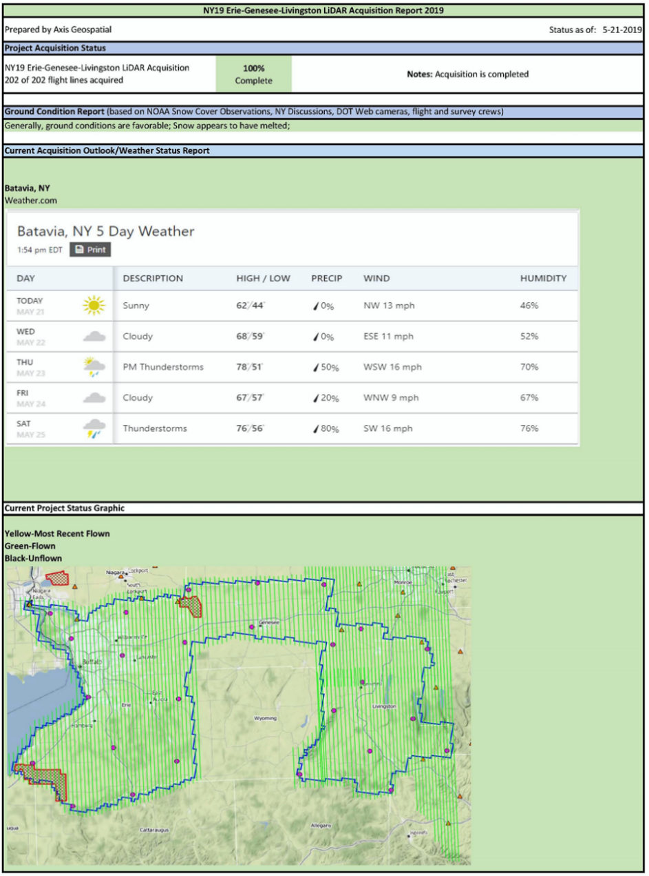

Figure 5-Daily Flight Report Graphical Section



Figure 6- Daily Flight Report tabular summary

## LiDAR System Acquisition Limitations

There are several limiting factors to LiDAR data acquisition which include weather, ground conditions, satellite configuration and equipment malfunctions.

During a LiDAR acquisition mission, there can be no clouds below the aircraft, rain, fog or excessive humidity between the sensor and the ground. Excessive, heavy winds, engaging the aircraft perpendicular to the line of flight, can result in “crab” of the aircraft which results in “gaps” or “slivers’ in the data between flight lines. Ground conditions which include pools of standing water and ditches filled with moving water affect the accuracy of LiDAR returns. The number of satellites “visible” to the aircraft during acquisition is an important factor and a poor Global Positioning System (GPS) configuration will contribute to less than desired accuracy. Therefore, satellite configuration, measured by PDOP (Positional Dilution of Precision) is checked each morning to ensure acquisition occurs during the most favorable geometric configuration of the satellites. Finally, despite the best maintenance routines and practices, systems malfunction and fail. Operator awareness is paramount to identifying the exact moment when a system malfunction occurs. This enables the crew to stop acquisition and correct the issue before continuing. At times, lines acquired with anomalies will need to be re-acquired.

## Acquisition Issues and Resolutions

Five (5) flight lines (line 86 flown 4-25 and lines 8, 9, 104, and 105 flown 5-6) were re-flown on 5-9 and 5-8 respectively due to potential cloud cover obscuring the sensor. These five (5) lines will be included in the calibration (highlighted in yellow in figure 7). Three flight lines including a cross strip were flown on 5-1 by aircraft N89LT. These lines were not processed due to the presence of clouds and high humidity. A reflight for these lines occurred on 5-5.

Figure 7-Flightlines re-flown due to clouds

## CORS Reference Stations

The presence of a high rate CORS (Continuously Operating Reference Station) and base station configuration allowed for the LiDAR to be acquired with Global Navigation Satellite System (GNSS) techniques and procedures. Table 4; “GPS Reference Station Coordinates” and Figure 8; “GPS Reference Stations” below contain a listing and graphic of the CORS and base stations that were used during the processing, their calculated latitude, longitude and ellipsoid height. Minor variations in position, due to changes in satellite availability, geometry and varying availability of the CORS stations, were observed, and are of millimeter level magnitude. These variations had no impact on system positioning and are unavoidable. Note that four of the stations (CAGS, CBRG, KNGS, and NRC1) are from the Canadian Spatial Reference System (CSRS) and were used by POSPac’s SmartBase processing software. The coordinates were transformed from ITRF2000 to NAD83 (2011). The remaining stations are from the NOAA NGS CORS Global Navigation Satellite System (GNSS) and Leica’s SmartNet Realtime network.

|  |  |  |  |
| --- | --- | --- | --- |
| STATION | Latitude | Longitude | Altitude |
| ASCS | N42°15'19.10769" | W77°47'49.22924" | 548.538 m |
| BFNY | N42°52'39.23726" | W78°53'25.64020" | 144.290 m |
| CBRG | N43°57'23.32432" | W78°09'51.82438" | 41.308 m |
| ERIE | N42°54'15.73798" | W78°57'34.77660" | 160.729 m |
| HICR | N43°46'03.53776" | W79°08'53.14082" | 53.843 m |
| NIAG | N43°05'52.87338" | W79°05'10.99836" | 154.728 m |
| NYBH | N42°06'35.13013" | W75°49'38.72671" | 311.870 m |
| NYBT | N42°59'17.99261" | W78°07'20.40236" | 261.064 m |
| NYCL | N42°35'03.74027" | W76°12'40.81708" | 329.690 m |
| NYCP | N42°11'16.47753" | W77°08'36.35388" | 276.424 m |
| NYDV | N42°32'56.12578" | W77°41'52.62184" | 187.389 m |
| NYFD | N42°25'41.81712" | W79°20'22.74730" | 211.315 m |
| NYFS | N42°12'16.82485" | W78°08'37.96572" | 441.358 m |
| NYHB | N42°43'02.69527" | W78°50'47.30102" | 211.325 m |
| NYLP | N43°09'54.88703" | W78°45'13.38492" | 165.130 m |
| NYMX | N43°28'12.41267" | W76°13'54.91145" | 89.978 m |
| NYNS | N43°07'07.78203" | W76°08'29.79779" | 97.413 m |
| NYPF | N43°05'35.51745" | W77°31'31.13893" | 112.313 m |
| NYRM | N43°10'40.06221" | W75°29'13.90624" | 127.360 m |
| NYSB | N42°40'45.06547" | W75°30'47.50106" | 295.899 m |
| NYSM | N42°11'31.41337" | W78°44'50.49244" | 409.417 m |
| NYWL | N42°53'55.26022" | W76°51'07.32787" | 108.778 m |
| NYWS | N42°42'03.15876" | W78°07'33.92212" | 313.264 m |
| ONBM | N43°54'10.32845" | W78°39'52.44020" | 57.684 m |
| ONCD | N44°17'28.61599" | W77°48'17.61856" | 118.068 m |
| ONTO | N43°36'56.41183" | W79°22'59.80627" | 51.189 m |
| OSPA | N43°27'53.59106" | W76°30'41.52295" | 49.983 m |
| PAPC | N41°45'51.93000" | W78°01'24.38195" | 483.389 m |
| VINE | N43°09'06.61401" | W79°23'36.05164" | 75.779 m |
| WELL | N42°59'41.26983" | W79°16'13.66059" | 147.493 m |
| WHIT | N43°51'38.24598" | W78°54'01.51670" | 60.037 m |
| YOU6 | N43°13'52.54367" | W78°58'11.32256" | 60.320 m |

Table 4: GPS Reference Station Coordinates

Figure 8: GPS Reference Stations

## Airborne GPS Kinematic and Processing

The Differential GPS unit in the aircraft collected positions at 2Hz. Airborne GPS data was processed using the POS Pac MMS v.8.3 software. Flights were flown with a minimum of 6 satellites in view (10° above the horizon) and with a PDOP of ≤3 when laser online. Distances from base station to aircraft were kept to a maximum of 50km.

For all flights, the GPS data can be classified as acceptable, with GPS residuals of 3cm average or better but none larger than 15cm being recorded when the laser is online.

Data collected by the LiDAR unit is reviewed for completeness, acceptable density and to make sure all data is captured without errors or corrupted values. In addition, all GPS, aircraft trajectory, mission information, and ground control files are reviewed and logged into a database.

Airborne Imaging utilized the latest in Airborne-GPS (AGPS) and Inertial Measurement Unit (IMU) systems to determine the precise three-dimensional trajectory of their aircraft in flight. These state-of-the-art sensor systems use the global navigation satellite system (GNSS), pitch-roll-yaw sensors, accelerometers and gyrocompasses to measure and record every change in the attitude, speed and direction of the aircraft during its data collection mission.

These measurements are linked together according to a precise time baseline that is collected as part of the GNSS message stream, allowing corrections for attitude variations to be known at the exact time the digital sensor records an image.

**AGPS/IMU Processing**

Airborne Imaging used Applanix POS Pac MMS v.8.1 to process Airborne GNSS/IMU datasets and compute Smoothed Best Estimated Trajectory (SBET) files for our LiDAR missions. This state-of-the-art GNSS/IMU processing technology uses a combination of GNSS data collected onboard the aerial platform during the mission, twenty-four (24) hours of satellite geometry and ephemeris data from the National CORS network that surrounds the flight mission footprint, and data from the onboard IMU that tracks the heading, acceleration/deceleration, pitch, roll and yaw of the aircraft during the flight.

The processing software uses all the data inputs to determine the precise three-dimensional trajectory of the aircraft during the mission. The process includes operator managed and software driven QA/QC checks, focusing on the geometry and spacing of the CORS network control points around the project area, data integrity and ensuring that software inputs and settings are properly configured to account for the system hardware locations in relation to the IMU reference location.

The workflow for each production block will follow a structured path, modified as needed to adjust for buy ups or other optional tasks:

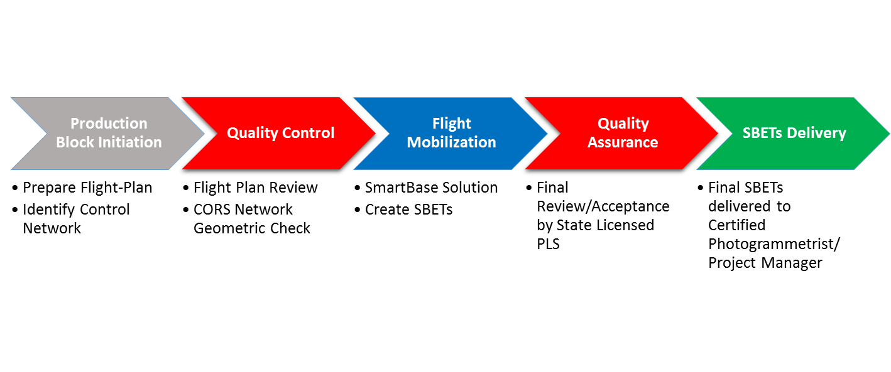

**SBET Processing Workflow Chart**

First, a flight plan and project are reviewed prior to mobilization to confirm CORS network geometry, station availability and data observation rates. Once approved for flight, the mission is executed by the flight operations team within the parameters of the flight plan, STATE requirements, applicable mapping guidelines, industry standards and in-house protocols. These requirements include collection of data on the ground before and after the flight, proper manipulation of the IMU during flight to avoid heading drift and careful navigation of the aircraft to avoid loss of satellite lock during the entire mission such as unduly steep banking turns, flight line deviations, or operation during turbulent conditions. Upon return to the airfield, the IMU and other data are downloaded, copied and made available for post processing. Post processing involves assembling flight data from the onboard GNSS and IMU, downloaded CORS vector data for a time balanced observation period centered on the takeoff to touchdown flight window of the data collection mission, published and vetted positional data for the CORS control stations, broadcast and precise ephemeris data documenting the projected and actual positions of the satellites during the mission.

GNSS Base Stations for the SmartBase processing are selected based on conformance with requirements of the software, including distance from the center of the flight mission, network station spacing, observation rates of the network base stations, and availability of both broadcast and precise ephemeris data for the satellites included in the GNSS dataset.

All these datasets are linked to the project database, checked for accuracy and readied for processing. The software uses a proprietary process to compute GNSS based forward and backward trajectories, IMU based forward and backward trajectories based on accelerometer and gyrocompass data, pitch, roll and yaw sensors, and then combine all of the independent solutions into a precisely computed string of plane and sensor positions during the mission. Due to the speed of travel of the aircraft, positioning is determined at the rate of fifty (50) times per second, based on actual observed data from equipment operating at that recording interval, not from interpolated data from equipment operating at slower data rates. This method yields truer positioning from direct observation rather than estimated positions between true fixes. The IMU system operates at very high speed, typically at two hundred measurements (200) per second, which allows the system to maintain a precise track on changes in aircraft attitude during acquisition. The GNSS data is combined with the IMU data to bridge the separations in position fixes and refine the precision of the plane’s trajectory down to nearly centimeter level three-dimensional precision.

The software downloads GNSS data from the CORS stations around the project area and performs a dataset integrity check of the GNSS RINEX files to find errors in the data such as gaps, incompatible collection rates or missing antenna information. The Applanix SmartBase software includes a SmartBase Quality Check module that performs an extremely accurate network analysis and adjustment on all the baselines and reference stations in the network. The Quality Check module uses 18 to 24 hours of reference station data to accurately compute the baselines between one station set as the control and the rest of the stations. The long duration of data is used to ensure that all multipath variations due to changes in satellite positions are averaged out as much as possible.

The output of the Quality Check module is a table indicating the estimated error for each set of reference station coordinates. If the estimated error is larger than 5 cm, the coordinates are flagged as unacceptable, indicating the input coordinate cannot be trusted. The user has the option of using the adjusted coordinates instead of the input coordinates, or not using the reference station at all in the Applanix SmartBase computations.

Additional quality checks are made on the individual reference station observation files before the Applanix SmartBase is computed. The result of this process ensures the integrity of the computed reference station data and coordinates are known and trusted before the airborne data set is even processed.

Once the network framework is approved, the software establishes a Virtual Reference Station near the project area. This technology is known as the Applanix SmartBase Solution and allows the software to minimize vector length from the primary base station to the aircraft, minimizing the effect of atmospheric and other systematic errors. Once the Virtual Reference Station is established, forward and backward processing of the GNSS and IMU datasets is executed to determine the exact path, known as the Smoothed Best Estimated Trajectory (SBET), of the airborne platform and its associated equipment.

**ABGPS/IMU QA Review & Analysis**

Once the SBET file is created, reports and output files of the data are automatically generated for review by the system operator. The primary analysis tool are the charts showing differences in values for aircraft roll-pitch and yaw values, positional quality information, satellite health and geometry, signal to noise ratios, and variances in direction or velocity vectors between forward and backward processed data that indicate some environmental variable has affected the data. The primary means of mitigating these errors is proper positioning support by the surrounding base station network, management of flight path length to eliminate IMU drift, and flight procedures that avoid interruption of satellite data reception.

**ABGPS/IMU Data Finalization and Preparation for LiDAR Production**

The SBET QA/QC review is finalized by independent assessment of the output charts and reports showing deviations between processing directions, spikes in aircraft attitude variations and quality of GNSS data and positional fixes. GPS processing results for each lift are included in Section5: GPS Processing.

# Flight Logs

Flight logs for each mission are in a folder named “FLIGHT_LOGS”. Please note LiDAR flight lines flown for an adjacent USGS LiDAR project are also included in the some of the flight logs. Lines used for this project are highlighted in yellow for logs containing adjoining flight lines.

# GPS Processing

Diagnostic QC Reports for each mission are in “GPS_PROC”. The report provides items such as trajectory plots, satellites used, CORS and GPS station maps and accuracy results, PDOP estimates, statistics for estimated accuracies, and combined separation plots. Please note that LiDAR swaths flown on 5-1 were not processed and therefore will not contain any GPS processing reports.

# Acquisition Swath Shapefiles

A shapefile containing the swaths processed for this project are also provided in a folder called “Acquisition_Swath_Shapefiles”. This shapefile has attributes for the following items:

**GPS_Start-**date format, minute resolution

**GPS_End-** date format, minute resolution

**TYPE**-Mission, Cross-Tie, or Other

**SwathName**-Name of processed swath for final LiDAR delivery

**MISSION**-Mission Name

**AIRCRAFT**-Aircraft Tail Number

**SENSOR**-Type of Riegl Sensor used

**DATE**-Date flown

**LINE**-Line Number in Flight Log

**PROJ_NAME**-Name of Project

**LIFT_ID**-Unique identifier of swath which is a combination of the MISSION and AIRCRAFT fields