New York State Airborne LIDAR
Final Review Report
New York State QL2 LIDAR Collection in Cattaraugus, Chautauqua, Allegany, Wyoming, and Genesee Counties
3DEP Project G17AC00096

NYS Office of Information Technology Services - GIS Program Office
In Partnership with
NYS Department of Transportation – Photogrammetry Section
August 6, 2018

Table of Contents

 | Page
Overview | 1
Qualitative Review | 1
Horizontal Position Review | 3
Vertical - Surveyed Checkpoints | 4
Vertical - NYSDOT Project Data | 4
Vertical - Mobile GPS Profile Data | 5
Summary | 6

In collaboration with our contractor, Axis Geospatial, LLC, the NYS Office of Information Technology Services - GIS Program Office (ITS-GPO) and the NYS Department of Transportation – Photogrammetry Section (NYSDOT) conducted quality assurance throughout the project. This started with defining the original project limits to cover the existing LIDAR gap while overlapping with neighboring existing datasets, and continued through reviews of flight and survey plans and into data collection and processing. Data acquisition and survey are documented in separate reports. A description of AXIS’ processing starts in the calibration report and continues through a general processing report.
Topic | AXIS Report Name
Acquisition | NY17_Southwest_17_B_Lidar_Acquisition_Report_08_27_2018.pdf  NY17_Southwest_17_B_Lidar_Acquisition_Report_Addendum_07_09_2018.pdf
Ground survey | NY17 Southwest 17 B LiDAR Survey Report 02_19_18.pdf
LIDAR and DEM Processing | NY17 Southwest 17-B LiDAR Accuracy and Processing Report_08_31_2018.pdf

This report describes the review process for classified LAS and DEMs, and provides the final accuracy statistics for the project. The subject dataset has been found to meet specifications detailed in USGS’ “LIDAR Base Specifications”, version 1.2, November 2014, plus clarification on water classification received from USGS and described below.
Qualitative Review
ITS-GPO performed detailed and systematic qualitative review of the classified LIDAR point cloud in LAS format. Most of the review steps touched every tile. This started with checking the LAS tiles for data gaps and areas of low point density. A first return surface with no interpolation was created and reviewed to look for data gaps. Gaps were linked to water surfaces which is acceptable, as were most lower density areas. During this early phase of review, the full collection of point classes present in all tiles was reviewed. The final tiles matched the minimum classification required.
Code | Description
1 | Processed, but unclassified.
2 | Bare earth.
7 | Low noise.
9 | Water.
10 | Ignored ground (near a breakline).
17 | Bridge decks.
18 | High noise.
LAS tiles were confirmed as LAS format 1.4. Where swaths overlapped, inclusion of points from both swaths was confirmed.
More detailed qualitative review stepped through different point classes. The locations and relative number of points in each class were reviewed at a high level to check for reasonableness. For example, water points were in areas with water features, and high and low noise classes were not overused to the detriment of modeling surface features. Review then switched to detailed review of specific classes, with most of the review and corrections focused on bare earth, water, and bridges. Throughout this process, profiles and 3D views were used to evaluate specific locations, and preexisting orthoimagery as well as intensity images from the LIDAR data were used as reference.
Bare earth points were reviewed independently for their overall density. Specific areas of lower density were reviewed and typically could be explained relative to the presence of water features, buildings, and occasionally very dense evergreen tree cover. A slope model filtered to focus on extremely steep slopes allowed for the detection of points which had been misclassified as bare earth, such as points on a building or a bridge which been incompletely removed.
Water points were reviewed both for reasonable usage and for meeting hydro-flattening requirements. A slope model based on the water points helped identify classification errors along the edges of water bodies. In these cases, points on the shoreline were reclassified as “bare earth” or “processed, but unclassified”. This review also indicated where hydro breaklines needed to be edited for more accurate depiction of water features. Ultimately, these areas also were reviewed for acceptable use of the “ignored ground” class.
The use of the bridge class was reviewed relative to known bridge locations in a NYSDOT database. In addition, orthoimagery was used to identify bridges which were not in the NYSDOT database. At each location, profiles and 3D views of the point cloud were used to identify misclassified points. Emphasis was placed on correcting points which affected modeling of stream channels below bridges.
After classification corrections were made to the LAS files and hydro breaklines were adjusted based on our review, bare earth digital elevation models (DEMs) were created with a 1-meter grid spacing. Additional review was performed on the DEMs. Initial review confirmed the overall extent of the DEM dataset. Tiles were reviewed together to ensure there were no edge effects. Bridge locations were reviewed, and additional breaklines were added where needed to maintain open stream channels in the DEMs. Finally, the locations of water bodies meeting the specs for hydro-flattening were reviewed. Standing water features were checked for no slope and proper handling of islands. Hydro-flattened flowing water features were checked for consistent and reasonable slopes.

Horizontal Position Review
Early in the review process, an intensity image was made from all tiles. In select areas, the horizontal position of features such as sidewalk corners, painted lines, and pavement intersections on this intensity image were compared to the locations of the same features on reference data. In most cases, the reference data were orthoimages or vector data digitized from the orthoimagery. In some cases, NYSDOT design scale mapping accurate to +/- 6 cm was also used. Occasionally, the project’s surveyed checkpoints also could be used. This check on the horizontal position of the LIDAR data was done to confirm a reasonable horizontal alignment before starting detailed vertical accuracy checks.
Below is an example where overlapping 1-ft resolution orthoimagery (horizontal accuracy better than +/- 4-ft at 95%) is shown with a 1-ft resolution intensity image created from the LAS point cloud.
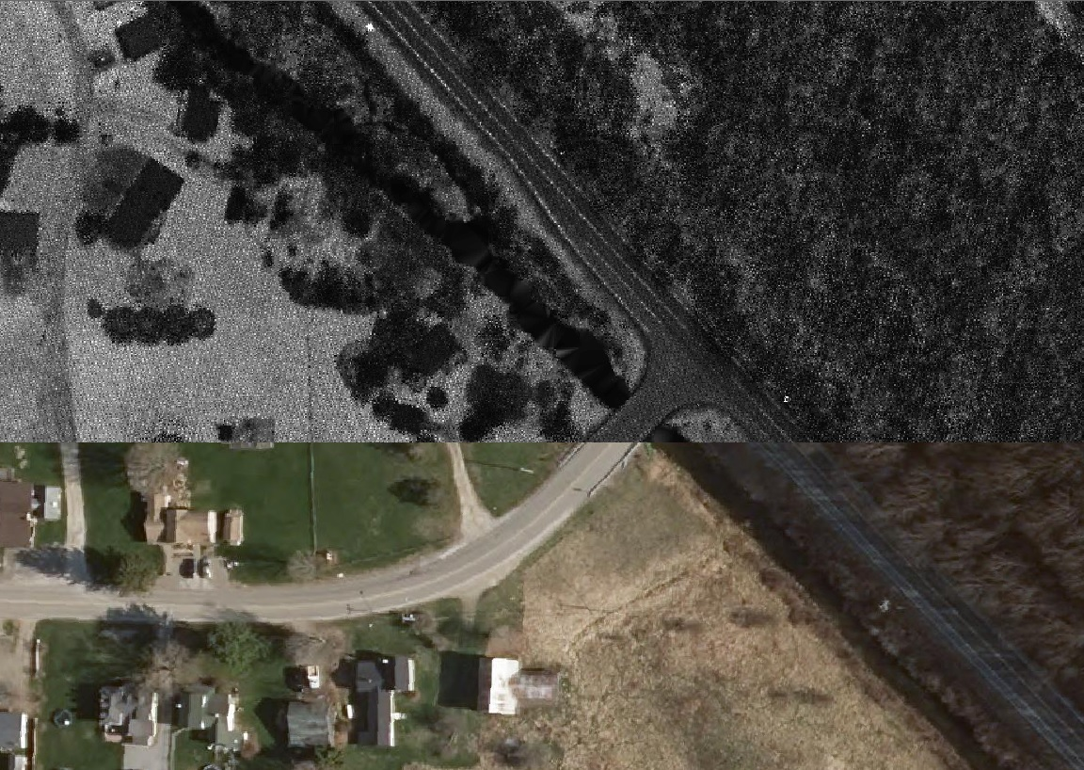

Vertical - Surveyed Checkpoints
Axis surveyed 139 checkpoints independently of the control points used in calibrating the swath data. These checkpoints were well distributed over the project. A range of land cover types were included, with 77 points in the nonvegetated vertical accuracy (NVA) group and 62 points in the vegetated vertical accuracy (VVA) group. For the ~5659 km² project, this number of checkpoints meets the number recommended in “ASPRS Accuracy Standards for Digital Geospatial Data”.
The surveyed checkpoints showed an acceptable vertical accuracy of the bare earth surface from the classified LAS tiles for Quality Level 2. Using an ESRI LAS dataset, the surface was modeled using a TIN and elevations at checkpoint locations were calculated by “draping” the surface on the points. Results are summarized below.
Comparison of Checkpoints to LAS-based Bare Earth Surface
Point Group | Number of Points | RMSE (m) | 95% (m)
All | 139 | 0.0617 | 0.1209
NVA | 77 | 0.0345 | 0.0677
VVA | 62 | 0.0840 | 0.1646

The surveyed checkpoints showed an acceptable vertical accuracy of the bare earth surface from the DEM for Quality Level 2. Elevations at checkpoint locations were calculated by “draping” the DEM surface on the points. Results are summarized below.
Comparison of Checkpoints to DEM Bare Earth Surface
Point Group | Number of Points | RMSE (m) | 95% (m)
All | 139 | 0.061024066 | 0.11960716
NVA | 77 | 0.032138653 | 0.06299176
VVA | 62 | 0.084059735 | 0.16475708

Vertical - NYSDOT Project Data
To increase our ability to evaluate the vertical quality of the LIDAR-derived surface, we used data from NYSDOT mapping projects. Control points used in these projects are surveyed to better than +/- 3 cm, while the final photogrammetric mapping is tested to meet vertical accuracies of +/- 6 cm. Using this data source expanded the portions of the project which had quantifiable vertical checks. Given their source and the resulting preponderance of hard surface (NVA) points, the NYSDOT checkpoints were kept separate from the checkpoints discussed above. The results are summarized below.
DOT Surveyed Project Control vs. LAS Bare Earth Surface
Number of Points | RMSE (m) | 95% (m)
587 | 0.072926408 | 0.142935761

Vertical - Mobile GPS Profile Data
A third dataset used to check the vertical quality of the LIDAR-derived surface was a street profile acquired with a GPS receiver mounted on a NYSDOT vehicle. Real time kinematic GPS processes were used to obtain the point locations. Points with poor quality solutions were removed from the dataset before being used to check the surface. These profile points are all on hard pavement surfaces. This technique has proved useful on past projects to identify systematic shifts whether they were abrupt steps or more gradual ramping. The collection was designed to cross as many collection swaths as possible because shifts on previous projects ultimately were traced back to poor calibration between swaths.
The mobile GPS profile points were kept separate from other quantitative comparisons, and the results are summarized below.
DOT Mobile Profile Points vs. LAS Bare Earth Surface
Number of Points | RMSE (m) | 95% (m)
1,776 | 0.0504 | 0.0987

Summary
This project succeeded in producing high quality LIDAR point cloud data and bare earth DEMs. Final products were judged to meet 3DEP specifications. As stated earlier in this report, many of the review steps included all tiles. Given the specific locations of the check data for quantitative vertical review, the following graphic provides an overview showing good distribution of these checks.
