P:\Survey\MCSD Projects\PR_USVI_Lidar 2018\Wes St. John's\VVA Doc Sheets\DOC031.tif

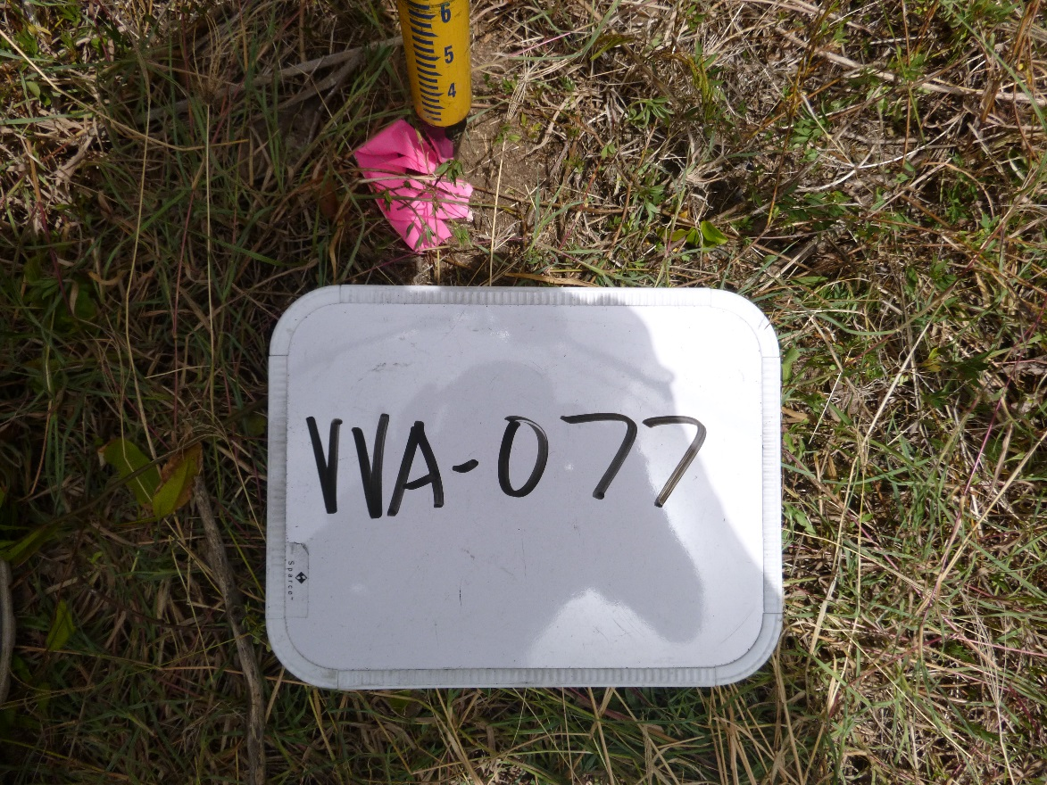

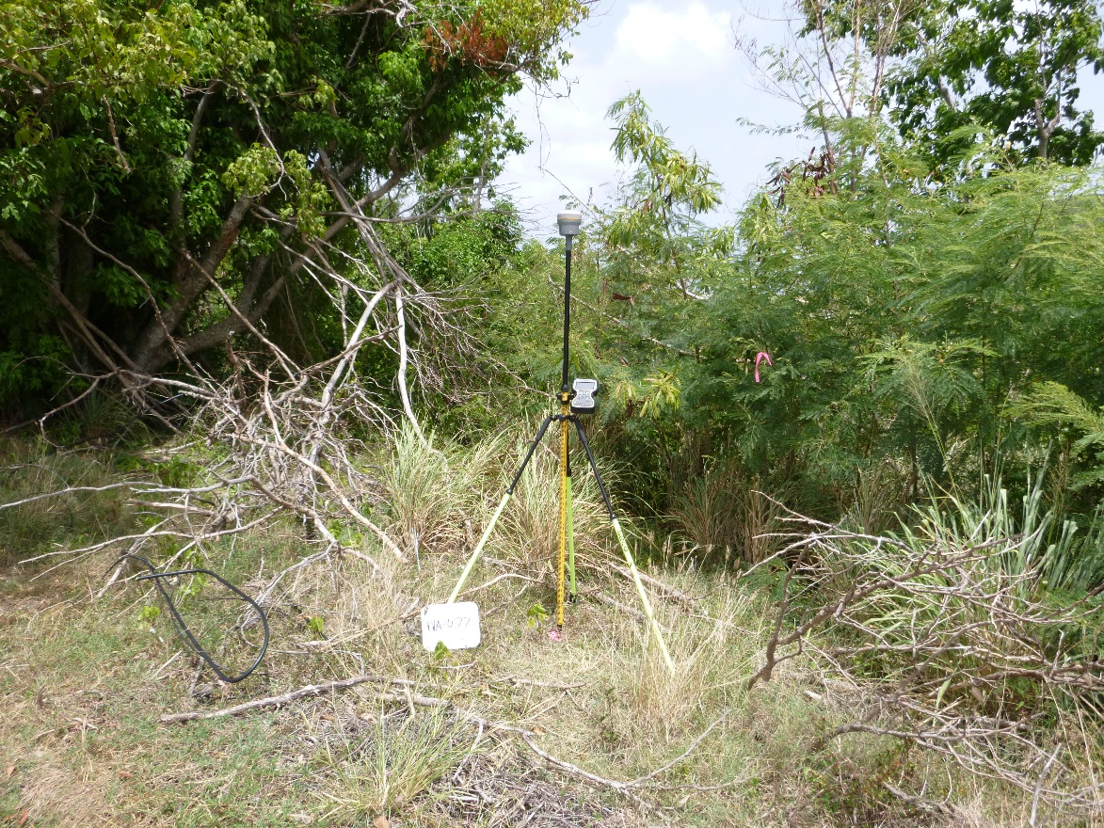

P:\Survey\MCSD Projects\PR_USVI_Lidar 2018\Wes St. John's\VVA Doc Sheets\DOC032.tif

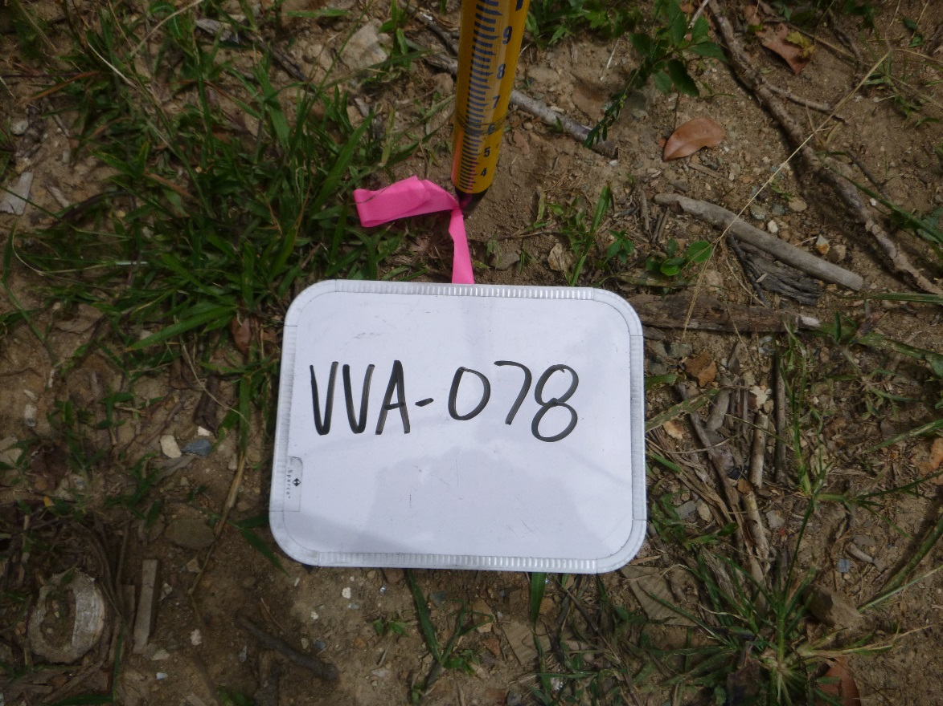

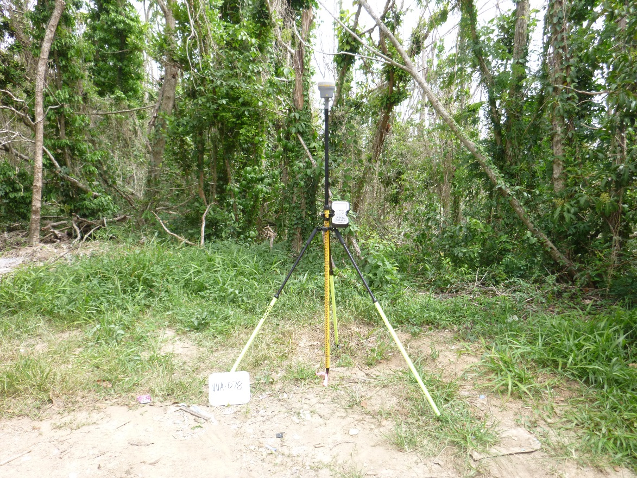

P:\Survey\MCSD Projects\PR_USVI_Lidar 2018\Wes St. John's\VVA Doc Sheets\DOC033.tif

