Geodetic Survey Report

CDI Project: 5134 Central Texas

CDI POC: Blaine Horner
blaineh@compassdatainc.com

Location of Survey: Texas

Date of Survey: January 2017

Customer: AECOM

POC: Bobby Riley

AECOM Project Name: Central Texas LIDAR QAQC

AECOM Purchase Order # 84863

AECOM Project # 60530314

Other Documents: 84863.CD Executed.pdf

Survey Report prepared by Philipp Hummel, PLS, CFedS, CP
phummel@compassdatainc.com

Table of Contents
Contents
Datum Requirements 3
Surveying Methods 3
Accuracy Summary 3
Post-Processing Procedure 3
Network and Base Stations 4
Network Adjustment 5

Datum Requirements

Contractual requirements for the survey by the client:

Horizontal: NAD83 (2011), UTM Zone 14, Meters.

Vertical: NAVD 1988 with Geoid 12B

The NAD83 (2011) datum is a geodetic datum with the Epoch of 2010.0.

Surveying Methods

The combination of static Global Navigation Satellite System (GNSS) observations, Real Time Kinematic network (RTK), GNSS Trimble Virtual Reference Station (VRS) Now network and RTK GNSS observations result in the highest accuracy of the coordinates. Static GNSS observations were performed at a minimum of 45 minutes long sessions. The RTK GNSS observations were based on RTK base setups on site established by CompassData on Control Points with multi-hour/multi-receiver static GNSS observations.
These are constrained to continuously operating reference stations (CORS) operated by the National Geodetic Survey (NGS). The field procedures for RTK provided two 90 second collects within each point visit. Between the two observations the GNSS unit was rotated by 180 degrees and re-setup. A second set of observations were collected on Targets and NVA points with a minimum time span of more than 2 hours between sets, but mostly on different days with independent RTK setups. All survey observations by CompassData were taken with Trimble GNSS units.

Accuracy Summary

CompassData designed the field work to be based on CORS and VRS station with independent checks. The different checks confirmed the design and are listed in the report. CompassData’s designed independent checks were done with static OPUS calculations and NGS monuments. All contracted 142 NVA points and all contracted 103 VVA meet the 6.5cm and 9.8cm 95-percent confidence level.

Post-Processing Procedure

The static data collected in the field was combined with static GNSS available from CORS stations, the Trimble VRS Now and SmartNet North America Network. The NGS CORS stations are operated by the Texas Department of Transportation. Coordinates for the control points were established by a constrained network adjustment (Least Square Method) and checked against Online Positioning User Service (OPUS) solutions for multi-hour observations. VRS network observations and RTK data from the site were also incorporated in the network adjustment. All observations are strengthening the network and ensure accuracy and confidence.
The AOI was separated into 5 smaller sub-areas. These are called bundle 1 to 5. Each bundle was processed by itself to minimize distortions due to the size. The datum integrity on all 5 bundles is anchored in the constrained CORS stations as listed below.

Network and Base Stations

The coordinates of the base stations provided by NGS and the Trimble VRS Now network were researched in more detail. The research confirmed the published coordinates by the NGS so that these coordinates could be chosen as constrains for the final adjustment.

Confirmed coordinates for the CORS stations SGI1, TXBO, TXCU, TXHO, TXPS, TXAN, TXPL, TXBS, TXBT, TXLL, TXAU, TXGZ, TXSE, TXWA, TXHE, TXJC, TXTA, ROD1, TXBC, TXCM. The Trimble VRS Now base stations SFDE, SSIA, SWEI and SmartNet North America base stations TXDV, TXFV, TXS4, TXSS, G4SM, LCJC, SGI1, LCLU, LCAS, LCMS, LCFR, TXGN, TXKL, LCBR, LCFL, TXKY, TXWN were included with baselines and RINEX information to strengthen the network adjustment, but without constraining to their published coordinates. This strategy pursued a best adjustment constrain to the official NGS NAD83 (2011) solution.

The following table lists the CORS stations for the different bundles. Constrained GNSS Base stations are the fixed coordinates from NGS datasheets and Check Stations are GNSS Base stations, which flexible to move according to calculations. The coordinates for the Check Stations serve as checks against published coordinates.

Bundle | Constrained Stations | Check Stations
1 | SGI1, TXBO, TXCU, TXHO, TXPS | TXAN, TXPL
2 | TXAN, TXBS, TXBT, TXLL | TXAU, TXGZ
3 | TXBS, TXLL, TXSE, TXWA | TXAU, TXBT
4 | TXGZ, TXHE, TXJC, TXTA | TXBS
5 | ROD1, TXBC, TXGZ, TXTA | TXCM

Figure 1: Table of CORS Stations per Bundle
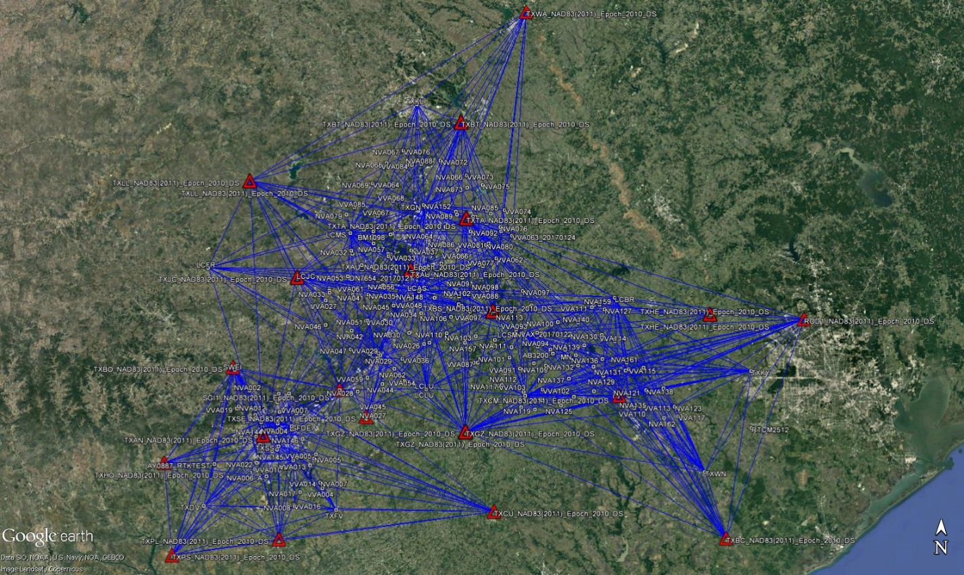

Figure 2: Network Map of AOI

For all bundles, first a free network adjustment was calculated, meaning without introduced coordinate constrains. The free network approach offers two main advantages. First, to install an optimized geometry of measurements, and secondly it indicates potential issues in the coordinates that later are used as constrains. The free network also gives an assessment of all used baselines and RTK- vectors.
In these bundles the CORS stations were introduced with coordinates.

Network Adjustment

The constrained network adjustment was calculated for the combined data of base stations coordinates, static observations, VRS- and RTK-observation. As described previously, special care was applied for the network base stations. The NGS CORS surrounding the AOI were constrained as fixed coordinates while Trimble VRS Now base stations were left unconstrained. An exception is bundle 1 containing coordinates from independent OPUS calculation for two VRS CORS Stations. The results of the adjustment demonstrate very high accuracy and high confidence. The accuracy for all coordinates is reported with a 95% confidence.

Before the accuracy reports of the adjustments are reported it is important to CompassData to include other measures to ensure quality. For this project the NGS monument availability was discussed beforehand. The general lack of good monuments in the area prompted the need for an additional quality checks. If monuments were not available or didn’t provide sufficient quality static observations were taken on the NGS Monuments.

The full network adjustment reports are attached in the APPENDIX.
For each bundle is a separate report. The main constrained network results are shown in these reports. Each includes metadata, general settings, statistical overview, adjusted coordinates in UTM and adjust coordinates in geographic coordinates, and error information with a 95% confidence level.

Monument Checks

Below the table with NGS monument checks against the network adjustments:
 | Monument ID | Difference | HZ | V | Comment
 | AB2776 | Static - Datasheet | 0.070m | 0.047m | 1/11/2017 4:33:22 PM - 1/11/2017 6:53:37 PM
 | AY0968* | Static - Datasheet | 0.271m | 0.055m | 1/6/2017 11:12:15 PM - 1/7/2017 12:03:05 AM
 |  | VRS - Datasheet | 0.260m | 0.087m | 1/7/2017
Bundle 1 |  | VRS - Datasheet | 0.261m | 0.094m | 1/8/2017
 | AB2776 | VRS - Datasheet | 0.068m | 0.028m | 1/11/2017
 | AY0887 | VRS - Datasheet | 0.062m | 0.038m | 1/10/2017
 | AY2100 | VRS - Datasheet | 0.028m | 0.025m | 1/10/2017 & 1/11/2017
Bundle 2 | DN7654 | Static - Datasheet | 0.004m | 0.037m | 1/16/2017 11:35:22 PM 1/17/2017 12:20:23 AM
 | DN7654 | VRS - Datasheet | 0.015m | 0.024m | 1/16/2017
Bundle 3 | BM1098 | Static - Datasheet | 0.006m | 0.006m | 1/18/2017 6:04:46 PM- 1/18/2017 6:51:21 PM
 | BM1098 | VRS - Datasheet | 0.023m | 0.014m | 1/18/2017
 | AB3200 | VRS - Datasheet | 0.013m | 0.024m | 1/31/2017
Bundle 4 | BM0534 | VRS - Datasheet | 0.016 | 0.003m | 1/23/2017
Bundle 5 | AB3200 | VRS - Datasheet | 0.016m | 0.023m | 1/31/2017

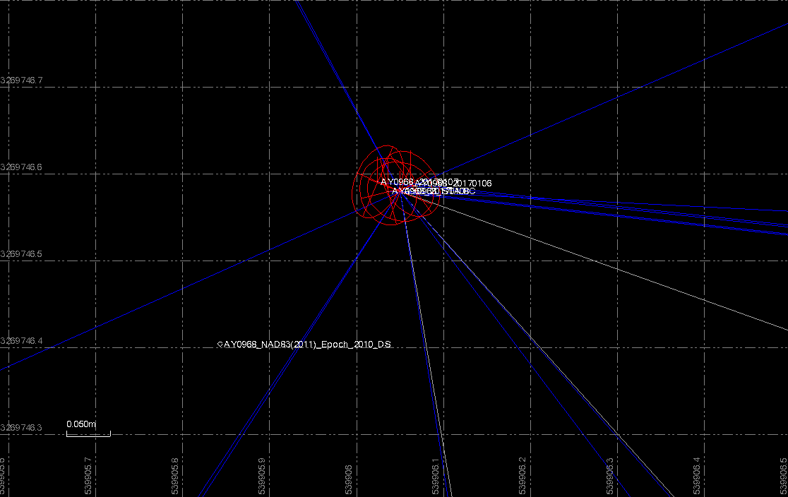

* NGS Monument AY0968 has a published coordinate with a NAD83 (1986) datum. This geodetic datum has an offset relative to the NAD83 (2011). All our measured observations calculate within a few centimeters as shown in the graphic above and confirm the accuracy despite the published coorinates.

Philipp Hummel, PLS, CFedS, CP
Technical Director
303.627.4058 Office
12353 E. Easter Avenue
Centennial, CO 80112
phummel@compassdatainc.com
www.compassdatainc.com

